Whiteboard Equations
Joint Task Offloading, Resource Allocation and Energy Optimisation in MEC
Transcribed from 26 board photos taken on 12 October 2026

How to read this document
Each photo has its own page. Photos 1-18 are in the order they were taken (by timestamp); photos 19-26 were sent later without timestamps, so they are in the order sent and each says which earlier board stage it matches. Every page gives the photo’s file name, then what is written on the board, then short notes. Equations are written as they appear on the board, including versions that were later corrected; the notes say what changed. Interpretations use Jiang et al., IEEE IoT Journal 2025 (“the paper”) and the final-year report (“the report”). The last two pages give the consolidated final model and points worth confirming.

Symbols used on the board
Symbol | Meaning | In paper / report
$$n, N$$ | Device index; number of devices | Same
$$m, M$$ | Edge node (EN) index; number of ENs | Same
$$x_{n,m}$$ | 1 if device $n$ is attached to EN $m$, else 0 | Paper eq. (1)
$$α_{n},β_{n},γ_{n}$$ | Share of task $n$ processed locally / at the EN / at the cloud | Paper eq. (2)
$$f^{L}, f^{L,max}$$ | Local CPU operating frequency and its maximum | Report $f_{n}^{L}$, (C6)
$$P_{n}, P_{n,max}$$ | Uplink transmit power of device $n$ and its maximum | Paper $p_{n}$; report $P_{n}^{tx}$, (C5)
$$R_{n}, R_{n,m}$$ | Uplink data rate from device $n$ to EN $m$ | Paper eqs. (3), (6)
$f, f_{n,m}$ (in the rate) | Channel bandwidth (not CPU frequency) | Paper $b$ / $B$
$$\left|h\right|$$ | Channel gain | Paper uses path loss $L\left(d_{n,m}\right)$
$$I_{n}, I_{n,j}$$ | Inter-cell interference | Paper eq. (4)
$$δ_{n}, δ^{2}$$ | Noise power | Paper $δ^{2}$ (AWGN)
$$d_{n}$$ | Input data size of task $n$ | Same
$$φ_{n}$$ | CPU cycles per bit of task $n$ | Paper / report $p_{n}$
$$K$$ | Effective switched-capacitance coefficient | Report $η≈{10}^{-27}$
$$E_{n}$$ | Energy consumed by device $n$ | Report eq. (3.19)
$$T_{n}$$ | Completion latency of task $n$ | Paper eq. (13)
$$t_{n}^{comm}$$ | Uplink transmission time | Paper eq. (7)
$$Φ$$ | Set of all decision variables | -

Photo 1 of 26: Early board: association constraints
IMG_20261012_115431_240.jpg
Professor at the board (back view). Left half only.
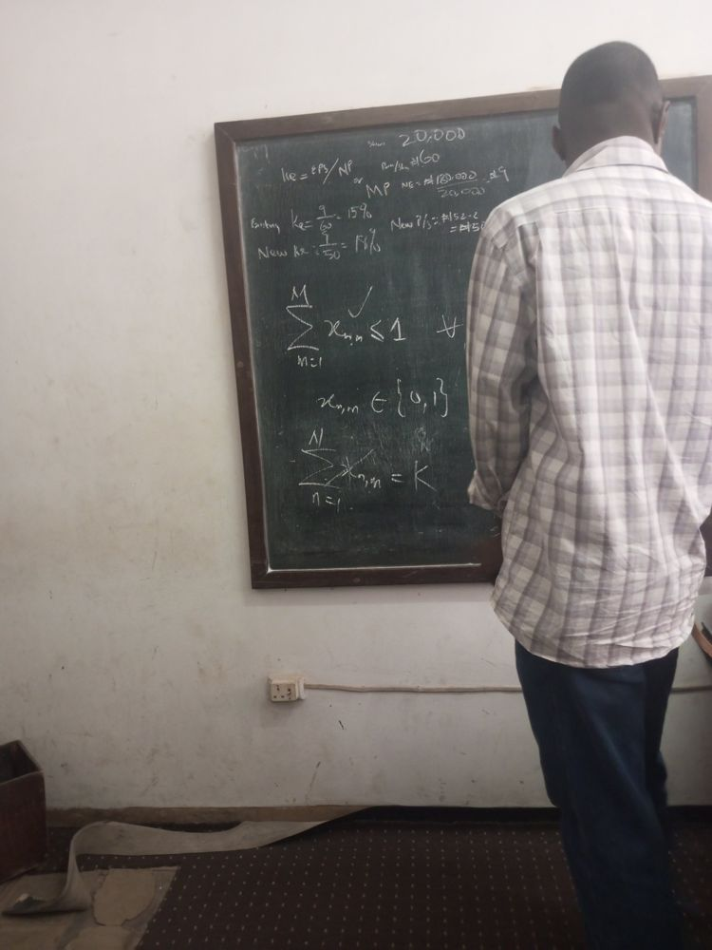

MEC constraints
Association constraint (ticked on the board) | $$\sum_{m=1}^{M}{x_{n,m}}≤1, ∀n$$
Binary association variable | $$x_{n,m}∈\{0,1\}$$
Crossed out on the board (rejected) | $$\sum_{n=1}^{N}{x_{n,m}}=K$$

Notes
- $x_{n,m}=1$ when device $n$ is attached to edge node $m$ (paper, eq. 1).
- m​xn,m≤1: each device connects to at most one EN, as in the paper’s Section III-A.
- The crossed-out n​xn,m=K would have forced every EN to serve exactly $K$ devices; it was dropped. This $K$ is a device count, unrelated to the energy coefficient $K$ used later.

Photo 2 of 26: Close-up of the association constraints
IMG_20261012_115438_718.jpg
Close-up of the same board as photo 1.
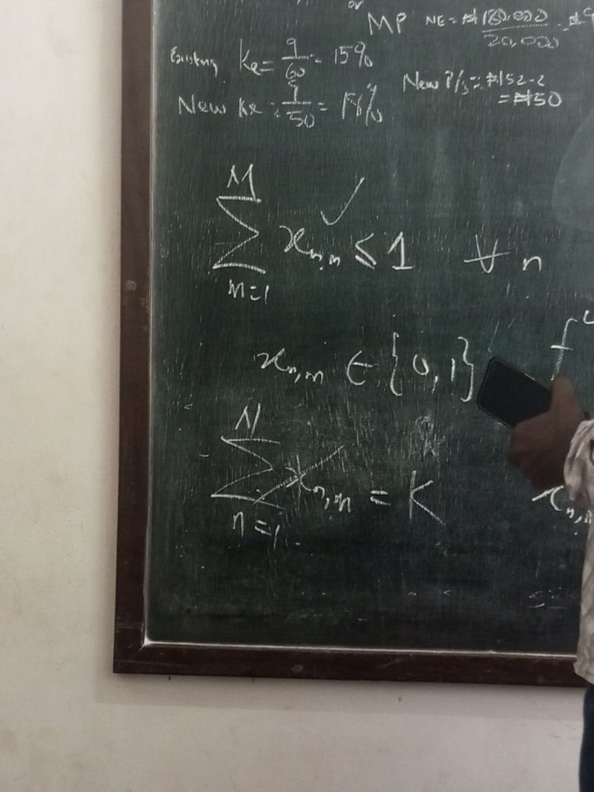

MEC constraints
Association constraint (ticked on the board) | $$\sum_{m=1}^{M}{x_{n,m}}≤1, ∀n$$
Binary association variable | $$x_{n,m}∈\{0,1\}$$
Crossed out on the board (rejected) | $$\sum_{n=1}^{N}{x_{n,m}}=K$$
Cut off at the right edge: the start of $f^{L}$ and $x_{n,m}$ (the list shown in photo 3).

Notes
- $x_{n,m}=1$ when device $n$ is attached to edge node $m$ (paper, eq. 1).
- m​xn,m≤1: each device connects to at most one EN, as in the paper’s Section III-A.
- The crossed-out n​xn,m=K would have forced every EN to serve exactly $K$ devices; it was dropped. This $K$ is a device count, unrelated to the energy coefficient $K$ used later.

Photo 3 of 26: Identifying the unknowns
IMG_20261012_115540_094.jpg
Side view. The decision variables are listed with question marks; “s.t.” is started at the top right.
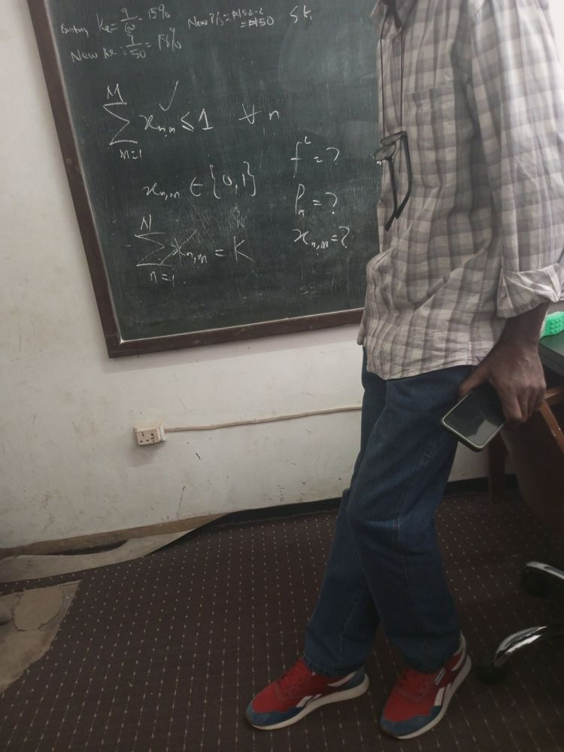

MEC constraints
Association constraint (ticked on the board) | $$\sum_{m=1}^{M}{x_{n,m}}≤1, ∀n$$
Binary association variable | $$x_{n,m}∈\{0,1\}$$
Crossed out on the board (rejected) | $$\sum_{n=1}^{N}{x_{n,m}}=K$$

Unknowns to be optimised (written as)
$$f^{L}= ?$$
$$P_{n}= ?$$
$$x_{n,m}= ?$$

Notes
- These are the first decision variables named: local CPU frequency $f^{L}$, transmit power $P_{n}$ and association $x_{n,m}$. The partition ratios $α_{n},β_{n},γ_{n}$ are added to the set in photo 5.
- Both $f^{L}$ and $P_{n}$ are new relative to the paper, which fixes CPU capacity and transmit power; the report adds them as DVFS and power control (Sections 3.3-3.4).

Photo 4 of 26: Identifying the unknowns (second shot)
IMG_20261012_115540_230.jpg
Second shot of photo 3; identical content.
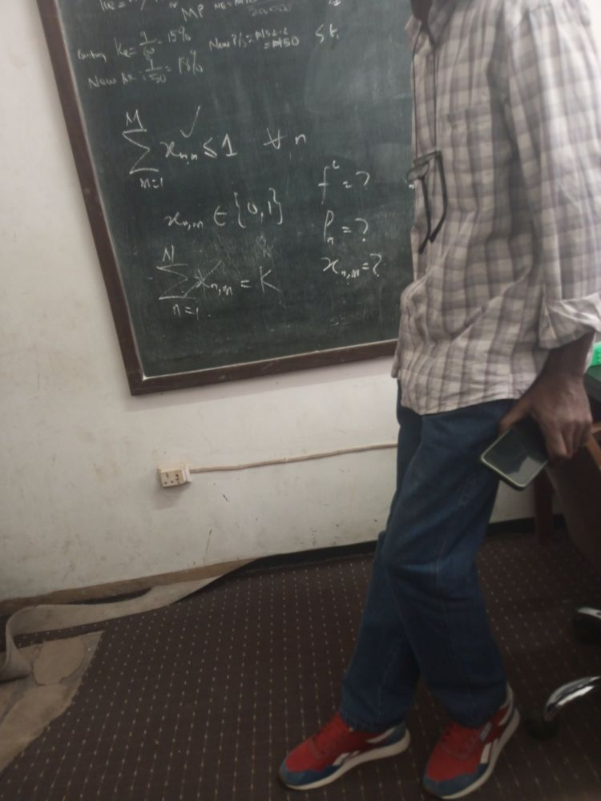

MEC constraints
Association constraint (ticked on the board) | $$\sum_{m=1}^{M}{x_{n,m}}≤1, ∀n$$
Binary association variable | $$x_{n,m}∈\{0,1\}$$
Crossed out on the board (rejected) | $$\sum_{n=1}^{N}{x_{n,m}}=K$$

Unknowns to be optimised
$$f^{L}= ?$$
$$P_{n}= ?$$
$$x_{n,m}= ?$$

Notes
- Same as photo 3.

Photo 5 of 26: First optimisation problem
IMG_20261012_120135_900.jpg
Right half of the board. The left edge shows part of the decision-variable set.
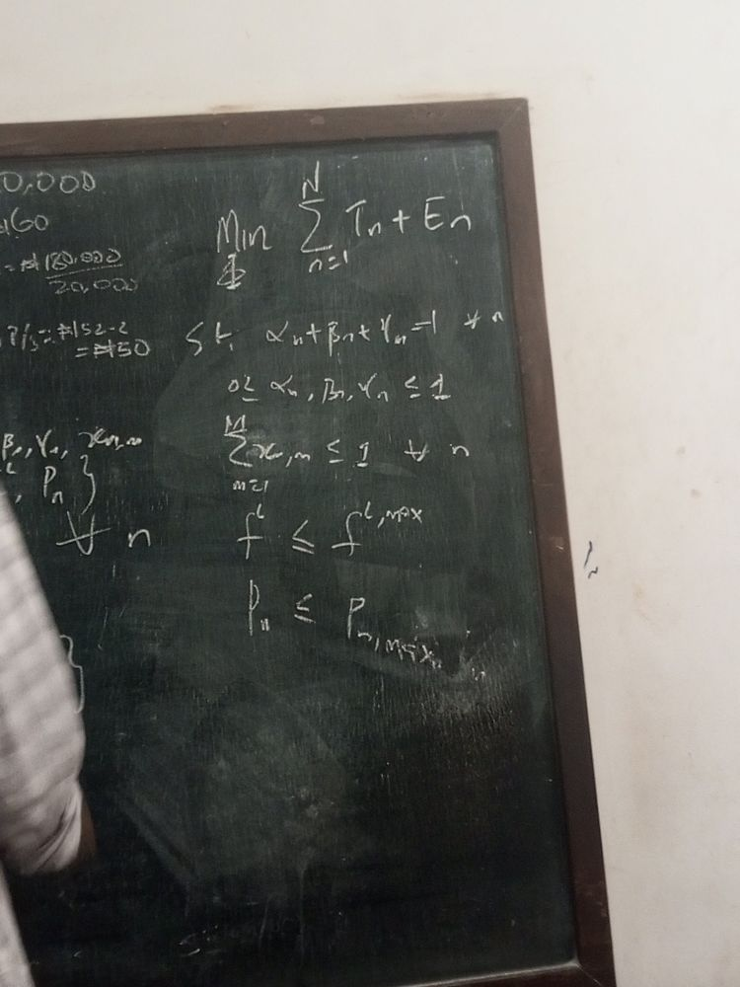

Decision variables (left edge, partly visible)
$$\{ …, β_{n}, γ_{n}, x_{n,m}, …, f^{L}, P_{n} \}, ∀n$$

Problem
Objective | $$\min_{Φ} \sum_{n=1}^{N}{\left(T_{n}+E_{n}\right)}$$
s.t. | $$α_{n}+β_{n}+γ_{n}=1, ∀n$$
 | $$0≤α_{n}, β_{n}, γ_{n}≤1$$
 | $$\sum_{m=1}^{M}{x_{n,m}}≤1, ∀n$$
 | $$f^{L}≤f^{L,max}$$
 | $$P_{n}≤P_{n,max}$$

Notes
- $Φ$ under Min is the set of decision variables (listed on the board as $f^{L},P_{n},α_{n},β_{n},γ_{n},x_{n,m}$).
- $E_{n}$ is underlined on the board: it is the new energy term added to the paper’s latency-only objective (paper eq. 14 minimises n​Tn only).
- $T_{n}$ is never written out on the board; it is the paper’s max-of-three-tiers latency (eqs. 12-13). See the last page.
- Constraint sources: partition ratios = paper (14a)-(14b); association = Section III-A; $f^{L}$ bound = report (C6); power bound = paper (14f) / report (C5).

Photo 6 of 26: First optimisation problem (variable set erased)
IMG_20261012_120441_410.jpg
Right half of the board after the left-hand variable set was wiped.
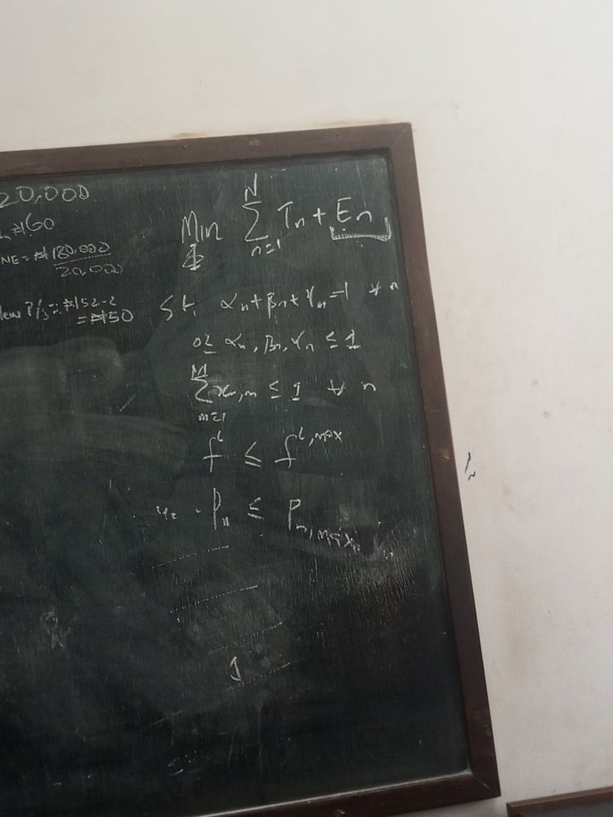

Problem
Objective | $$\min_{Φ} \sum_{n=1}^{N}{\left(T_{n}+E_{n}\right)}$$
s.t. | $$α_{n}+β_{n}+γ_{n}=1, ∀n$$
 | $$0≤α_{n}, β_{n}, γ_{n}≤1$$
 | $$\sum_{m=1}^{M}{x_{n,m}}≤1, ∀n$$
 | $$f^{L}≤f^{L,max}$$
 | $$P_{n}≤P_{n,max}$$

Notes
- $Φ$ under Min is the set of decision variables (listed on the board as $f^{L},P_{n},α_{n},β_{n},γ_{n},x_{n,m}$).
- $E_{n}$ is underlined on the board: it is the new energy term added to the paper’s latency-only objective (paper eq. 14 minimises n​Tn only).
- Small isolated marks (something like “u2” before the power constraint and a lone “1” lower down) do not appear to belong to any equation and are left out.

Photo 7 of 26: Rate and energy model (first draft)
IMG_20261012_121303_478.jpg
Professor writing the energy terms. Problem still on the right.
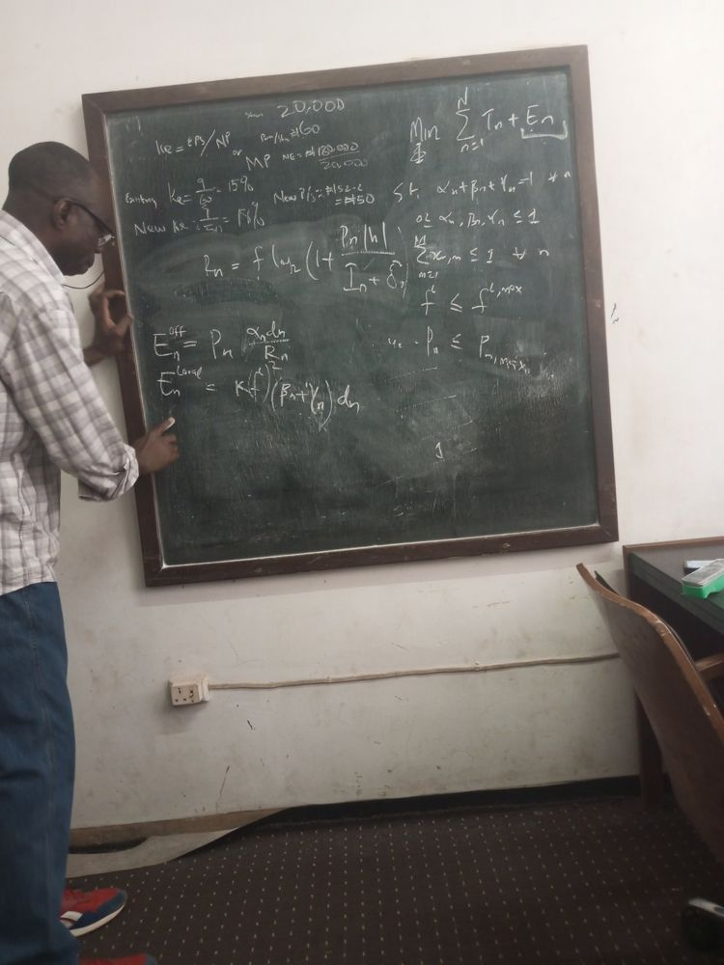

Rate and energy (left)
Uplink data rate | $$R_{n}=f\log_{2}\left(1+\frac{P_{n} |h|}{I_{n}+{δδ_{n }}^{2}}\right)$$
Offloading (transmission) energy | $$E_{n}^{Local}=P_{n} \frac{α_{n}d_{n}}{R_{n}}$$
Local computation energy | $$E_{n}^{off}=K{\left(f^{L}\right)}^{2}\left(β_{n}+γ_{n}\right) d_{n}$$

Problem (right)
Objective | $$\min_{Φ} \sum_{n=1}^{N}{\left(T_{n}+E_{n}\right)}$$
s.t. | $$α_{n}+β_{n}+γ_{n}=1, ∀n$$
 | $$0≤α_{n}, β_{n}, γ_{n}≤1$$
 | $$\sum_{m=1}^{M}{x_{n,m}}≤1, ∀n$$
 | $$f^{L}≤f^{L,max}$$
 | $$P_{n}≤P_{n,max}$$

Notes
- $R_{n}$ is the Shannon rate (paper eqs. 3 and 6). The $f$ in front of $\log_{2}$ is the channel bandwidth ($b$/$B$ in the paper), not the CPU frequency $f^{L}$.
- $\left|h\right|$ is the channel gain; $I_{n}$ is inter-cell interference; $δ_{n}$ is the noise term (later rewritten as $δ^{2}$).
- $E^{off}$ = transmit power $×$ transmission time. $E^{Local}$ is the DVFS model $Kf^{2}×$ (work), matching the report’s eq. (3.17).
- In this version $α_{n}$ is treated as the local share and $β_{n}+γ_{n}$ as the offloaded share. That is the reverse of the paper (where $α_{n}$ = local).

Photo 8 of 26: Total energy, first draft
IMG_20261012_121423_291.jpg
Full board (slightly blurred). Total energy added and boxed. Readings confirmed against photo 9.
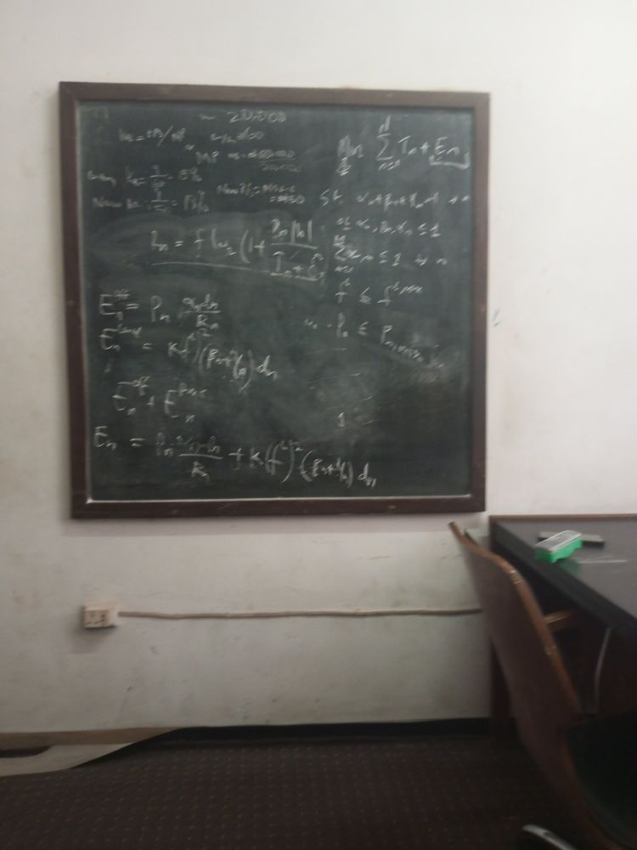

Rate and energy
Uplink data rate | $$R_{n}=f\log_{2}\left(1+\frac{P_{n} |h|}{I_{n}+δ_{n}}\right)$$
Offloading (transmission) energy | $$E_{n}^{Local}=P_{n} \frac{α_{n}d_{n}}{R_{n}}$$
Local computation energy | $$E_{n}^{off}=K{\left(f^{L}\right)}^{2}\left(β_{n}+γ_{n}\right) d_{n}$$
Total device energy (written as a sum of the two parts) | $$E_{n}=E_{n}^{off}+E_{n}^{Local}$$
Boxed result | $$E_{n}=P_{n} \frac{α_{n}d_{n}}{R_{n}}+K{\left(f^{L}\right)}^{2}\left(β_{n}+γ_{n}\right) d_{n}$$

Problem
Objective | $$\min_{Φ} \sum_{n=1}^{N}{\left(T_{n}+E_{n}\right)}$$
s.t. | $$α_{n}+β_{n}+γ_{n}=1, ∀n$$
 | $$0≤α_{n}, β_{n}, γ_{n}≤1$$
 | $$\sum_{m=1}^{M}{x_{n,m}}≤1, ∀n$$
 | $$f^{L}≤f^{L,max}$$
 | $$P_{n}≤P_{n,max}$$

Notes
- $E^{off}$ = transmit power $×$ transmission time. $E^{Local}$ is the DVFS model $Kf^{2}×$ (work), matching the report’s eq. (3.17).
- In this version $α_{n}$ is treated as the local share and $β_{n}+γ_{n}$ as the offloaded share. That is the reverse of the paper (where $α_{n}$ = local).

Photo 9 of 26: Full board, first draft (with variable list)
IMG_20261012_121522_104.jpg
Sharp full view. The decision-variable list has been added at the top left.
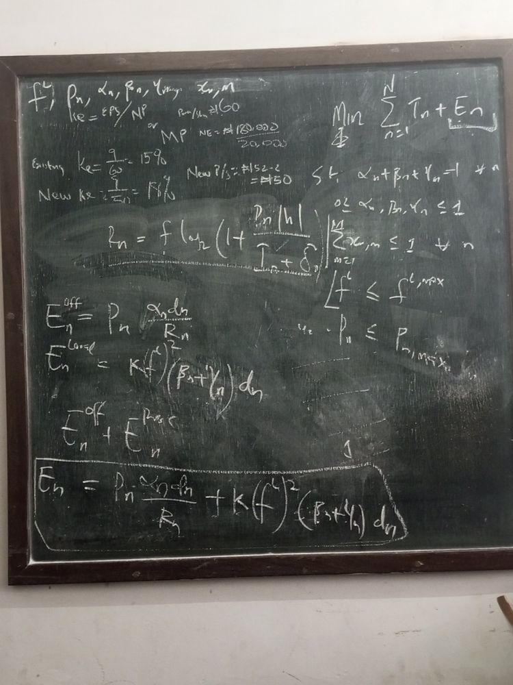

Decision variables (top left)
$$Φ=\left\{f^{L}, P_{n}, α_{n}, β_{n}, γ_{n}, x_{n,m}\right\}$$

Problem
Objective | $$\min_{Φ} \sum_{n=1}^{N}{\left(T_{n}+E_{n}\right)}$$
s.t. | $$α_{n}+β_{n}+γ_{n}=1, ∀n$$
 | $$0≤α_{n}, β_{n}, γ_{n}≤1$$
 | $$\sum_{m=1}^{M}{x_{n,m}}≤1, ∀n$$
 | $$f^{L}≤f^{L,max}$$
 | $$P_{n}≤P_{n,max}$$

Rate and energy
Uplink data rate | $$R_{n}=f\log_{2}\left(1+\frac{P_{n} |h|}{I_{n}+δ_{n}}\right)$$
Offloading (transmission) energy | $$E_{n}^{off}=P_{n} \frac{α_{n}d_{n}}{R_{n}}$$
Local computation energy | $$E_{n}^{Local}=K{\left(f^{L}\right)}^{2}\left(β_{n}+γ_{n}\right) d_{n}$$
Total device energy (written as a sum of the two parts) | $$E_{n}=E_{n}^{off}+E_{n}^{proc}$$
Boxed result | $$E_{n}=P_{n} \frac{α_{n}d_{n}}{R_{n}}+K{\left(f^{L}\right)}^{2}\left(β_{n}+γ_{n}\right) d_{n}$$

Notes
- The variable list at the top left defines $Φ$ in the objective. A small word after $γ_{n}$ is illegible.
- In this version $α_{n}$ is treated as the offloaded share and $β_{n}+γ_{n}$ as the local share. That is the reverse of the paper (where $α_{n}$ = local). It is corrected in photo 11.

Photo 10 of 26: Full board, first draft (second shot)
IMG_20261012_121522_455.jpg
Second shot of photo 9; identical content.
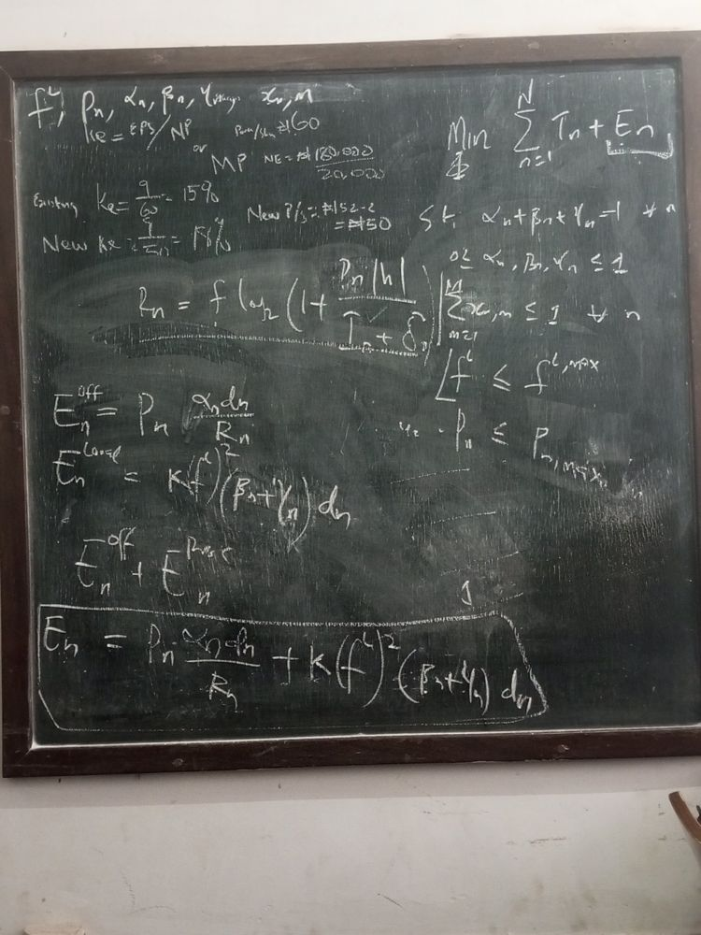

Decision variables
$$Φ=\left\{f^{L}, P_{n}, α_{n}, β_{n}, γ_{n}, x_{n,m}\right\}$$

Problem
Objective | $$\min_{Φ} \sum_{n=1}^{N}{\left(T_{n}+E_{n}\right)}$$
s.t. | $$α_{n}+β_{n}+γ_{n}=1, ∀n$$
 | $$0≤α_{n}, β_{n}, γ_{n}≤1$$
 | $$\sum_{m=1}^{M}{x_{n,m}}≤1, ∀n$$
 | $$f^{L}≤f^{L,max}$$
 | $$P_{n}≤P_{n,max}$$

Rate and energy
Uplink data rate | $$R_{n}=f\log_{2}\left(1+\frac{P_{n} |h|}{I_{n}+δ_{n}}\right)$$
Offloading (transmission) energy | $$E_{n}^{off}=P_{n} \frac{α_{n}d_{n}}{R_{n}}$$
Local computation energy | $$E_{n}^{Local}=K{\left(f^{L}\right)}^{2}\left(β_{n}+γ_{n}\right) d_{n}$$
Total device energy (written as a sum of the two parts) | $$E_{n}=E_{n}^{off}+E_{n}^{proc}$$
Boxed result | $$E_{n}=P_{n} \frac{α_{n}d_{n}}{R_{n}}+K{\left(f^{L}\right)}^{2}\left(β_{n}+γ_{n}\right) d_{n}$$

Notes
- Same as photo 9.

Photo 11 of 26: Energy model corrected
IMG_20261012_121812_372.jpg
Angled shot. The local/offload shares in the energy terms have been swapped and a rate example added.
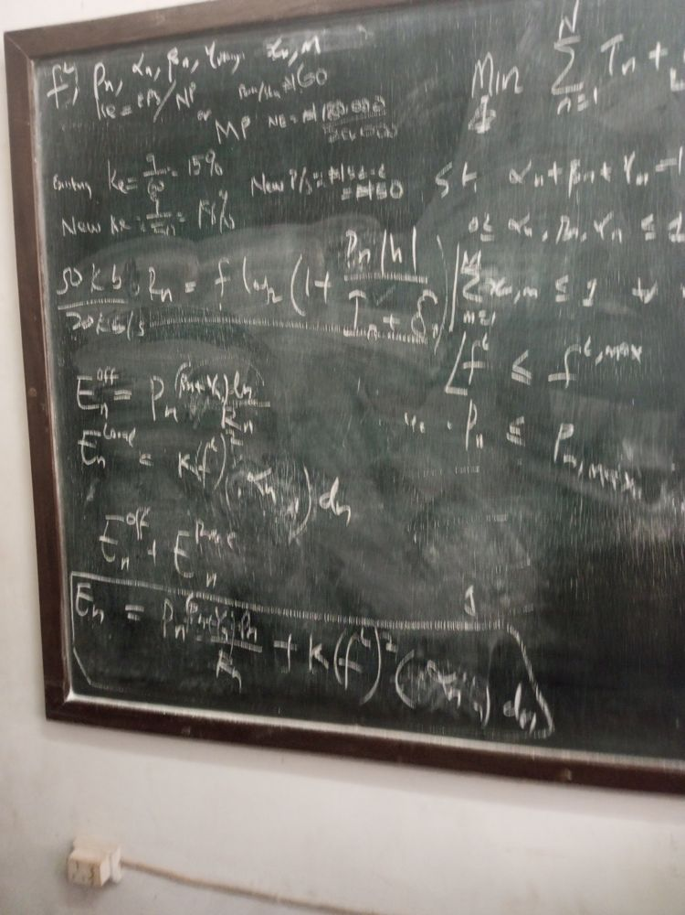

Rate and energy
Side calculation written beside the rate | $$\frac{50 kb}{20 kb/s} = 2.5 s$$
Uplink data rate | $$R_{n}=f\log_{2}\left(1+\frac{P_{n} |h|}{I_{n}+δ_{n}}\right)$$
Offloading (transmission) energy (corrected) | $$E_{n}^{off}=P_{n} \frac{\left(β_{n}+γ_{n}\right) d_{n}}{R_{n}}$$
Local computation energy (corrected) | $$E_{n}^{Local}=K{\left(f^{L}\right)}^{2}α_{n} d_{n}$$
Total device energy | $$E_{n}=E_{n}^{off}+E_{n}^{proc}$$
Boxed result (corrected) | $$E_{n}=P_{n} \frac{\left(β_{n}+γ_{n}\right) d_{n}}{R_{n}}+K{\left(f^{L}\right)}^{2}α_{n} d_{n}$$

Problem (right edge partly cut off)
Objective | $$\min_{Φ} \sum_{n=1}^{N}{\left(T_{n}+E_{n}\right)}$$
s.t. | $$α_{n}+β_{n}+γ_{n}=1, ∀n$$
 | $$0≤α_{n}, β_{n}, γ_{n}≤1$$
 | $$\sum_{m=1}^{M}{x_{n,m}}≤1, ∀n$$
 | $$f^{L}≤f^{L,max}$$
 | $$P_{n}≤P_{n,max}$$

Notes
- Correction relative to photos 7-10: offloaded share is now $β_{n}+γ_{n}$ (edge + cloud) and local share is $α_{n}$, matching the paper’s definition.
- The 50 kb / 20 kb/s side calculation illustrates why $d_{n}/R_{n}$ is a time: data size divided by rate gives seconds.
- $E^{proc}$ (local processing) and $E^{Local}$ are the same term under two names.

Photo 12 of 26: Binary constraint added
IMG_20261012_121928_334.jpg
Full board. $x_{n,m}∈\{0,1\}$ added under the power constraint.
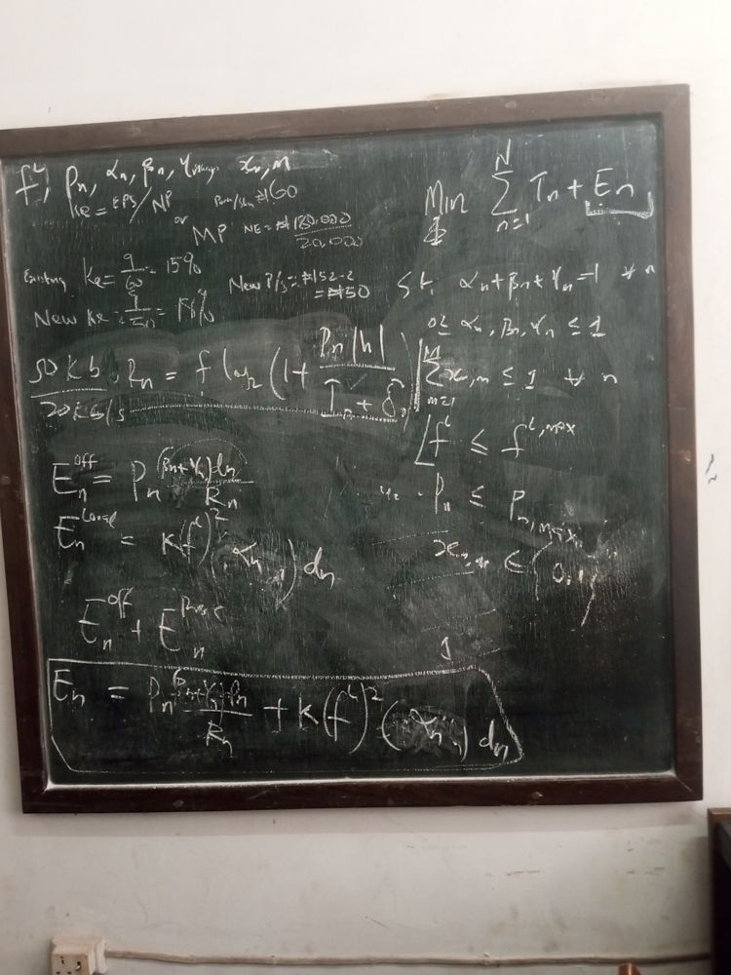

Decision variables
$$Φ=\left\{f^{L}, P_{n}, α_{n}, β_{n}, γ_{n}, x_{n,m}\right\}$$

Problem
Objective | $$\min_{Φ} \sum_{n=1}^{N}{\left(T_{n}+E_{n}\right)}$$
s.t. | $$α_{n}+β_{n}+γ_{n}=1, ∀n$$
 | $$0≤α_{n}, β_{n}, γ_{n}≤1$$
 | $$\sum_{m=1}^{M}{x_{n,m}}≤1, ∀n$$
 | $$f^{L}≤f^{L,max}$$
 | $$P_{n}≤P_{n,max}$$
 | $$x_{n,m}∈\{0,1\}$$

Rate and energy
Side calculation written beside the rate | $$\frac{50 kb}{20 kb/s} = 2.5 s$$
Uplink data rate | $$R_{n}=f\log_{2}\left(1+\frac{P_{n} |h|}{I_{n}+δ_{n}}\right)$$
Offloading (transmission) energy (corrected) | $$E_{n}^{off}=P_{n} \frac{\left(β_{n}+γ_{n}\right) d_{n}}{R_{n}}$$
Local computation energy (corrected) | $$E_{n}^{Local}=K{\left(f^{L}\right)}^{2}α_{n} d_{n}$$
Total device energy | $$E_{n}=E_{n}^{off}+E_{n}^{proc}$$
Boxed result (corrected) | $$E_{n}=P_{n} \frac{\left(β_{n}+γ_{n}\right) d_{n}}{R_{n}}+K{\left(f^{L}\right)}^{2}α_{n} d_{n}$$

Notes
- Correction relative to photos 7-10: offloaded share is now $β_{n}+γ_{n}$ (edge + cloud) and local share is $α_{n}$, matching the paper’s definition.
- Adding the binary constraint makes the problem mixed-integer: continuous $α,β,γ,f^{L},P_{n}$ plus binary $x_{n,m}$.

Photo 13 of 26: Binary constraint added (second shot)
IMG_20261012_121930_115.jpg
Second shot of photo 12; identical content.
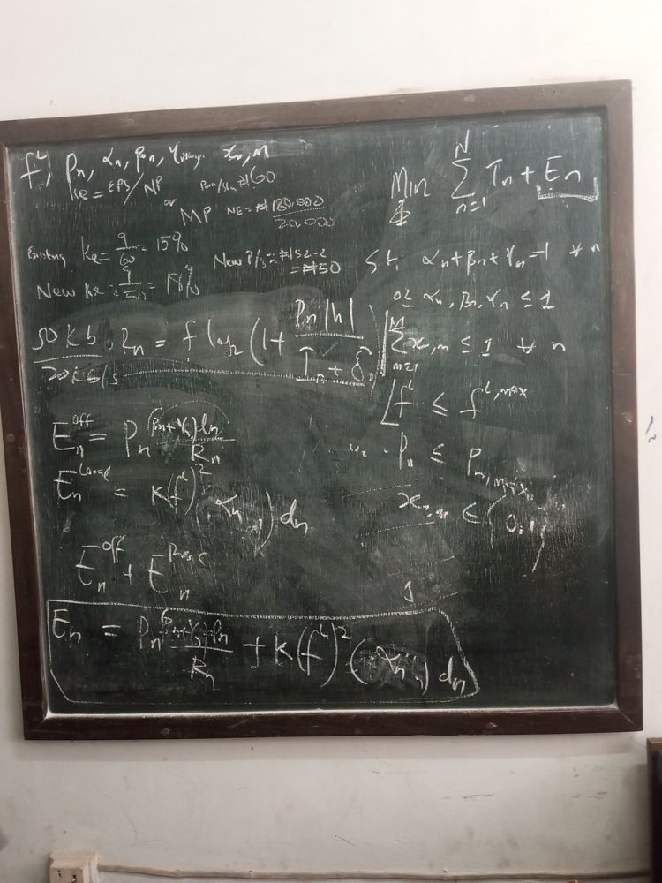

Decision variables
$$Φ=\left\{f^{L}, P_{n}, α_{n}, β_{n}, γ_{n}, x_{n,m}\right\}$$

Problem
Objective | $$\min_{Φ} \sum_{n=1}^{N}{\left(T_{n}+E_{n}\right)}$$
s.t. | $$α_{n}+β_{n}+γ_{n}=1, ∀n$$
 | $$0≤α_{n}, β_{n}, γ_{n}≤1$$
 | $$\sum_{m=1}^{M}{x_{n,m}}≤1, ∀n$$
 | $$f^{L}≤f^{L,max}$$
 | $$P_{n}≤P_{n,max}$$
 | $$x_{n,m}∈\{0,1\}$$

Rate and energy
Side calculation written beside the rate | $$\frac{50 kb}{20 kb/s} = 2.5 s$$
Uplink data rate | $$R_{n}=f\log_{2}\left(1+\frac{P_{n} |h|}{I_{n}+δ_{n}}\right)$$
Offloading (transmission) energy (corrected) | $$E_{n}^{off}=P_{n} \frac{\left(β_{n}+γ_{n}\right) d_{n}}{R_{n}}$$
Local computation energy (corrected) | $$E_{n}^{Local}=K{\left(f^{L}\right)}^{2}α_{n} d_{n}$$
Total device energy | $$E_{n}=E_{n}^{off}+E_{n}^{proc}$$
Boxed result (corrected) | $$E_{n}=P_{n} \frac{\left(β_{n}+γ_{n}\right) d_{n}}{R_{n}}+K{\left(f^{L}\right)}^{2}α_{n} d_{n}$$

Notes
- Same as photo 12.

Photo 14 of 26: Problem class labelled
IMG_20261012_122021_932.jpg
“NLMIP” written at the top, next to the objective.
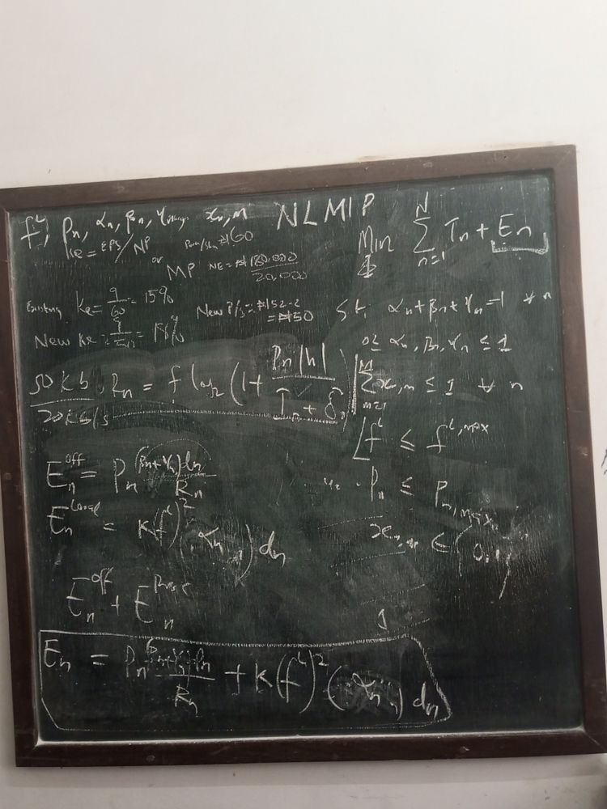
Label written on the board: NLMIP (non-linear mixed-integer programme).

Decision variables
$$Φ=\left\{f^{L}, P_{n}, α_{n}, β_{n}, γ_{n}, x_{n,m}\right\}$$

Problem
Objective | $$\min_{Φ} \sum_{n=1}^{N}{\left(T_{n}+E_{n}\right)}$$
s.t. | $$α_{n}+β_{n}+γ_{n}=1, ∀n$$
 | $$0≤α_{n}, β_{n}, γ_{n}≤1$$
 | $$\sum_{m=1}^{M}{x_{n,m}}≤1, ∀n$$
 | $$f^{L}≤f^{L,max}$$
 | $$P_{n}≤P_{n,max}$$
 | $$x_{n,m}∈\{0,1\}$$

Rate and energy
Side calculation written beside the rate | $$\frac{50 kb}{20 kb/s} = 2.5 s$$
Uplink data rate | $$R_{n}=f\log_{2}\left(1+\frac{P_{n} |h|}{I_{n}+δ_{n}}\right)$$
Offloading (transmission) energy (corrected) | $$E_{n}^{off}=P_{n} \frac{\left(β_{n}+γ_{n}\right) d_{n}}{R_{n}}$$
Local computation energy (corrected) | $$E_{n}^{Local}=K{\left(f^{L}\right)}^{2}α_{n} d_{n}$$
Total device energy | $$E_{n}=E_{n}^{off}+E_{n}^{proc}$$
Boxed result (corrected) | $$E_{n}=P_{n} \frac{\left(β_{n}+γ_{n}\right) d_{n}}{R_{n}}+K{\left(f^{L}\right)}^{2}α_{n} d_{n}$$

Notes
- Non-linear because of $\log_{2}$, the product $P_{n}/R_{n}$ and ${\left(f^{L}\right)}^{2}$; mixed-integer because $x_{n,m}$ is binary. Relabelled MINLP in photo 16.

Photo 15 of 26: Problem class labelled (second shot)
IMG_20261012_122022_042.jpg
Second shot of photo 14; identical content.
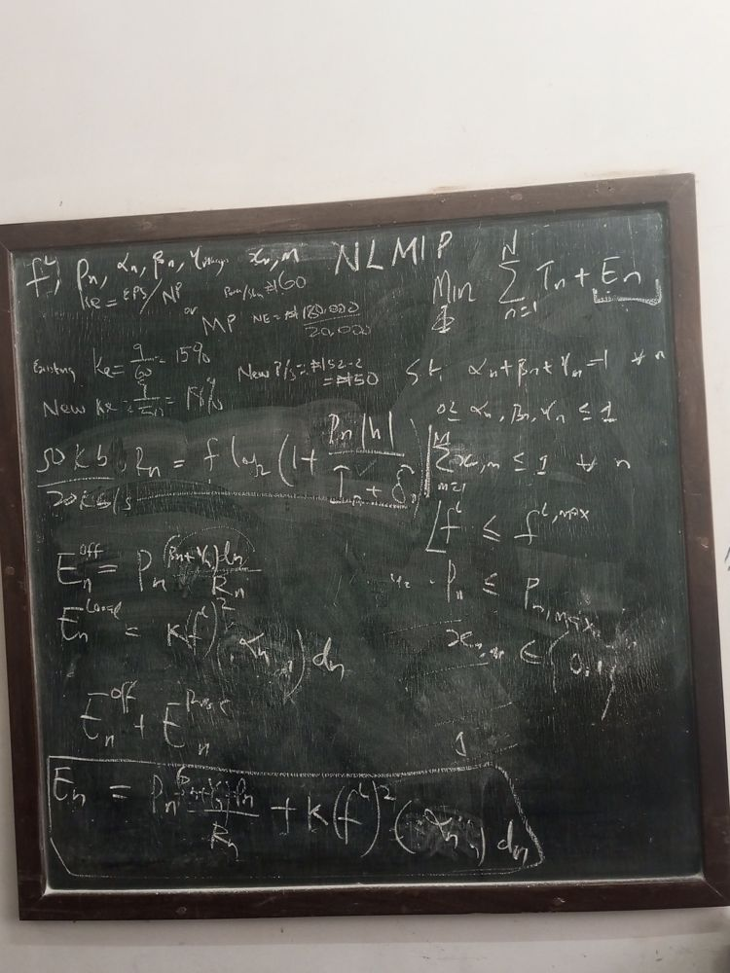
Label: NLMIP.

Decision variables
$$Φ=\left\{f^{L}, P_{n}, α_{n}, β_{n}, γ_{n}, x_{n,m}\right\}$$

Problem
Objective | $$\min_{Φ} \sum_{n=1}^{N}{\left(T_{n}+E_{n}\right)}$$
s.t. | $$α_{n}+β_{n}+γ_{n}=1, ∀n$$
 | $$0≤α_{n}, β_{n}, γ_{n}≤1$$
 | $$\sum_{m=1}^{M}{x_{n,m}}≤1, ∀n$$
 | $$f^{L}≤f^{L,max}$$
 | $$P_{n}≤P_{n,max}$$
 | $$x_{n,m}∈\{0,1\}$$

Rate and energy
Side calculation written beside the rate | $$\frac{50 kb}{20 kb/s} = 2.5 s$$
Uplink data rate | $$R_{n}=f\log_{2}\left(1+\frac{P_{n} |h|}{I_{n}+δ_{n}}\right)$$
Offloading (transmission) energy (corrected) | $$E_{n}^{off}=P_{n} \frac{\left(β_{n}+γ_{n}\right) d_{n}}{R_{n}}$$
Local computation energy (corrected) | $$E_{n}^{Local}=K{\left(f^{L}\right)}^{2}α_{n} d_{n}$$
Total device energy | $$E_{n}=E_{n}^{off}+E_{n}^{proc}$$
Boxed result (corrected) | $$E_{n}=P_{n} \frac{\left(β_{n}+γ_{n}\right) d_{n}}{R_{n}}+K{\left(f^{L}\right)}^{2}α_{n} d_{n}$$

Notes
- Same as photo 14.

Photo 16 of 26: Problem class: MINLP
IMG_20261012_122312_358.jpg
“MINLP” written large in the middle of the board.
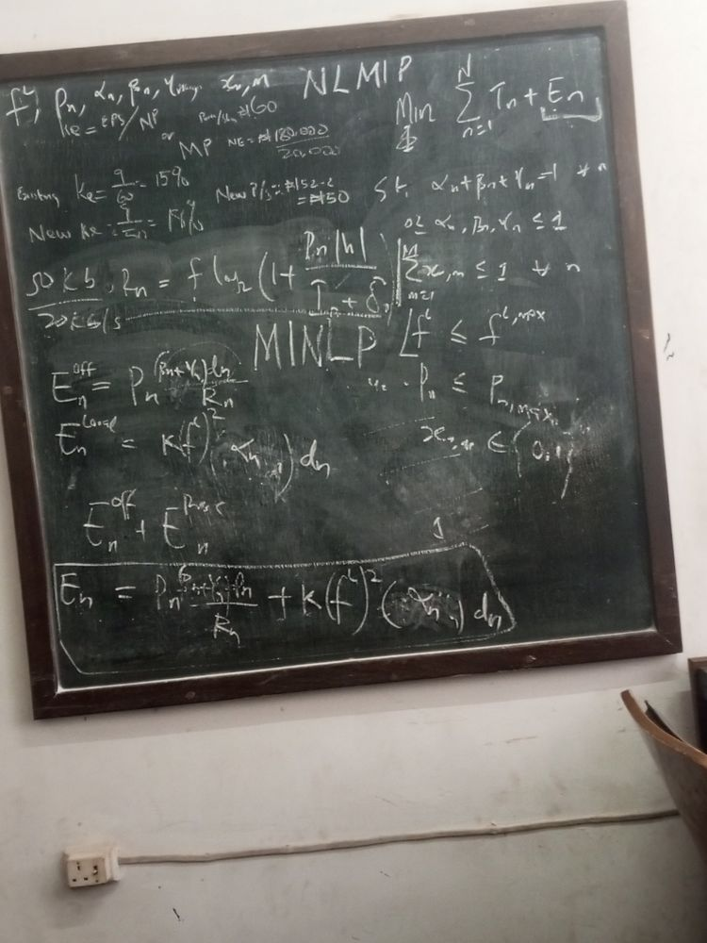
Labels on the board: NLMIP (top) and MINLP (middle).

Decision variables
$$Φ=\left\{f^{L}, P_{n}, α_{n}, β_{n}, γ_{n}, x_{n,m}\right\}$$

Problem
Objective | $$\min_{Φ} \sum_{n=1}^{N}{\left(T_{n}+E_{n}\right)}$$
s.t. | $$α_{n}+β_{n}+γ_{n}=1, ∀n$$
 | $$0≤α_{n}, β_{n}, γ_{n}≤1$$
 | $$\sum_{m=1}^{M}{x_{n,m}}≤1, ∀n$$
 | $$f^{L}≤f^{L,max}$$
 | $$P_{n}≤P_{n,max}$$
 | $$x_{n,m}∈\{0,1\}$$

Rate and energy
Side calculation written beside the rate | $$\frac{50 kb}{20 kb/s} = 2.5 s$$
Uplink data rate | $$R_{n}=f\log_{2}\left(1+\frac{P_{n} |h|}{I_{n}+δ_{n}}\right)$$
Offloading (transmission) energy (corrected) | $$E_{n}^{off}=P_{n} \frac{\left(β_{n}+γ_{n}\right) d_{n}}{R_{n}}$$
Local computation energy (corrected) | $$E_{n}^{Local}=K{\left(f^{L}\right)}^{2}α_{n} d_{n}$$
Total device energy | $$E_{n}=E_{n}^{off}+E_{n}^{proc}$$
Boxed result (corrected) | $$E_{n}=P_{n} \frac{\left(β_{n}+γ_{n}\right) d_{n}}{R_{n}}+K{\left(f^{L}\right)}^{2}α_{n} d_{n}$$

Notes
- MINLP (mixed-integer non-linear programme) is the standard name, and it is what the report uses in Section 3.8. NLMIP and MINLP mean the same thing here.

Photo 17 of 26: Clean rewrite of the formulation
IMG_20261012_123356_487.jpg
Board partly wiped and the whole model rewritten. This is the latest complete version.
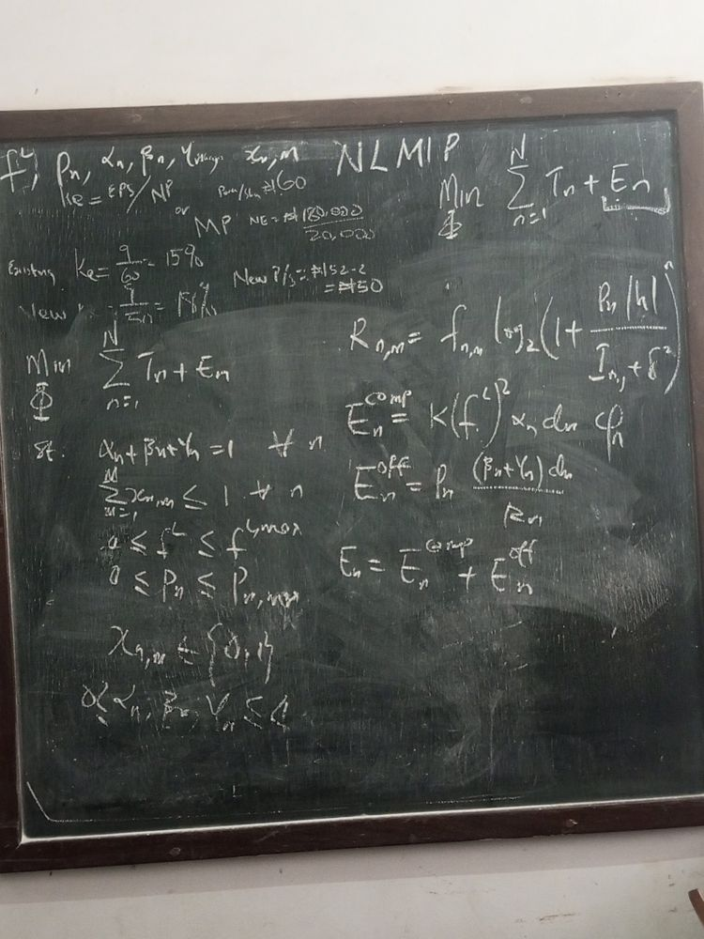

Decision variables
$$Φ=\left\{f^{L}, P_{n}, α_{n}, β_{n}, γ_{n}, x_{n,m}\right\}$$

Problem (left)
Objective | $$\min_{Φ} \sum_{n=1}^{N}{\left(T_{n}+E_{n}\right)}$$
s.t. | $$α_{n}+β_{n}+γ_{n}=1, ∀n$$  $$0≤α_{n}, β_{n}, γ_{n}≤1$$
 | $$\sum_{m=1}^{M}{x_{n,m}}≤1, ∀n$$
 | $$0≤f^{L}≤f^{L,max}$$
 | $$0≤P_{n}≤P_{n,max}$$
 | $$x_{n,m}∈\{0,1\}$$

Rate and energy (right)
Uplink data rate, now per device-EN pair | $$R_{n,m}=f_{n,m}\log_{2}\left(1+\frac{P_{n} |h|}{I_{n,j}+δ^{2}}\right)$$
Local computation energy | $$E_{n}^{comp}=K{\left(f^{L}\right)}^{2}α_{n} d_{n} φ_{n}$$
Offloading (transmission) energy | $$E_{n}^{off}=P_{n} \frac{\left(β_{n}+γ_{n}\right) d_{n}}{R_{n}}$$
Total device energy | $$E_{n}=E_{n}^{comp}+E_{n}^{off}$$

Notes
- New in this version: lower bounds $0≤f^{L}$ and $0≤P_{n}$; the rate is indexed by $\left(n,m\right)$; noise is written as $δ^{2}$ (as in the paper).
- $φ_{n}$ (CPU cycles per bit, $p_{n}$ in the paper and report) now multiplies the computation energy. Without it the earlier $K{\left(f^{L}\right)}^{2}α_{n}d_{n}$ was missing the cycles term. The glyph could also be read as $c_{n}$.
- $E^{comp}$ is the same term as $E^{Local}$/$E^{proc}$ in earlier photos.
- The interference subscript reads $I_{n,j}$ as in the paper’s eq. (4), where $j$ runs over the other ENs.

Photo 18 of 26: Transmission time identified
IMG_20261012_123716_553.jpg
Same as photo 17 with the offloading fraction circled and labelled.
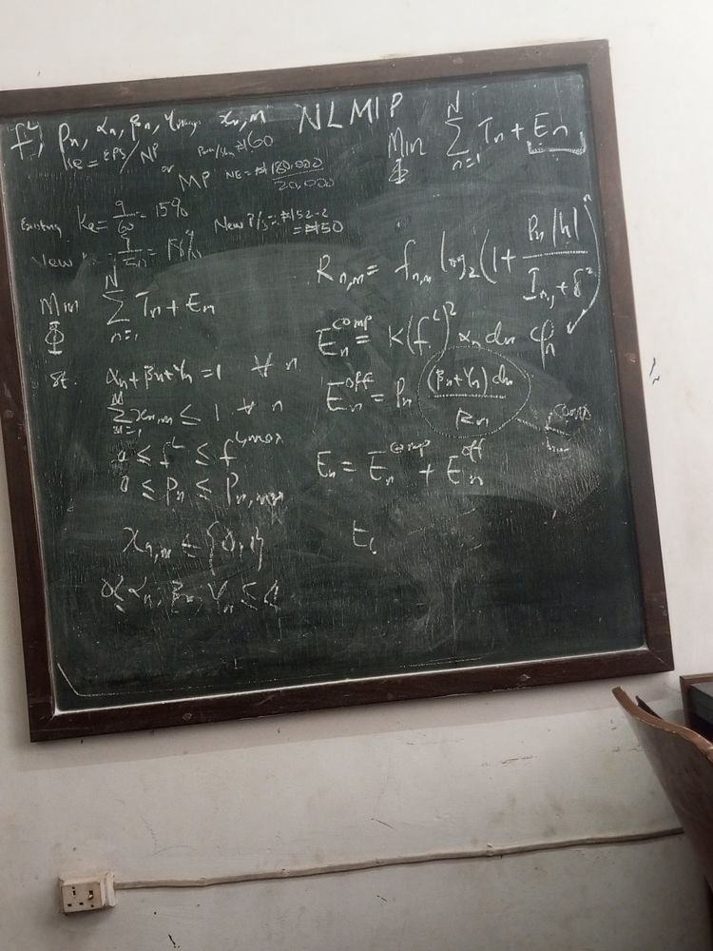

Decision variables
$$Φ=\left\{f^{L}, P_{n}, α_{n}, β_{n}, γ_{n}, x_{n,m}\right\}$$

Problem
Objective | $$\min_{Φ} \sum_{n=1}^{N}{\left(T_{n}+E_{n}\right)}$$
s.t. | $$α_{n}+β_{n}+γ_{n}=1, ∀n$$  $$0≤α_{n}, β_{n}, γ_{n}≤1$$
 | $$\sum_{m=1}^{M}{x_{n,m}}≤1, ∀n$$
 | $$0≤f^{L}≤f^{L,max}$$
 | $$0≤P_{n}≤P_{n,max}$$
 | $$x_{n,m}∈\{0,1\}$$

Rate and energy
Uplink data rate | $$R_{n,m}=f_{n,m}\log_{2}\left(1+\frac{P_{n} |h|}{I_{n,j}+δ^{2}}\right)$$
Local computation energy | $$E_{n}^{comp}=K{\left(f^{L}\right)}^{2}α_{n} d_{n} φ_{n}$$
Offloading energy | $$E_{n}^{off}=P_{n} \frac{\left(β_{n}+γ_{n}\right) d_{n}}{R_{n}}$$
Circled term, labelled on the board | $$t_{n}^{comm}=\frac{\left(β_{n}+γ_{n}\right) d_{n}}{R_{n}} ⇒ E_{n}^{off}=P_{n} t_{n}^{comm}$$
Total device energy | $$E_{n}=E_{n}^{comp}+E_{n}^{off}$$
An incomplete line starting “$E_{t}$” / “$t_{t}$” is written below; nothing after it is legible.

Notes
- The circled fraction is the uplink transmission time, the paper’s eq. (7). So offloading energy is power $×$ time, matching the report’s $E_{n}^{tx}=P_{n}^{tx} t_{comm,n}^{\left(E\right)}$ (eq. 3.18).
- The label beside the circle reads as “comm” with a $t$ or $E$ underneath; $t^{comm}$ is the reading that fits the maths.

Photo 19 of 26: First draft, professor explaining
Second batch (sent later, no timestamp), image 1 of 8
Close shot with the professor’s arm across the middle of the board. Board state matches photo 9 (first draft, before the energy terms were corrected).
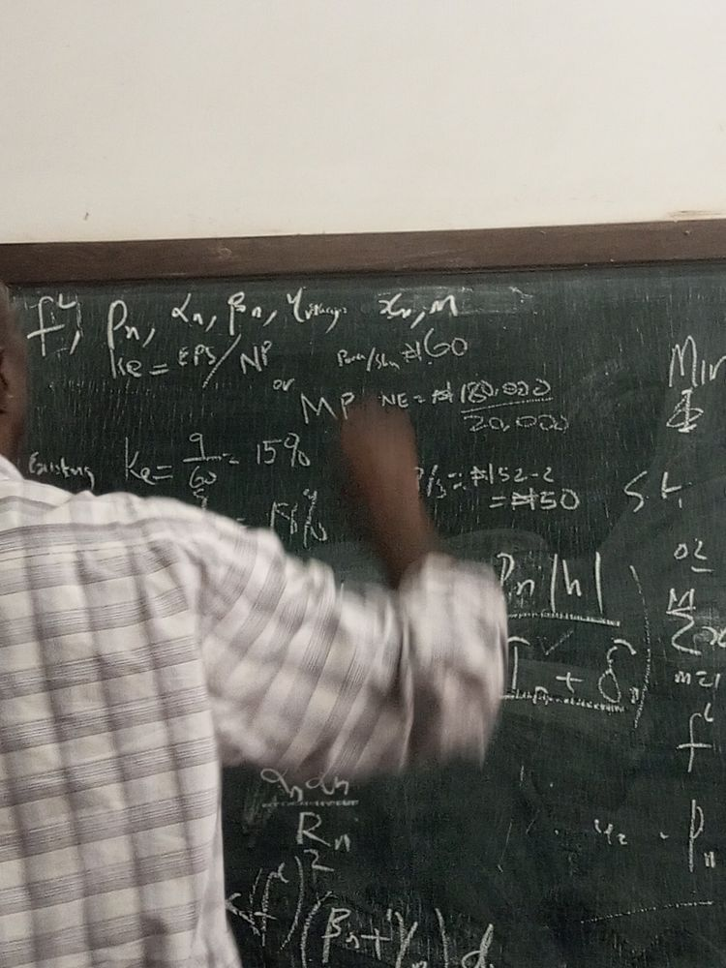

Decision variables (top left)
$$Φ=\left\{f^{L}, P_{n}, α_{n}, β_{n}, γ_{n}, x_{n,m}\right\}$$

Partly visible (arm in the way)
Rate fraction inside the log | $$\frac{P_{n} |h|}{I_{n}+δ_{n}}$$
Offloading energy fraction | $$\frac{α_{n}d_{n}}{R_{n}}$$
Local energy term | $$K{\left(f^{L}\right)}^{2}\left(β_{n}+γ_{n}\right) d_{n}$$
At the right edge: the start of “s.t.”, $0≤$, $∑x_{n,m}$, $f^{L}$ and $P_{n}$ (the constraint list of photo 9). The objective is cut off.

Notes
- Additional shot of the same board state as photo 9; content matches that page.
- Only fragments are visible, so the full equations are given on the photo 9 page.
- In this version $α_{n}$ is treated as the offloaded share and $β_{n}+γ_{n}$ as the local share. That is the reverse of the paper (where $α_{n}$ = local). It is corrected in photo 11.

Photo 20 of 26: Full board, first draft (third shot)
Second batch (sent later, no timestamp), image 2 of 8
Straight-on full view of the first-draft board with the boxed energy result.
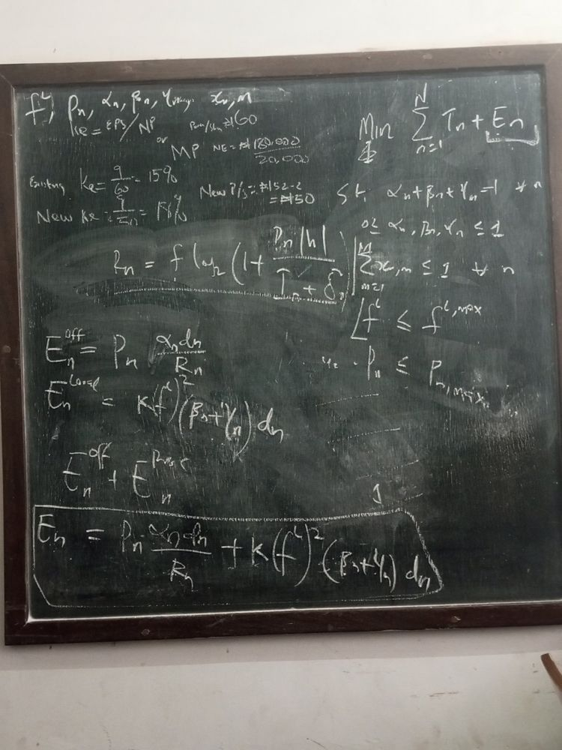

Decision variables
$$Φ=\left\{f^{L}, P_{n}, α_{n}, β_{n}, γ_{n}, x_{n,m}\right\}$$

Problem
Objective | $$\min_{Φ} \sum_{n=1}^{N}{\left(T_{n}+E_{n}\right)}$$
s.t. | $$α_{n}+β_{n}+γ_{n}=1, ∀n$$
 | $$0≤α_{n}, β_{n}, γ_{n}≤1$$
 | $$\sum_{m=1}^{M}{x_{n,m}}≤1, ∀n$$
 | $$f^{L}≤f^{L,max}$$
 | $$P_{n}≤P_{n,max}$$

Rate and energy
Uplink data rate | $$R_{n}=f\log_{2}\left(1+\frac{P_{n} |h|}{I_{n}+δ_{n}}\right)$$
Offloading (transmission) energy | $$E_{n}^{off}=P_{n} \frac{α_{n}d_{n}}{R_{n}}$$
Local computation energy | $$E_{n}^{Local}=K{\left(f^{L}\right)}^{2}\left(β_{n}+γ_{n}\right) d_{n}$$
Total device energy (written as a sum of the two parts) | $$E_{n}=E_{n}^{off}+E_{n}^{proc}$$
Boxed result | $$E_{n}=P_{n} \frac{α_{n}d_{n}}{R_{n}}+K{\left(f^{L}\right)}^{2}\left(β_{n}+γ_{n}\right) d_{n}$$

Notes
- Additional shot of the same board state as photo 9; content matches that page.
- In this version $α_{n}$ is treated as the offloaded share and $β_{n}+γ_{n}$ as the local share. That is the reverse of the paper (where $α_{n}$ = local). It is corrected in photo 11.

Photo 21 of 26: Energy model corrected (professor pointing)
Second batch (sent later, no timestamp), image 3 of 8
Full board with the professor’s hand at the left edge. Shares swapped in the energy terms; rate example added; no binary constraint yet.
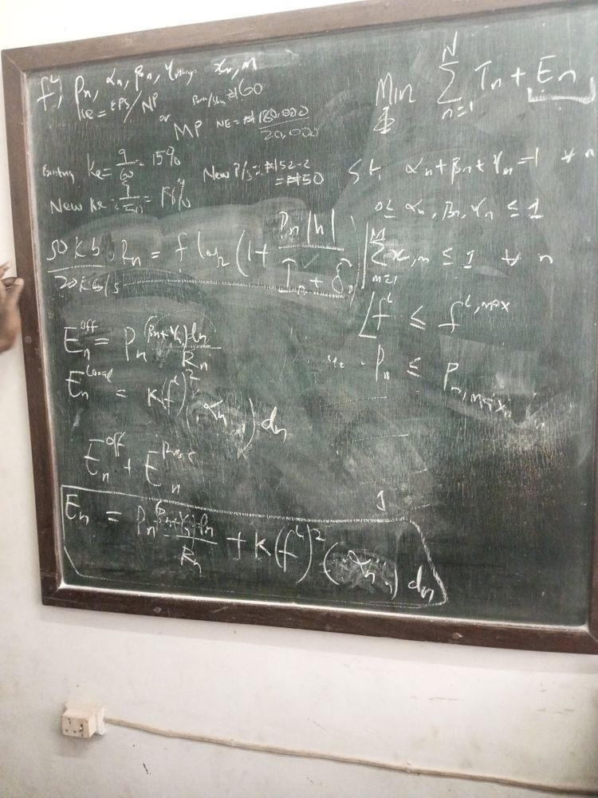

Rate and energy
Side calculation written beside the rate | $$\frac{50 kb}{20 kb/s} = 2.5 s$$
Uplink data rate | $$R_{n}=f\log_{2}\left(1+\frac{P_{n} |h|}{I_{n}+δ_{n}}\right)$$
Offloading (transmission) energy (corrected) | $$E_{n}^{off}=P_{n} \frac{\left(β_{n}+γ_{n}\right) d_{n}}{R_{n}}$$
Local computation energy (corrected) | $$E_{n}^{Local}=K{\left(f^{L}\right)}^{2}α_{n} d_{n}$$
Total device energy | $$E_{n}=E_{n}^{off}+E_{n}^{proc}$$
Boxed result (corrected) | $$E_{n}=P_{n} \frac{\left(β_{n}+γ_{n}\right) d_{n}}{R_{n}}+K{\left(f^{L}\right)}^{2}α_{n} d_{n}$$

Problem
Objective | $$\min_{Φ} \sum_{n=1}^{N}{\left(T_{n}+E_{n}\right)}$$
s.t. | $$α_{n}+β_{n}+γ_{n}=1, ∀n$$
 | $$0≤α_{n}, β_{n}, γ_{n}≤1$$
 | $$\sum_{m=1}^{M}{x_{n,m}}≤1, ∀n$$
 | $$f^{L}≤f^{L,max}$$
 | $$P_{n}≤P_{n,max}$$

Notes
- Additional shot of the same board state as photo 11; content matches that page.
- Correction relative to photos 7-10: offloaded share is now $β_{n}+γ_{n}$ (edge + cloud) and local share is $α_{n}$, matching the paper’s definition.
- The 50 kb / 20 kb/s side calculation illustrates why $d_{n}/R_{n}$ is a time: data size divided by rate gives seconds.

Photo 22 of 26: Energy model corrected (angled shot)
Second batch (sent later, no timestamp), image 4 of 8
Angled full view of the corrected board; binary constraint not yet added.
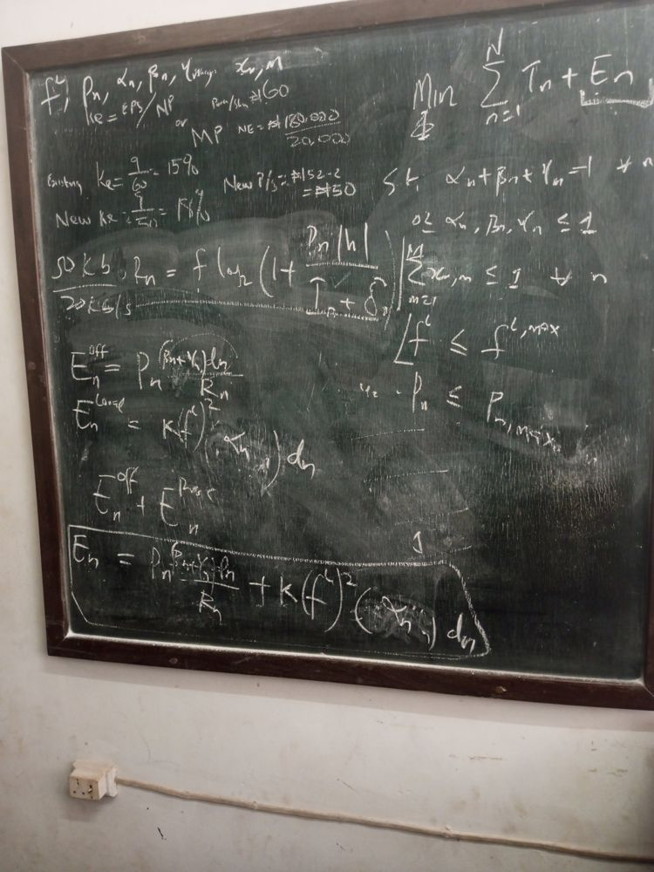

Rate and energy
Side calculation written beside the rate | $$\frac{50 kb}{20 kb/s} = 2.5 s$$
Uplink data rate | $$R_{n}=f\log_{2}\left(1+\frac{P_{n} |h|}{I_{n}+δ_{n}}\right)$$
Offloading (transmission) energy (corrected) | $$E_{n}^{off}=P_{n} \frac{\left(β_{n}+γ_{n}\right) d_{n}}{R_{n}}$$
Local computation energy (corrected) | $$E_{n}^{Local}=K{\left(f^{L}\right)}^{2}α_{n} d_{n}$$
Total device energy | $$E_{n}=E_{n}^{off}+E_{n}^{proc}$$
Boxed result (corrected) | $$E_{n}=P_{n} \frac{\left(β_{n}+γ_{n}\right) d_{n}}{R_{n}}+K{\left(f^{L}\right)}^{2}α_{n} d_{n}$$

Problem
Objective | $$\min_{Φ} \sum_{n=1}^{N}{\left(T_{n}+E_{n}\right)}$$
s.t. | $$α_{n}+β_{n}+γ_{n}=1, ∀n$$
 | $$0≤α_{n}, β_{n}, γ_{n}≤1$$
 | $$\sum_{m=1}^{M}{x_{n,m}}≤1, ∀n$$
 | $$f^{L}≤f^{L,max}$$
 | $$P_{n}≤P_{n,max}$$

Notes
- Additional shot of the same board state as photo 11; content matches that page.

Photo 23 of 26: Binary constraint added (third shot)
Second batch (sent later, no timestamp), image 5 of 8
Full board with $x_{n,m}∈\{0,1\}$ under the power constraint; no problem-class label yet.
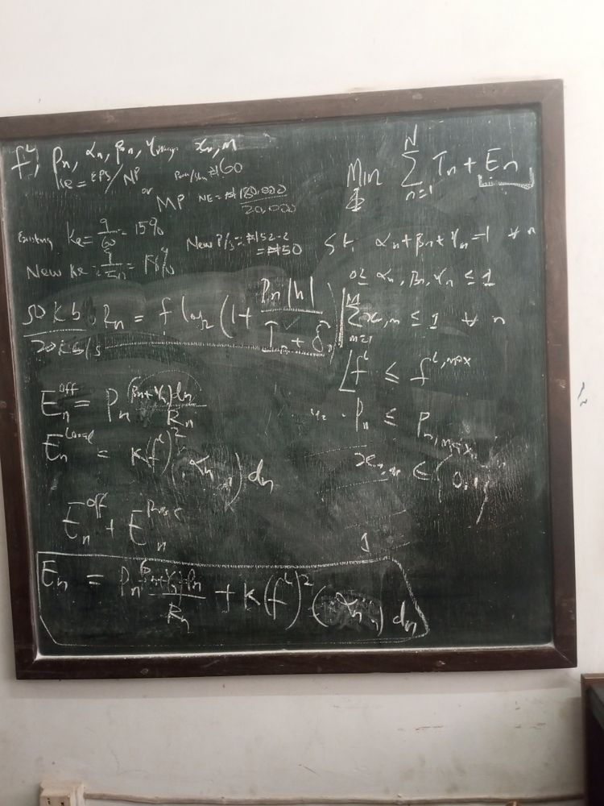

Decision variables
$$Φ=\left\{f^{L}, P_{n}, α_{n}, β_{n}, γ_{n}, x_{n,m}\right\}$$

Problem
Objective | $$\min_{Φ} \sum_{n=1}^{N}{\left(T_{n}+E_{n}\right)}$$
s.t. | $$α_{n}+β_{n}+γ_{n}=1, ∀n$$
 | $$0≤α_{n}, β_{n}, γ_{n}≤1$$
 | $$\sum_{m=1}^{M}{x_{n,m}}≤1, ∀n$$
 | $$f^{L}≤f^{L,max}$$
 | $$P_{n}≤P_{n,max}$$
 | $$x_{n,m}∈\{0,1\}$$

Rate and energy
Side calculation written beside the rate | $$\frac{50 kb}{20 kb/s} = 2.5 s$$
Uplink data rate | $$R_{n}=f\log_{2}\left(1+\frac{P_{n} |h|}{I_{n}+δ_{n}}\right)$$
Offloading (transmission) energy (corrected) | $$E_{n}^{off}=P_{n} \frac{\left(β_{n}+γ_{n}\right) d_{n}}{R_{n}}$$
Local computation energy (corrected) | $$E_{n}^{Local}=K{\left(f^{L}\right)}^{2}α_{n} d_{n}$$
Total device energy | $$E_{n}=E_{n}^{off}+E_{n}^{proc}$$
Boxed result (corrected) | $$E_{n}=P_{n} \frac{\left(β_{n}+γ_{n}\right) d_{n}}{R_{n}}+K{\left(f^{L}\right)}^{2}α_{n} d_{n}$$

Notes
- Additional shot of the same board state as photo 12; content matches that page.

Photo 24 of 26: Problem class: NLMIP and MINLP (second shot)
Second batch (sent later, no timestamp), image 6 of 8
Both labels visible: “NLMIP” at the top and “MINLP” in the middle.
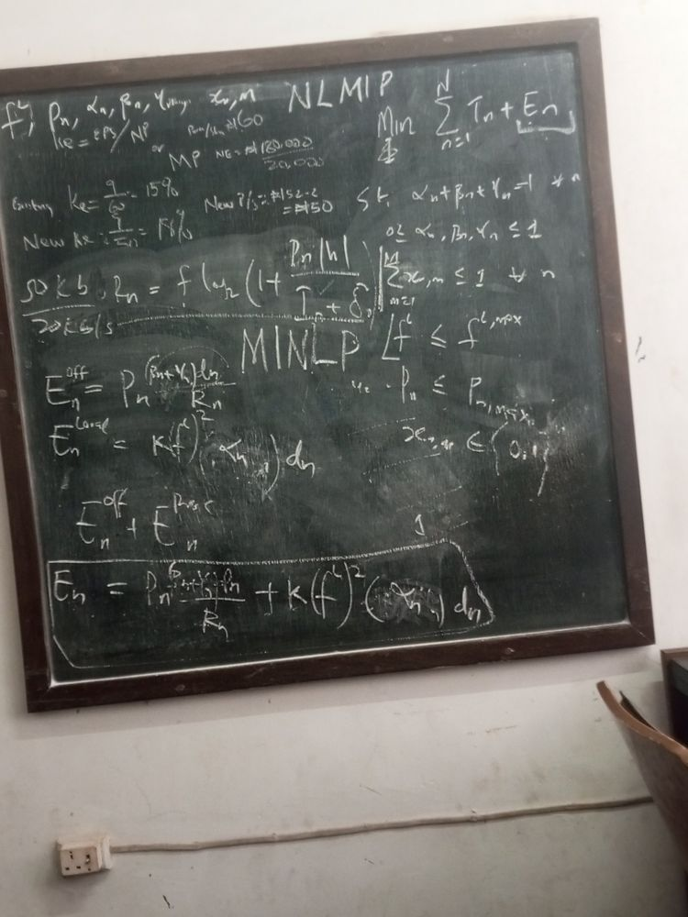
Labels on the board: NLMIP (top) and MINLP (middle).

Decision variables
$$Φ=\left\{f^{L}, P_{n}, α_{n}, β_{n}, γ_{n}, x_{n,m}\right\}$$

Problem
Objective | $$\min_{Φ} \sum_{n=1}^{N}{\left(T_{n}+E_{n}\right)}$$
s.t. | $$α_{n}+β_{n}+γ_{n}=1, ∀n$$
 | $$0≤α_{n}, β_{n}, γ_{n}≤1$$
 | $$\sum_{m=1}^{M}{x_{n,m}}≤1, ∀n$$
 | $$f^{L}≤f^{L,max}$$
 | $$P_{n}≤P_{n,max}$$
 | $$x_{n,m}∈\{0,1\}$$

Rate and energy
Side calculation written beside the rate | $$\frac{50 kb}{20 kb/s} = 2.5 s$$
Uplink data rate | $$R_{n}=f\log_{2}\left(1+\frac{P_{n} |h|}{I_{n}+δ_{n}}\right)$$
Offloading (transmission) energy (corrected) | $$E_{n}^{off}=P_{n} \frac{\left(β_{n}+γ_{n}\right) d_{n}}{R_{n}}$$
Local computation energy (corrected) | $$E_{n}^{Local}=K{\left(f^{L}\right)}^{2}α_{n} d_{n}$$
Total device energy | $$E_{n}=E_{n}^{off}+E_{n}^{proc}$$
Boxed result (corrected) | $$E_{n}=P_{n} \frac{\left(β_{n}+γ_{n}\right) d_{n}}{R_{n}}+K{\left(f^{L}\right)}^{2}α_{n} d_{n}$$

Notes
- Additional shot of the same board state as photo 16; content matches that page.
- MINLP is the standard name and the one the report uses.

Photo 25 of 26: Clean rewrite of the formulation (second shot)
Second batch (sent later, no timestamp), image 7 of 8
Straight-on view of the rewritten model, before the circle annotation was added.
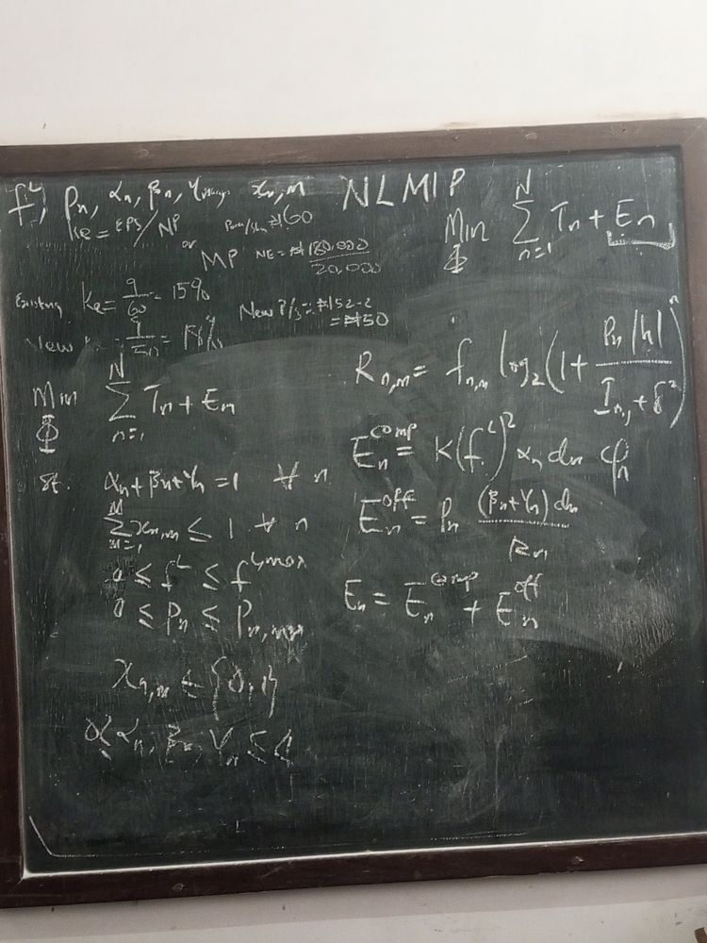

Decision variables
$$Φ=\left\{f^{L}, P_{n}, α_{n}, β_{n}, γ_{n}, x_{n,m}\right\}$$

Problem (left)
Objective | $$\min_{Φ} \sum_{n=1}^{N}{\left(T_{n}+E_{n}\right)}$$
s.t. | $$α_{n}+β_{n}+γ_{n}=1, ∀n$$  $$0≤α_{n}, β_{n}, γ_{n}≤1$$
 | $$\sum_{m=1}^{M}{x_{n,m}}≤1, ∀n$$
 | $$0≤f^{L}≤f^{L,max}$$
 | $$0≤P_{n}≤P_{n,max}$$
 | $$x_{n,m}∈\{0,1\}$$

Rate and energy (right)
Uplink data rate | $$R_{n,m}=f_{n,m}\log_{2}\left(1+\frac{P_{n} |h|}{I_{n,j}+δ^{2}}\right)$$
Local computation energy | $$E_{n}^{comp}=K{\left(f^{L}\right)}^{2}α_{n} d_{n} φ_{n}$$
Offloading (transmission) energy | $$E_{n}^{off}=P_{n} \frac{\left(β_{n}+γ_{n}\right) d_{n}}{R_{n}}$$
Total device energy | $$E_{n}=E_{n}^{comp}+E_{n}^{off}$$

Notes
- Additional shot of the same board state as photo 17; content matches that page.
- This sharper shot confirms the readings on photo 17: $f_{n,m}$ in front of $\log_{2}$, $I_{n,j}+δ^{2}$ in the denominator, and the cycles-per-bit factor at the end of $E_{n}^{comp}$.
- In the objective the second term’s subscript looks like $E_{m}$; it is read as $E_{n}$ (the sum runs over $n$).

Photo 26 of 26: Transmission time identified (second shot)
Second batch (sent later, no timestamp), image 8 of 8
Rewritten model with the offloading fraction circled, an arrow from the rate, and an unfinished line below.
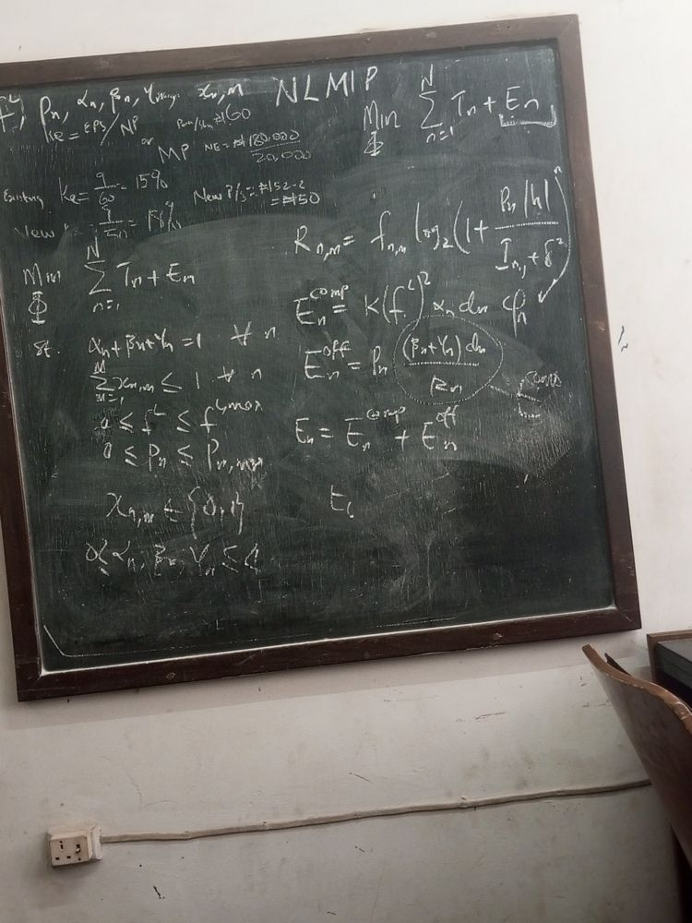

Decision variables
$$Φ=\left\{f^{L}, P_{n}, α_{n}, β_{n}, γ_{n}, x_{n,m}\right\}$$

Problem
Objective | $$\min_{Φ} \sum_{n=1}^{N}{\left(T_{n}+E_{n}\right)}$$
s.t. | $$α_{n}+β_{n}+γ_{n}=1, ∀n$$  $$0≤α_{n}, β_{n}, γ_{n}≤1$$
 | $$\sum_{m=1}^{M}{x_{n,m}}≤1, ∀n$$
 | $$0≤f^{L}≤f^{L,max}$$
 | $$0≤P_{n}≤P_{n,max}$$
 | $$x_{n,m}∈\{0,1\}$$

Rate and energy
Uplink data rate | $$R_{n,m}=f_{n,m}\log_{2}\left(1+\frac{P_{n} |h|}{I_{n,j}+δ^{2}}\right)$$
Local computation energy | $$E_{n}^{comp}=K{\left(f^{L}\right)}^{2}α_{n} d_{n} φ_{n}$$
Offloading energy | $$E_{n}^{off}=P_{n} \frac{\left(β_{n}+γ_{n}\right) d_{n}}{R_{n}}$$
Circled term, labelled on the board | $$t_{n}^{comm}=\frac{\left(β_{n}+γ_{n}\right) d_{n}}{R_{n}} ⇒ E_{n}^{off}=P_{n} t_{n}^{comm}$$
Total device energy | $$E_{n}=E_{n}^{comp}+E_{n}^{off}$$
An arrow runs from the rate $R_{n,m}$ down to the energy terms. An unfinished line starting “$E_{t}$” sits below $E_{n}$.

Notes
- Additional shot of the same board state as photo 18; content matches that page.
- The arrow points out that $R_{n,m}$ feeds the offloading energy through the transmission time.

Consolidated final model (from photos 17-18)
The board’s latest formulation, written cleanly. The latency terms are not on the board; they are the paper’s eqs. (7)-(13) rewritten in the board’s notation, with $f^{L}$ replacing the fixed local CPU capacity.

Special Note to SREVEE(1)
NOTE TO SREVEE:
The corrections concerns The IV. PROBLEM FORMULATION section of the paper, specifically from the equations (14) to (14f) where Energy consumption ($E_{n}),$ i.e the Energy consumed by device $n$ , is added to the problem objectives [Check equation (14) in the IV. PROBLEM FORMULATION section of the paper, and see the new changes] and as such, new constraints are added and old ones are adjusted to fit the nature of the problem [Check equation (14a)to(14f) in the IV. PROBLEM FORMULATION section of the paper, and see the new changes].
The Energy section is the necessary and relevant equations (Also found in the III. SYSTEM MODEL section of the paper) to calculate $E_{n}$ as if you look look closely, it all leads to $E_{n}$
The Decision variables part are the new unknowns we need to account for in the course of the new experiments as the equation rests on the shoulders on this unknowns.
The latency part is based on the last experiment we did and isn’t currently a new change, just something we used in the last normal experiments we did. So it currently has no relevance per say.
P.S: NLMIP stands for Non-Linear Mixed-Integer Programming. It just the type of problem the new constraints bring about. Nothing fancy about it aside from that.

Optimisation problem (MINLP)
Objective
$$\min_{Φ} \sum_{n=1}^{N}{\left(T_{n}+E_{n}\right)}$$
Subject to
$$α_{n}+β_{n}+γ_{n}=1, ∀n$$
$$0≤α_{n}, β_{n}, γ_{n}≤1, ∀n$$
$$\sum_{m=1}^{M}{x_{n,m}}≤1, ∀n$$
$$x_{n,m}∈\{0,1\}, ∀n,m$$
$$0≤f^{L}≤f^{L,max}$$
$$0≤P_{n}≤P_{n,max}, ∀n$$
with $Φ=\{f^{L},P_{n},α_{n},β_{n},γ_{n},x_{n,m}\}$. i.e.

Decision variables
$$Φ=\left\{f^{L}, P_{n}, α_{n}, β_{n}, γ_{n}, x_{n,m}\right\}$$

Energy (from the board)
Rate
$$R_{n,m}=f_{n,m}\log_{2}\left(1+\frac{P_{n} \left|h\right|}{I_{n,j}+δ^{2}}\right)$$
Computation
$$E_{n}^{comp}=K{\left(f^{L}\right)}^{2}α_{n} d_{n} φ_{n}$$
Offloading
$$E_{n}^{off}=P_{n} \frac{\left(β_{n}+γ_{n}\right) d_{n}}{R_{n}}$$
Total
$$E_{n}=E_{n}^{comp}+E_{n}^{off}$$

Latency (from the paper, not on the board)
Local tier
$$t_{n}^{L}=\frac{α_{n}d_{n}φ_{n}}{f^{L}}$$
Edge tier
$$t_{n}^{E}=\frac{\left(β_{n}+γ_{n}\right)d_{n}}{R_{n,m}}+\frac{β_{n}d_{n}φ_{n}L_{m}}{c_{m}^{\left(E\right)}}$$
Cloud tier
$$t_{n}^{C}=\frac{\left(β_{n}+γ_{n}\right)d_{n}}{R_{n,m}}+\frac{γ_{n}d_{n}}{c}+\frac{γ_{n}d_{n}φ_{n}}{c_{n}^{\left(C\right)}}$$
Task latency
$$T_{n}=max\left\{t_{n}^{L}, t_{n}^{E}, t_{n}^{C}\right\}$$

Special Note to SREVEE(2)
NOTE TO SREVEE ABOUT EXPECTED RESULTS:

The results we generated earlier is valid and must be maintained and kept. So don’t adjust the old ipynb file. Rather, duplicate it and keep the old one. We still need the results without it being untouched.
For the duplicate file, we are going to adjust the constraints to the new ones and also include the new problem formulation.
The new results we are meant to get along side the rest is two:
- Baseline DQN (i.e Old DQN model without accounting for Energy Consumption) Vs Enhanced DQN (i.e Old DQN model without accounting for Energy Consumption) Comparing the Latency and Energy Consumption. It should look something like this:
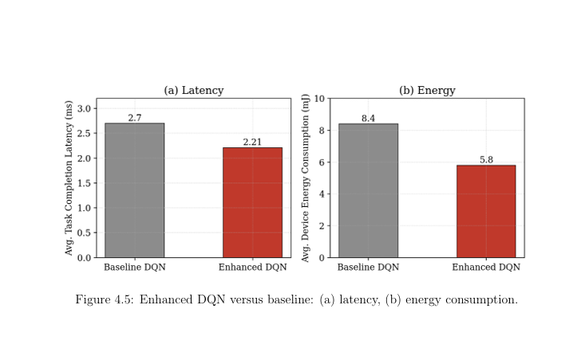
- The Enhanced DQN Vs the Other Algorithms (i.e RA.GA, Q-learning). Basically like the old bar chart but the difference that there should be two joint bar chart for each algorithms comparing not only latency but energy consumption as well under the new constraint. I’m referring to the old graph but energy consumption below:
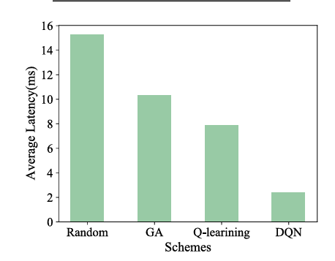
You can make it two separate graph or Join the 2 parameters into one. Anyone that works for you

The corrections Points worth confirming with your supervisor
- Cycles per bit. $φ_{n}$ only appears in the final version. The report’s eq. (3.17) already includes it ($p_{n}$), so the two agree.
- Two meanings of $f$. The board uses $f$ for bandwidth in $R_{n,m}$ and $f^{L}$ for CPU frequency. Renaming the bandwidth $B$ (as the paper does) would avoid confusion.
- Channel gain. The board writes $P_{n}\left|h\right|$. Shannon rate normally uses power gain ${\left|h\right|}^{2}$ (or path loss $L\left(d\right)$ as in the paper). Worth confirming which is intended.
- Per-device CPU frequency. The board writes $f^{L}$ with no device index; the report uses $f_{n}^{L}$. Confirm whether every device has its own frequency.
- Linking rate to association. $x_{n,m}$ only appears in constraints. A link such as Rn=m​xn,mRn,m would tie the association to the rate used in $E_{n}$.

