# PA5 – Programming Workflow Template

Name: Bonan Jia

UCSD email: bojia@ucsd.edu

## First 20 Minutes

### Screenshot or copy/paste of program:

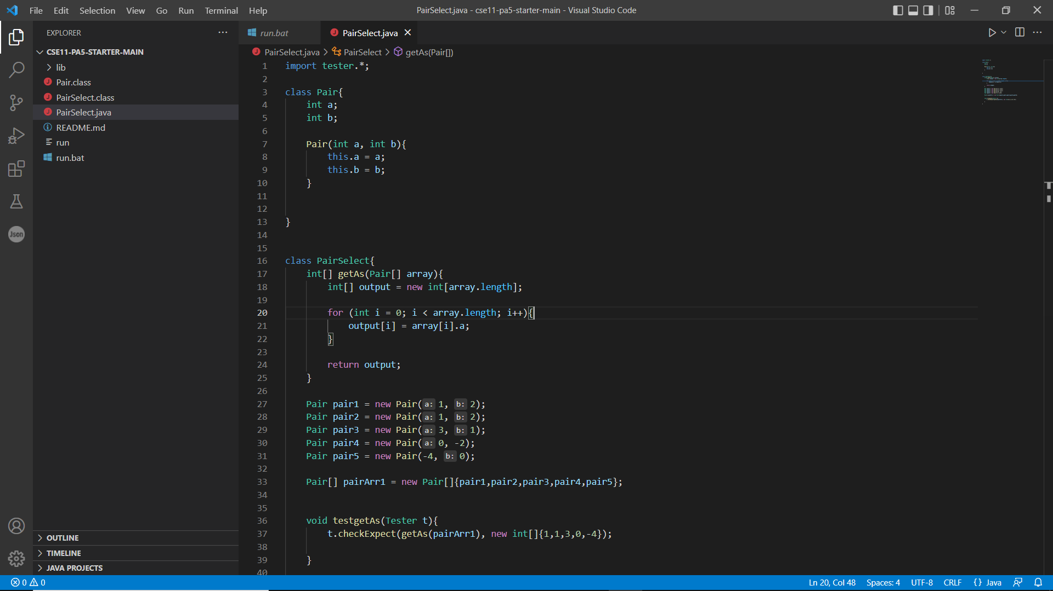

### Screenshot or copy/paste of ./run or java/javac output (if any):

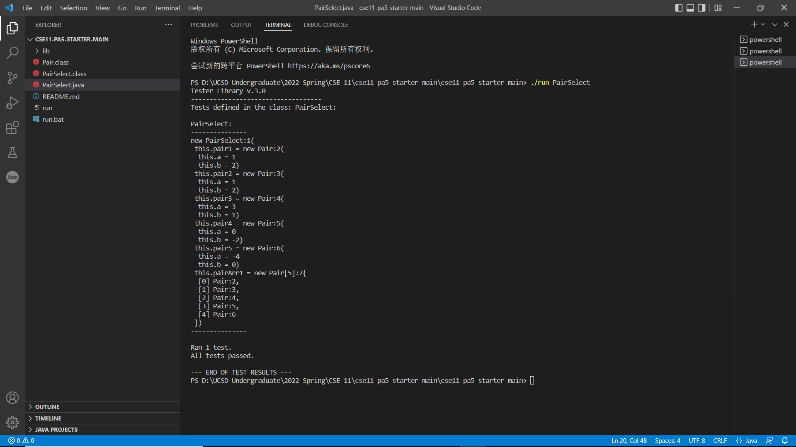

### Thoughts on your progress:

I think I have utilized the time wisely and effectively as I spent like 6-7 mins to figure out what I need to do for both tasks and then start to write my program. However, I forgot how to initialize an array and how to write the test cases so I went back to my notes and then figure it out. Thus, it was kind of consolidation of knowledge of previous concepts for me.

### Distractions:

Well, I got distracted by the sound of TV show that my roommate is watching and also the sound of notification of my discord.

## Second 20 minutes:

### Screenshot or copy/paste of program:

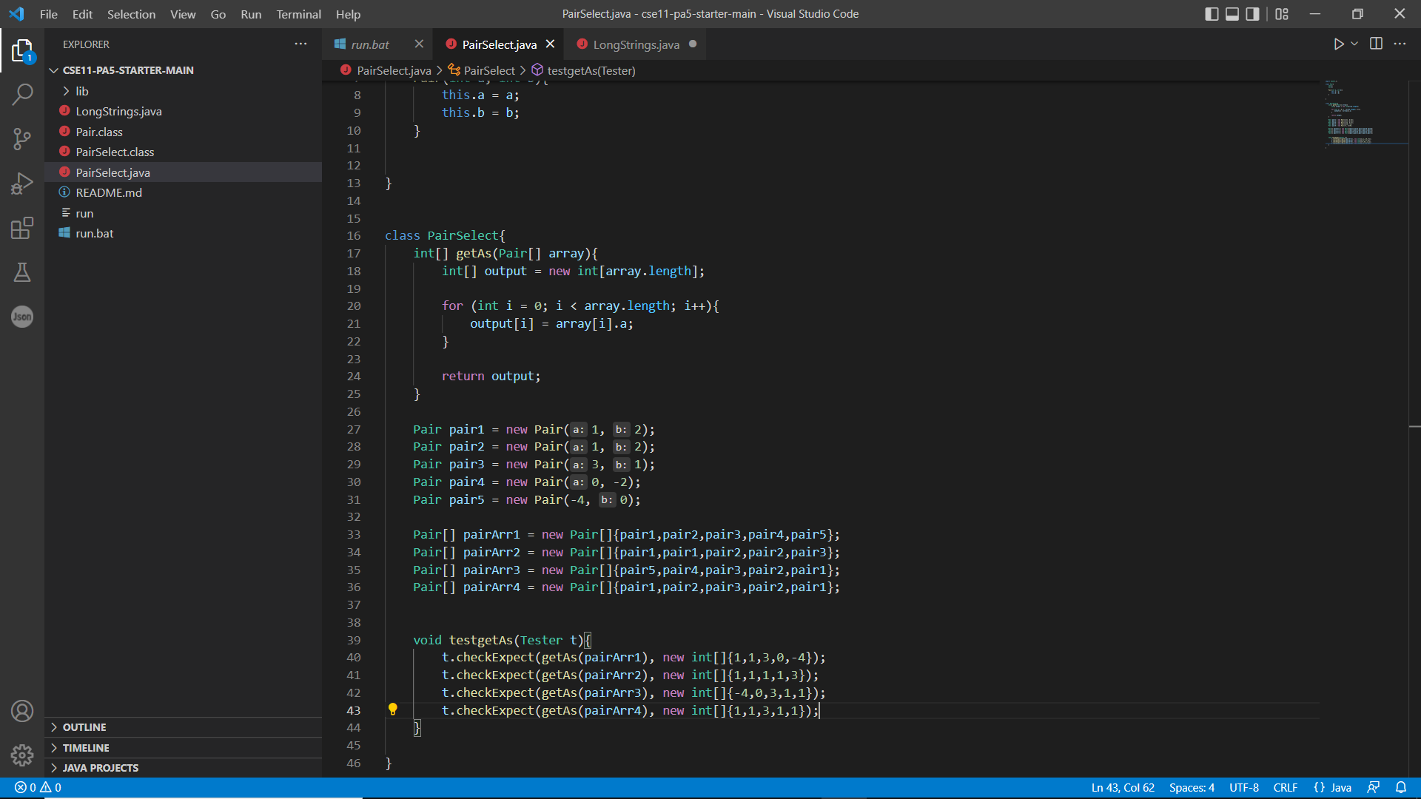

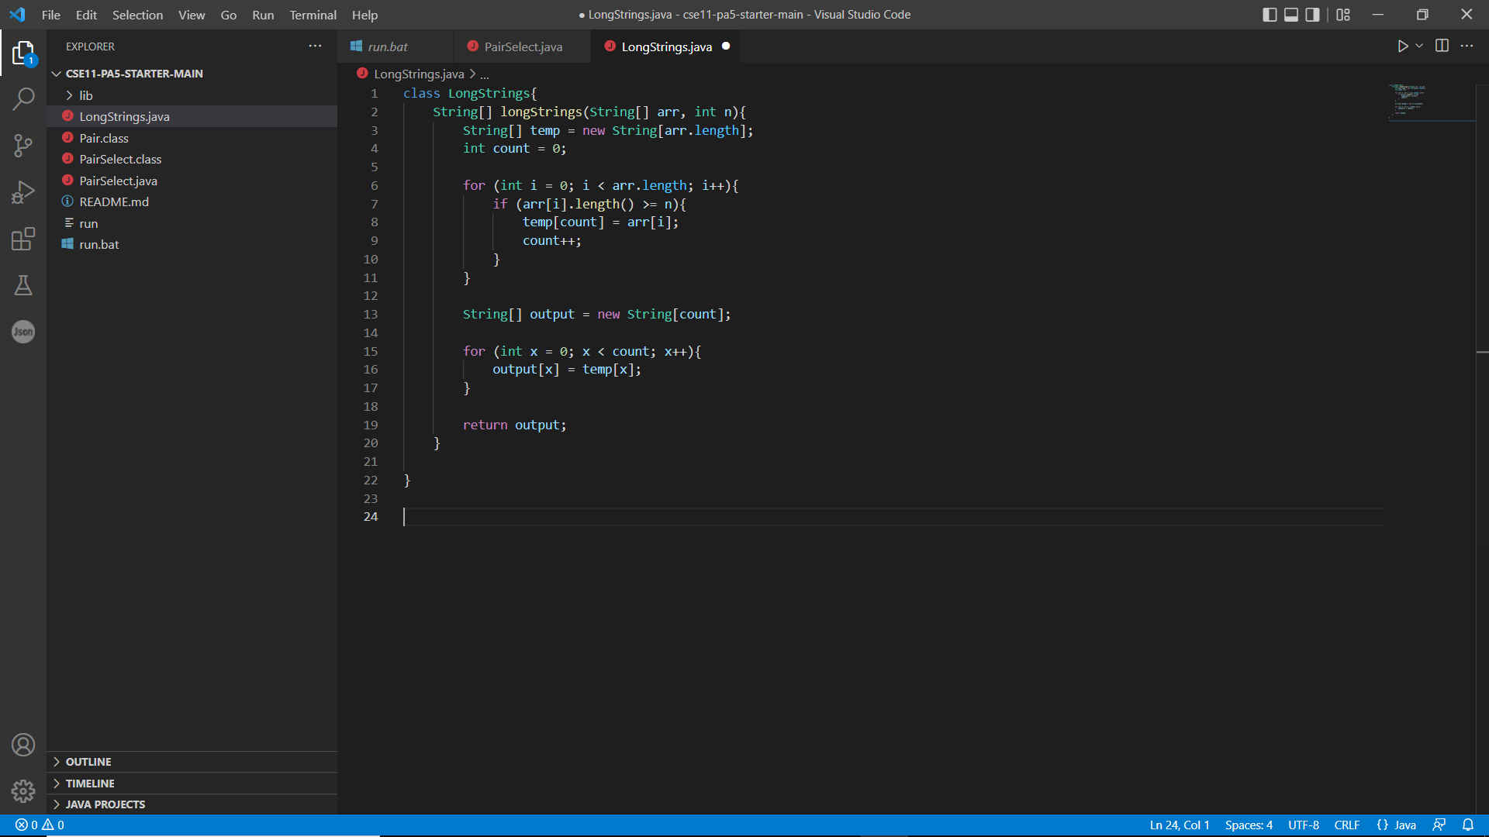

### Screenshot or copy/paste of ./run or java/javac output (if any):

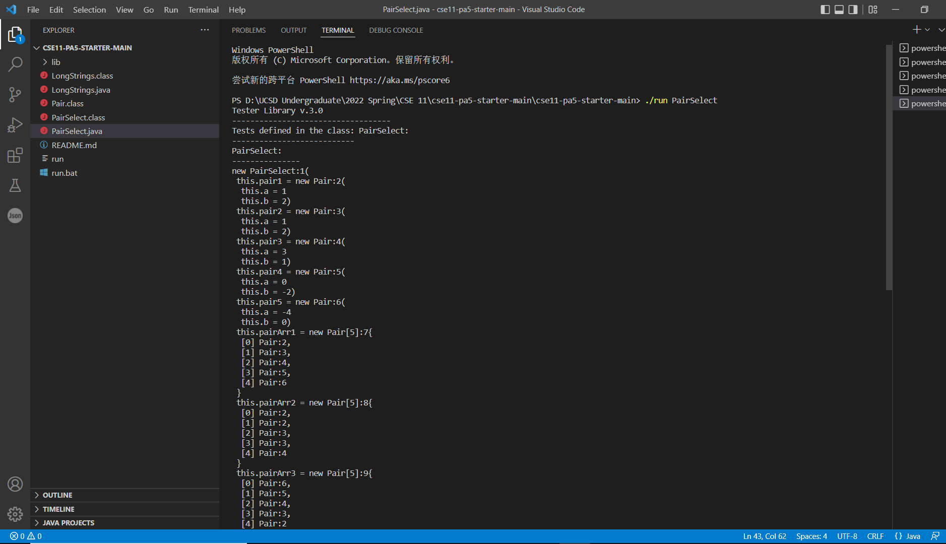

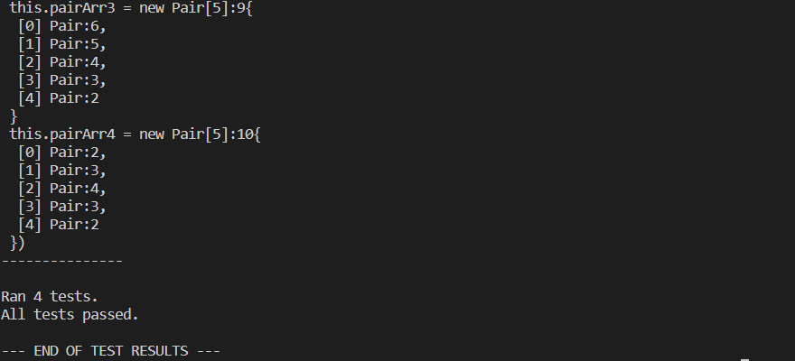

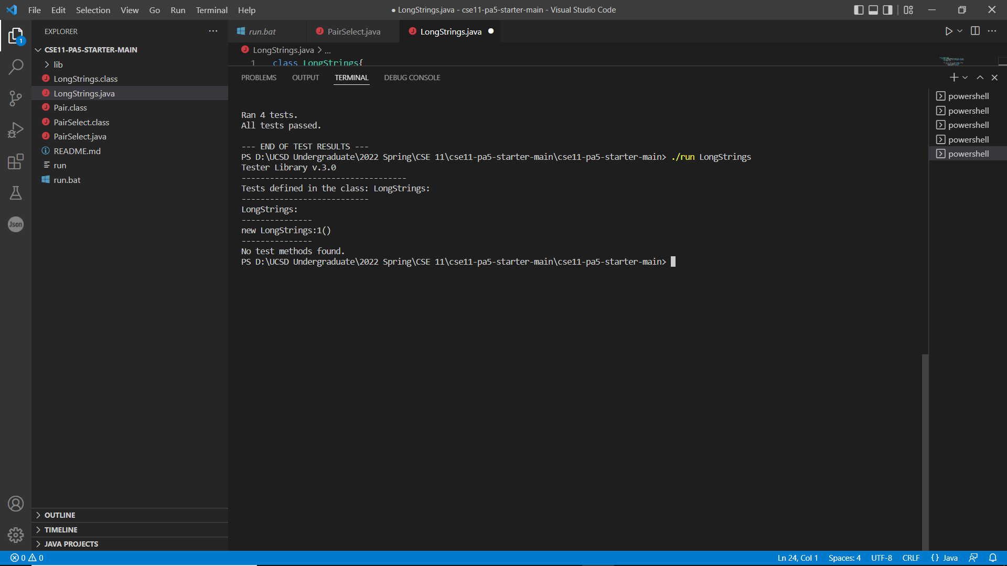

### Thoughts on your progress:

Well, I have finalized my test for first task first and then I spent many mins to figure out how to accomplish my second tasks since the output array might be shorter than the input one. Then, after laying down some ideas on my paper, I got the idea to do that and then wrote out the code even though I was not sure whether it would be working.

## Distractions:

I seemed to be distracted by the 20 mins time clock as I got a mind of completing most of work within this time spot. Also, distracted by the noise from outside.

### 

## Final 20 minutes:

### Screenshot or copy/paste of program:

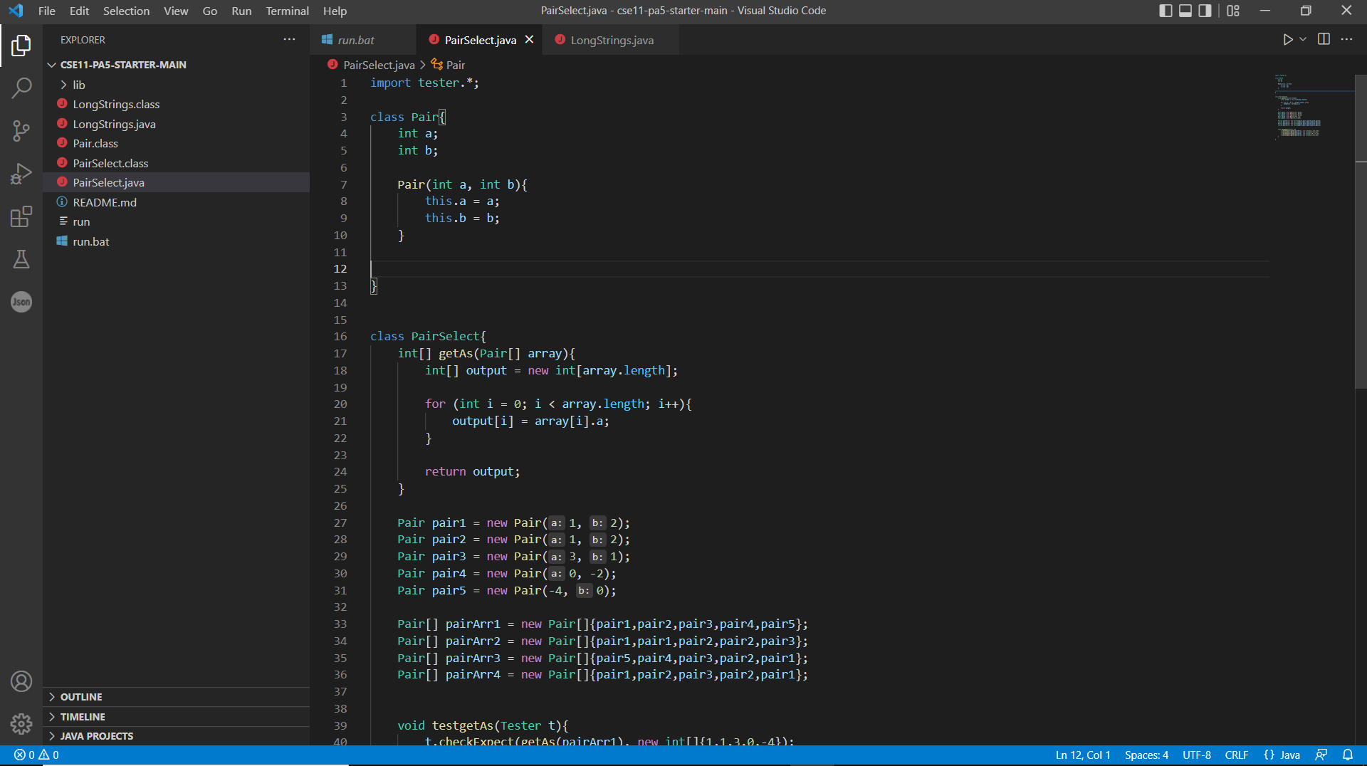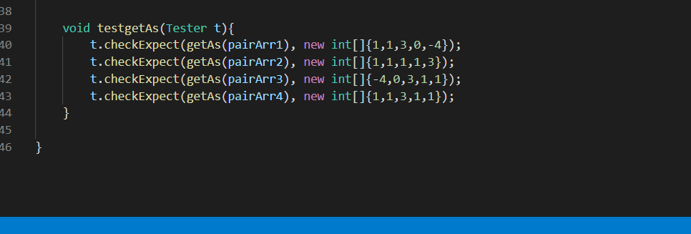

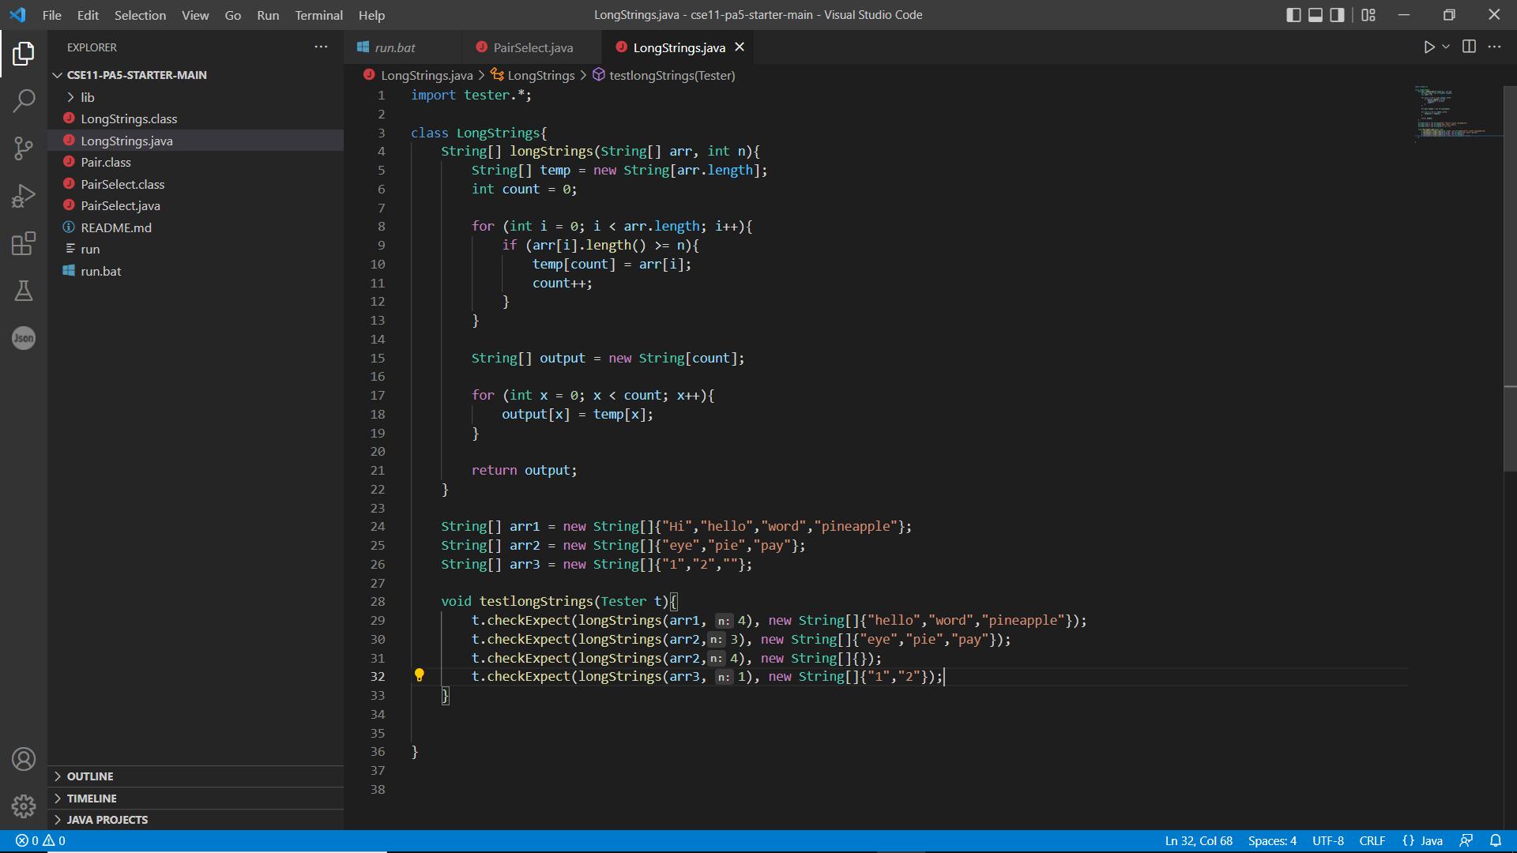

### Screenshot or copy/paste of ./run or java/javac output (if any):

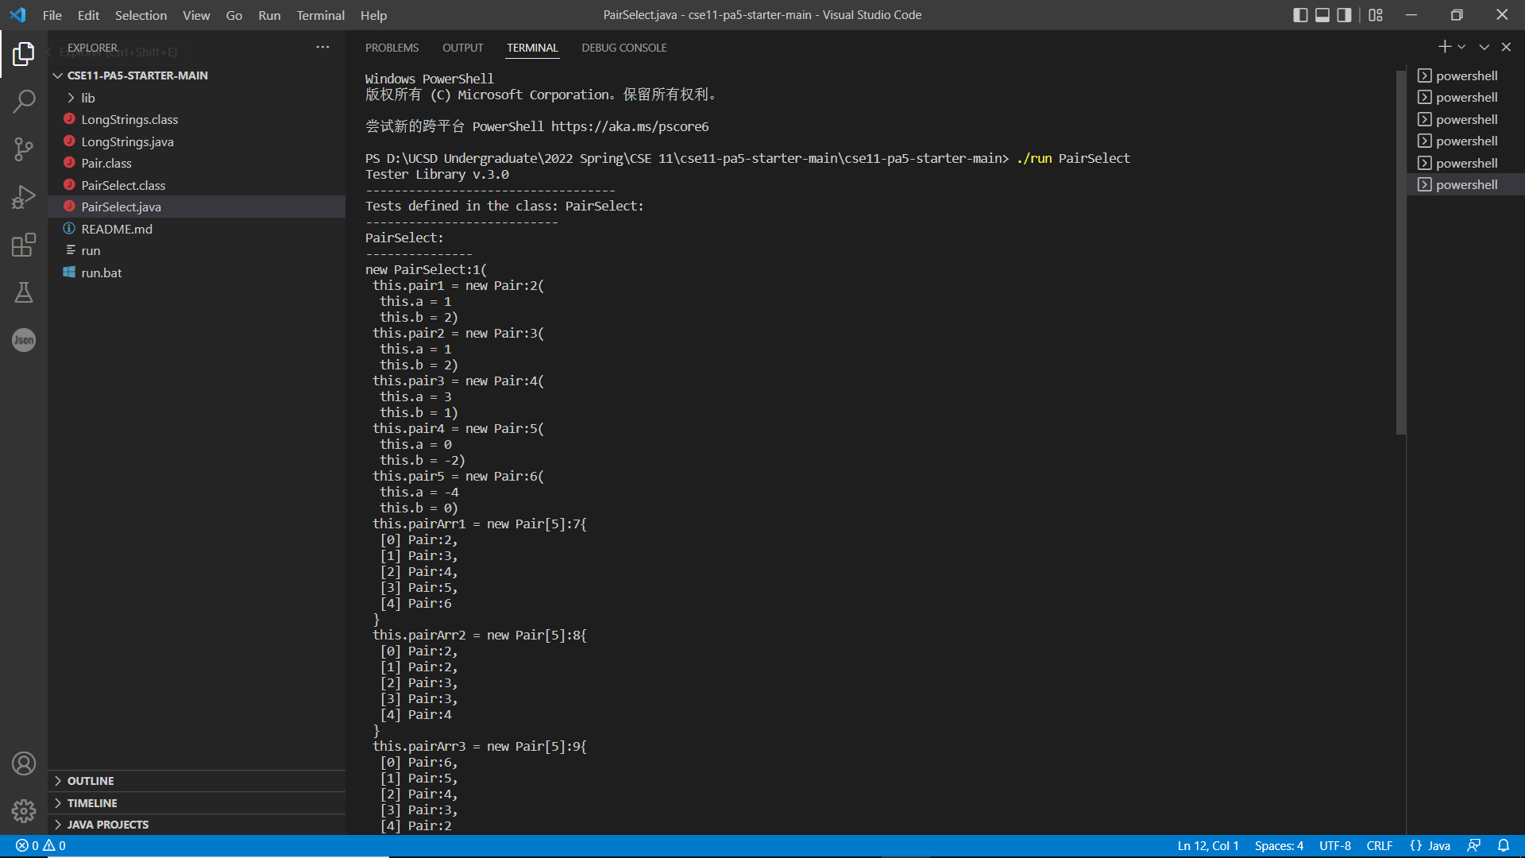

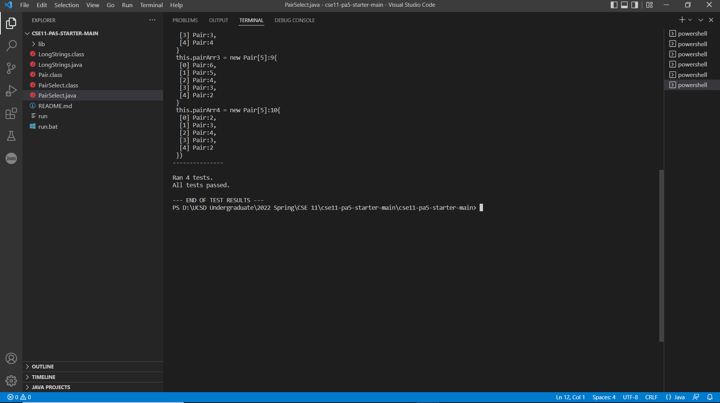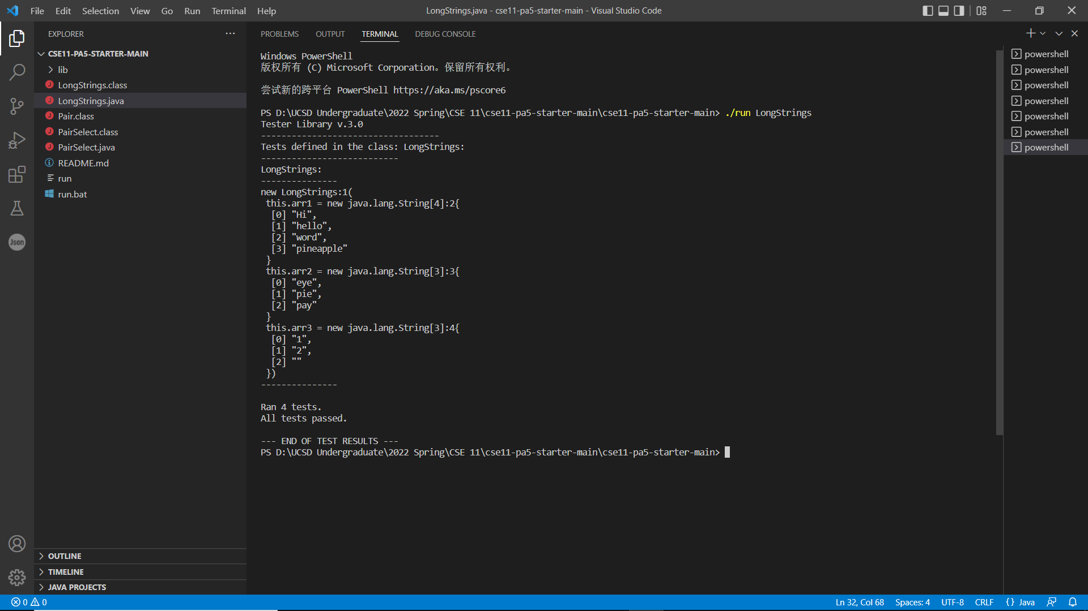

### Thoughts on your progress:

Well, I kind of spent one full hour to complete my tasks without barely no errors. In this final 20 mins, I kind of looking for possible errors in my program and check whether there is error that not detected by my test cases.

## Distractions:

Distracted by urging to finish my program and the eager to play games.

## Overall Reflection

Overall, I think I spent most of time reading the questions as it is very important that I do not misunderstand the task. Also, I spent some time going through my notes in looking for some code format in java. For others, I think it went pretty smoothly. To reduce the time, probably need to review my notes ahead of assignment so as to give my best effort in the work. Also, close chatting applications to avoid distractions. Well, following this process indeed helps me reflect more on the assignment and could see how I progress in coding. If I do it as normal, I would probably not care a lot about how I thought during the coding process. What I learnt is that it is helpful for me to actually stop and think what I have done during this period such as what I did well or what still need to be improved; thus, I could have better idea to work in the next period.