

**SCHOOL OF COMPUTING DEPARTMENT OF INFORMATION TECHNOLOGY**

**LAB MANUAL**

**213INT2302 Principles of compiler Design Lab**

**Student Name : Register Number : Year : Semester : Branch :**



**DEPARTMENT OF INFORMATION TECHNOLOGY BONAFIDE CERTIFICATE**

**This is a bonafide record of work done by studying**

**in ……………………… Year/Semester in the laboratory**

**during the Even semester of the academic year 2025-2026.**

**Signature of the Faculty-in -Charge Signature of Head of Department**

**Submitted for the practical examination held at Kalasalingam Academy of Research an Education , Anand Nagar, Krishnankovil on ……………………..**

**Register No: **

**Internal Examiner External Examiner**

|  |  |
| --- | --- |
| **UNIVERSITY VISION** | **UNIVERSITY MISSION** |
| To be a University of Excellence of International Repute in Education and Research | M1: To provide a scholarly teaching- learning ambience which results in creating graduates equipped with skills and acumen to solve real-life problems.  M2: To promote research and create knowledge for human welfare, rural and societal development. M3: To nurture entrepreneurial ambition, industrial and societal connect by creating an environment through which innovators and leaders emerge |

|  |  |
| --- | --- |
| **INFORMATION TECHNOLOGY DEPARTMENT** | |
| **VISION** | **MISSION** |
| To be a department of repute offering programmes in frontier areas of IT through quality education, research and imbibing societal values. | * To provide quality education through effective curriculum and innovative teaching. * To facilitate conductive learning environment for students and faculty to investigate knowledge. * To instill the ethical behavior and social responsibilities to provide sustainable information technology solutions |

Within a few years of obtaining an undergraduate degree in Computer Science and Engineering, the students will be able to:

**PEO-1:** The graduates will be successful IT professionals in their chosen area and / or pursue higher studies.

**PEO-2:** The graduates will comprehend, analyze, design and create novel products and technologies that provide sustainable solutions.

**PEO-3:** The graduates will demonstrate multidisciplinary knowledge, personal and interpersonal

skills and work as an effective team member with ethical standards.

**PROGRAMME EDUCATIONAL OBJECTIVES**

At the end of the Programme, the students will be able to:

**PSO-1:** Ability to identify, design and develop processes and systems for enterprises

**PSO-2:** Ability to identify, deploy and maintain the IT infrastructure based on the needs of the businesses.

**PSO-3:** Practice and promote information technologies for societal needs

**PROGRAMME SPECIFIC OUTCOMES**

**PROGRAMME OUTCOMES**

At the end of the programme, the students will be able to:

1. **Engineering knowledge:** Apply the knowledge of mathematics, science, engineering fundamentals, and an engineering specialization to the solution of complex engineering problems.
2. **Problem analysis:** Identify, formulate, review research literature, and analyze complex engineering problems reaching substantiated conclusions using first principles of mathematics, natural sciences, and engineering sciences.
3. **Design/development of solutions:** Design solutions for complex engineering problems and design system components or processes that meet the specified needs with appropriate consideration for the public health and safety, and the cultural, societal, and environmental considerations.
4. **Conduct investigations of complex problems:** Use research-based knowledge and research methods including design of experiments, analysis and interpretation of data, and synthesis of the information to provide valid conclusions.
5. **Modern tool usage:** Create, select, and apply appropriate techniques, resources, and modern engineering and IT tools including prediction and modeling to complex engineering activities with an understanding of the limitations.
6. **The engineer and society:** Apply reasoning informed by the contextual knowledge to assess societal, health, safety, legal and cultural issues and the consequent responsibilities relevant to the professional engineering practice.
7. **Environment and sustainability:** Understand the impact of the professional engineering solutions in societal and environmental contexts, and demonstrate the knowledge of, and need for sustainable development.
8. **Ethics:** Apply ethical principles and commit to professional ethics and responsibilities and norms of the engineering practice.
9. **Individual and team work:** Function effectively as an individual, and as a member or leader in diverse teams, and in multidisciplinary settings.
10. **Communication:** Communicate effectively on complex engineering activities with the engineering community and with society at large, such as, being able to comprehend and write effective reports and design documentation, make effective presentations, and give and receive clear instructions.
11. **Project management and finance:** Demonstrate knowledge and understanding of the Engineering and management principles and apply these to one’s own work, as a member and leader in a team, to manage projects and in multidisciplinary environments.
12. **Life -long learning:** Recognize the need for, and have the preparation and ability to engage in independent and life -long learning in the broadest context of technological change.

**Mapping of the Programs’s Student Outcomes (PSOs) With the ABET Student Outcomes (ASOs)**

|  |  |
| --- | --- |
| **ASOs** | **ABET-CAC Student outcomes (ASOs)/CO** |
| **ASO1**. | Analyze a complex computing problem and to apply principles of computing and other relevant disciplines to identify solutions. |
| **ASO2**. | Design, implement, and evaluate a computing-based solution to meet a given set of computing requirements in the context of the program’s discipline. |
| **ASO3.** | Communicate effectively in a variety of professional contexts. |
| **ASO4**. | Recognize professional responsibilities and make informed  judgments in computing practice based on legal and ethical principles |
| **ASO5**. | Function effectively as a member or leader of a team engaged in activities appropriate to the program’s discipline.  Identify and analyze user needs to take them into account in the selection, creation, integration, evaluation, and administration of computing-based systems. |
| **ASO6**. |

**SYLLABUS**

# COMPILER LABORATORY

# OBJECTIVES:

The student should be made to:

* Be exposed to compiler writing tools.
* Learn to implement the different Phases of compiler
* Be familiar with control flow and data flow analysis
* Learn simple optimization techniques

# LIST OF EXPERIMENTS:

1. Implementation of Symbol Table
2. Develop a lexical analyzer to recognize a few patterns in C. (Ex. identifiers, constants, comments, operators etc.)
3. Implementation of Lexical Analyzer using Lex Tool
4. Generate YACC specification for a few syntactic categories.
   1. Program to recognize a valid arithmetic expression that usesoperator +, - , * and /.
   2. Program to recognize a valid variable which starts with a letter followed by any number of letters or digits.
   3. Implementation of Calculator using LEX and YACC
5. Convert the BNF rules into Yacc form and write code to generate Abstract Syntax Tree.
6. Implement type checking
7. Implement control flow analysis and Data flow Analysis
8. Implement any one storage allocation strategies(Heap,Stack,Static)
9. Construction of DAG
10. Implement the back end of the compiler which takes the three address code and produces the 8086 assembly language instructions that can be assembled and run using a 8086 assembler. The target assembly instructions can be simple move, add, sub, jump. Also simple addressing modes are used.
11. Implementation of Simple Code Optimization Techniques (Constant Folding., etc.)

**TABLE OF CONTENTS**

|  |  |  |  |  |
| --- | --- | --- | --- | --- |
| **EXP**  **/NO.** | **Date** | **Experiment Name** | **Marks** | **Staff Sign** |
| 1 |  | Write a C program to implementation of Symbol Table. |  |  |
| 2 |  | Develop a lexical analyzer to recognize a few patterns in C. |  |  |
| 3 |  | Implementation of Lexical Analyzer using Lex Tool |  |  |
| 4.a |  | Program to recognize a valid arithmetic expression that Uses operator +, - , * and /. |  |  |
| 4.b |  | Program to recognize a valid variable which starts with a letter followed by any number of letters or digits. |  |  |
| 4.c |  | Implementation of Calculator using LEX and YACC. |  |  |
| 5 |  | Convert the BNF rules into YACC form and write code to generate Abstract Syntax Tree |  |  |
| 6 |  | Implement type checking |  |  |
| 7 |  | Implementation of Stack  ( storage allocation strategies) |  |  |
| 8 |  | Construction of DAG |  |  |
| 9 |  | Implementation of the back end of the compiler |  |  |
| 10 |  | Implementation of Simple Code optimization Techniques |  |  |

**Ex.No : 1 DATE:**

## IMPLEMENTATION OF SYMBOL TABLE

**AIM:**

To write a C program to implement Symbol Table.

**ALGORITHM:**

1. Start the program for performing insert, display, delete, search and modify option in symbol table
2. Define the structure of the Symbol Table
3. Enter the choice for performing the operations in the symbol Table
4. If the entered choice is 1, search the symbol table for the symbol to be inserted. If the symbol is already present, it displays “Duplicate Symbol”. Else, insert the symbol and the corresponding address in the symbol table.
5. If the entered choice is 2, the symbols present in the symbol table are displayed.
6. If the entered choice is 3, the symbol to be deleted is searched in the symbol table. If it is not found in the symbol table it displays “Label Not found”. Else, the symbol is deleted.
7. If the entered choice is 5, the symbol to be modified is searched in the symbol table. The label or address or both can be modified.

## PROGRAM:

#include<stdio.h> #include<conio.h> #include<stdlib.h> #include<string.h> struct table

{

char var[10]; int value;

};

struct table tbl[20]; int i,j,n;

void create(); void modify();

int search(char variable[],int n); void insert();

void display(); void main()

{

int ch,result=0; char v[10]; clrscr();

do

{

printf("Enter your choice\n1.Create\n2.Insert\n3.Modify\n4.Search\n5.Display\n6.Exit:"); scanf("%d",&ch);

switch(ch)

{

case 1:

case 2:

case 3:

case 4:

create(); break;

insert(); break;

modify(); break;

printf("Enter the variable to be searched for:\n"); scanf("%s",&v);

result=search(v,n); if(result==0)

printf("The variable does not belong to the table\n"); else

printf("The location of the variable is %d\nThe value of %s is

%d\n",result,tbl[result].var,tbl[result].value); break;

}

while(ch!=6);

getch();

}

case 5:

case 6:

}

display(); break;

exit(1);

void create()

{

printf("Enter the no. of entries:"); scanf("%d",&n);

printf("Enter the variable and the value:\n"); for(i=1;i<=n;i++)

{

scanf("%s%d",tbl[i].var,&tbl[i].value); check: if(tbl[i].var[0]>='0'&&tbl[i].var[0]<='9')

{

}

check1:

printf("The variable should start with an alphabet\nEnter correct variable name:\n"); scanf("%s%d",tbl[i].var,&tbl[i].value);

goto check;

for(j=1;j<i;j++)

{

if(strcmp(tbl[i].var,tbl[j].var)==0)

{

printf("The variable already exists.Enter another variable\n"); scanf("%s%d",tbl[i].var,&tbl[i].value);

goto check1;

}

}

}

printf("The table after creation is:\n"); display();

}

void insert()

{

if(i>=20)

printf("Cannot insert.Table is full\n");

else

{

n++;

printf("Enter the value and variable\n"); scanf("%s%d",tbl[n].var,&tbl[n].value); check: if(tbl[i].var[0]>='0'&&tbl[i].var[0]<='9')

{

}

check1:

printf("The variable should start with an alphabet\nEnter correct variable name:\n"); scanf("%s%d",tbl[i].var,&tbl[i].value);

goto check;

for(j=1;j<n;j++)

{

if(strcmp(tbl[j].var,tbl[i].var)==0)

{

printf("The variable already exist.Enter another variable\n"); scanf("%s%d",tbl[i].var,&tbl[i].value);

goto check1;

}

}

printf("The table after insertion is:\n"); display();

}

}

void modify()

{

char variable[10]; int result=0;

printf("Enter the variable to be modified\n"); scanf("%s",&variable); result=search(variable,n);

if(result==0)

printf("%s does not belong to table\n",variable);

else

{

printf("The current value of the variable %s is %d\nEnter the new variable and its value\n",tbl[result].var,tbl[result].value); scanf("%s%d",tbl[result].var,&tbl[result].value);

check: if(tbl[i].var[0]>='0'&&tbl[i].var[0]<='9')

{

printf("The variable should start with an alphabet\nEnter correct variable name:\n"); scanf("%s%d",tbl[i].var,&tbl[i].value);

goto check;

}

}

printf("The table after modification is:\n"); display();

}

int search(char variable[],int n)

{

int flag; for(i=1;i<=n;i++)

{

if(strcmp(tbl[i].var,variable)==0)

{

flag=1; break;

}

}

if(flag==1)

return i;

else

return 0;

}

void display()

{

printf("VARIABLE\t VALUE\n"); for(i=1;i<=n;i++)

printf("%s\t\t%d\n",tbl[i].var,tbl[i].value);

}

## OUTPUT

Enter your choice 1.Create

1. Insert 3.Modify 4.Search 5.Display 6.Exit:1

Enter the no. of entries:3

Enter the variable and the value: AIM 45

ASK 34

BALL 56

The table after creation is: VARIABLE VALUE

AIM 45

ASK 34

BALL 56

Enter your choice 1.Create

1. Insert 3.Modify 4.Search 5.Display 6.Exit:2

Enter the value and variable SIM 25

The table after insertion is: VARIABLE VALUE AIM 45

ASK 34

BALL 56

SIM 25

Enter your choice 1.Create

1. Insert 3.Modify 4.Search 5.Display 6.Exit:3

Enter the variable to be modified ASK

The current value of the variable ASK is 34

Enter the new variable and its value RIM 40

The table after modification is:

VARIABLE VALUE AIM 45

RIM 40

BALL 56

SIM 25

Enter your choice 1.Create

1. Insert 3.Modify 4.Search 5.Display 6.Exit:4

Enter the variable to be searched for:

RIM

The location of the variable is 2 The value of RIM is 40

|  |  |
| --- | --- |
| Enter your choice 1.Create  2.Insert |  |
| 3.Modify 4.Search 5.Display 6.Exit:5 |
| VARIABLE | VALUE |
| AIM | 45 |
| RIM | 40 |
| BALL | 56 |
| SIM | 25 |
| Enter your choice 1.Create  2.Insert 3.Modify  4.Search |  |
| 1. Display 2. Exit:6 |  |

**RESULT:**

Thus the C program to implement Symbol Table was executed and verified successfully.

**Ex.No :2 DATE:**

## DEVELOPMENT OF LEXICAL ANALYSER

**AIM:**

To develop a lexical analyzer to recognize a few patterns in C.

## ALGORITHM:

1. Open the input file in read mode.
2. Read the string from file till end of file.
3. If the character is a slash then call skipcomment() for skip the comment statements in the file.
4. If the first string matches with any delimiters operator then print as a delimiter.
5. If the first string matches with any header then print that string as a header file.
6. If the first string matches with any operator then print that as an operator.
7. If the first string matches with any keywords then print that string as a keyword.
8. If the string is not a keyword then print that as an identifier.

## PROGRAM:

/* This program is for creating a Lexical Analyzer. lexical.c */ #include<stdio.h>

#include<string.h> //Necessary Header files

#include<conio.h> #include<ctype.h>

FILE *fp; //File pointer for accessing the file

char delim[14]={‘ ‘,’\t’,’\n’,’,’,’;’,’(‘,’)’,’{‘,’}’,’[‘,’]’,’#’,’<‘,’>‘};

char oper[7]={‘+’,’-’,’*’,’/’,’%’,’=‘,’!’};//Array holding all the operators

/* Set of Keywords to check and list out */

char key[21][12]= {“int”,”float”,”char”,”double”,”bool”,”void”,”extern”,”unsigned”,”goto”,

”static”,”class”,”struct”,”for”,”if”,”else”,”return”,”register”,”long”,”while”,”do”};

/*The Preprocessor directives*/

char predirect[2][12]={“include”,”define”};

/*The possible header files*/

char header[6][15]={“stdio.h”,”conio.h”,”malloc.h”,”process.h”,”string.h”,”ctype.h”}; void skipcomment(); //Function to skip comments.

void analyze(); //Function analyzing the input file

void check(char[]); //Function to check whether the string matches any of the keywords int isdelim(char); //Function to check if the character retrieved from the file is a delimiter int isop(char); //Function to check if the character retrieved from the file is an operator

int fop=0,numflag=0,f=0; //necessary flag values

char c,ch,sop; //necessary character variables to store the characters retrieved

void main() //Main Function

{

char fname[12]; clrscr();

printf(“\nEnter filename : “); scanf(“%s”,fname); fp=fopen(fname,”r”); //Opening the file

if(fp==NULL) //Checking Existence of the File

printf(“\nThe file doesn’t exist.”);

else //If Check succeeds

analyze(); printf(“\nEnd of file\n”); getch();

} //End of Main function

void analyze() //Analyse Function

{

char token[50]; //Declare a token character array

int j=0;

while(!feof(fp)) //While the file is not over

{

c=getc(fp);

if(c==‘/’) //checking for comments in the file

{

skipcomment(); //Function to skip comment statements

}

else if(c==‘“‘) //Skipping printf statements and other such display

while((c=getc(fp))!=‘“‘);

else if(isalpha(c)) //checking if the character is an alphabet or not

{

if(numflag==1)

{

}

else

{

}

if(f==0)

token[j]=‘\0’; check(token); numflag=0; j=0;

f=0;

token[j]=c; //Combining the characters to get the token

j++;

f=1;

}

else if(isalnum(c))

{

}

else

{

if(numflag==0)

numflag=1;

token[j]=c;//combining the characters to get the token

j++;

if(isdelim(c)) //Checking for delimiters.

{

if(numflag==1)

{

token[j]=‘\0’; check(token); numflag=0;

}

if(f==1)

{

token[j]=‘\0’; numflag=0; check(token);

} j=0; f=0;

printf(“\nDelimitter\t %c”,c);

}

else if(isop(c)) //Checking for operators

{

if(numflag==1)

{

token[j]=‘\0’; check(token); numflag=0; j=0;

f=0;

}

if(f==1)

{

}

if(fop==1)

{

token[j]=‘\0’; j=0;

f=0;

numflag=0; check(token);

fop=0;

printf(“\nOperator\t %c%c”,c,sop); //In case the operator is like ‘++’or ‘--

}

else

printf(“\nOperator\t %c”,c); //In other cases.

}

else if(c==‘.’)

{

token[j]=c; j++;

}

}

}

}

int isdelim(char c) //Function to check if the character retrieved from the file is a delimiter.

{

int i; for(i=0;i<14;i++)

{

if(c==delim[i])

return 1;

}

return 0;

}

int isop(char c) //Function to check if the character retrieved from the file is an operator.

{

int i,j; char ch;

for(i=0;i<7;i++)

{

if(c==oper[i])

{

ch=getc(fp);

for(j=0;j<6;j++) //In case the operator is like ‘++’ or ‘--’, etc.

{

if(ch==oper[j])

{

fop=1; sop=ch; return 1;

}

}

ungetc(ch,fp); return 1;

}

}

return 0;

}

void check(char t[]) //Function to check if the token is an identifier, keyword, header file name

{

int i; if(numflag==1)

{

printf(“\nNumber\t\t %s”,t); return;

}

for(i=0;i<2;i++)

{

if(strcmp(t,predirect[i])==0)

{

printf(“\nPreprocessor directive %s”,t); return;

}

}

for(i=0;i<6;i++)

{

if(strcmp(t,header[i])==0)

{

printf(“\nHeader file\t %s”,t); return;

}

}

for(i=0;i<21;i++)

{

if(strcmp(key[i],t)==0)

{

printf(“\nKeyword\t\t %s”,key[i]); return;

}

}

printf(“\nIdentifier\t %s”,t);

}

void skipcomment() //Function to skip over the comment statements in the file.

{

ch=getc(fp);

if(ch==‘/’) //Checking single line comments

{

while((ch=getc(fp))!=‘\n’);

}

else if(ch==‘*’) //Checking multiple line comments.

{

while(f==0)

{

ch=getc(fp); if(ch==‘*’)

{

c=getc(fp); if(c==‘/’)

f=1;

}

} f=0;

}

}

**INPUT FILE: iplex.c** #include<stdio.h> #include<conio.h> void main()

{

clrscr(); printf(“Welcome\n”); getch();

}

## OUTPUT

Enter filename : iplex.c

Delimitter #

Preprocessor directive include Delimitter <

Header file stdio.h Delimitter > Delimitter

Delimitter #

Preprocessor directive include Delimitter <

Header file conio.h Delimitter > Delimitter

Keyword void Delimitter Identifier main

Delimitter (

Delimitter ) Delimitter

Delimitter { Delimitter

Identifier clrscr

Delimitter (

Delimitter )

Delimitter ; Delimitter

Identifier printf

Delimitter (

Delimitter )

Delimitter ; Delimitter Identifier getch

Delimitter (

Delimitter )

Delimitter ; Delimitter Delimitter } End of file

## RESULT

Thus the C program for implementation of a lexical analyzer to recognize a few patterns was executed and verified successfully.

**Ex. No: 3 DATE:**

## IMPLEMENTATION OF LEXICAL ANALYSER USING LEX TOOL

**AIM:**

To write a ‘C’ program to implement a lexical analyzer for separation of tokens using LEX Tool.

## ALGORITHM:

**Step 1:** Declare and Initialize the required variable.

**Step 2:** If the statement starts with #.* print it as preprocessor directive.

**Step 3:** Check for the given list of keywords and print them as keyword if it is encountered.

**Step 4:** If the given string is ‘/*’ or ‘*/’ print it as comment line.

**Step 5:** For a function, print the beginning and ending of the function block.

**Step 6:** Similarly print the corresponding statements for numbers, identifiers and assignment operators.

**Step 7:** In the main function get the input file as argument and open the file in read mode.

**Step 8:** Then read the file and print the corresponding lex statement given above.

## PROGRAM 1:

**Program Name: id.l**

%{

#include<stdio.h>

%}

%%

if|else|while|int|switch|for {printf("%s is a keyword",yytext);}

[a-z|A-Z]([a-z|A-Z]|[0-9])* {printf("%s is an identifier",yytext);} [0-9]* {printf("%s is a number",yytext);}

%%

int main()

{

yylex(); return 0;

}

int yywrap()

{

}

**OUTPUT**

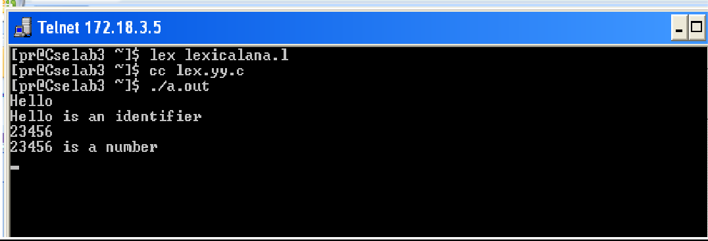

**PROGRAM 2:**

%{

%}

identifier [a-z|A-Z]|[a-z|A-Z|0-9]*

|  |  |  |
| --- | --- | --- |
| %% |  | |
|  | #.* | {printf("\n%s is a preprocessor dir",yytext);} |
|  | int | {printf("\n\t%s is a keyword",yytext);} |
|  | {identifier}\( | {printf("\n\nFUNCTION\n\t%s",yytext);} |
|  | \{ | {printf("\nBLOCK BEGINS");} |
|  | \} | {printf("\nBLOCK ENDS");} |
|  | {identifier} | {printf("\n%s is an IDENTIFIER",yytext);} |
|  | . | \n |  |
| %% |  |  |

int main(int argc,char **argv)

{

if(argc>1)

{

FILE *file; file=fopen(argv[1],"r"); if(!file)

{

printf("\n couldnot open %s\n",argv[1]); exit(0);

}

yyin=file;

}

yylex();

printf("\n\n"); return 0;

}

int yywrap()

{

return 0;

}

**Input ( in.c )**

#include<stdio.h> main()

{

int a ;

}

## OUTPUT:

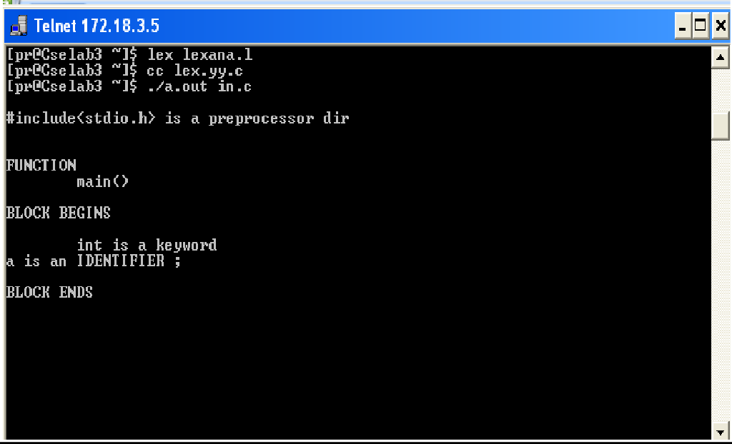

**RESULT:**

Thus the C program for the implementation of lexical analyzer using LEX Tool was executed successfully.

**Ex. No: 4 (a) DATE:**

## GENERARATION OF YACC SPECIFICATION RECOGNIZING A VALID ARITHMETIC EXPRESSION

**AIM:**

To write a program to recognize a valid arithmetic expression that uses operator +, - , * and / using YACC tool.

**ALGORITHM:**

# LEX

1. Declare the required header file and variable declaration with in ‘%{‘ and ‘%}’.
2. LEX requires regular expressions to identify valid arithmetic expression token of lexemes.
3. LEX call **yywrap()** function after input is over. It should return 1 when work is done or should return 0 when more processing is required.

**YACC**

1. Declare the required header file and variable declaration with in ‘%{‘ and ‘%}’.
2. Define tokens in the first section and also define the **associativity** of the operations
3. Mention the grammar productions and the action for each production.
4. **$$** refer to the top of the stack position while **$1** for the first value, **$2** for the second value in the stack.
5. Call **yyparse()** to initiate the parsing process.
6. **yyerror()** function is called when all productions in the grammar in second section doesn't match to the input statement.

## PROGRAM:

**//art_expr.l**

%{

#include<stdio.h> #include "y.tab.h"

%}

%%

[a-zA-Z][0-9a-zA-Z]* {return ID;} [0-9]+ {return DIG;}

[ \t]+ {;}

. {return yytext[0];}

\n {return 0;}

%%

int yywrap()

{

return 1;

}

**//art_expr.y**

%{

#include<stdio.h>

%}

%token ID DIG

%left '+''-'

%left '*''/'

%right UMINUS

%%

stmt:expn ; expn:expn'+'expn

|expn'-'expn

|expn'*'expn

|expn'/'expn

|'-'expn %prec UMINUS

|'('expn')'

|DIG

|ID

;

%%

int main()

{

printf("Enter the Expression \n"); yyparse();

printf("valid Expression \n"); return 0;

}

int yyerror()

{

printf("Invalid Expression"); exit(0);

}

## OUTPUT

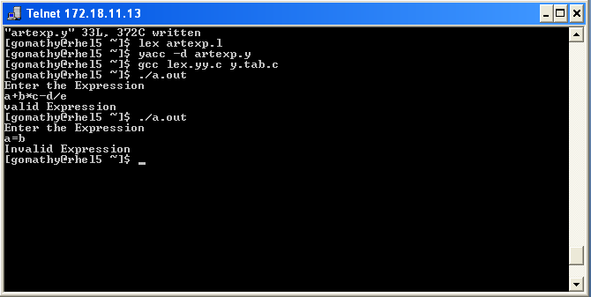

**RESULT:**

Thus the program to recognize a valid arithmetic expression that uses operator +, - , * and / using YACC tool was executed and verified successfully.

**Ex. No: 4 (b) DATE:**

## RECOGNIZING A VALID VARIABLE

**AIM:**

To write a program to recognize a valid variable which starts with a letter followed by any number of letters or digits using YACC tool.

**ALGORITHM:**

# LEX

1. Declare the required header file and variable declaration with in ‘%{‘ and ‘%}’.
2. LEX requires regular expressions or patterns to identify token of lexemes for recognize a valid variable.
3. Lex call **yywrap()** function after input is over. It should return 1 when work is done or should return 0 when more processing is required.

**YACC**

1. Declare the required header file and variable declaration with in ‘%{‘ and ‘%}’.
2. Define tokens in the first section and also define the **associativity** of the operations
3. Mention the grammar productions and the action for each production.
4. **$$** refer to the top of the stack position while **$1** for the first value, **$2** for the second value in the stack.
5. Call **yyparse()** to initiate the parsing process.
6. **yyerror()** function is called when all productions in the grammar in second section doesn't match to the input statement.

## PROGRAM:

**//valvar.l**

%{

#include "y.tab.h"

%}

%%

[a-zA-Z] {return LET;}

[0-9] {return DIG;}

. {return yytext[0];}

\n {return 0;}

%%

int yywrap()

{

return 1;

}

**//valvar.y**

%{

#include<stdio.h>

%}

%token LET DIG

%%

variable:var

;

var:var DIG

|var LET

|LET

;

%%

int main()

{

printf("Enter the variable:\n"); yyparse();

printf("Valid variable \n");

return 0;

}

int yyerror()

{

printf("Invalid variable \n"); exit(0);

}

## OUTPUT:

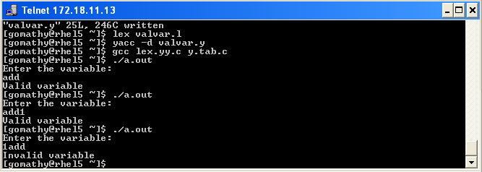

**RESULT:**

Thus the program to recognize a valid variable which starts with a letter followed by any number of letters or digits using YACC tool was executed and verified successfully.

**Ex.NO: 4(c) DATE:**

## IMPLEMENTATION OF CALCULATOR USING LEX AND YACC

**AIM:**

To write a program to implement Calculator using LEX and YACC.

## ALGORITHM:

**Step 1:** Start the program.

**Step 2:** In the declaration part of lex, includes declaration of regular definitions as digit.

**Step 3:** In the translation rules part of lex, specifies the pattern and its action that is to be executed whenever a lexeme matched by pattern is found in the input in the cal.l.

**Step 4:** By use of Yacc program,all the Arithmetic operations are done such as +,-,*,/.

**Step 5:** Display error is persist.

**Step 6:** Provide the input. **Step 7:** Verify the output. **Step 8:** End.

## PROGRAM:

**cal.l**

DIGIT [0-9]+

%option noyywrap

%%

{DIGIT} { yylval=atof(yytext); return NUM;}

\n|. { return yytext[0];}

%%

**cal.y**

%{

%}

#include<ctype.h> #include<stdio.h>

#define YYSTYPE double

%token NUM

%left ‘+’ ‘-‘

%left ‘*’ ‘/’

%right UMINUS

%%

Statment:E { printf(“Answer: %g \n”, $$); }

|Statment ‘\n’

;

E : E'+'E { $$ = $1 + $3; }

| E'-'E { $$=$1-$3; }

| E'*'E { $$=$1*$3; }

| E'/'E { $$=$1/$3; }

| NUM

;

%%

## OUTPUT:

"cal2.y" 59L, 1186C written [exam01@Cselab3 ~]$ lex cal2.l [exam01@Cselab3 ~]$ yacc yaccal2.y [exam01@Cselab3 ~]$ cc y.tab.c [exam01@Cselab3 ~]$ ./a.out

Enter the expression:2+2 Answer: 4

## RESULT:

Thus the program for implementing calculator using LEX and YACC is executed and verified.

**Ex.No:5 DATE:**

## CONVERSION OF THE BNF RULES INTO YACC FORM AND GENERATION ABSTRACT SYNTAX TREE

**AIM:**

To write the program to convert the BNF rules into YACC form and write code to generate abstract syntax tree.

## ALGORITHM:

1. Start the program.
2. Reading an input file line by line.
3. Convert it in to abstract syntax tree using three address codes.
4. Represent three address codes in the form of quadruple tabular form.

## PROGRAM:

**<int.l>**

%{

%}

#include"y.tab.h" #include<stdio.h> #include<string.h> int LineNo=1;

identifier [a-zA-Z][_a-zA-Z0-9]* number [0-9]+|([0-9]*\.[0-9]+)

%%

%%

<**int.y>**

%{

main\(\) return MAIN; if return IF;

else return ELSE; while return WHILE; int |

char |

float return TYPE;

{identifier} {strcpy(yylval.var,yytext); return VAR;}

{number} {strcpy(yylval.var,yytext); return NUM;}

\< |

\> |

\>= |

\<= |

== {strcpy(yylval.var,yytext); return RELOP;}

[ \t] ;

\n LineNo++;

. return yytext[0];

#include<string.h> #include<stdio.h> struct quad

{

char op[5]; char arg1[10]; char arg2[10]; char result[10];

}QUAD[30];

struct stack

{

int items[100]; int top;

}stk;

int Index=0,tIndex=0,StNo,Ind,tInd; extern int LineNo;

%}

%union

{

char var[10];

}

%token <var> NUM VAR RELOP

%token MAIN IF ELSE WHILE TYPE

%type <var> EXPR ASSIGNMENT CONDITION IFST ELSEST WHILELOOP

%left '-' '+'

%left '*' '/'

%%

PROGRAM : MAIN BLOCK

;

BLOCK : '{' CODE '}'

;

CODE: BLOCK

| STATEMENT CODE

| STATEMENT

;

STATEMENT: DESCT ';'

| ASSIGNMENT ';'

| CONDST

| WHILEST

;

DESCT: TYPE VARLIST

;

VARLIST: VAR ',' VARLIST

| VAR

;

ASSIGNMENT: VAR '=' EXPR{

strcpy(QUAD[Index].op,"="); strcpy(QUAD[Index].arg1,$3); strcpy(QUAD[Index].arg2,""); strcpy(QUAD[Index].result,$1); strcpy($$,QUAD[Index++].result);

}

;

EXPR: EXPR '+' EXPR {AddQuadruple("+",$1,$3,$$);}

| EXPR '-' EXPR {AddQuadruple("-",$1,$3,$$);}

| EXPR '*' EXPR {AddQuadruple("*",$1,$3,$$);}

| EXPR '/' EXPR {AddQuadruple("/",$1,$3,$$);}

| '-' EXPR {AddQuadruple("UMIN",$2,"",$$);}

| '(' EXPR ')' {strcpy($$,$2);}

| VAR

| NUM

;

CONDST: IFST{

Ind=pop(); sprintf(QUAD[Ind].result,"%d",Index); Ind=pop(); sprintf(QUAD[Ind].result,"%d",Index);

}

| IFST ELSEST

;

IFST: IF '(' CONDITION ')' {

strcpy(QUAD[Index].op,"=="); strcpy(QUAD[Index].arg1,$3);

strcpy(QUAD[Index].arg2,"FALSE"); strcpy(QUAD[Index].result,"-1"); push(Index);

Index++;

}

BLOCK {

strcpy(QUAD[Index].op,"GOTO"); strcpy(QUAD[Index].arg1,"");

strcpy(QUAD[Index].arg2,"");

strcpy(QUAD[Index].result,"-1"); push(Index);

Index++;

};

ELSEST: ELSE{

tInd=pop(); Ind=pop(); push(tInd);

sprintf(QUAD[Ind].result,"%d",Index);

} BLOCK{

Ind=pop(); sprintf(QUAD[Ind].result,"%d",Index);

};

CONDITION: VAR RELOP VAR {AddQuadruple($2,$1,$3,$$); StNo=Index-1;

}

| VAR

| NUM

;

WHILEST: WHILELOOP{

Ind=pop(); sprintf(QUAD[Ind].result,"%d",StNo); Ind=pop(); sprintf(QUAD[Ind].result,"%d",Index);

}

;

WHILELOOP: WHILE '(' CONDITION ')' {

strcpy(QUAD[Index].op,"=="); strcpy(QUAD[Index].arg1,$3); strcpy(QUAD[Index].arg2,"FALSE"); strcpy(QUAD[Index].result,"-1"); push(Index);

Index++;

}

BLOCK {

strcpy(QUAD[Index].op,"GOTO"); strcpy(QUAD[Index].arg1,"");

strcpy(QUAD[Index].arg2,"");

strcpy(QUAD[Index].result,"-1"); push(Index);

Index++;

}

;

%%

extern FILE *yyin;

int main(int argc,char *argv[])

{

FILE *fp; int i; if(argc>1)

{

fp=fopen(argv[1],"r"); if(!fp)

{

printf("\n File not found"); exit(0);

}

yyin=fp;

}

yyparse();

printf("\n\n\t\t ""\n\t\t Pos Operator Arg1 Arg2 Result" "\n\t\t

");

for(i=0;i<Index;i++)

{

printf("\n\t\t %d\t %s\t %s\t %s\t

%s",i,QUAD[i].op,QUAD[i].arg1,QUAD[i].arg2,QUAD[i].result);

}

printf("\n\t\t ");

printf("\n\n"); return 0;

}

void push(int data)

{

stk.top++; if(stk.top==100)

{

printf("\n Stack overflow\n"); exit(0);

}

stk.items[stk.top]=data;

}

int pop()

{

int data; if(stk.top==-1)

{

printf("\n Stack underflow\n"); exit(0);

}

data=stk.items[stk.top--]; return data;

}

void AddQuadruple(char op[5],char arg1[10],char arg2[10],char result[10])

{

strcpy(QUAD[Index].op,op); strcpy(QUAD[Index].arg1,arg1); strcpy(QUAD[Index].arg2,arg2); sprintf(QUAD[Index].result,"t%d",tIndex++); strcpy(result,QUAD[Index++].result);

}

yyerror()

{

printf("\n Error on line no:%d",LineNo);

}

**Input**

$vi test.c main()

{

int a,b,c; if(a<b)

{

a=a+b;

}

while(a<b)

{

a=a+b;

}

if(a<=b)

{

}

else

{

}

}

c=a-b;

c=a+b;

## OUTPUT:

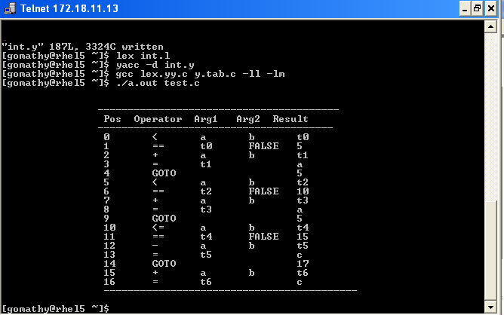

**RESULT:**

Thus the program to convert the BNF rules into YACC forms and writes code to generate abstract syntax tree was executed successfully.

**Ex.No: 6 DATE:**

## IMPLEMENTATION OF TYPE CHECKING

**AIM:**

To write a C program to implement type checking.

## ALGORITHM:

1. Start the program for type checking of given expression
2. Read the expression and declaration
3. Based on the declaration part define the symbol table
4. Check whether the symbols present in the symbol table or not. If it is found in the symbol table it displays “Label already defined”.
5. Read the data type of the operand 1, operand 2 and result in the symbol table.
6. If the both the operands’ type are matched then check for result variable. Else, print “Type mismatch”.
7. If all the data type are matched then displays “No type mismatch”.

## PROGRAM:

#include<stdio.h> #include<string.h> #include<conio.h>

int count=1,i=0,j=0,l=0,findval=0,k=0,kflag=0; char key[4][12]= {"int","float","char","double"}; char dstr[100][100],estr[100][100];

char token[100],resultvardt[100],arg1dt[100],arg2dt[100]; void entry();

int check(char[]); int search(char[]); void typecheck();

struct table

{

char var[10]; char dt[10];

};

struct table tbl[20];

void main()

{

clrscr();

printf("\n IMPLEMENTATION OF TYPE CHECKING \n");

printf("\n DECLARATION \n\n"); do

{

printf("\t");

gets(dstr[i]); i++;

} while(strcmp(dstr[i-1],"END")); printf("\n EXPRESSION \n\n"); do

{

printf("\t");

gets(estr[l]); l++;

}while(strcmp(estr[l-1],"END"));

i=0;

printf("\n SEMANTIC ANALYZER(TYPE CHECKING): \n");

while(strcmp(dstr[i],"END"))

{

} l=0;

entry(); printf("\n"); i++;

while(strcmp(estr[l],"END"))

{

typecheck(); printf("\n");

l++;

}

printf("\n PRESS ENTER TO EXIT FROM TYPE CHECKING\n");

getch();

}

void entry()

{

j=0; k=0;

memset(token,0,sizeof(token)); while(dstr[i][j]!=' ')

{

token[k]=dstr[i][j]; k++;

j++;

}

kflag=check(token); if(kflag==1)

{

strcpy(tbl[count].dt,token); k=0;

memset(token,0,strlen(token)); j++;

while(dstr[i][j]!=';')

{

token[k]=dstr[i][j]; k++;

j++;

}

findval=search(token); if(findval==0)

{

}

else

{

}

strcpy(tbl[count].var,token);

printf("The variable %s is already declared",token);

}

else

{

}

kflag=0; count++;

printf("Enter valid datatype\n");

}

void typecheck()

{

memset(token,0,strlen(token)); j=0;

k=0;

while(estr[l][j]!='=')

{

token[k]=estr[l][j]; k++;

j++;

}

findval=search(token); if(findval>0)

{

}

else

{

} k=0;

strcpy(resultvardt,tbl[findval].dt); findval=0;

printf("Undefined Variable\n");

memset(token,0,strlen(token)); j++;

while(((estr[l][j]!='+')&&(estr[l][j]!='-')&&(estr[l][j]!='*')&&(estr[l][j]!='/')))

{

token[k]=estr[l][j]; k++;

j++;

}

findval=search(token); if(findval>0)

{

}

else

{

} k=0;

strcpy(arg1dt,tbl[findval].dt); findval=0;

printf("Undefined Variable\n");

memset(token,0,strlen(token)); j++;

while(estr[l][j]!=';')

{

token[k]=estr[l][j]; k++;

j++;

}

findval=search(token); if(findval>0)

{

}

else

{

}

strcpy(arg2dt,tbl[findval].dt); findval=0;

printf("Undefined Variable\n");

if(!strcmp(arg1dt,arg2dt))

{

if(!strcmp(resultvardt,arg1dt))

{

}

else

{

}

else

{

}

printf("\tThere is no type mismatch in the expression %s ",estr[l]);

printf("\tLvalue and Rvalue should be same\n");

printf("\tType Mismatch\n");

}

}

int search(char variable[])

{

int i; for(i=1;i<=count;i++)

{

if(strcmp(tbl[i].var,variable) == 0)

{

return i;

}

}

return 0;

}

int check(char t[])

{

int in; for(in=0;in<4;in++)

{

if(strcmp(key[in],t)==0)

{

return 1;

}

}

return 0;

}

## OUTPUT:

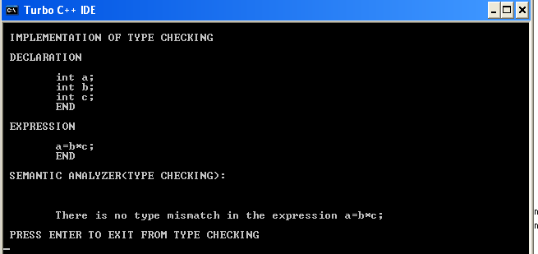

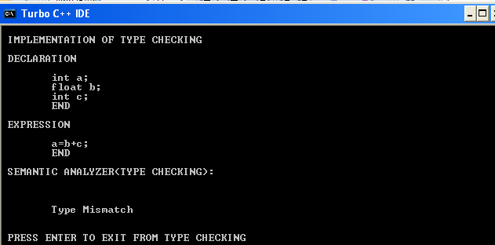

**RESULT:**

Thus the program for type checking is executed and verified.

**Ex.No: 7 DATE:**

## CONSTRUCTION OF DAG

**AIM:**

To write a C program to construct DAG.

## ALGORITHM:

1. Read the intermediate code as input from the file.
2. Store the argument1 as left node and argument2 as right node.
3. Attach the result variable to the root node of an expression.
4. Use the same node if the variable and values are same.
5. Finally construct the DAG

## PROGRAM:

#include<stdio.h> #include <conio.h> struct node

{

struct node *next; char id[10];

char left[10]; char right[10];

char attach[3][10];

};

struct node *head; FILE *f;

int i,s=0;

char str[25],store[10][25]; void construct_tree()

{

struct node *temp; struct node *t; struct node *ptr; int flag=0,f1=0; temp=head; if(s==5||s==6)

{

while (temp->next!=NULL)

{

if(!strcmp(store[2],temp->next->left))

flag+=1; if(!strcmp(store[4],temp->next->right))

flag+=2; if(flag!=0)

break; temp=temp->next;

}

t=head;

while(t->next!=NULL)

t=t->next; if(flag==0)

{

ptr=(struct node*)malloc(sizeof(struct node)); t->next=ptr;

if(s==5)

strcpy(ptr->id,store[3]);

else

strcpy(ptr->id,strcat(store[3],store[5]));

t=head;

while(t->next!=NULL)

{

if(!strcmp(t->next->attach[0],store[2]))

{

f1=1;

break;

}

if(strcmp(t->next->attach[1],"")) if(!strcmp(t->next->attach[1],store[2]))

{

f1=1;

break;

}

t=t->next;

}

if(f1)

strcpy(ptr->left,t->next->id);

else

strcpy(ptr->left,store[2]);

f1=0;

t=head;

while(t->next!=NULL)

{

if(!strcmp(t->next->attach[0],store[4]))

{

f1=1;

break;

}

if(strcmp(t->next->attach[1],"")) if(!strcmp(t->next->attach[1],store[4]))

{

f1=1;

break;

}

t=t->next;

}

if(f1)

strcpy(ptr->right,t->next->id);

else

strcpy(ptr->right,store[0]); strcpy(ptr->attach[1],""); ptr->next=NULL;

}

else if(flag==3)

strcpy(temp->next->attach[1],store[0]);

}

if(s==3)

{

while(temp->next!=NULL)

{

if(!strcmp(store[2],temp->next->attach[0])) break;

temp=temp->next;

}

strcpy(temp->next->attach[1],store[0]);

}

}

int main()

{

struct node *temp; struct node *t; clrscr();

f=fopen("C:\\DAG.txt","r");

head=(struct node*)malloc(sizeof(struct node));

head->next=NULL; while(!feof(f))

{

fscanf(f,"%s",str);

if(!strcmp(str,";"))

{

construct_tree(); s=0;

}

else

strcpy(store[s++],str);

}

printf("\n\nID\tLEFT\tRIGHT\tATTACHED IDs\n\n"); temp=head;

while(temp->next!=NULL)

{

printf("\n\n%s\t%s\t%s\t%s\t",temp->next->id,

temp->next->left,temp->next->right,temp->next->attach[0]); if(strcmp(temp->next->attach[1],""))

printf("\t%s",temp->next->attach[1]); temp=temp->next;

}

getch(); return 0;

}

|  |  |  |  |  |
| --- | --- | --- | --- | --- |
| **INPUT:**  t1=4*i; t2=a[t1]; t3=4*i; t4=b[t3]; t5=t2*t4; t6=prod+t5; prod=t6; t7=i+1;  i=t7; |  | | | |
| **OUTPUT:**  ID | LEFT | RIGHT | ATTACHED | IDs |
| * []  []  *  + | 4  a b []  prod | I  *  * []  * | t1 t2 t4 t5  t6 | t3  prod |
| + | I |  | t7 | i |

## RESULT:

Thus the program for construction of DAG is executed and verified.

**Ex.No: 8 DATE:**

## IMPLEMENTATION OF STACK

**AIM:**

To implement a storage allocation using stack.

## ALGORITHM:

1. Get the size of the stack.
2. Read the choice of operation.
3. If the choice is 1push the items into the stack
4. To push the elements perform the following.
   1. If the top of stack is equal to size of stack elements can’t be pushed.
   2. Read item to be pushed.
   3. Set or increment the top by one.
   4. Assign the item to the stack [top].
   5. Repeat the steps until it is required.
5. If choice is 2 pop the items from the stack
   1. Check for empty stack.
   2. Decrement the top by one.
   3. Return the popped item.
6. If choice is 3 display the contents of Stack.

## PROGRAM:

#include<stdio.h> #include<conio.h> #include<stdlib.h>

#define size 5 struct stack

{

} st;

int s[size]; int top;

int stfull()

{

if(st.top>=size-1) return 1;

else return 0;

}

void push(int item)

{

st.top++; st.s[st.top] = item;

}

int stempty()

{

if(st.top==-1)

return 1;

else

}

return 0;

int pop()

{

int item;

item = st.s[st.top]; st.top--;

return (item);

}

void display()

{

int i; if(stempty())

printf("\nStack Is Empty!"); else

{

for(i=st.top;i>=0;i--)

printf("\n%d",st.s[i]);

}

}

int main()

{

int item, choice; char ans;

st.top = -1;

printf("\n\tImplementation Of Stack"); do

{

printf("\nMain Menu");

printf("\n1.Push \n2.Pop \n3.Display \n4.exit"); printf("\nEnter Your Choice");

scanf("%d", &choice); switch (choice)

{

case 1:

printf("\nEnter The item to be pushed"); scanf("%d", &item);

if (stfull())

printf("\nStack is Full!");

case 2:

else

push(item); break;

if(stempty())

printf("\nEmpty stack!Underflow !!");

case 3:

else

{

}

break;

item = pop();

printf("\nThe popped element is %d", item);

case 4:

}

display(); break;

exit(0);

printf("\nDo You want To Continue?"); ans=getche();

}

while(ans=='Y'||ans =='y');

return 0;

}

## OUTPUT:

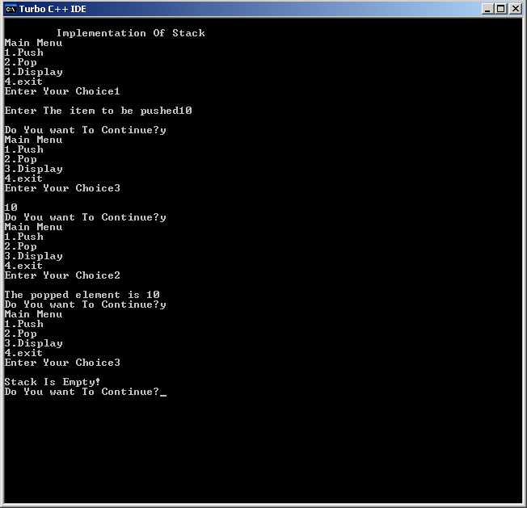

**RESULT:**

Thus the program for stack implementation is executed and verified.

**Ex.No: 9 DATE:**

## IMPLEMENTATION OF BACKEND

**AIM:**

To write a ‘C’ program to generate the machine code for the given intermediate code.

## ALGORITHM:

**Step1:** Get the input expression from the user.

**Step2:** The given expression is transformed into tokens.

**Step3:** Display the assembly code according to the operators present in the given expression.

**Step4:** Use the temporary registers (R0, R1) while storing the values in assembly code programs.

## PROGRAM:

**/* CODE GENERATOR */**

#include<stdio.h> #include<string.h> int count=0,i=0,l=0; char str[100][100]; void gen();

void main()

{

clrscr();

printf("\n CODE GENERATOR \n");

printf("\n ENTER THREE ADDRESS CODE \n\n"); do

{

printf("\t");

gets(str[i]); i++;

} while(strcmp(str[i-1],"QUIT"));

i=0;

printf("\n ASSEMBLY LANGUAGE CODE: \n");

while(strcmp(str[i-1],"QUIT"))

{

gen();

printf("\n");

i++;

}

printf("\n PRESS ENTER TO EXIT FROM CODE GENERATOR\n");

getch();

}

void gen()

{

int j; printf("\n");

for(j=strlen(str[i])-1;j>=0;j--)

{

char reg='R';

if(isdigit(str[i][j])||(isalpha(str[i][j]))|| str[i][j]=='+'||str[i][j]=='-'||str[i][j]=='*'||str[i][j]=='/'||str[i][j]==' '||str[i][j]=='|'||str[i][j]=='&'||str[i][j]==':'||str[i][j]=='=')

{

switch(str[i][j])

{

case '+':

printf("\n\t MOV\t%c,%c%d",str[i][j-1],reg,count);

case '-':

case '*':

case '/':

case '|':

printf("\n\t ADD\t%c,%c%d",str[i][j+1],reg,count); break;

printf("\n\t MOV\t%c,%c%d",str[i][j-1],reg,count); printf("\n\t SUB\t%c,%c%d",str[i][j+1],reg,count); break;

printf("\n\t MOV\t%c,%c%d",str[i][j-1],reg,count); printf("\n\t MUL\t%c,%c%d",str[i][j+1],reg,count); break;

printf("\n\t MOV\t%c,%c%d",str[i][j-1],reg,count); printf("\n\t DIV\t%c,%c%d",str[i][j+1],reg,count); break;

printf("\n\t MOV\t%c,%c%d",str[i][j-1],reg,count); printf("\n\t OR\t%c,%c%d",str[i][j+1],reg,count); break;

case '&':

printf("\n\t MOV\t%c,%c%d",str[i][j-1],reg,count); printf("\n\t AND\t%c,%c%d",str[i][j+1],reg,count); break;

case ':':

if(str[i][j+1]=='=')

{

printf("\n\t MOV\t%c%d,%c",reg,count,str[i][j-1]); count++;

}

else

{

printf("\n syntax error...\n");

}

default:

}

}

break; break;

else printf("\n Error\n");

}

}

## OUTPUT:

CODE GENERATOR

ENTER THREE ADDRESS CODE A:=B+C

D:=E/F QUIT

ASSEMBLY LANGUAGE CODE: MOV B,R0

ADD C,R0 MOV R0,A

MOV E,R1 DIV F,R1 MOV R1,D

PRESS ENTER TO EXIT FROM CODE GENERATOR

## RESULT:

Thus the program for generation of Machine Code for the given intermediate code is executed and verified.

**Ex.No:10 DATE:**

## IMPLEMENTATION OF CODE OPTMIZATION TECHNIQUES

**AIM:**

To write a C program to implement Simple Code Optimization Techniques.

## ALGORITHM:

1. Read the un-optimized input block.
2. Identify the types of optimization
3. Optimize the input block
4. Print the optimized input block
5. Execute the same with different set of un-optimized inputs and obtain the optimized input block.

## PROGRAM:

#include<stdio.h> #include<conio.h> #include<ctype.h> void main()

{

char a[25][25],u,op1='*',op2='+',op3='/',op4='-'; int p,q,r,l,o,ch,i=1,c,k,j,count=0;

FILE *fi,*fo;

// clrscr();

printf("Enter three address code"); printf("\nEnter the ctrl-z to complete:\n"); fi=fopen("infile.txt","w"); while((c=getchar())!=EOF)

fputc(c,fi); fclose(fi);

printf("\n Unoptimized input block\n"); fi=fopen("infile.txt","r"); while((c=fgetc(fi))!=EOF)

{

k=1;

while(c!=';'&&c!=EOF)

{

a[i][k]=c; printf("%c",a[i][k]); k++;

c=fgetc(fi);

}

}

count=i; fclose(fi); i=1;

printf("\n"); i++;

printf("\n Optimized three address code"); while(i<count)

{

if(strcmp(a[i][4],op1)==0&&strcmp(a[i][5],op1)==0)

{

printf("\n type 1 reduction in strength"); if(strcmp(a[i][6],'2')==0)

{

for(j=1;j<=4;j++)

printf("%c",a[i][j]);

printf("%c",a[i][3]);

}

}

else if(isdigit(a[i][3])&&isdigit(a[i][5]))

{

printf("\n type2 constant floding"); p=a[i][3];

q=a[i][5]; if(strcmp(a[i][4],op1)==0)

r=p*q; if(strcmp(a[i][4],op2)==0)

r=p+q; if(strcmp(a[i][4],op3)==0)

r=p/q; if(strcmp(a[i][4],op4)==0)

r=p-q; for(j=1;j<=2;j++)

printf("%c",a[i][j]); printf("%d",r);

printf("\n");

}

else if(strcmp(a[i][5],'0')==0||strcmp(a[i][5],'1')==0)

{

cprintf("\n type3 algebraic expression elimation");

if((strcmp(a[i][4],op1)==0&&strcmp(a[i][5],'1')==0)||(strcmp(a[i][4],op3)==0&&strcmp(a[i][5],' 1')==0))

{

for(j=1;j<=3;j++)

printf("%c",a[i][j]); printf("\n");

}

else

printf("\n sorry cannot optimize\n");

}

else

{

printf("\n Error input");

}

i++;

}

getch();

}

# infile.txt

a=d/1; b=2+4; c=s**2;

**OUTPUT**

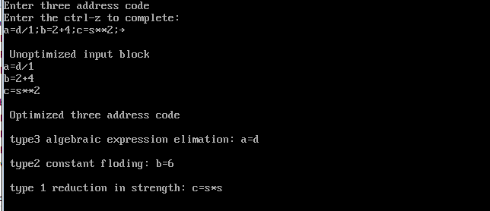

**RESULT**

Thus the C program for implementation of Code optimization was executed successfully.