**Montgomery College**

**CMSC 203**

**Assignment 6 Design**

Class: CMSC203 CRN 46519

 Program: Assignment 6 Design

Instructor: Professor Eivazi

 Summary of Description: (This application creates and processes orders of different types of beverages. It provides information on all the orders and the total amount on a specific order. Additionally, it reports the monthly total number of orders and monthly sale report.)

 Due Date: 08/11/2022

 Integrity Pledge: I pledge that I have completed the programming assignment independently.

 I have not copied the code from a student or any source.

Student: Fakhreya Mohammadi

**Testing:**

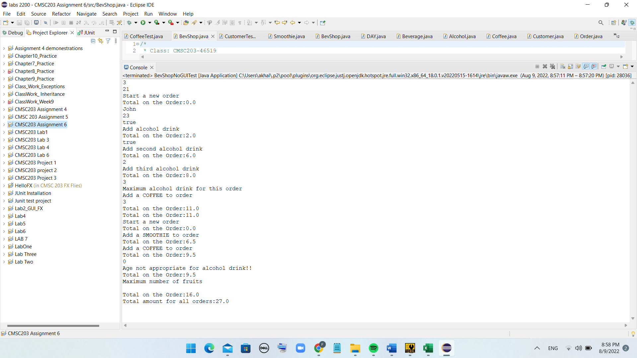

**UML diagram and the relationship of classes with each other:**

­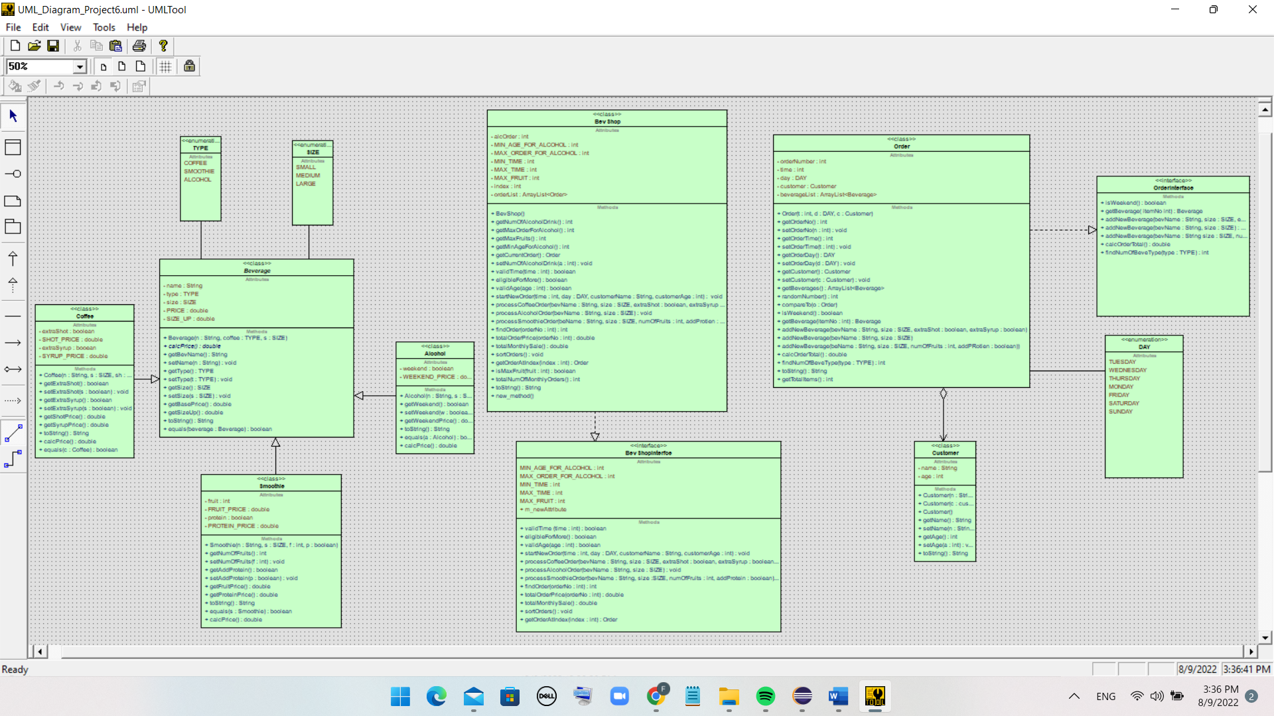

**UML diagram for each of the classes:**





















**Junit Test:**

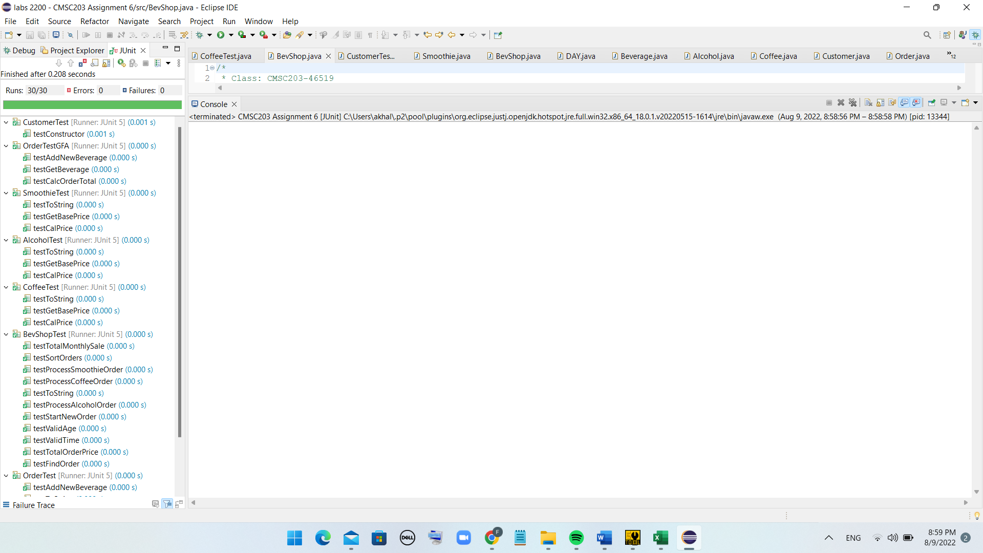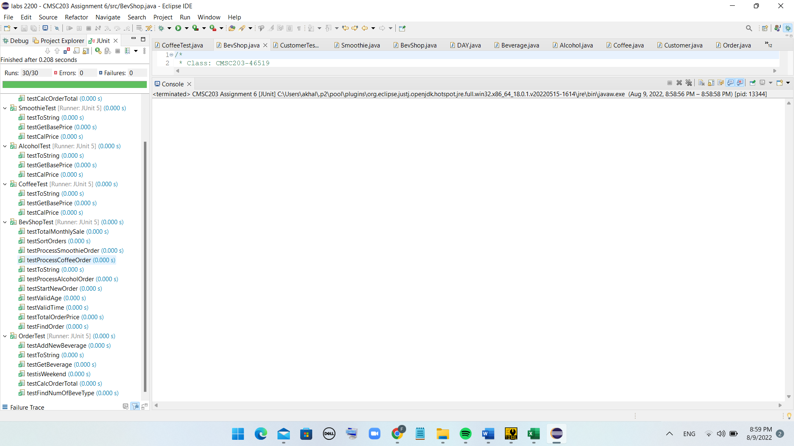

**GitHub Submission:**

Lessons Learned:

* Lessons Learned: highlight your lessons learned and learning experience from working on this project.

Working on this project gave me the opportunity to practice almost everything we have covered in this class. Specially, it was really helpful to practice the concepts that are more related to object-oriented aspect of java programming language. It was a huge project and required more time to work on compared to the other projects; therefore, I started working on this project earlier. Although it was a little complex and huge assignment but I was comfortable working on it and complete it. The concepts I practiced by working on this project was Aggregation, Searching an ArrayList, Selection sort, Enumeration, Inheritance, Interface, Polymorphism, Abstract classes, and Overriding methods.

* What have you learned?

I learned how to work with Aggregation and aggregated classes, Search an ArrayList, apply Selection sort, apply Enumeration, apply Inheritance, Interface and Polymorphism, create Abstract classes, and Override methods. Additionally, I learned how to present these concepts in UML diagram.

* What did you struggle with?

One of the things that was hard for me to figure out was sorting the orders. I had some difficulties writing the code for the method that sorts the orders.

* What will you do differently on your next project?

I will use the provided materials such videos and PowerPoints, instructor’s office hours, and the coach’s office hors to discuss the difficulties I would have related to the project.

* Include what parts of the project you were successful at, and what parts (if any) you were not successful at.

I was successful with all the parts of the project.

Assignment 6 Check List (include Yes/No or N/A for each item)

|  |  |  |  |
| --- | --- | --- | --- |
| **#** |  | **Y/N or N/A** | **Comments** |
|  | **Assignment files:** |  |  |
|  | * FirstInitialLastName_ Assignment6_Moss.zip | **Y** |  |
|  | * FirstInitialLastName_Assignment6_Complete.zip | **Y** |  |
|  | **Program compiles** | **Y** |  |
|  | **Program runs with desired outputs related to a Test Plan** | **Y** |  |
|  | **Documentation file:** |  |  |
|  | * Comprehensive Test Plan | **N/A** |  |
|  | * Screenshots for each Junit Test | **Y** |  |
|  | * Screenshots for each Test case listed in the Test Plan | **N/A** |  |
|  | * Screenshots of your java file BevShopNoGUITest run | **Y** |  |
|  | * Screenshots of your GitHub account with submitted Assignment# (if required) | **Y** |  |
|  | * UML Diagram | **Y** |  |
|  | * Lessons Learned | **Y** |  |
|  | * Checklist is completed and included in the Documentation | Y |  |