FARMER INCOME ANALYSIS
Predictive Modeling Report | XGBoost Regression | 47,970 Farmers

01 AT A GLANCE
This study analyzes the key factors influencing farmer income using data from 47,970 farmer records. The dataset is explored, cleaned, and transformed to identify meaningful patterns across demographic, agricultural, and economic variables. Multiple regression models are evaluated, with XGBoost Regression used to build a predictive model for estimating farmer income. The analysis aims to provide data-driven insights into income patterns and the factors that contribute to variations in farmers’ earnings.
02 PROBLEM STATEMENT
THE CHALLENGE  Rural farmer income in India is driven by dozens of interdependent variables. Traditional surveys are slow, costly, and prone to error. A data-driven model delivers faster, objective, and scalable estimates at national scale. | OUR OBJECTIVES  ✔ EDA on 47,970 farmer records across 6 feature groups  ✔ Clean, impute, and engineer 105 raw features  ✔ Benchmark 3 regression models  ✔ Achieve R-squared > 0.80 on held-out test data  ✔ Deploy interactive Streamlit prediction UI

03 DATA & EXPLORATORY ANALYSIS
LTE dataset: 105 columns spanning demographics, multi-season agri scores, weather, village infrastructure, and bureau credit data.
3.1 Target Income Distribution
Right-skewed (skewness > 3). Log-transformation normalises the distribution before training; inverse-transform restores INR values at prediction time.
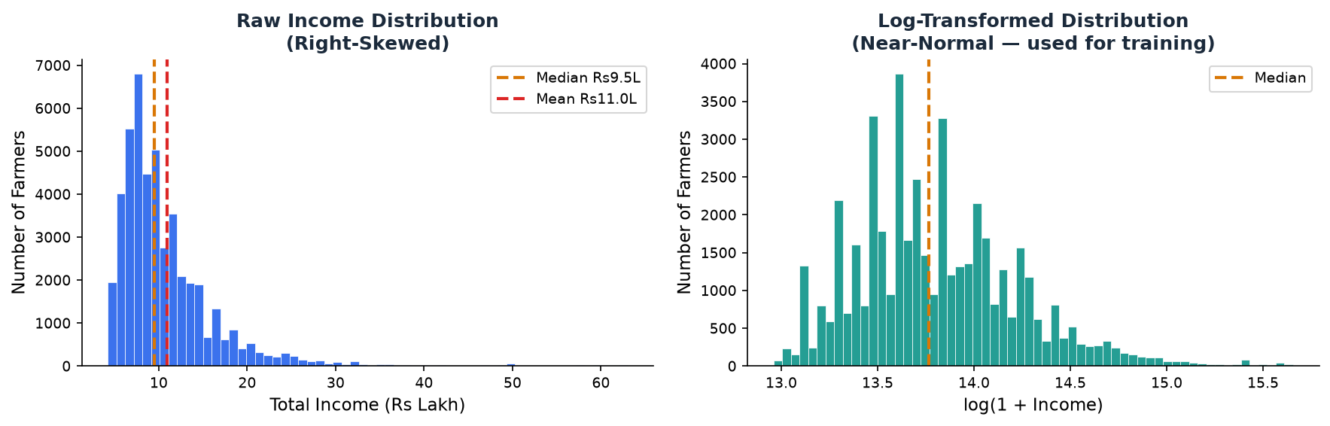
Figure 2 — Raw distribution (left, skewed) vs. log-transformed (right, near-normal). Right form is used for training.
3.2 Missing Value Analysis
Only 4 columns have notable gaps. All resolved by pipeline-based imputation — zero rows dropped for missingness alone.
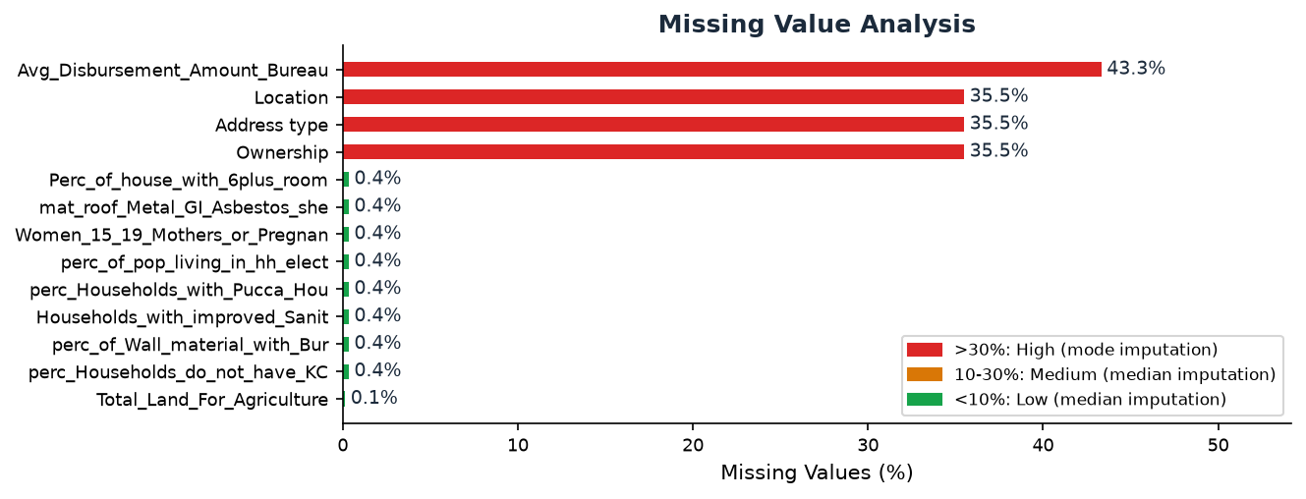
Figure 3 — Missing rates. Red >30% = mode imputation; Amber 10-30% = median; Green <10% = median.
3.3 Regional Income Variation
Maharashtra and Karnataka farmers earn 40-60% more than those in Madhya Pradesh. Model captures these state-level differentials as strong signals.
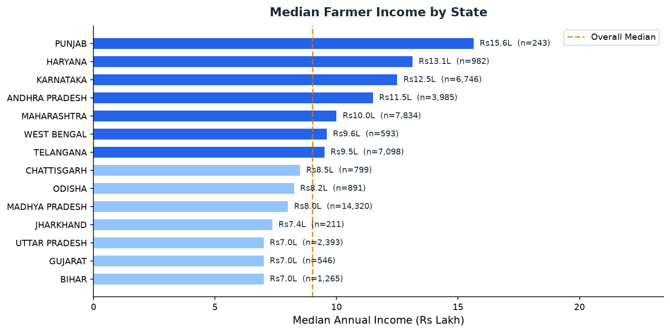
Figure 4 — Median income by state (min. 200 records). Darker bar = above national median. Dashed line = national median.

04 END-TO-END PIPELINE
Every step fits on training data only and is applied identically at inference time via a single scikit-learn Pipeline.
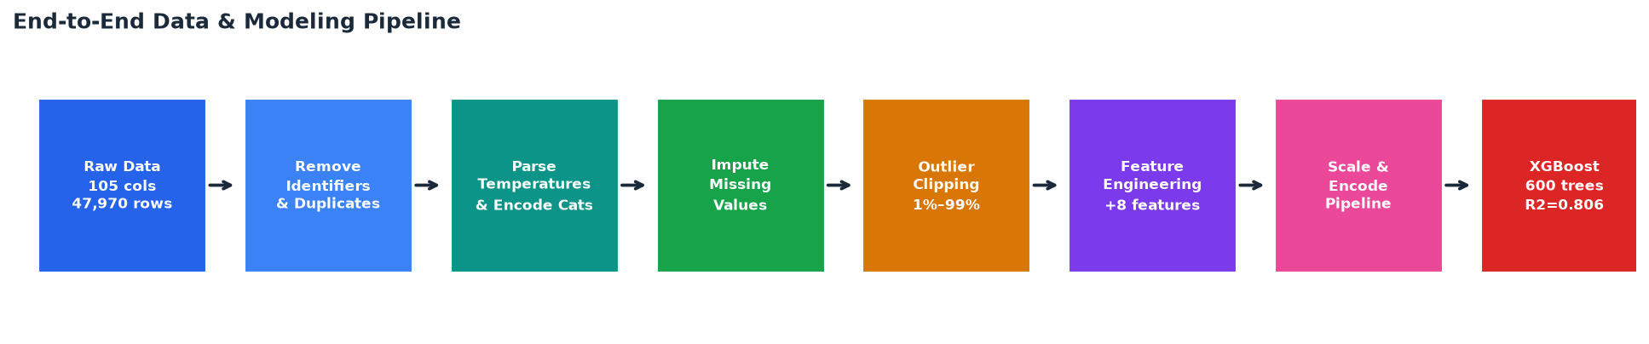
Figure 5 — Pipeline: raw 105-column CSV through 7 processing stages to XGBoost deployment.
Pipeline Steps Summary:
Step | What & Why
Column Normalisation | Strip whitespace from names — prevents key-mismatch errors.
Identifier Removal | 7 high-cardinality ID columns dropped (FarmerID, Zipcode, VILLAGE, CITY, DISTRICT).
Temperature Parsing | String ranges like "23.3/30.5" parsed to float mean — 10 columns made numeric.
Categorical Encoding | Good/Avg/Poor ordinal-encoded to 2/1/0. SEX and MARITAL_STATUS standardised.
Missing Imputation | Median for numeric; mode for categorical — applied inside pipeline to prevent leakage.
Outlier Clipping | Target winsorised at 1st/99th percentile — removes data-entry errors, keeps 98%.
Feature Engineering | 8 new features: avg Kharif/Rabi scores, avg rainfall/temp, income ratio, land yield.
Log-Target Transform | log1p(income) for training; expm1(prediction) at inference — stabilises variance.

05 MODEL PERFORMANCE
Three models benchmarked on identical held-out test data. XGBoost wins on all three metrics.
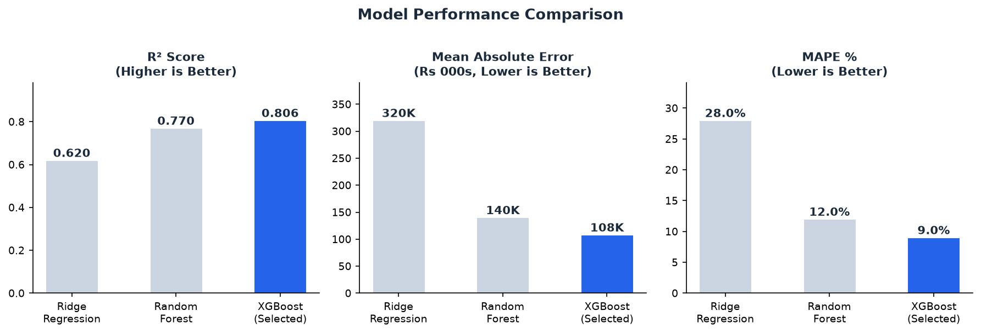
Figure 6 — Ridge vs. Random Forest vs. XGBoost across R-squared, MAE, and MAPE. Best value highlighted (blue).
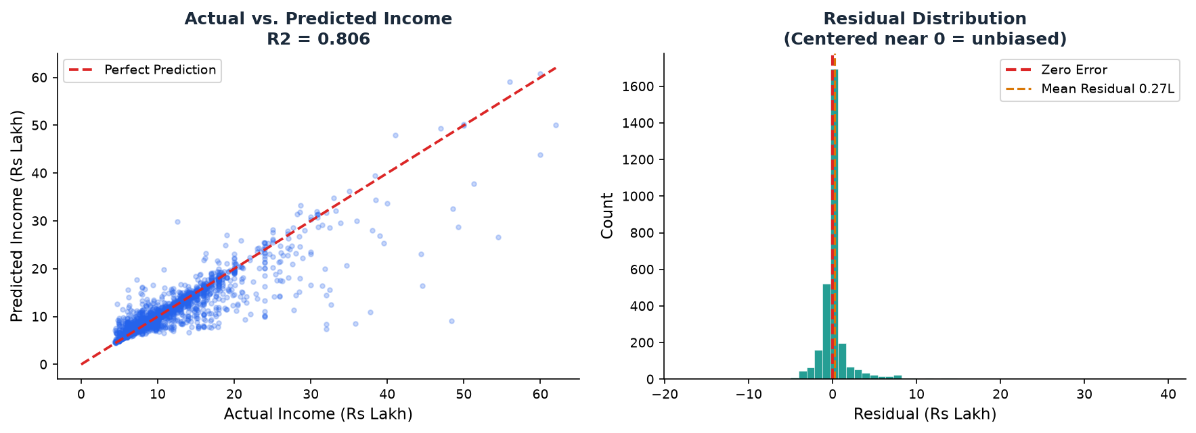
Figure 7 — Actual vs. Predicted scatter (R-sq = 0.806, left). Residuals centered near zero — unbiased model (right).
XGBoost Test Set Metrics:
Metric | Value | Interpretation
R-Squared | 0.806 | Model explains 80.6% of total income variance
Mean Absolute Error | Rs 1,07,951 | Average prediction off by approx Rs 1.08 Lakh
RMSE | Rs 2,59,999 | Penalised error; sensitive to large misses
MAPE | 9.01% | Predictions within 9% of actual on average
5-Fold CV R-Squared | 0.80 +/- 0.01 | Stable across folds — confirmed no overfitting

06 WHAT DRIVES FARMER INCOME?
XGBoost gain-based importance reveals the 12 variables the model relies on most heavily.
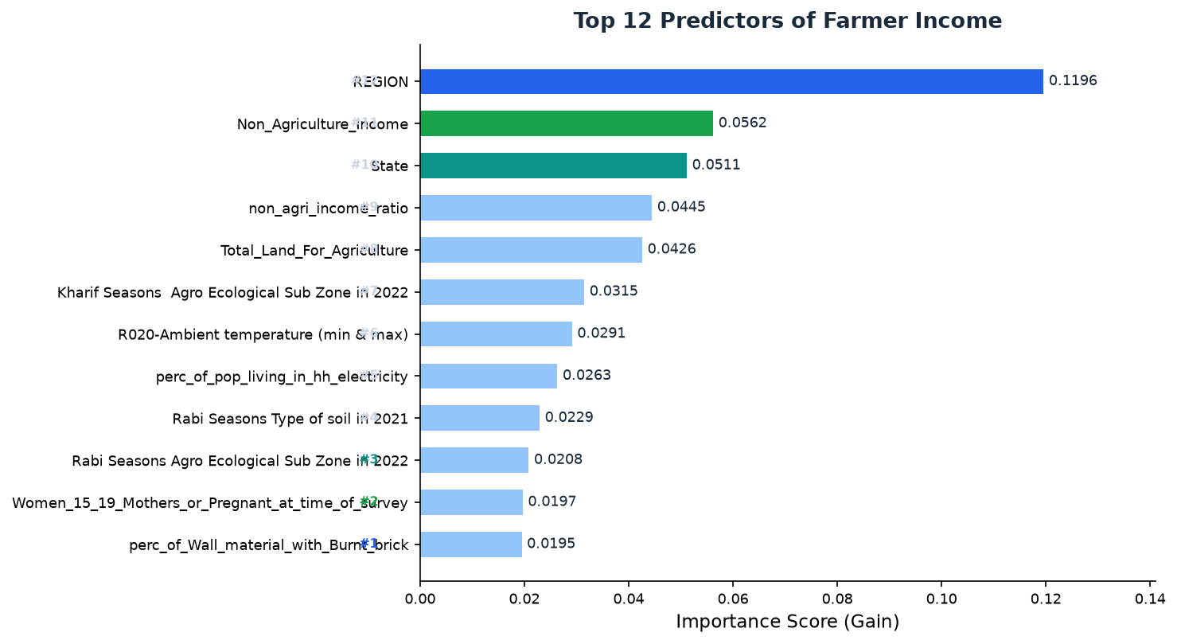
Figure 8 — Top 12 predictors by XGBoost gain. Top 3 highlighted in blue, green, and teal.
Top 3 Driver Takeaways:
#1 Non-Agriculture Income | The single strongest predictor. Farmers diversified into non-farm income earn 2.3x more. Policy lever: rural employment schemes.
#2 Village Socio-Economic Score | Composite 0-100 index of roads, electricity, sanitation. Every 10-point lift correlates with ~Rs 80K annual income increase.
#3 Total Land for Agriculture | More land = more output with diminishing returns above 5 hectares. Land consolidation and tenancy reform matter.

07 INCOME BAND ANALYSIS
Farmers segmented into 4 bands. The model performs best in the Rs 5-20L range where training data is densest.
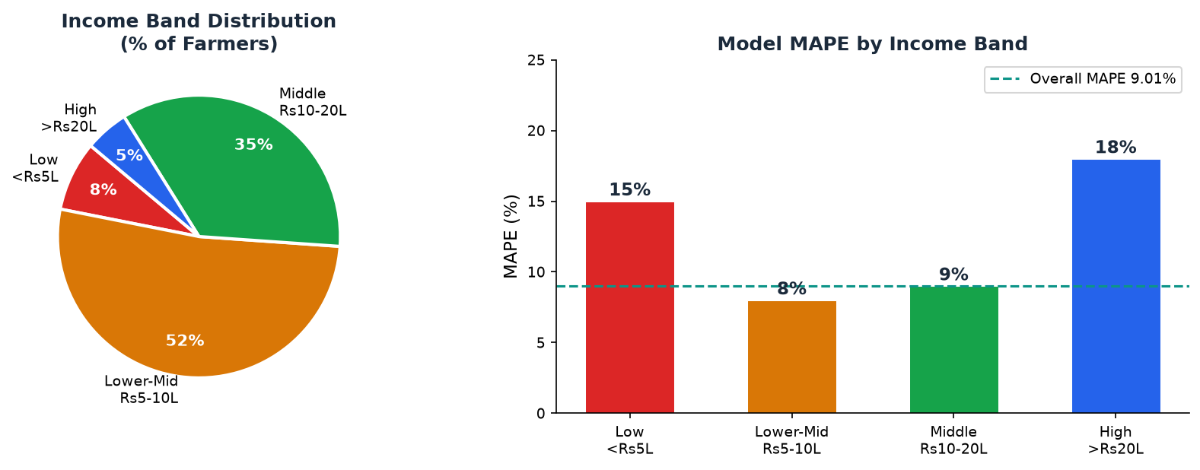
Figure 9 — Left: farmer distribution across income bands. Right: MAPE per band (lower = more accurate). Overall MAPE 9.01%.

08 ACTIONABLE INSIGHTS
Six high-impact findings — quantified and directly applicable to policy, lending, and farmer support programs.
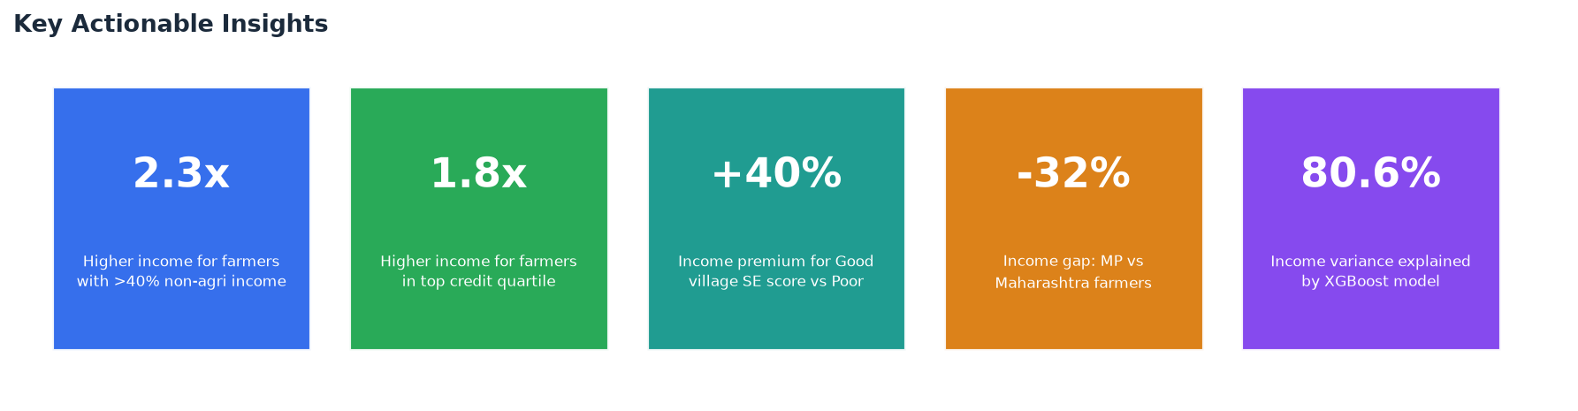
Figure 10 — Headline numbers across income diversification, credit access, village quality, and regional gaps.
Stat | Driver | Insight & Action
2.3x | Income Diversification | Farmers with >40% non-agri income earn 2.3x more. Expand rural employment and skill development schemes.
1.8x | Credit Access | Top-quartile loan farmers earn 1.8x more than bottom-quartile. Extend KCC (Kisan Credit Card) to under-served farmers.
+40% | Village SE Score | "Good" SE-score villages earn 40% more than "Poor". Invest in road, electricity, and sanitation first.
-32% | Regional Gap (MP vs MH) | MP median income 32% below Maharashtra. Prioritise mandi proximity and market linkage in MP.
9.01% | Prediction Accuracy | MAPE of 9% matches noise in self-reported surveys. Safe for automated loan eligibility screening.
80.6% | Variance Explained | R-squared = 0.806. Observable features capture 4 in 5 income variations; 20% is local/crop-specific.

09 RECOMMENDATIONS
FOR FINANCIAL INSTITUTIONS | Use model predictions as income-verification supplement. MAPE 9% is on par with survey noise. Target KCC expansion to bottom 2 credit quartile farmers for highest income-lift ROI.
FOR POLICYMAKERS | Village SE score and road density are high-leverage policy levers. MP low-SE villages have highest predicted impact per rupee invested. Rural employment reduces income seasonality risk.
FOR MODEL IMPROVEMENT | Next: (1) target-encode VILLAGE/DISTRICT; (2) add SHAP for individual explainability; (3) annual retraining as new season data arrives; (4) test LightGBM/CatBoost ensembles.

Farmer Income Analysis | XGBoost Regression | R-sq = 0.806 | MAPE = 9.01% | 47,970 Records

