
Case Study
How Does a CPU Execute Instructions?

Student Name | Falak Baharwani
UID | 25BAI10018
Course Name | Computer Architechture and Organization
Faculty Name | Dr. Ruchika Gupta
Department | Computer Science and Engineering
University | Chandigarh University

Introduction
The Central Processing Unit (CPU) The CPU is the brain of the computer , it controls and performs the operations needed to run programs . When we perform a calculation or run a command the CPU works through three main stages to process the instruction. Fetch, Decode and Execute.
For example, consider a program that must compute:
A = B + C
Where:
B=12.
C=8
The CPU then takes those values, adds them together using its Arithmetic Logic Unit (ALU), and stores the answer. The process involves different parts of the CPU such as registers, control unit, ALU and Program Counter.
Problem Statement
To understand how a CPU performs addition, we need to look at how the internal components work together. The primary objective is to trace the flow of instructions and data as they are executed and to comprehend the function of each component.

Case Study Questions
Describe the Fetch, Decode, and Execute stages.
The CPU executes an instruction by going through three basic stages, one after another. This is usually called the Instruction Cycle.
1. Fetch Stage :
- The CPU then fetches the next instruction from the main memory.
- The Program Counter (PC) holds the address of the next instruction to be executed.
- The CPU then uses this address to pull the needed instruction from memory.
- The fetched instruction is moved to the Instruction Register (IR).
- The Program Counter is incremented to point to the next instruction.
2. Decode Stage
- The Control Unit fetches the instruction and then inspects it to find out what has to be done.
- It indicates the operation referred to in the instruction.
- It finds out which registers hold the data it wants.
- It generates control signals to synchronise the various CPU components.
- For example , if the instruction is ADD , the Control Unit knows it has to add two values .
3. Execute Stage
- At this stage, the CPU performs the operation it was required to do.
- The values that are required are read from the CPU registers.
- Both values are passed to the ALU.
- The ALU adds.
- The result of the calculation is returned to a register or some other storage location.
- For example, if you add 12 and 8 the ALU gives you the answer of 20.

What is the purpose of the Program Counter?

The address of the next instruction that the CPU needs to execute is stored in a special-purpose register known as the Program Counter (PC).

Its main objectives are:

It retains the memory address of the next instruction.

It helps the CPU execute directives in the correct sequence.

An instruction is updated once it is retrieved.

It can also jump to a different location when a branch or jump instruction is executed.

Without the Program Counter, the CPU wouldn't know which instruction to process next.

Which component performs arithmetic addition?

Logical and arithmetic operations are handled by the CPU's Arithmetic Logic Unit (ALU).

Among its responsibilities are:
- Addition and subtraction.
- Multiplication and division (depending on the CPU architecture).
- Logical functions such as AND, OR, and NOT.
- Comparison of values.

In this case, the ALU receives two operands, 12 and 8, adds them, and yields the following outcome:

12 + 8 = 20

Why are CPU registers used?
CPU registers are tiny, incredibly quick storage spaces found inside the processor. Instructions, data, memory addresses, and computation results are all momentarily stored in them.
Registers are crucial due to:
- They enable the CPU to swiftly retrieve frequently needed data.
- They lessen the need to often access slower main memory.
- Before an operation, they temporarily store operands.
- They store the intermediate and final computation results.
For instance, R3 holds their addition result, which is 20, whereas R1 and R2 hold the numbers 12 and 8.
Where can the result be stored after execution?
Depending on the instruction and the needs of the program, the result of an executed instruction may be stored in several places.
Typical places for storage include:
- CPU Registers: For speedy access, the outcome can be put straight into a register.
- Main Memory (RAM): If the outcome needs to be saved for later use, it can be moved to memory.
- Cache Memory: To increase processing performance, frequently used data may be kept in cache.
The addition's outcome is kept in register R3 in our example.
Consequently:
R3 is 20.

Assignment
Trace the Instruction ADD R3, R1, R2
Given Information
Consider the following register values:
R1 = 12
R2 = 8
R3 = Initially empty
The instruction is: ADD R3, R1, R2
This instruction tells the CPU to add the values in R1 and R2 and put the result in R3.
Step-by-Step Execution
Step 1: Fetch
- The program counter contains the address of the ADD instruction.
- The CPU fetches the instruction from memory.
- The instruction is loaded into the Instruction Register.
- The program counter is incremented to point to the address of the next instruction.
Step 2: Decode
- The Control Unit reads the instruction which is stored in the Instruction Register.
- It identifies ADD as the required operation.
- It identifies R1 and R2 as the source registers.
- It identifies R3 as the destination register.
- The Control Unit sends the appropriate signals to the registers and ALU.
Step 3: Read Operands
- The value of 12 comes from R1.
- The value of 8 comes from R2.
- Both values are passed into the ALU via the CPU's internal data path.
Step 4: Execute
- The ALU performs the addition:
- 12 + 8 = 20
- The answer from the ALU is 20.
Step 5: Store the Result
- The result is written back to the register file.
- Register R3 receives the value 20.
- The instruction has now been completed.

Final Register Values
Register | Value
R1 | 12
R2 | 8
R3 | 20

Final Output: R3 = 20

Basic CPU Block Diagram
The following diagram shows the main components of a CPU and how data moves between them during an addition instruction.

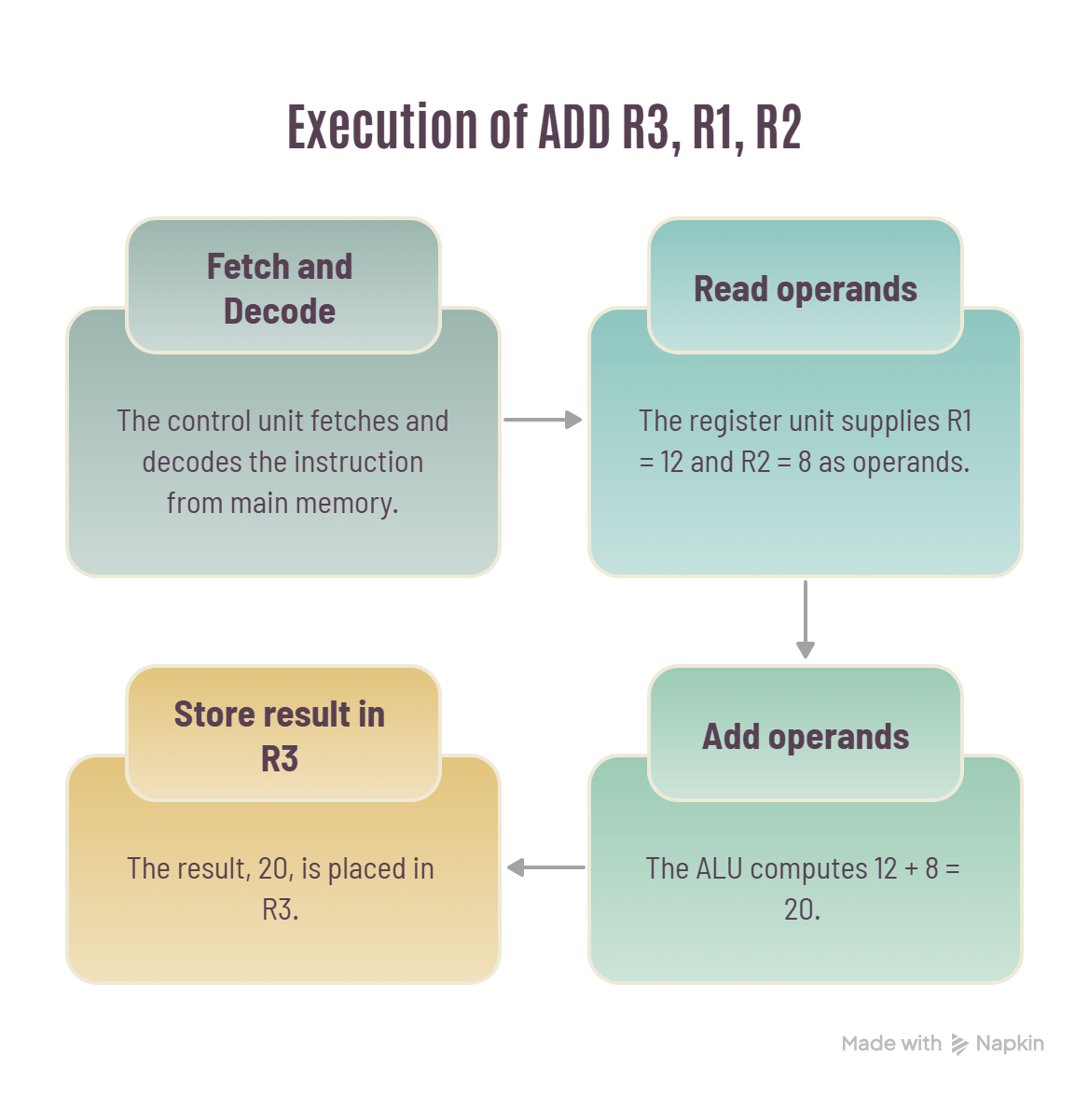

Explanation of Data Flow
- Instruction Fetch: The CPU gets the ADD instruction from main memory via the address in the Program Counter.
- Instruction Decode: The Control Unit determines the operation and identifies which registers are required.
- Operand Transfer: The values in R1 and R2 (12 and 8) are passed to the ALU.
- Arithmetic operation: ALU adds both operands and produces the result 20.
- Result storage: The calculated value is returned to the register unit and stored in R3.

Conclusion

In this case study, it is clear how various CPU parts interact in order to complete the addition operation. The Program Counter monitors the instructions; the Control Unit controls the processing of the instructions while the registers act as temporary data storage. The ALU, on the other hand, performs the calculations.

The ADD R3, R1, R2 instruction is processed by CPU as it takes 12 from R1, 8 from R2 and completes the addition operation to produce the sum of 20 in R3.

