**Лабораторная работа №2**

1.path_to_wave **=** "/content/anna_voice.wav"

*2.***import** numpy **as** np

**from** IPython.display **import** Audio

**from** scipy.io **import** wavfile

**from** scipy.fftpack **import** fft, dct

**import** matplotlib.pyplot **as** plt

**from** itertools **import** zip_longest

**import** more_itertools **as** mits

3. frame_rate, sound_data **=** wavfile**.**read(path_to_wave)

time **=** np**.**arange(0,len(sound_data))**/**frame_rate

sound_data **=** sound_data**.**T[0]

print('Sample rate:',frame_rate,'Hz')

print(f'Total time: {len(sound_data)**/**frame_rate}s')

plt**.**plot(time, sound_data)

plt**.**title("Raw")

plt**.**xlabel("Time, s")

plt**.**ylabel("Amplitude")

plt**.**show()

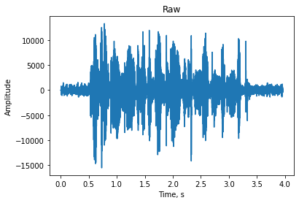

4. Audio(sound_data,rate**=**frame_rate)

5. dimension **=** 2 **\*\*** 8

spctr **=** round(frame_rate**/**dimension)

overlap **=** 0.25

6. seqs **=** list(mits**.**windowed(sound_data, n**=**dimension, step**=**int(overlap **\*** dimension)))

prep_seqs **=** list()

**for** val **in** seqs[**-**1]:

**if** val **is** **not** **None**:

prep_seqs**.**append(val)

seqs[**-**1] **=** prep_seqs

seqs **=** [i **\*** np**.**hamming(len(i)) **for** i **in** seqs]

**for** index, element **in** enumerate(seqs):

seqs[index] **=** fft(element)

spector **=** []

**for** element **in** seqs:

spector**.**append(sum([k **\*\*** 2 **for** k **in** element[:int(len(element) **/** 2)]]) **\*\*** 0.5)

spector **=** np**.**array([el**.**real **for** el **in** spector])

plt**.**plot(spector)

plt**.**show()

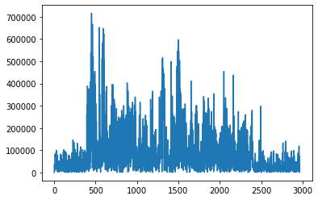

7. sr **=** int(frame_rate **/** dimension)

limit_k **=** 2

F0 **=** []

trace **=** [spector[k:k **+** sr] **for** k **in** range(len(spector))[::sr]]

**for** element **in** trace:

limit **=** element**.**mean() **\*** limit_k

**if** element**.**max() **>** limit:

F0 **+=** list(element)

**else**:

F0 **+=** list(np**.**zeros(len(element)))

plt**.**plot(F0)

plt**.**show()



8.length_f0 **=** len(F0)

**def** calculate_F(index_f):

result **=** []

index_f **+=** 1

**for** i **in** range(length_f0):

**if** index_f **\*** i **+** 1 **>=** length_f0 **or** index_f **\*** i **-** 1 **<** 0:

result**.**append([0])

**else**:

limit **=** max(F0[index_f **\*** i **-** 1], F0[index_f **\*** i], F0[index_f **\*** i **+** 1])

**if** F0[i] **>** limit_k **\*** limit:

result**.**append([limit])

**else**:

result**.**append([0])

**return** result

F **=** []

**for** i **in** range(1, 4):

F**.**append(calculate_F(i))

fig, ax **=** plt**.**subplots()

ax**.**set_title("Форманты")

**for** idx, f **in** enumerate(F):

ax**.**plot(f, label**=**f"F{idx**+**1}")

ax**.**legend()

plt**.**show()

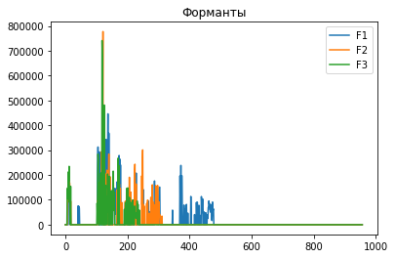

9. trace **=** [spector[k:k **+** sr] **for** k **in** range(len(spector))[::sr]]

amp **=** []

**for** i **in** trace[:**-**1]:

amp**.**append(i)

amp **=** np**.**array(amp)

**import** plotly.express **as** px

fig **=** px**.**imshow(amp)

fig**.**show()

