**Better Display of The Assignment Page in Expertiza**

**Description**

the current assignment page does not allow users to view assignment by courses, this is not convenient when a large number of assignments from different courses are presented. So we need to implement some sorting functionality so users can sort assignments by course, thus have a better and organized view of assignments.

**Functionality Analysis**

We have extended the required functionality so that use can sort assignments by different criteria; the following table shows what we have implanted.

|  |  |  |  |
| --- | --- | --- | --- |
| Sort Criteria | 2 Way Sorting? | Required | Implemented |
| Assignment Name | checkmark.png | polls_525px_X_mark_svg_1531_677876_answer_2_xlarge.png | checkmark.png |
| Course Name | checkmark.png | checkmark.png | checkmark.png |
| Topic Name | checkmark.png | polls_525px_X_mark_svg_1531_677876_answer_2_xlarge.png | checkmark.png |
| Current Stage | checkmark.png | polls_525px_X_mark_svg_1531_677876_answer_2_xlarge.png | checkmark.png |
| Stage Deadline | checkmark.png | polls_525px_X_mark_svg_1531_677876_answer_2_xlarge.png | checkmark.png |
| Publishing Rights | checkmark.png | polls_525px_X_mark_svg_1531_677876_answer_2_xlarge.png | checkmark.png |

**Result**

All the functionalities are implemented successfully, users only have to click the column name in the header of the assignment table to initiate sorting by that particular column, if he/she click the name again, the table will sort in the other direction. Some of the snapshots are presented below:

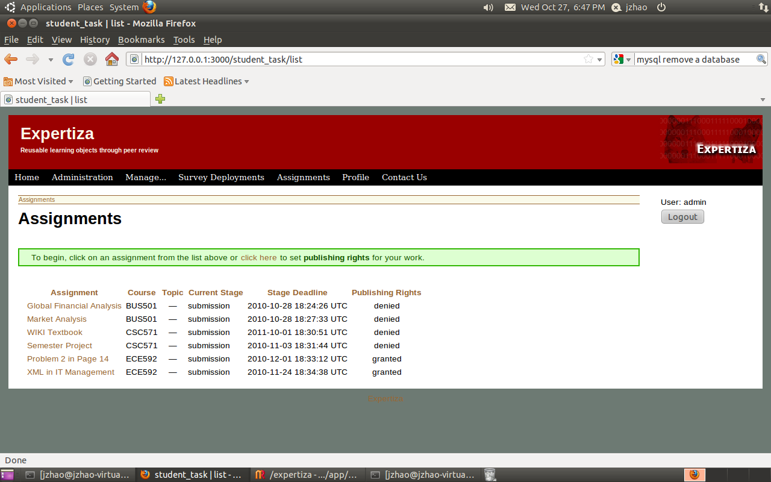

By default, assignments are sorted by the date it was created.

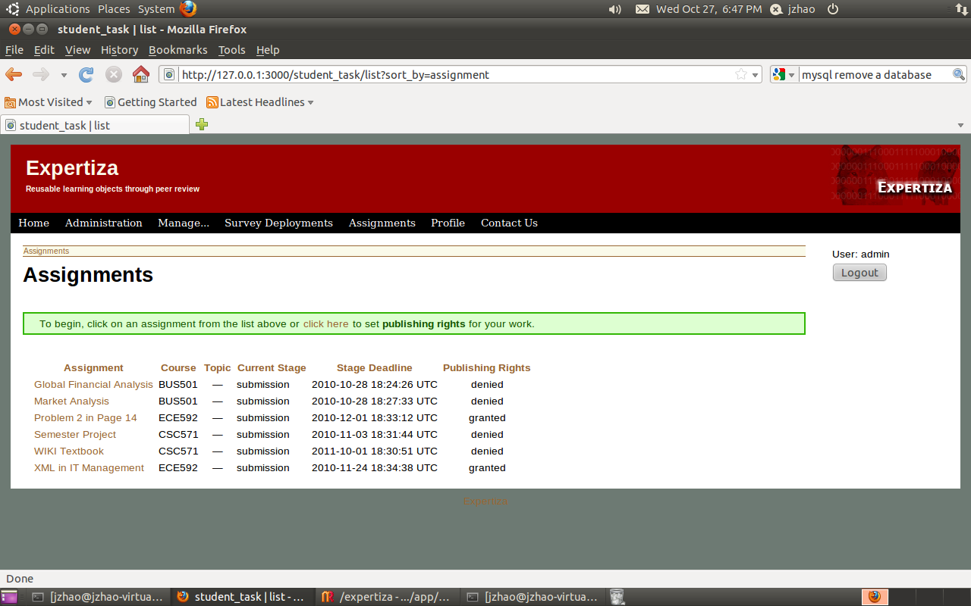

Here is what you see when you click “Assignment” in the header of the table.

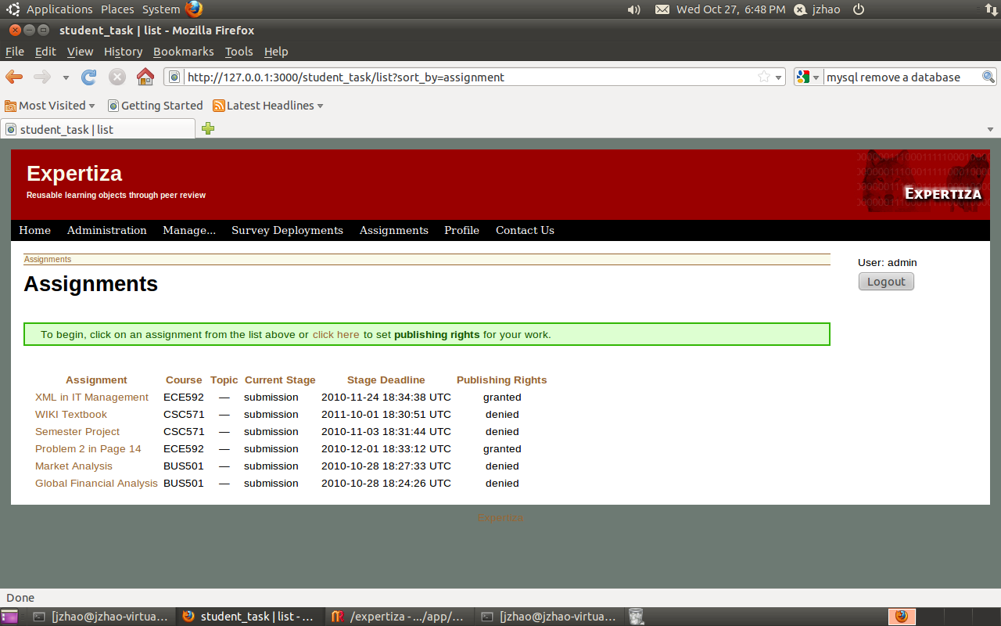

Here is what you see when you click “Assignment” in the header of the table for the second time.

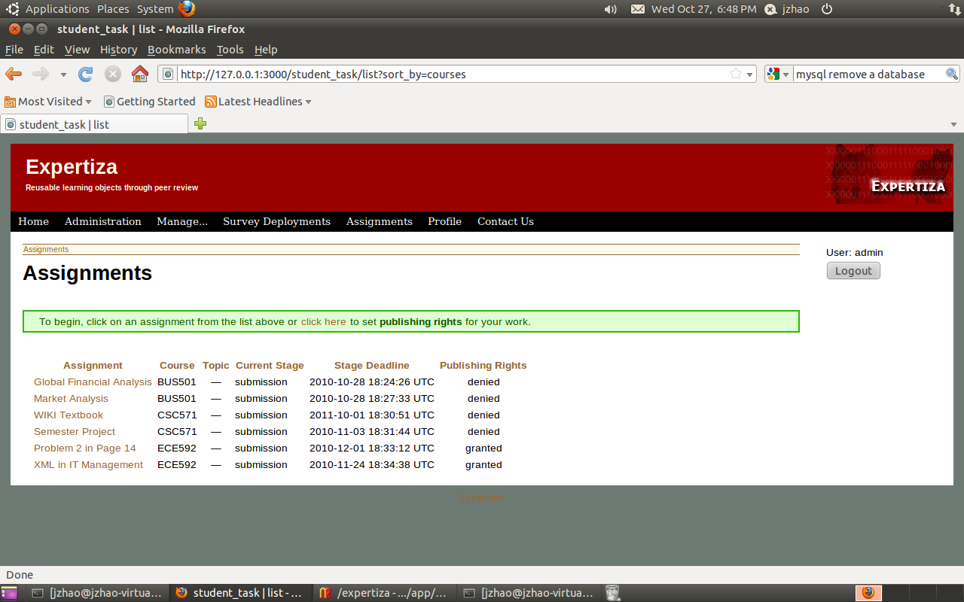

Here is what you see when you click “Course” in the header of the table.

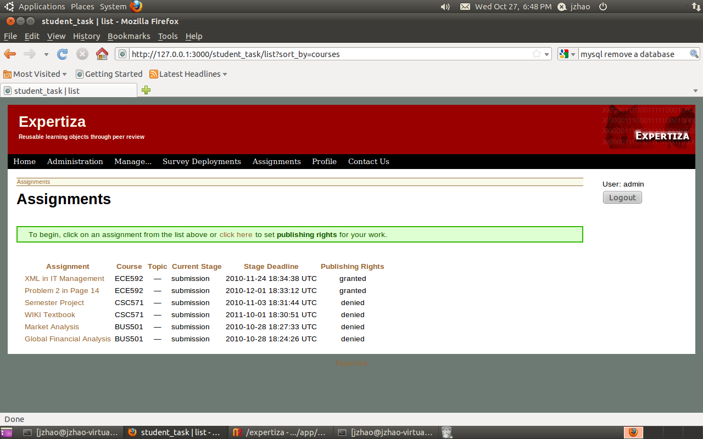

Here is what you see when you click “Course” in the header of the table for the second time.

You can also click other columns to see how the sorting works.

**Run the program**

Program runs successfully in Ubuntu (Linux) environment. Note that you may experience problems when you try to run the server in Windows due some compatibility issues in MySql gem. Here is how you can import the testing database and run the server in Ubuntu (Linux) environment.

1. Unzip the submission, extract it.
2. Open the project in IDE, run DB:migrat rake task
3. Dump our testing database to your MySql database in the local machine using:

mysqldump –u root –p pg\_development < pg\_development.sql

note that pg\_development.sql is a SQL dump file located in the folder you extracted in step 1

1. Enjoy