DEDICATION

B-TECH SWE

ACKNOWLEDGMENT
This work was been realized thanks to the assistance of some people, not citing them. Our sincere thanks go particularly to:
- Mr. CEDRIC DJAMBOU, President of IUG for the establishment of this structure for the purpose of training students.

- Mr. NSANKONG Boris, our design project lecturer who has been a source of inspiration and motivation for us. Always guiding and giving us advice on how to do things in every aspect of life.

- All our skillful lecturers for the knowledge they instilled in us.

- Our lovely families for their moral, financial and emotional support in the context of our studies and even out of studies.

- All our friend and classmates who in one way or the order contributed to the realization of this work.

ABSTRACT
The rapid advancement of information and communication technologies has significantly transformed modern recruitment processes, increasing the demand for efficient and professional resume creation tools. A resume serves as a critical document that represents an individual’s qualifications, skills, and professional experience to potential employers. However, many job seekers face challenges in creating well-structured and visually appealing resumes due to limited formatting skills, time constraints, and lack of knowledge of professional standards. This project presents the design and implementation of an automated resume generation system called ResumeFlow. The system aims to simplify the resume creation process by allowing users to input their personal, academic, and professional information into a structured platform. ResumeFlow automatically organizes and formats the provided data using predefined professional templates, thereby generating high-quality resumes in commonly accepted formats such as PDF and DOC.

RESUME
L’évolution rapide des technologies de l’information et de la communication a profondément transformé les processus de recrutement modernes, entraînant une demande accrue d’outils efficaces et professionnels pour la création de curriculum vitae. Le CV constitue un document essentiel permettant de présenter les qualifications, les compétences et l’expérience professionnelle d’un individu aux employeurs potentiels. Cependant, de nombreux chercheurs d’emploi rencontrent des difficultés dans la conception de CV bien structurés et attrayants en raison du manque de compétences en mise en forme, des contraintes de temps et d’une connaissance limitée des normes professionnelles. Ce projet présente la conception et la mise en œuvre d’un système automatisé de génération de CV dénommé ResumeFlow. Le système vise à simplifier le processus de création de CV en permettant aux utilisateurs de saisir leurs informations personnelles, académiques et professionnelles sur une plateforme structurée. ResumeFlow organise et met automatiquement en forme les données fournies à l’aide de modèles professionnels prédéfinis, générant ainsi des CV de haute qualité dans des formats largement acceptés tels que PDF et DOC.

PREFACE
Founded in 1993, the University Institute of the Gulf of Guinea is a group of three higher education institutions based on the same campus in Base-Douala. Specialized in fields as commerce and management, communication and information technologies, industry and new technologies, and paramedical training, its offer allows students to adapt their course as they evolve.
The University Institute of the Gulf of Guinea trains young professionals in the technical, medical and business environments. Since its creation in 1993, the advanced school of management has been striving to answer urgent calls of economic operators needing forepersons and management staff. With the launching of the BACHELOR OF TECHNOLOGY, the University Institute of the Gulf of Guinea is becoming the first bilingual higher institution of learning in Central Africa.
The Cameroon government has taken as duty to train and educate youths in all fields of vocational training to build up their professional skills. It is in this light the order n◦ 008/CAB/PR of 19/03/1993 brought about the creation of private state universities and higher professional institutes, among which is ISTA (Institut Supérieur des Technologies Avancées).
ISTA was created by the ministerial order n◦ 05/0038 of 15th March 2005. It had a mission to employ good lecturers who were devoted and willing to train students to obtain the Bachelor of Technology after a three-year course. Below are some of the professional training offered by the University Institute of the Gulf of Guinea;
- Computer engineering,
- Banking and Finance,
- Telecommunications,
- Accountancy,
- Transport and Logistics,
- Electrical power systems,
- Nursing,
- Midwifery,
- Mechatronics, and
- Road and civil engineering.

LIST OF TABLES
Table 1: Limitations of existing case study…………………………………………………..
Table 2: Human financial resource distribution……………………………………………..
Table 3: Human resource role explanation…………………………………………………..
Table 4: Hardware resources…………….…………………………………………………..
Table 1: Miscellaneous cost…………….…………………………………………………..

LIST OF FIGURES
Figure 1: The Agile Model……………………………………………………………………
Figure 2: …………………………………………………
Figure 3: Class Diagrams and relationships …………………………………………………
Figure 4: Sequence Diagram…………………………………………………………………
Figure 5: TailwindCss……………………………………………………………………….
Figure 6: Superbase…………………………………………………………………………
Figure 7: MySQL……………………………………………………………………………
Figure 8: React………………………………………………………………………………
Figure 9 Github………………………………………………………………………………
Figure 10: Google Chrome………………………………………………………………….
Figure 11: Login……………………………………………………………………………
Figure 12: Resume Templates………………………………………………………………
Figure 13: Resume Edit page………………………………………………………………

LIST OF ABRIVIATIONS
Ms Word: Microsoft Word
MVC Model: Model-View-Controller
ATS: Applicant Tracking System

TABLE OF CONTENT
DEDICATION 1
ACKNOWLEDGMENT 2
ABSTRACT 3
RESUME 4
PREFACE 5
LIST OF TABLES 6
LIST OF FIGURES 7
LIST OF ABRIVIATIONS 8
TABLE OF CONTENT 9
GENERAL INTRODUCTION 10
CHAPTER ONE: STATE OF THE ART OF AN AUTOMATED RESUME GENERATION SYSTEM. 12
1.1 GLOBAL CONTEXT 12
1.2 African Context 13
1.3 Cameroon Context 13
CHAPTER 2: PRELIMINARY STUDY 15
2.1 Case Study 15
CHAPTER 3: RESULTS OBTAINED 29
TOOLS ANS TECHNOLOGIES USED 29
RESULTS OBTAINED 32
GENERAL CONCLUSION 34
REFERENCES 37

GENERAL INTRODUCTION
In today’s highly competitive job market, a well-structured and professionally designed resume plays a crucial role in determining an individual’s chances of securing s chances of securing employment opportunities.
A resume serves as the first point of contact between a job seeker and a potential employer, summarizing the applicant’s qualifications, skills, experience and career objectives. How ever, despite its importance many people face significant challenges in creating effective resume due to limited formatting skills, lack of design knowledge, time constraints, and uncertainty about industry standard.
As a result, poorly structured resumes often fail to communicate the true potential of candidates, thereby reducing their employability.

With the rapid advancement of information technology and increasing adoption of digital solutions across various sectors, automation has become a key driver of efficiency an productivity.
Automated systems are now widely used to simplify complex tasks, reduce human error, and improve overall performance. In this context comes in our topic titled “IMPLEMENTATION OF AN AUTOMATED RESUME GENERATION SYSTEM”. The creation of automated resume has emerged as a practical and necessary solution to address the limitations of traditional manual resume writing processes. An Automated resume generation system leverages technology to streamline the creation of professional resumes by guiding through structured data entry, applying standardized templates and generating output documents in an accepted professional format.

The AUTOMATED RESUME GENERATION SYSTEM, (ResumeFlow) is designed to provide an intelligent and user-friendly platform that enables users to generate high-quality resume with minimal effort. ResumeFlow allows users to input professional information, educational background, work experience, skills, certifications, and languages into a structured system. Once the required data is provided, the system automatically organizes the information, applies appropriate formatting rules, and produces a professional resume based on predefined templates. This process ensures consistency, accuracy and compliance with modern resume standards while significantly reducing the time used to create a resume.

ResumeFlow addresses the growing demand for accessible and efficient resume-building tools, particularly for students, fresh graduates, and professionals who may not possess advanced document design skills. By eliminating the need for manual formatting and repeated editing. The system enhance user productivity and minimize errors such misalignment, inconsistent fonts, and poorly structured sections. Furthermore, the automated nature of ResumeFlow allows users to easily update their resumes, customize them, and export them in commonly used formats such as PDF.

From a technological perspective, the implementation of ResumeFlow integrates key software engineering concepts, including user authentication, data validation, templates management and document generation. The system follows a structural architectural approach, typically based on a client-server or Model-View-Controller (MVC) architecture, ensuring scalability, maintainability and security. By combining front-end user interface with back-end processing and database management, ResumeFlow demonstrate the practical application of automation solving real-world problems.

Thus, the implementation of an automated resume generation system such as ResumeFlow represents a significant step towards modernizing the job application process. It does not only provide the quality and professionalism of resumes but also enhance accessibility and efficiency for the users from different backgrounds.
As technology continues to advance, systems like ResumeFlow can also evolve with advanced features such as AI, Job Specific Optimization, Applicant Tracking System (ATS) compatibility. Making it essential tool in today’s digital employment ecosystem.

CHAPTER ONE: STATE OF THE ART OF AN AUTOMATED RESUME GENERATION SYSTEM.
The rapid evolution of information and communication has significantly transformed the way individuals interact with employment system worldwide.
One of the most critical elements in the recruitment process is the resume, which serves as a formal document that presents an individual’s qualifications, skills, professional experience, and career objectives to potential employers. Over time, resume creation has evolved from handwritten documents to typewritten formats, and eventually to digitally formatted resumes created using word processors and online platforms.

Despite these advancements, many individuals still encounter difficulties in producing professional and well-structured resumes. These challenges include limited formatting skills, lack of awareness of modern resume standards, time constraints and difficulty adapting resumes to different job roles. To address these issues, automated resume generation system have emerged as innovative solutions that simplify the resume creation process by using structured data input, predefined templates and automated document formatting.

This chapter presents the state of the art of automated resume generation system by examining their development and adoption within the global context, African context and Cameroonian context. The aim is to highlight existing practices, identify challenges and demonstrate the need for a system such as ResumeFlow.

1.1 GLOBAL CONTEXT
At the global level, the employment sector has increasingly embraced digitalization particularly in the developed economies where online recruitment platform and automated tools have become standard practice. Employers now rely heavily on digital resumes submitted through online job portals, corporate websites and professional networking platforms. As a result, the demand for well-structured, machine-readable, and professional Formatted resumes has grown significantly.
Automated resume generation system has gained widespread popularity in regions such as North America, Europe, and in some parts of Assia.
Platforms like LinkedIn, Indeed, Europass, Canvas, Resume Builder and other specialized resume tools provide user with guided resume creation process. These systems allow user to enter their information into structured forms, select from multiple templates, and generate resumes that complies with the international recruitment standards. Many of these platforms also integrate applicant tracking systems (ATS), enabling employers to efficiently scan and filter resumes based on Keywords, Skills, and Experience

1.2 African Context
In the African context, the adoption of automated resume generation systems is gradually increasing, driven by growing internet penetration, mobile technology usage and digital literacy. Across many African countries, most young graduates and job seekers are increasingly using online platform to search for employment opportunities both locally and internationally. However, the level of access to advanced resume-building tools remains uneven across the continent.
Many African job seekers still rely on manual methods such as Ms Word or handwritten templates to create resumes. This often results to poorly formatted document that does not match international standard, thereby reducing the competitiveness of African candidates in the global job market. Furthermore, limited exposure lack of career guidance service contribute to inconsistencies in resume quality.

1.3 Cameroon Context
In Cameroon, the challenges associated with resume creation are particularly pronounced among students, recent graduates, and job seekers entering the labor market. While higher education institutions emphasize academic knowledge, limited attention is often given to practical career preparation skills such as professional resume writing. As a result, many graduates struggle to present their qualifications effectively to employers.

The Cameroonian job market is increasingly competitive, with employers receiving a large volume of applications for limited job opportunities. In this environment, resumes that are poorly structured, inconsistently formatted, or lacking clarity are often disregarded. Many job seekers still rely on manually created resumes using basic word processing tools, leading to frequent errors in formatting, grammar, and content organization.

Although internet access and smartphone usage are steadily increasing in Cameroon, the use of automated resume generation systems remains limited. This can be attributed to factors such as lack of awareness, limited access to paid platforms, and the absence of locally adapted digital career tools. Furthermore, some international In Cameroon, the challenges associated with resume creation are particularly pronounced among students, recent graduates, and job seekers entering the labor market. While higher education institutions emphasize academic knowledge, limited attention is often given to practical career preparation skills such as professional resume writing. As a result, many graduates struggle to present their qualifications effectively to employers.

CHAPTER 2: PRELIMINARY STUDY
This chapter presents the preliminary study conducted prior to the design and implementation of the automated resume generation system known as ResumeFlow. The purpose of this chapter is to analyze existing systems related to resume creation, identify their strength and weaknesses, and justify the need for new automated solutions. The chapter also outlines the proposed solutions, justifies the choice of technology and methodologies also present the software process model, including system architecture and design considerations. Finally resources estimation required for the successful development of the system are discussed.

2.1 Case Study
The existing case study fucoses on traditional and online resume creation system currently used by job seekers. These systems can be broadly classified into
- Manual Resume Creation
- Use of word processors such as Ms Word
- Handwritten or typed resume
- Repeated manual formatting

- Online Resume Builders
- Platform such as Canva, LinkedIn Resume Builder, Europass
- Mostly template-based
- Often requires paid subscription for advanced features
In the current system, users are required to manually enter and format resume content, choose fonts, align sections, and ensure consistency throughout the document. This process demands a certain level of technical and design knowledge which many users lack. As a result, resumes produced through these methods often suffer from formatting errors, inconsistence layouts, and lack of professionalism
In such systems common workflow include
- User opens a word processor or online platform
- User manually personal and professional information
- User selects or creates a layout
- User manually adjust formatting
- User Saves or exports the resume

2.2 Criticism or Limitations of Existing Case Study
Despite the availability of various resume creation tools, several limitations persist. These limitations negatively affect the quality of resume and the user experience.

Here are some common limitations
Issue | Description | Impact
Manual formatting | Users must format resumes themselves | Poor layout and unprofessional appearance
Time consumption | Resume creation requires extensive time | Reduce productivity
Lack of standardization | No uniform resume structure | Inconsistent resumes
Limited customization | Templates are rigid or locked | Users cannot tailor resumes
Cost of premium Tools | Advanced features are paid | Limited accessibility
No Error validation | No structured data checking | Frequent grammatical and data errors
Poor local Adaption | Tools not adapted to local context | Reduced relevance for African users
Table 1: limitations of case study

2.3 Proposed Solutions
To address the limitations identified in the existing systems, the following solutions are proposed through the implementation of ResumeFlow.

2.3.1 Automation of Resume Creation
ResumeFlow will automate the entire resume creation process by allowing users to input structured data into predefined fields. The system will automatically organize and format the information into a professional resume.

Notes:
• Eliminates manual formatting
• Ensures consistency
• Saves time
• Reduces human errors

2.3.2 Use of Professional Resume Templates

The system will provide multiple professionally designed templates that comply with modern recruitment standards.

Notes:
• Improves resume appearance
• Suitable for different job roles
• Enhances professionalism

2.3.3 Data Validation and Error Reduction

ResumeFlow will validate user input to ensure correctness and completeness.

Notes:
• Prevents missing information
• Reduces grammatical and formatting errors
• Improves data accuracy

2.3.4 Easy Customization and Updates

Users will be able to edit, update, and customize their resumes easily without starting from scratch.

Notes:
• Supports multiple resume versions
• Allows job-specific customization
• Enhances flexibility

2.3.5 Export in Multiple Formats

The system will support resume export in PDF and DOC formats.

Notes:
• Compatible with employer requirements
• Easy sharing and printing

2.4 JUSTIFICATION OF TOPIC
The choice of developing ResumeFlow is justified based on the following reasons:
• Addresses real-world problems faced by job seekers
• Automates a repetitive and error-prone task
• Improves resume quality and consistency
• Enhances employability
• Suitable for students, graduates, and professionals
• Adaptable to the Cameroonian and African context
• Cost-effective compared to existing premium platforms

ResumeFlow provides a balanced solution that combines simplicity, accessibility, and professionalism.

2.5 Software Process Model
2.5.1 Agile Methodology
The Agile methodology is chosen for the development of ResumeFlow due to its flexibility and iterative nature.

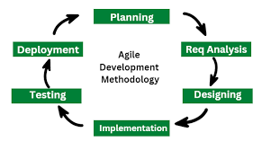
Fig 1: Agile Model

Characteristics:
• Incremental development
• Continuous feedback
• Frequent testing
• User-centered design

Notes:
• Allows easy modification of features
• Reduces project risks
• Ensures user satisfaction

2.5.2 MVC(Model-View-Controller) Architecture
The system will be implemented using the MVC architectural pattern.

Model
• Handles data logic
• Manages resume information
• Interacts with the database

View
• User interface
• Displays forms, templates, and previews

Controller
• Handles user requests
• Coordinates between Model and View

Notes:
• Improves code organization
• Enhances maintainability
• Supports scalability ``

2.5.3 SYSTEM DESIGN (UML Diagram)
The system design includes the following UML diagrams:

- Use Case Diagram:
Shows interactions between users and the system

Class Diagram:
Represents system classes and relationships
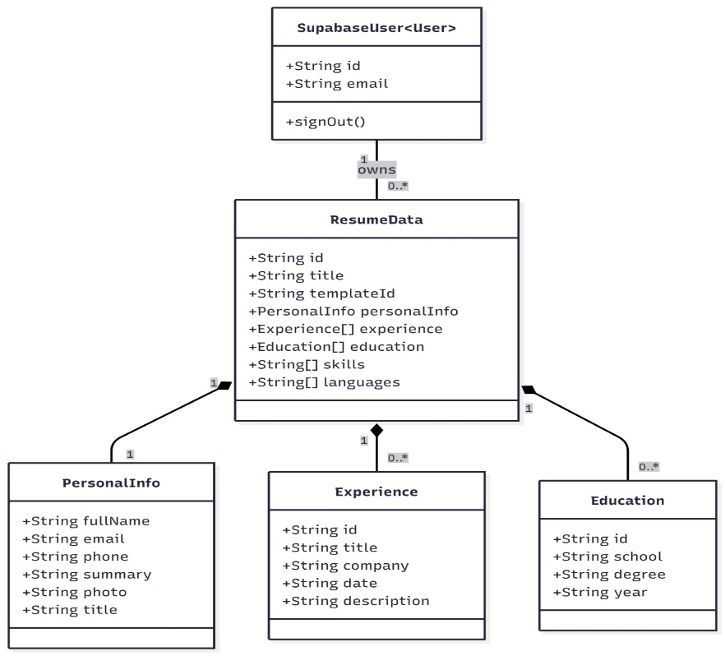
Fig 3: Class Diagrams and relationships

Sequence Diagram:
Illustrates system workflow

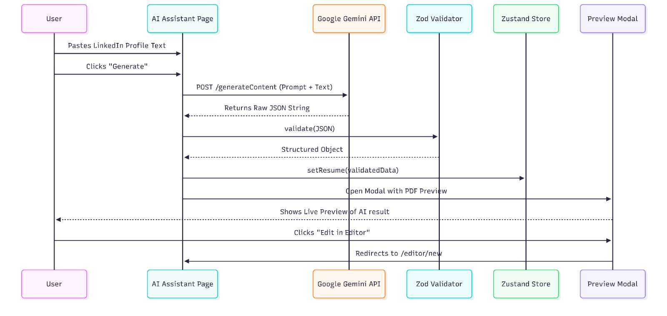
Fig 4: Sequence Diagram

Notes:
• Helps visualize system structure
• Improves understanding
• Guides implementation

2.5.2 SYSTEM TESTING
System testing is a critical phase in the development of the automated resume generation system, ResumeFlow. The main objective of testing is to ensure that the system functions correctly, efficiently, and according to the specified requirements. Testing helps identify errors, verify system behavior, and validate that the final product meets user expectations. Through systematic testing, potential defects are detected early, reducing system failure and improving reliability.

In ResumeFlow, testing was carried out at different levels to validate both functional and non-functional requirements. Each test was designed to ensure accuracy, performance, usability, and security of the system.

2.0 Objectives of Testing

The objectives of testing ResumeFlow include:
• To verify that all system functionalities work as intended
• To detect and correct errors and bugs
• To ensure data accuracy and consistency
• To validate system performance and reliability
• To confirm user interface usability
• To ensure system security and data protection
• To validate compliance with system requirements

Notes:
• Testing reduces deployment risks
• Improves system quality
• Ensures user satisfaction
• Prevents system failure after deployment

3.0 Testing Strategy

A structured testing strategy was adopted to evaluate the ResumeFlow system. The strategy involved testing individual components, integrated modules, and the complete system under different conditions.

Notes:
• Testing was conducted both manually and logically
• Each module was tested independently before integration
• Errors were documented and corrected
• Retesting was performed after bug fixes

4.0 Types of Testing

4.1 Unit Testing

Unit testing focuses on testing individual modules or components of the system separately.

Components Tested:
• User registration module
• Login authentication module
• Resume data input module
• Template selection module
• Resume generation module

Notes:
• Ensures each module works correctly
• Errors are easier to identify
• Prevents defect propagation
• Improves code quality

2.6 Resource Estimation
a) Human resources
Table 2: Human financial resource
Designation | Price per Month (Francs CFA) | Total Price for two (02) months (Francs CFA)
Project Manager | 300000 | 600000
System Analyst | 120000 | 240000
UI/UX Designer | 100000 | 200000
Backend Developer | 200000 | 400000
Frontend Developer | 170000 | 340000
Tester | 130000 | 260000
Deployment Engineer | 100000 | 200000

Role | Responsibility
System Analyst | Requirement analysis
Developer(Front- End/ Back-End) | System implementation
Tester | Testing and Validation
Project Manager | Project Monitoring
UI/UX Designer | Designs what the user sees
Deployment Engineering | Responsible for the deployment
Table 3: Human resource role explanation

TOTAL HUMAN COST= 2,240,4000 Franc CFA
Return on Investment: Implementing subscription on Advanced features of the system
b) Software Cost
- React: Free
- VS Code: Free
- MySQL: Free
- Supabase: Free
- Github: Free

c) Hardware resource
Designation | Prices (Francs CFA)
Modem + internet | 40000
Total | 40000
Table 4: Hardware Resources

TOTAL Hardware Cost:40000 Francs CFA

d) Miscellaneous cost
Item | Estimated Cost
Transport(meetings) | 30000
Training end users | 50000

TOTAL Miscellaneous cost= 80000 Francs CFA

TOTAL PROJECT COST= 2,314,000 Franc CFA

CHAPTER 3: RESULTS OBTAINED
This chapter presents the results obtained from the design and implementation of the automated resume generation system, ResumeFlow. It highlights the tools and technologies used in the development process and explains how these tools contributed to the successful realization of the system. The chapter also discusses the effectiveness of the implemented solution in addressing the problems identified during the preliminary study. The results obtained demonstrate that ResumeFlow meets its functional and non-functional requirements by providing an efficient, user-friendly, and automated resume creation platform

TOOLS ANS TECHNOLOGIES USED
This chapter presents the results obtained from the design and implementation of the automated resume generation system, ResumeFlow. It highlights the tools and technologies used in the development process and explains how these tools contributed to the successful realization of the system. The chapter also discusses the effectiveness of the implemented solution in addressing the problems identified during the preliminary study. The results obtained demonstrate that ResumeFlow meets its functional and non-functional requirements by providing an efficient, user-friendly, and automated resume creation platform
- Programming Languages:
- React (JavaScript Framework):
React was used as the main front-end programming framework for developing the ResumeFlow user interface. React enables the creation of dynamic, responsive, and interactive user interfaces through reusable components.

- Tailwind CSS:
Tailwind CSS was used as the main design and styling framework for ResumeFlow.
- MySQL:
MySQL was used as the primary relational database management system for storing user data and resume information.
- Supabase:
Supabase was used to handle backend services such as authentication, API access, and real-time database interaction.
- GitHub:
GitHub was used for version control and collaboration.

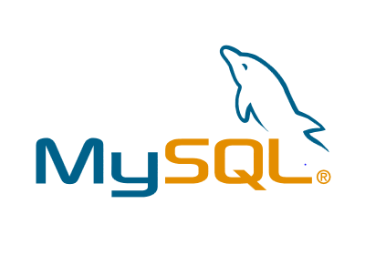
Fig 5: TailwindCss Fig 6: Supabese Fig 7: MySQL


Fig 8: React Fig 9: Github

- Web Browser
- Google Chrome:
Google Chrome was used for the testing and running the ResumeFlow


Fig 10: Google Chrome

RESULTS OBTAINED
This were the results we obtained:


Fig 11: Login

Here is the login pages where users can access the application in order to generate their resumes

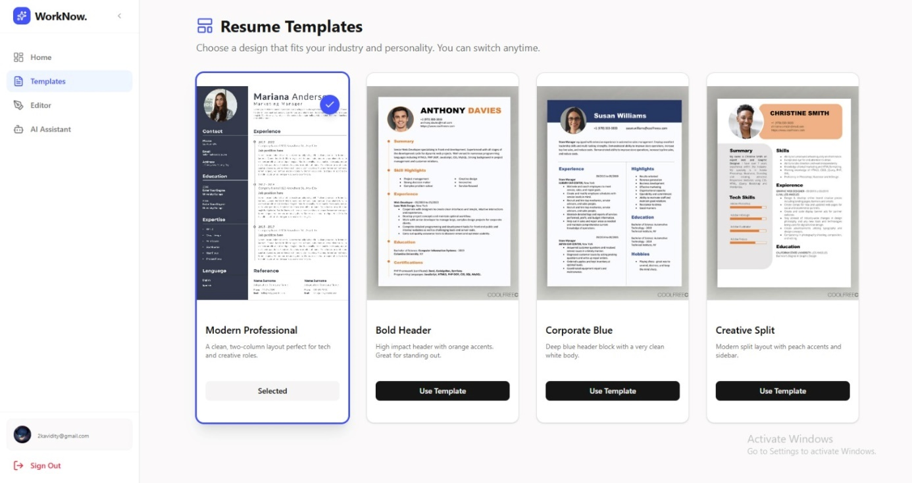
Fig 12: Resumes Templates page

These is the page where users chooses the templates which sweets them
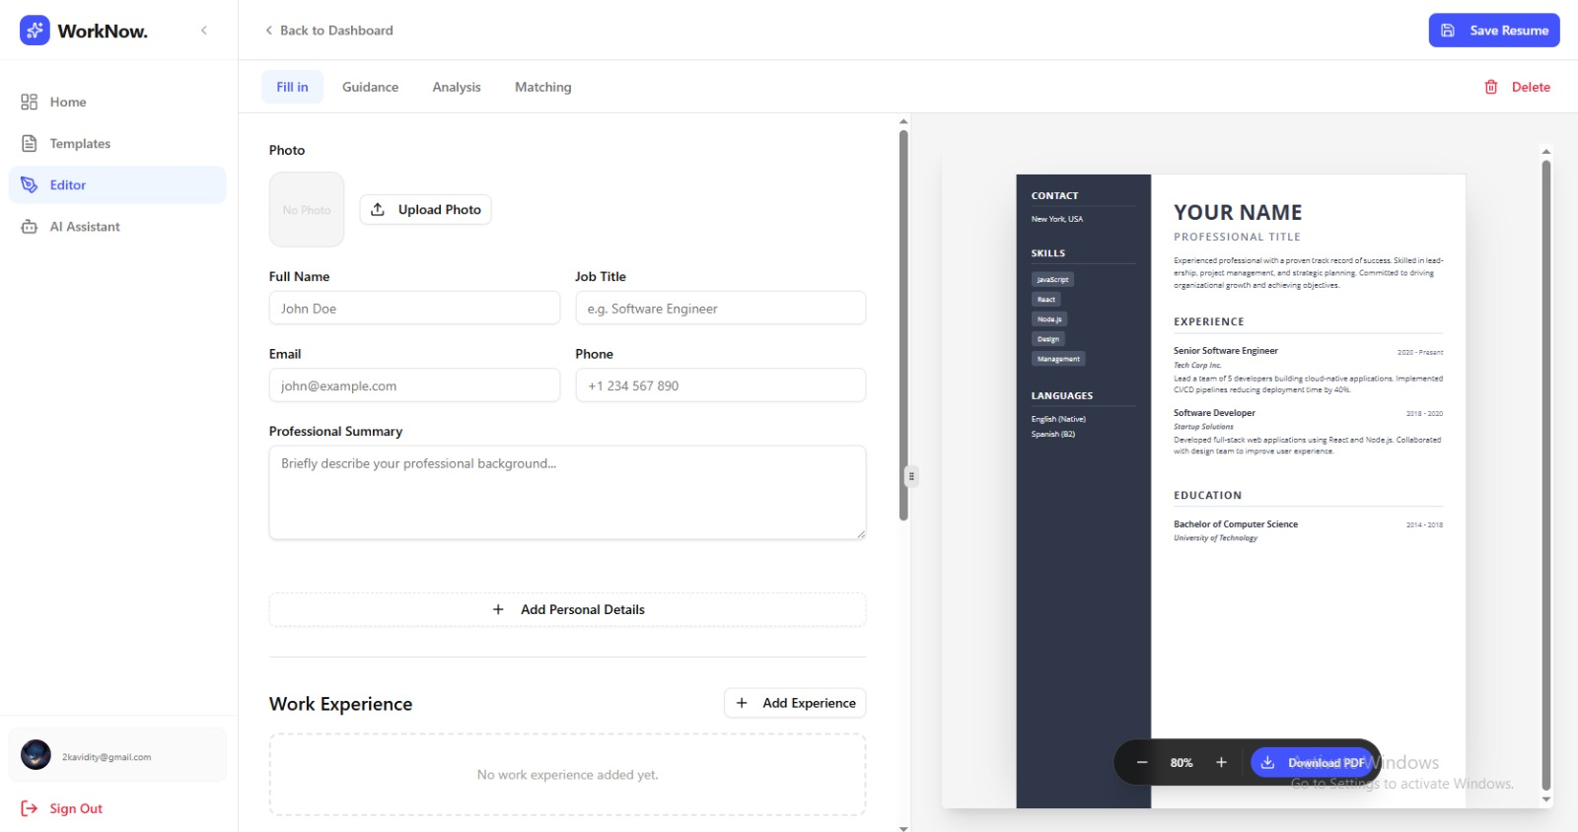
Fig 13: Resume Edit page

This is the page where the cv is been edited

GENERAL CONCLUSION
This project focused on the design and implementation of an automated resume generation system known as ResumeFlow, developed to address the challenges associated with traditional resume creation methods. In an increasingly competitive and digitally driven job market, the resume remains a critical document that influences recruitment decisions. However, many job seekers struggle to produce professional, well-structured, and consistent resumes due to limited technical skills, lack of formatting knowledge, and time constraints. The primary objective of this project was therefore to provide an efficient, accessible, and automated solution that simplifies the resume creation process while improving the quality of the final output.

Throughout the course of this project, a comprehensive analysis of existing resume creation systems was conducted. This analysis highlighted significant limitations such as excessive manual formatting, lack of standardization, high dependency on paid platforms, and poor adaptability to local contexts, particularly within African and Cameroonian environments. These limitations justified the need for a locally adaptable, user-friendly, and cost-effective automated resume generation system. ResumeFlow was conceptualized and developed to fill this gap by providing a structured platform that guides users through resume creation while ensuring professional formatting and consistency.

The development of ResumeFlow followed established software engineering principles and methodologies. The Agile development approach was adopted to allow flexibility, continuous improvement, and user-centered design throughout the project lifecycle. This methodology enabled iterative development, frequent testing, and early identification of system issues. In addition, the Model–View–Controller (MVC) architectural pattern was employed to ensure a clear separation of concerns, improved maintainability, and scalability of the system. These design choices contributed significantly to the stability and robustness of the final system.

The implementation phase demonstrated the effective integration of modern web technologies and development tools. React was used to build a responsive and interactive user interface, while Tailwind CSS facilitated the creation of a clean, consistent, and modern design. Supabase and MySQL were utilized to manage backend services, authentication, and structured data storage, ensuring data integrity and security. GitHub supported version control and collaborative development, and Visual Studio Code served as the primary development environment. The use of Google Chrome for testing and debugging ensured compatibility with modern web standards. Collectively, these technologies contributed to the successful realization of the ResumeFlow system.

Extensive testing was carried out to evaluate the functionality, performance, usability, and security of the system. Unit testing, integration testing, system testing, and user acceptance testing confirmed that ResumeFlow met its functional and non-functional requirements. The testing process helped identify and resolve minor issues, improved system reliability, and ensured a smooth user experience. The results obtained from testing demonstrated that ResumeFlow effectively automates resume creation, reduces errors, saves time, and enhances the overall quality of generated resumes.

Despite the success achieved, the system has certain limitations. The current version of ResumeFlow offers a limited number of resume templates and does not yet incorporate advanced features such as artificial intelligence-based recommendations or applicant tracking system (ATS) optimization. Additionally, the system relies on internet connectivity, which may limit accessibility in low-connectivity environments. However, these limitations do not undermine the overall effectiveness of the system; rather, they present opportunities for future improvement and expansion.

In conclusion, the implementation of ResumeFlow has demonstrated that automation can significantly improve the resume creation process by enhancing efficiency, consistency, and accessibility. The system provides a practical and reliable solution for students, graduates, and professionals seeking to create high-quality resumes without requiring advanced technical or design skills. By addressing both global and local employment challenges, ResumeFlow contributes meaningfully to digital career development and employability. Future enhancements, including artificial intelligence integration, multilingual support, and job-specific customization, could further strengthen the system’s impact and relevance. Overall, this project successfully achieved its objectives and provides a solid foundation for further research and development in automated career support systems.

REFERENCES
- Tailwind Labs(2023), Tailwind CSS Official Documentation
- Supabese Inc(2023), Superbase Official Documentation
- Github Inc, Github official Documentation

