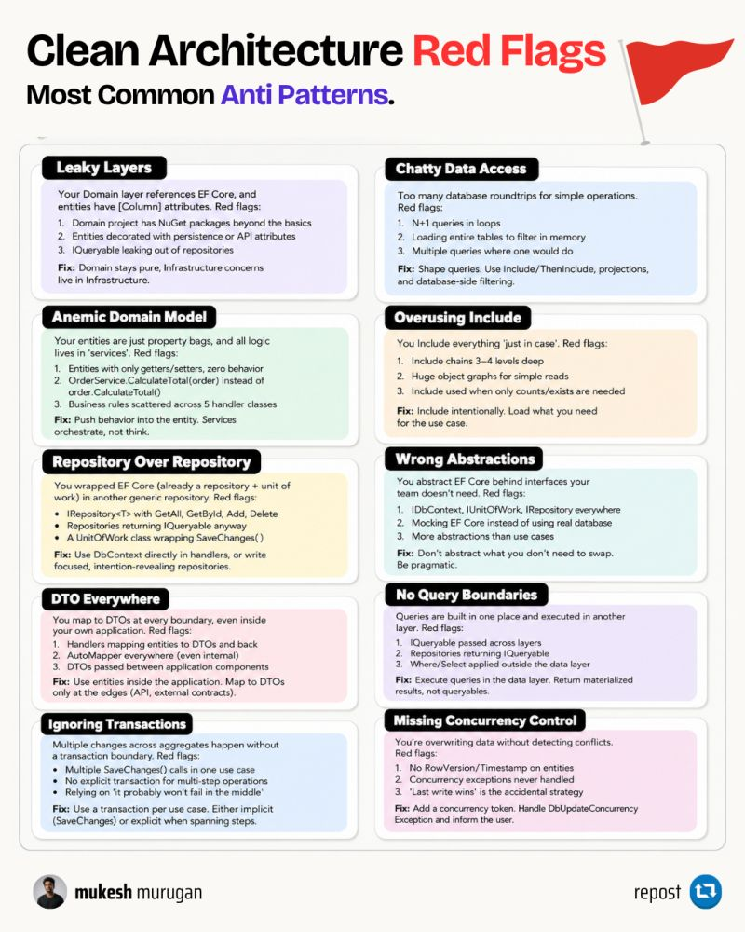

I’ve been learning more about system design lately, and one thing is starting to make a lot more sense:
Good system design isn’t about adding more components. It’s knowing when you actually need them.
If an API + PostgreSQL can handle your traffic, that’s not a “basic” architecture. That’s probably the right architecture.
-Redis should come when caching solves a real bottleneck.
-Queues when work needs to happen asynchronously.
-Read replicas when reads actually become a problem.
Because every new box in your architecture diagram also introduces a new failure mode.
Redis brings cache invalidation. Queues bring retries and duplicate processing. Replicas bring replication lag. Microservices bring network complexity.
So instead of asking:
“What should I add to make this scalable?”
I’m starting to think the better question is:
“What’s actually breaking right now?”
Start simple. Measure. Find the bottleneck. Fix it. Repeat.
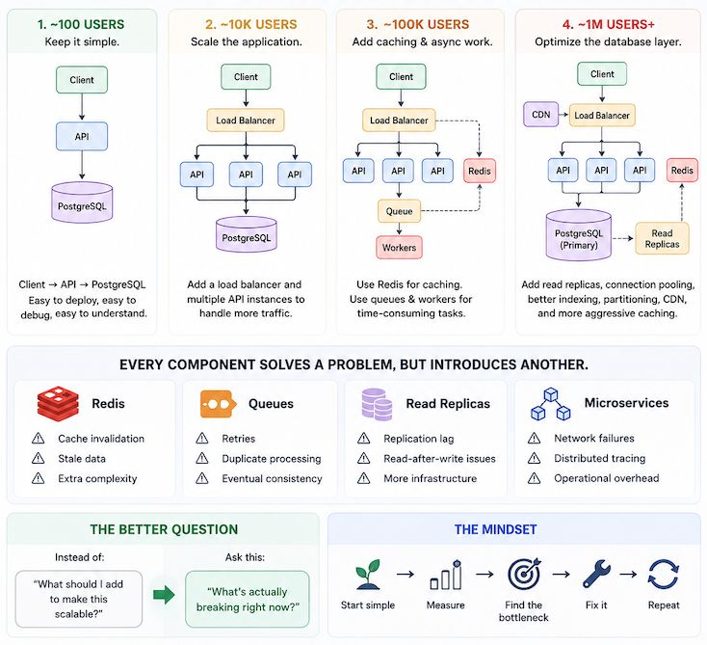
One of the most common misconceptions I still see in .NET discussions is:
❌ IEnumerable<T> = Client-side
❌ IQueryable<T> = Database-side
While this explanation is convenient, it often hides the real issue.
Consider the following code:
var users = repository.GetUsers()
.Where(u => u.IsActive)
.ToList();
The important question is not:
"Am I using IEnumerable or IQueryable?"
The important question is:
👉 When is the query actually executed?
If GetUsers() returns an IQueryable<T>, the Where clause can be translated into SQL and executed by the database.
If it returns an IEnumerable<T>, the data may have already been loaded into memory, meaning the filtering happens within the application.
The code looks almost identical.
The performance characteristics can be completely different.
This is why, during code reviews, I pay less attention to the LINQ operators themselves and more attention to where the query stops being an expression and becomes a materialized result.
Many performance issues in .NET applications start exactly at that boundary.
What is the most expensive LINQ-related mistake you've found in production?

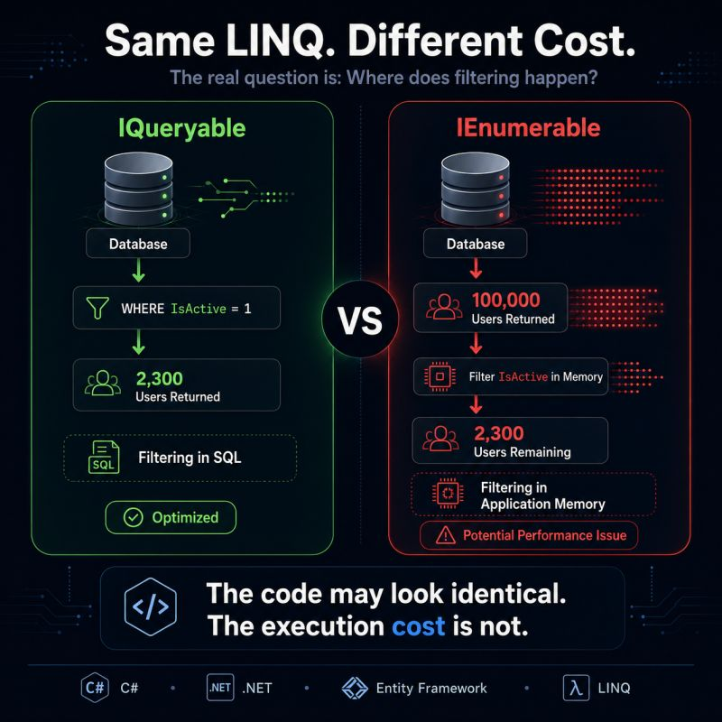

My API handled 10,000 requests flawlessly in testing.
Crashed in production within 2 hours.
The problem? I used the wrong API type.
APIs aren't one-size-fits-all. Different problems need different types.
OPEN API
- Public access for anyone.
- Use for: Weather data, login systems, product catalogs
- Example: Stripe payments, Google Maps
REST API
- HTTP-based, simple, universal.
- Use for: 90% of modern web apps
-Example: Mobile app fetching user data
SOAP API
- XML-based, strict, formal.
Use for: Banks, insurance, government
Example: Processing insurance claims, wire transfers
GraphQL API
Query exactly what you need.
Use for: Complex data with many relationships
- Example: Facebook feed (only fetch what's needed)
BACKEND TO BACKEND
Internal microservices talking.
- Use for: Your own system architecture
- Example: Auth service → User service → Payment service
FRONTEND TO BACKEND
- Your Ul requesting server data.
Use for: Every web/mobile app interaction
- Example: Login, search, profile updates
SERVICE TO DATABASE
- Backend querying databases.
- Use for: All data operations
- Example: Storing users, fetching orders B2B INTEGRATION
PARTNER API
- Controlled access for trusted partners.
Use for: Affiliate programs, reseller systems
- Example: Amazon affiliate tracking
DATA SHARING API
- Secure exchange of sensitive data. - Use for: Health records, financial data - Example: Hospital systems sharing patient info
The pattern:
X Use REST for everything
✓ Match API type to problem
My decision framework: Public access? → Open API or REST Complex queries? → GraphQL Enterprise/legacy? → SOAP Internal services? → Backend to Backend Business partners? → Partner API Sensitive data? → Data Sharing API
Which API type saves you the most time?
Repost if this clears up API confusion
- Follow Aryan Gupta for more resources


Redis is much more than a cache.
It is one of those technologies that quietly sits behind some of the fastest, most responsive applications we use every day.
And once you understand its core patterns, Redis becomes useful far beyond simple key-value storage.
Here are 8 practical Redis use cases every developer should know:
→ Caching
Store frequently requested data in memory to reduce database calls and improve response times.
→ Session Store
Keep user sessions centralized so multiple application instances can access the same state.
→ Rate Limiting
Track requests per user, API key, or IP and enforce limits in real time.
→ Leaderboards
Use Sorted Sets to continuously rank players, users, or scores efficiently.
→ Vector Search & Semantic Caching
Retrieve semantically similar content and reuse responses for related AI queries.
→ Queues & Streams
Connect producers and workers for asynchronous jobs and event-driven processing.
→ Pub/Sub
Publish messages to channels and instantly distribute them to active subscribers.
→ Distributed Locks
Coordinate multiple services competing for the same shared resource.
The bigger lesson?
Redis is not just about making applications faster.
It can become a core building block for real-time systems, distributed architectures, event-driven applications, and AI workloads.
Understanding these patterns makes it much easier to recognize where Redis fits when designing scalable systems.


IRepository<T> wrapped around every DbSet.
That's a repository wrapping a repository.
EF Core's DbContext is already the Unit of Work. DbSet<T> is already repository-style set access. Change tracking, SaveChanges, composable LINQ. All built in, with no extra layer required.
Adding IRepository<T> on top adds a layer of cost.
𝗪𝗵𝘆 𝘁𝗲𝗮𝗺𝘀 𝗱𝗼 𝗶𝘁 𝗮𝗻𝘆𝘄𝗮𝘆
The justifications all sound reasonable:
→ Keep data access abstract
→ Swap databases later
→ Make testing easier
→ Standardize CRUD
Each one falls apart in real projects.
𝗪𝗵𝗮𝘁 𝘆𝗼𝘂 𝗮𝗰𝘁𝘂𝗮𝗹𝗹𝘆 𝗹𝗼𝘀𝗲
EF Core gives you composable LINQ, Include, projection, AsNoTracking, ExecuteUpdate, batching, provider-aware SQL translation, and full tracking control.
One composable Where + Select chain, and EF Core translates it to a single SQL query.
A generic IRepository<T> collapses all of that to Add, Update, Delete, GetById, GetAll. Every query that doesn't fit those 5 methods gets a new method on the interface.
𝗧𝗵𝗲 𝗚𝗲𝘁𝗕𝘆𝗫 𝗽𝗿𝗼𝗯𝗹𝗲𝗺
You start with GetById and GetAll. A week later someone needs GetByStatus. Then GetByDateRange. Then GetByCustomer. Then GetPagedByStatus, GetActiveByType, GetTopSpenders, GetOrdersByMonth, GetByCreatedAfter.
The interface grows with every new query requirement. Or you return IQueryable<T> to stay flexible, and you've leaked EF Core through the abstraction you built to hide it.
Neither is a good outcome.
𝗧𝗵𝗲 𝗱𝗮𝘁𝗮𝗯𝗮𝘀𝗲 𝘀𝘄𝗮𝗽 𝗮𝗿𝗴𝘂𝗺𝗲𝗻𝘁
❌ If you actually swap SQL Server for Postgres, your queries, migrations, and performance assumptions all change. The repository layer doesn't absorb that cost. You rewrite the data layer either way.
You don't swap production databases in a weekend.
𝗧𝗲𝘀𝘁𝗶𝗻𝗴 𝗴𝗲𝘁𝘀 𝗵𝗮𝗿𝗱𝗲𝗿
Hand-rolled IRepository<T> mocks test fake behavior. They miss query translation issues, performance problems, and concurrency edge cases. Tests pass confidently against logic that breaks on a real database.
Integration tests with real Postgres or an EF Core test DB catch what actually matters. They're more honest and cheaper to maintain.
𝗘𝘅𝘁𝗿𝗮 𝗶𝗻𝗱𝗶𝗿𝗲𝗰𝘁𝗶𝗼𝗻
With a generic repository: API → Service → Repository → EF Core → DB.
❌ Slower onboarding: new devs learn the interface before they see a query.
❌ Harder to debug: stack traces are longer, the SQL is further from view.
❌ Harder to use EF Core well: features like ExecuteUpdate, raw SQL, or split queries require workarounds or leaking DbContext anyway.
Without it: API → Service → DbContext → DB. One fewer layer. Full EF Core where you need it.
𝗪𝗵𝗲𝗻 𝗶𝘁 𝗱𝗼𝗲𝘀 𝗺𝗮𝗸𝗲 𝘀𝗲𝗻𝘀𝗲
A focused query class per aggregate is fine. If a complex LINQ expression runs in 5 places, give it a name.
A generic IRepository<T> applied to every entity by default is the trap.
Use DbContext directly. Add a query class when a query gets complex enough to name.

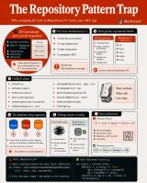
I've interviewed 50+ .NET engineers for microservices roles.
Less than 10 could explain the Saga pattern without googling it.
If you don't know these 7 things, you're not doing microservices — you're running a 𝘥𝘪𝘴𝘵𝘳𝘪𝘣𝘶𝘵𝘦𝘥 𝘮𝘰𝘯𝘰𝘭𝘪𝘵𝘩 𝘸𝘪𝘵𝘩 𝘦𝘹𝘵𝘳𝘢 𝘴𝘵𝘦𝘱𝘴.
𝟭. 𝗦𝗮𝗴𝗮 𝗣𝗮𝘁𝘁𝗲𝗿𝗻
No distributed transactions across services. Order + Payment + Inventory must succeed together? Use choreography (events) or orchestration (a coordinator). Reaching for a two-phase commit is red flag #1.
𝟮. 𝗢𝘂𝘁𝗯𝗼𝘅 𝗣𝗮𝘁𝘁𝗲𝗿𝗻
DB write succeeds, broker call fails → silent data loss. Write the event in the same DB transaction, then publish it via a background process. Prevents more incidents than anything else here.
𝟯. 𝗖𝗶𝗿𝗰𝘂𝗶𝘁 𝗕𝗿𝗲𝗮𝗸𝗲𝗿𝘀 (𝗣𝗼𝗹𝗹𝘆)
Service B goes down, Service A's threads pile up waiting, and failure cascades upstream. Polly gives you circuit breakers, retries, and timeouts in a few lines. No resilience policy = one bad deploy from an outage.
𝟰. 𝗜𝗱𝗲𝗺𝗽𝗼𝘁𝗲𝗻𝗰𝘆 𝗞𝗲𝘆𝘀
Retries will happen. If a client retries "charge $50" and your API isn't idempotent, you just double-charged them. Every state-changing endpoint needs an idempotency key.
𝟱. 𝗔𝗣𝗜 𝗚𝗮𝘁𝗲𝘄𝗮𝘆
Without one (Ocelot, YARP, etc.), every client must know every service address and handle its own auth and retries. A gateway centralizes routing, auth, and rate limiting.
𝟲. 𝗗𝗮𝘁𝗮𝗯𝗮𝘀𝗲-𝗽𝗲𝗿-𝗦𝗲𝗿𝘃𝗶𝗰𝗲
Shared DB across services = hidden coupling, not microservices. Harder cross-service queries are the tradeoff you're signing up for.
𝟳. 𝗗𝗶𝘀𝘁𝗿𝗶𝗯𝘂𝘁𝗲𝗱 𝗧𝗿𝗮𝗰𝗶𝗻𝗴 (𝗢𝗽𝗲𝗻𝗧𝗲𝗹𝗲𝗺𝗲𝘁𝗿𝘆)
A request touches 6 services and fails — which one? Without correlation IDs and tracing, you're grep-ing logs at 2am. OpenTelemetry + Jaeger/App Insights turns that into one readable trace.
The uncomfortable truth: microservices don't fix bad architecture. They distribute it — and add network calls, eventual consistency, and partial failure on top.
If you're going microservices because "that's what good companies do" and not for a real scaling or team-boundary problem, a well-built modular monolith beats a poorly-implemented microservices system every time.
Which of these 7 did your team learn the hard way — in production?
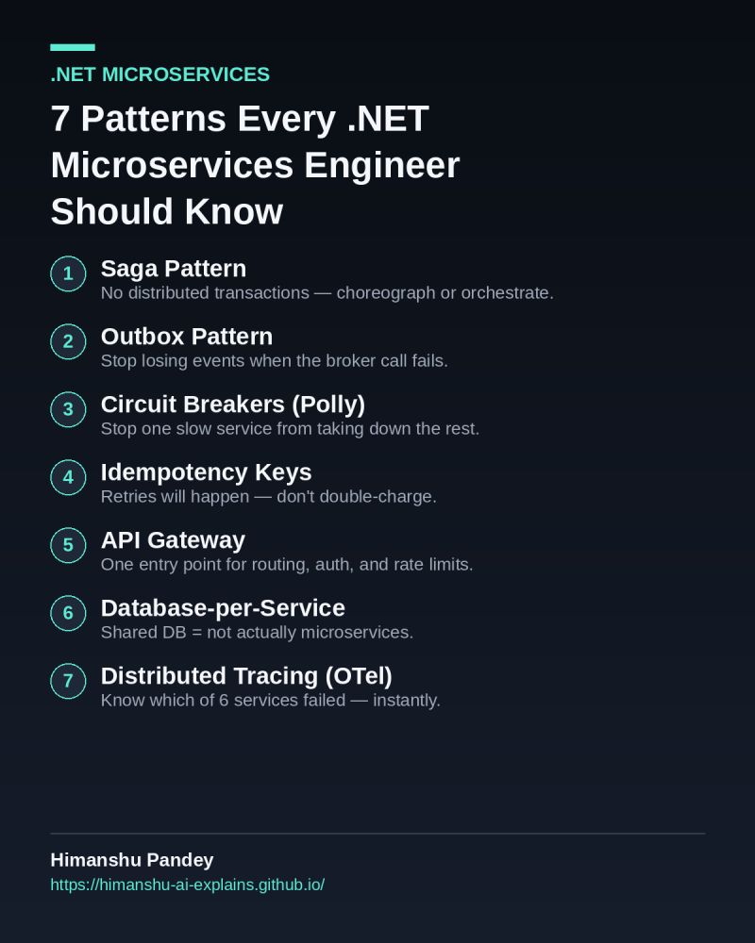
𝟭𝟮 𝗠𝗼𝗱𝗲𝗿𝗻 𝗙𝗲𝗮𝘁𝘂𝗿𝗲𝘀 𝗶𝗻 𝗖#⚡
C# has evolved dramatically over the last few releases.
Many developers still write C# the same way they did 10 years ago.
Here are 12 modern C# features worth knowing:
𝟭. 𝗖𝗼𝗹𝗹𝗲𝗰𝘁𝗶𝗼𝗻 𝗘𝘅𝗽𝗿𝗲𝘀𝘀𝗶𝗼𝗻𝘀
Collection expressions provide a concise way to create arrays, lists, and other collection types without repetitive syntax.
Less noise, better readability.
𝟮. 𝗣𝗿𝗶𝗺𝗮𝗿𝘆 𝗖𝗼𝗻𝘀𝘁𝗿𝘂𝗰𝘁𝗼𝗿𝘀
Primary constructors let you declare constructor parameters directly in the class definition, reducing boilerplate code.
Especially useful for dependency injection in ASP .NET Core services and controllers.
𝟯. 𝗥𝗲𝗾𝘂𝗶𝗿𝗲𝗱 𝗠𝗲𝗺𝗯𝗲𝗿𝘀
The required keyword ensures important properties are initialized when an object is created.
Helps prevent partially initialized objects.
𝟰. 𝗣𝗮𝘁𝘁𝗲𝗿𝗻 𝗠𝗮𝘁𝗰𝗵𝗶𝗻𝗴
Modern pattern matching makes conditional logic more expressive and easier to read.
Often replaces long chains of if statements.
𝟱. 𝗥𝗲𝗰𝗼𝗿𝗱𝘀
Records are designed for immutable data and provide built-in value equality.
Perfect for DTOs and domain models.
𝟲. 𝗡𝘂𝗹𝗹𝗮𝗯𝗹𝗲 𝗥𝗲𝗳𝗲𝗿𝗲𝗻𝗰𝗲 𝗧𝘆𝗽𝗲𝘀
Nullable reference types help detect potential null-reference issues during compilation.
This feature catches many bugs before they reach production.
𝟳. 𝗙𝗶𝗹𝗲-𝗦𝗰𝗼𝗽𝗲𝗱 𝗧𝘆𝗽𝗲𝘀
Introduced in C# 11, file-scoped types allow a type to be visible only within a single source file.
Useful for implementation details that should never leak outside the file.
𝟴. 𝗥𝗮𝘄 𝗦𝘁𝗿𝗶𝗻𝗴 𝗟𝗶𝘁𝗲𝗿𝗮𝗹𝘀
Raw string literals make it easier to work with JSON, XML, SQL, and multi-line text without excessive escaping.
Much cleaner than traditional escaped strings.
𝟵. 𝗜𝗻𝗹𝗶𝗻𝗲 𝗔𝗿𝗿𝗮𝘆𝘀
Inline arrays provide a low-allocation way to store a fixed number of elements directly inside a struct.
Useful in high-performance and memory-sensitive scenarios.
𝟭𝟬. 𝗡𝘂𝗹𝗹-𝗖𝗼𝗻𝗱𝗶𝘁𝗶𝗼𝗻𝗮𝗹 𝗔𝘀𝘀𝗶𝗴𝗻𝗺𝗲𝗻𝘁 𝗢𝗽𝗲𝗿𝗮𝘁𝗼𝗿
Null-conditional assignment lets you assign a value only when the target isn't null, reducing repetitive null checks.
𝟭𝟭. 𝗡𝗲𝘄 𝗟𝗼𝗰𝗸 𝗧𝘆𝗽𝗲
The new System.Threading.Lock type is designed to provide safer and more efficient synchronization.
It avoids some of the pitfalls of locking on arbitrary objects.
𝟭𝟮. 𝗘𝘅𝘁𝗲𝗻𝘀𝗶𝗼𝗻 𝗠𝗲𝗺𝗯𝗲𝗿𝘀
Extension members, introduced in C# 14, provide a new syntax for adding methods, properties, and other members to existing types.
This could significantly improve how libraries add functionality to existing types.
Which feature has had the biggest impact on your codebase so far?

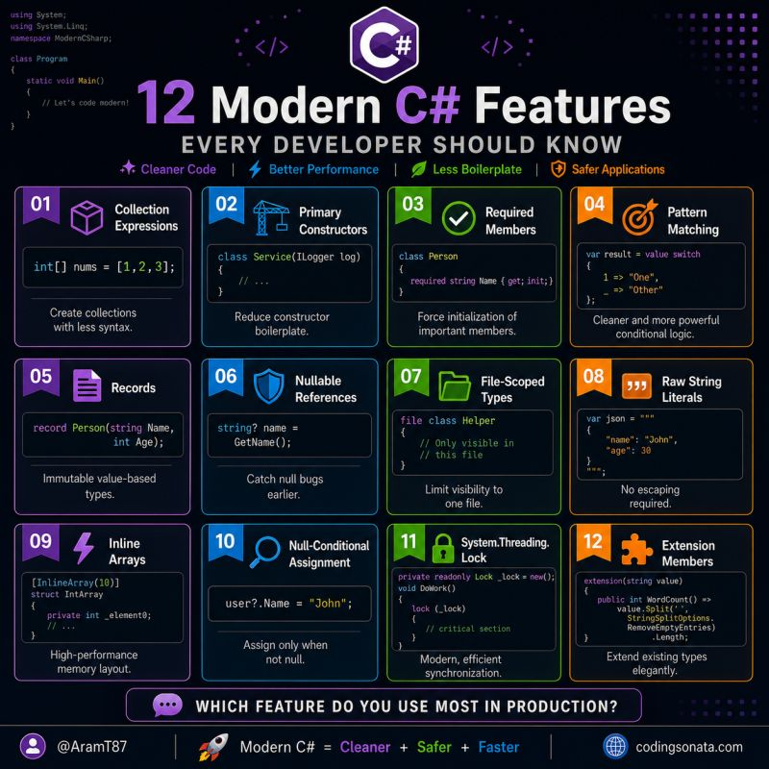

Technical Architect vs Solution Architect vs Enterprise Architect vs AI Solution Architect — what’s the difference?
These titles are often used interchangeably, but they operate at very different levels of responsibility.
🔹 Technical Architect
Focuses on how the system is built:
• Architecture & design patterns
• Microservices & APIs
• Databases & messaging
• Cloud, DevOps & scalability
• Security & performance
🔹 Solution Architect
Focuses on how technology solves a business problem:
• Business requirements
• End-to-end solution design
• Integrations
• Data & security
• Cost and trade-offs
• Business and technical alignment
🔹 Enterprise Architect
Focuses on the organization as a whole:
• Business & technology strategy
• Enterprise architecture
• Data governance
• Application portfolio
• Technology standards
• Long-term technology roadmap
🔹 AI Solution Architect
Focuses on how AI can create real business value:
• LLMs & Generative AI
• RAG & Vector Databases
• AI Agents & Tool Calling
• AI integration & orchestration
• AI security & guardrails
• Evaluation, observability & cost optimization
The important point is that these aren't completely separate careers.
A strong architect needs to understand the layers:
Enterprise Strategy → Business Solution → AI Capabilities → Technical Implementation
For software engineers and technical leads, the next step isn't only learning more technologies.
It's learning to answer bigger questions:
👉 Why this architecture?
👉 What business problem are we solving?
👉 What are the trade-offs?
👉 How will the solution scale?
👉 What will it cost?
👉 Where can AI create measurable value?
👉 How do we make the architecture secure, maintainable and future-ready?
Architecture is not just about choosing technologies.
It's about making the right decisions at the right level.
Technical Architect vs Solution Architect vs Enterprise Architect vs AI Solution Architect — what’s the difference?
These titles are often used interchangeably, but they operate at very different levels of responsibility.
🔹 Technical Architect
Focuses on how the system is built:
• Architecture & design patterns
• Microservices & APIs
• Databases & messaging
• Cloud, DevOps & scalability
• Security & performance
🔹 Solution Architect
Focuses on how technology solves a business problem:
• Business requirements
• End-to-end solution design
• Integrations
• Data & security
• Cost and trade-offs
• Business and technical alignment
🔹 Enterprise Architect
Focuses on the organization as a whole:
• Business & technology strategy
• Enterprise architecture
• Data governance
• Application portfolio
• Technology standards
• Long-term technology roadmap
🔹 AI Solution Architect
Focuses on how AI can create real business value:
• LLMs & Generative AI
• RAG & Vector Databases
• AI Agents & Tool Calling
• AI integration & orchestration
• AI security & guardrails
• Evaluation, observability & cost optimization
The important point is that these aren't completely separate careers.
A strong architect needs to understand the layers:
Enterprise Strategy → Business Solution → AI Capabilities → Technical Implementation
For software engineers and technical leads, the next step isn't only learning more technologies.
It's learning to answer bigger questions:
👉 Why this architecture?
👉 What business problem are we solving?
👉 What are the trade-offs?
👉 How will the solution scale?
👉 What will it cost?
👉 Where can AI create measurable value?
👉 How do we make the architecture secure, maintainable and future-ready?
Architecture is not just about choosing technologies.
It's about making the right decisions at the right level.

🚀 After years of building enterprise .NET applications and architecting large-scale systems, one lesson stands out...
There is no "best" software architecture.
There is only the architecture that best fits your business domain, team, and expected scale.
I see many developers asking:
"Should I use Clean Architecture?"
"Is Microservices better than Monolith?"
"Do I need DDD for every project?"
The answer is almost always...
👉 It depends.
Here's the way I think about it:
Start a New Project
│
▼
Monolith
│
▼
Growing Product?
│
▼
Modular Monolith
│
▼
Complex Business Rules?
│
▼
Clean Architecture
+
DDD
│
▼
Need Independent Teams?
│
▼
Microservices
│
▼
High Async Communication?
│
▼
Event-Driven Architecture
│
▼
Audit, Banking, Healthcare?
│
▼
CQRS + Event Sourcing
🏛️ Foundational
✅ Layered (N-Tier)
✅ Monolith
✅ Modular Monolith
🧅 Domain-Centric
✅ Clean Architecture
✅ Onion Architecture
✅ Hexagonal (Ports & Adapters)
✅ Vertical Slice
✅ Domain-Driven Design (DDD)
☁️ Distributed & Cloud Native
✅ Microservices
✅ Event-Driven Architecture
✅ CQRS + Event Sourcing
✅ Serverless (Azure Functions)
📌 My rule of thumb
❌ Don't start with Microservices because they're trendy.
❌ Don't use DDD just because everyone talks about it.
❌ Don't build Clean Architecture for a simple CRUD application.
Instead...
✔ Start simple.
✔ Optimize when the business requires it.
✔ Let complexity emerge naturally.
Remember:
Architecture is about making the right trade-offs—not choosing the most popular pattern.
The best software architects don't memorize patterns.
They understand when NOT to use them.
📚 Books that significantly influenced my thinking:
Clean Architecture — Robert C. Martin
Domain-Driven Design — Eric Evans
Patterns of Enterprise Application Architecture — Martin Fowler
Fundamentals of Software Architecture — Richards & Ford
Building Microservices — Sam Newman
.NET Microservices: Architecture for Containerized Applications (Microsoft)
💬 Which architecture do you use most in your projects, and why?

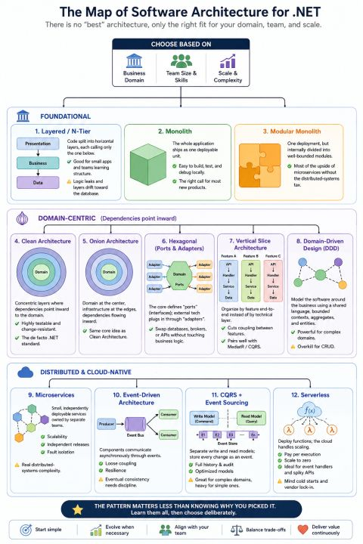

🔒 Two users update the same order at the same time.
One save wins. One save disappears. Nobody gets an error.
Here's what breaks first
Most .NET apps run on "last write wins" by default.
User A loads a record. User B loads it 2 seconds later.
User A saves. User B saves 10 seconds after that.
User B's write silently overwrites User A's changes.
No exception. No log entry. No trace of the conflict.
𝗧𝗵𝗶𝘀 𝗶𝘀 𝘁𝗵𝗲 𝗹𝗼𝘀𝘁 𝘂𝗽𝗱𝗮𝘁𝗲 𝗽𝗿𝗼𝗯𝗹𝗲𝗺.
It only shows up when two people touch the same row close together which is exactly why it survives in production for years.
→ Silent data loss, no audit trail
→ Support tickets nobody can reproduce
→ Bugs that only happen under real concurrent load
✅ 𝗧𝗵𝗲 𝗳𝗶𝘅: 𝗮 𝗿𝗼𝘄 𝘃𝗲𝗿𝘀𝗶𝗼𝗻 𝘁𝗼𝗸𝗲𝗻
EF Core has supported this since day one. SQL Server gives you `rowversion` for free.
→ EF reads the version column with the entity
→ SaveChanges adds a WHERE clause checking that version
→ If it changed, SaveChanges throws 𝗗𝗯𝗨𝗽𝗱𝗮𝘁𝗲𝗖𝗼𝗻𝗰𝘂𝗿𝗿𝗲𝗻𝗰𝘆𝗘𝘅𝗰𝗲𝗽𝘁𝗶𝗼𝗻
→ You decide: reload, merge, or reject
🔎 𝗪𝗵𝗲𝗻 𝘁𝗼 𝘂𝘀𝗲 𝘄𝗵𝗮𝘁:
𝗢𝗽𝘁𝗶𝗺𝗶𝘀𝘁𝗶𝗰 𝗰𝗼𝗻𝗰𝘂𝗿𝗿𝗲𝗻𝗰𝘆
→ Low collision rate
→ Web apps, APIs, most CRUD systems
𝗣𝗲𝘀𝘀𝗶𝗺𝗶𝘀𝘁𝗶𝗰 𝗹𝗼𝗰𝗸𝗶𝗻𝗴
→ High collision rate
→ Financial transactions, inventory reservation
𝗡𝗼 𝗰𝗵𝗲𝗰𝗸 𝗮𝘁 𝗮𝗹𝗹
→ Single-user data, reference tables
Row version or pessimistic lock - what's your default?
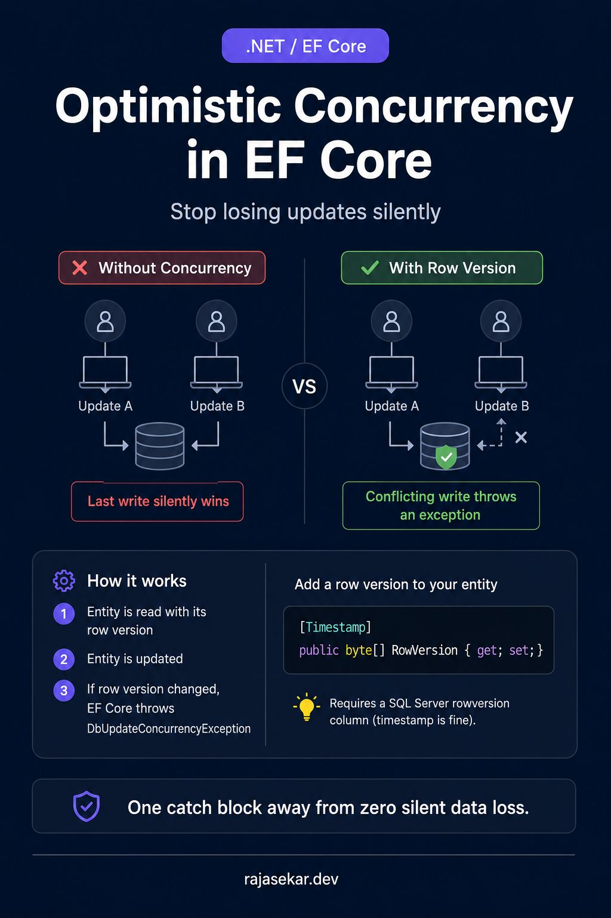

Saga Pattern — Microservices Cheat Sheet 🚀
Distributed transactions are one of the trickiest parts of Microservices architecture.
The Saga Pattern helps solve this by breaking a business transaction into multiple local transactions and using compensating transactions when something fails.
🔹 Example
Order → Payment → Inventory → Shipping
If Shipping fails:
Shipping ❌
→ Release Inventory
→ Refund Payment
→ Cancel Order
🔹 Two Saga approaches
1. Choreography
Event-driven
No central coordinator
Good for simpler workflows
2. Orchestration
Central Saga Orchestrator
Better control and visibility
Suitable for complex workflows
🔹 Production-ready Saga
Combine it with:
✅ Kafka
✅ Transactional Outbox
✅ Idempotency
✅ Retry + Exponential Backoff
✅ Timeout
✅ Dead Letter Queue
✅ Observability & Distributed Tracing
🔥 Key interview point
Saga does NOT provide distributed ACID rollback.
It achieves eventual consistency through local transactions + business-level compensation.
Save this cheat sheet for your next Microservices/System Design interview. 📌
