A Privacy-Aware Web Dashboard for Comparative Community Energy Analytics Using Simulated Smart Circuit Controller Data

Bongani Nyoni
Dept. of Electrical, Electronic and Computer Engineering
Cape Peninsula University of Technology
Cape Town, South Africa
260119806@mycput.ac.za
Mukovhe Ratshitanga
Dept. of Electrical, Electronic and Computer Engineering
Cape Peninsula University of Technology
Cape Town, South Africa
RatshitangaM@cput.ac.za

Abstract—Household electricity readings are increasingly available from smart meters and smart circuit controllers, yet raw values of voltage, current and power seldom show whether consumption is rising, which load dominates, when demand peaks or how a home compares with similar homes. This paper presents the design and technical evaluation of a web-based community energy monitoring dashboard that turns circuit-level readings into comparative analytics. Because access to a commercial controller application programming interface (API) was not available, a controlled dataset was simulated for ten anonymized sites, six controller channels and 30 days at 15-minute resolution (172 800 readings). The dataset models a generic multi-channel smart circuit controller (per-channel voltage, current, power and energy) and contains known data-quality faults and abnormal-use events. A layered pipeline validates, stores and aggregates the readings in a relational database, and eight transparent algorithms compute energy, estimated cost, peak demand, load ranking, baseline and peer ratios, data completeness and abnormal-use warnings. All 240 injected invalid records were rejected. Independent recomputation matched the pipeline to within 10⁻¹³ relative errors. Short-gap interpolation reduced the mean monthly energy error against ground truth from 1.63 % to 1.33 %. On a separately generated hold-out dataset, a two-stage warning rule raised precision from 0.49 to 1.00 at the cost of recall, which fell from 0.63 to 0.40. The pipeline was further run unmodified against ten real households from the public Low Carbon London smart-meter dataset, confirming compatibility with independent real-world meter data. Participant-based usability testing is defined as the remaining validation step.
Keywords—smart energy monitoring, community energy dashboard, comparative analytics, energy feedback, smart circuit controller, data quality, privacy by design, POPIA

Introduction
Access to mains electricity in South Africa rose from 76.7 % of households in 2002 to 90.2 % in 2024 [1], and Eskom's smart meter programme, which started in 2025, is planned to run until 2029 [2]. Measurement is therefore becoming common, but measurement alone does not help a household act. A reading of 87.6 W or 13.21 kWh does not say whether the home is using more than usual, which appliance is responsible, when the daily peak occurs or whether the result is high for a home of that kind.
Energy feedback research explains why this interpretation layer matters. Darby [3] argues that domestic energy use is largely invisible and that feedback makes it understandable. Fischer [4] shows that effective feedback depends on frequency, appliance breakdown, comparison and presentation, and the meta-analysis of Karlin, Zinger and Ford [5] shows that the effect of feedback depends on how it is designed. Social comparison can reduce consumption [6], but poorly framed comparisons can push low users upward [7]. A dashboard is therefore a feedback mechanism, not only a viewer for stored readings.
Smart circuit controllers such as the CBi Astute Smart Controller combine Wi-Fi (wireless local area networking) connectivity, energy monitoring, scheduling and load switching, and they respond to current, voltage, time and power [8]. Their data normally pass through a vendor cloud, and access to that cloud through an application programming interface (API) cannot be assumed in a student project. This work therefore simulates controller-style readings under controlled conditions. Simulation gives a known ground truth for every fault and abnormal event, so the pipeline and analytics can be tested against exact expected outputs before real data are connected.
The aim of this work is to design, implement and technically evaluate a web-based community energy monitoring dashboard that uses simulated smart circuit controller data to provide comparative analytics for household and small-community electricity consumption. Five objectives guided this aim: (1) specify the electrical variables and dataset structure required for a smart-circuit-controller-based dashboard, including value ranges, units and data-quality thresholds; (2) design and implement a secure pipeline that ingests, validates, stores and pre-processes the readings, with schema-enforced tables, explicit validation rules and an audit log; (3) develop comparative analytics algorithms for consumption baselines, community comparison, peak-demand detection, device-level ranking, anomaly warnings and estimated cost, each verified against a hand-calculated reference case; (4) build a responsive web-based dashboard that presents individual and community-level energy information through interactive visualisations across desktop and mobile; and (5) evaluate the prototype against calculation accuracy, data completeness, responsiveness and abnormal-use warning performance, and define the usability-evaluation instrument for the participant-based study that remains as future work.
The contributions are: (i) a dataset specification and a simulator that records ground truth for injected faults and abnormal-use events; (ii) a source-agnostic validation and storage pipeline; (iii) eight transparent comparative analytics algorithms, each verified against hand-calculated and independent references; (iv) a responsive, privacy-aware dashboard; and (v) a quantitative technical evaluation, including a hold-out test of the warning rules. Section II reviews related work, Section III describes the design, Section IV the evaluation method, Section V the results, Section VI the limitations and Section VII the conclusions.

Related Work

Energy Feedback and Comparison
Reviews of household intervention studies find that feedback is one of the more effective tools for reducing consumption, particularly when it is frequent and specific [9], [10]. Large field evidence shows that peer comparison reports reduced average household consumption by about 2 % [6]. Schultz et al. [7] showed that descriptive norms alone can cause a boomerang effect among low consumers, and that adding an approving cue avoids it. These findings shaped two design choices actually carried through to the implementation: every peer comparison is paired with the household's own baseline, and the result is reported as a neutral status band (below average, typical or above average) rather than a numeric leaderboard position, for the main resident-facing dashboard. The peer figure itself (Section III, A6) is a whole-community, leave-one-out average; a separate administrator-only view additionally ranks all households by consumption for operational oversight, which residents do not see.

Household Load Data and Simulation
Public datasets such as UK-DALE (UK Domestic Appliance-Level Electricity) [11] and REFIT [12] show how whole-house and appliance-level readings can be structured as time series with device labels. South African studies built on the Domestic Electrical Load (DEL) metering data cluster daily load profiles into archetypes [13] and synthesise statistically representative demand profiles [14]. These studies support two points used here: household consumption follows repeatable daily and weekly shapes, and synthetic profiles are an accepted way to test methods when real data are restricted. Non-intrusive load monitoring (NILM) [15] separates appliances from an aggregate signal; it is not needed here because each controller channel is labelled at source.

Privacy of Smart Energy Data
Fine-grained electricity data reveal occupancy and routines [16], and household characteristics can be inferred from them [17]. South Africa's Protection of Personal Information Act (POPIA) requires accountability, purpose specification, minimality and security safeguards for personal information [18]. The k-anonymity model [19], in which each released record cannot be distinguished from at least k − 1 others, motivates the rule used here: a peer comparison is shown only when the peer group contains at least k sites.

Anomaly detection in smart meter data
Anomaly-detection research for electricity consumption spans a spectrum from heavyweight AI methods to lightweight statistical rules. Himeur et al. [24] survey AI-based anomaly detection for building energy use and find that most published methods rely on supervised or deep-learning models trained on richly labelled, sub-metered data, which real household deployments seldom have. Al-Ghaili et al. [25] review anomaly detection specifically for advanced metering infrastructure and note that fine time granularity makes anomalies easier for a utility to catch, but most of the techniques they cover target data manipulation and theft rather than ordinary abnormal-use events. Closer to the approach used here, Jurj et al. [26] apply an interquartile-range outlier rule to building electricity data and find it a practical, interpretable baseline, though sensitive to seasonal variation in the underlying distribution. Taken together, this literature motivates the lightweight approach used here: a per-channel Tukey fence over daily and night-time totals (Section III, A8) is far simpler than the deep models most reviews favour, trading some detection power for transparency and a threshold a non-expert user can sanity-check, and the real evaluation in Section V quantifies that trade-off directly rather than assuming it away.

Existing monitoring platforms
Several deployed systems demonstrate the dashboard half of this problem without the validation half. Bagde et al. [23] built a web-based IoT dashboard that visualises real-time and periodic electrical data with interactive charts to help users spot peak-usage periods, but, like most deployed dashboards, it reports visualisation without documenting data validation, quantitative pipeline accuracy or peer comparison. Muhammed et al. [27] report a similar IoT home-energy-monitoring prototype with real-time display in both wireless and offline modes, and Mohamed Ariff et al. [28] add real-time monitoring to a smart-home energy-management system; neither paper quantifies validation accuracy, reports a gap-handling strategy, or compares a household against its peers. This is the gap this paper targets directly: not a new way to visualise consumption, but a documented, testable pipeline between the circuit-level reading and the comparison shown on screen.

Review analysis
The gap addressed is practical: feedback and comparison are well studied, and load datasets exist, but there are few openly documented, testable pipelines that take controller-level readings through validation, storage and comparative analytics into a privacy-aware interface, and that report how accurately each step performs.

System Design
The system has six layers (Fig. 1): data source, ingestion and validation, gap handling, storage, analytics and dashboard. Each layer can be tested on its own, and the data source can change from simulated CSV (comma-separated values) files to an approved API or a local gateway without changing the later layers.
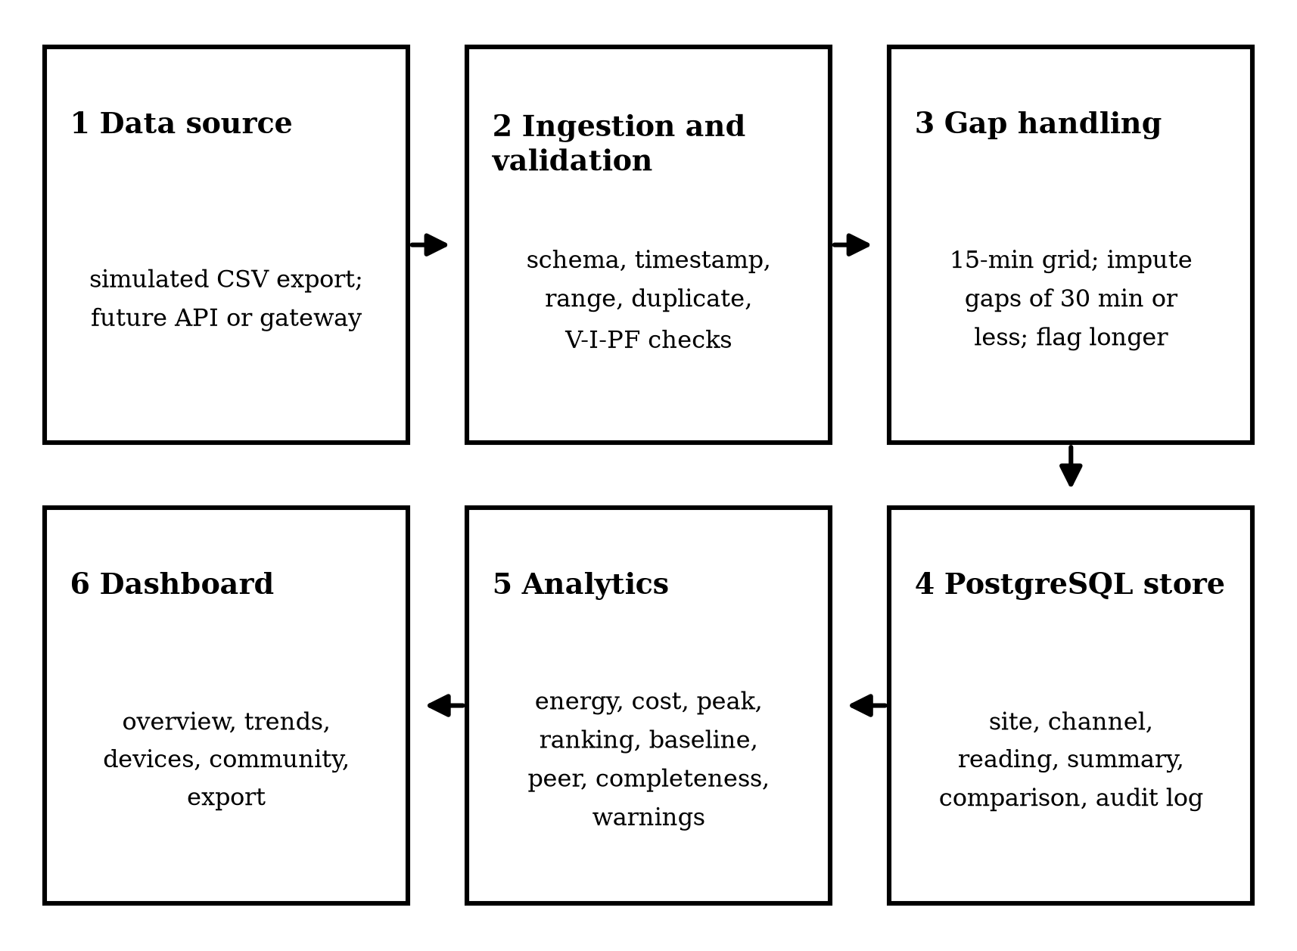
- Layered architecture of the prototype.

Data Specification and Simulated Dataset
Each reading carries the fields in Table I. The electrical fields are kept physically consistent through (1) to (3), where V is RMS (root mean square) voltage in volts, I is RMS current in amperes, PF is the power factor, P is active power in kilowatts, Δt = 0.25 h and T is a configurable tariff in rand per kilowatt-hour.
P = V·I·PF / 1000 (1)
E = Σ P·Δt (2)
C = E·T (3)
Table 1 READING FIELDS USED BY THE PIPELINE
Field | Content and use
$$site_id$$ | pseudonymised site; no name or address stored
device_id | controller channel identifier
controller_channel | load category: geyser, fridge, lighting, plugs, cooking or background
timestamp | ISO 8601 time with offset; 15-min grid
voltage_v, current_a | RMS values; range and consistency checks
power_kw | active power; primary input for energy
energy_kwh_interval | energy in the interval
cumulative_energy_kwh | running energy total
switching_state | on, standby or off
quality_flag | valid, imputed, missing, duplicate, out-of-range or abnormal_event

The simulator generates ten sites (three low-use, four medium-use and three high-use) with six channels each for 1 to 30 January 2026. Rated power and power factor per channel are: geyser 3.0 kW and 1.0, fridge 0.15 kW and 0.85, lighting 0.30 kW and 0.98, plugs 0.60 kW and 0.95, cooking 2.4 kW and 1.0, and background load 0.08 kW and 0.9. Geysers heat in morning and evening windows, with weekend mornings 1.5 h later, plus random standing-loss reheats. The fridge follows a 33 % to 43 % compressor duty cycle. Lighting, plug loads and cooking follow occupancy windows scaled by the site profile. Supply voltage is drawn around 230 V with a 5 V evening sag. This gives 2 880 intervals per channel and 172 800 readings in total.
Faults were injected into the export the pipeline receives: a 4 h communication gap at one site (96 readings removed), random loss of 0.3 % of readings (550), 200 duplicate re-imported readings, 30 out-of-range voltages (0 V, 298.7 V and 312.4 V), 10 negative power values, and shuffled arrival order. Each dataset separately injects 30 abnormal-use events on randomly chosen site-channel-days: 20 full-day events, with one channel’s power for a whole day scaled by a factor of 1.15 to 3.5, and 10 overnight-only events, with the 00:00–05:00 total scaled by a factor of 1.2 to 3.0, giving a realistic mix of clear and borderline cases rather than only easy ones. Dataset B, generated with a different seed, was used only for hold-out testing.

Ingestion, Validation and Gap Handling
Six rules are applied, the first that fails setting the flag: R1 schema presence, enforced before a row reaches the other rules; then, in evaluation order, R3 uniqueness of (device, timestamp); R2 a valid timestamp on the native sampling grid (15 min for the simulator; a half-hourly source, as used in Section IV, also satisfies this, since every half-hour mark is a 15-min mark too); R4 voltage within 230 V ± 10 % (207 V to 253 V), checked only when a source reports voltage; R5 0 ≤ P ≤ 1.2 P_{rated}, checked only when a source reports both voltage and current; and R6 agreement between P and V·I·PF within 5 %. Every reading, flagged or not, is kept in the same table under its quality_flag, so nothing is silently discarded. Valid readings are then aligned to the expected grid. Gaps of up to two native intervals are filled by linear interpolation and flagged as imputed; longer gaps stay missing so the dashboard does not invent consumption.

Storage
PostgreSQL is used for the prototype, both locally and via a managed instance on Render for the deployed system. The schema contains site, controller_channel, reading, daily_summary, comparison_result and audit_log tables; flagged and rejected readings stay in the same reading table under their quality_flag rather than a separate quarantine table, and warnings (A8) are computed on demand from stored daily summaries rather than persisted in their own table. switching_state and quality_flag are enforced by CHECK constraints at the database level; duplicate and range checks (R3-R6) are enforced in the validation layer rather than repeated as database constraints. Sites are shown only as Site A to Site J. Every pipeline stage writes an audit-log entry.

Comparative Analytics
Eight algorithms are implemented as pure functions. A1 computes interval and period energy by (2). A2 estimates cost by (3); an illustrative flat tariff of R3.50/kWh is used, and the value is labelled as an estimate, not a bill. A3 finds the peak site demand P_{max}, the hour with the highest mean demand and intervals above the 95th percentile. A4 ranks channels by energy. A5 compares the last nine days with the household's own baseline B, the mean daily energy for weekdays or weekend days over days 1 to 21:
R_{b} = Σ E_{d} / Σ B_{type(d)} (4)
A6 compares site i with the mean G_{i} of all other sites for the same period (leave-one-out), where n is the number of other sites:
R_{i} = E_{i} / G_{i} (5)
G_{i} = Σ_{j≠i} E_{j} / n (6)
A ratio between 0.90 and 1.10 is reported as in line, and values outside that band as above or below the group. The comparison is displayed only when n ≥ k = 3. A7 reports completeness η as the share of expected readings that are valid:
η = N_{valid} / N_{expected} (7)
A8 generates abnormal-use warnings in two stages. Stage 1 applies Tukey's interquartile range (IQR) fence [20] to each channel's 30 daily energy totals, with a floor at 15 % above the median:
τ = max(Q₃ + 1.5·IQR, 1.15·median) (8)
Stage 2 grades each exceedance by its severity s = E_{d}/τ. Values with s ≥ 1.25 are raised as warnings and smaller exceedances as notices. Stage 2 also adds a night base-load rule on energy between 00:00 and 05:00, with threshold max(Q₃ + 1.5·IQR, 2·median, median + 1.0 kWh). All thresholds were set using dataset A only.

Dashboard
The dashboard (Fig. 6) is a single responsive page generated from the database, with no third-party scripts. It shows three key performance indicator (KPI) cards (today’s consumption, peak power and status against the whole-community average) and five chart panels: a daily consumption trend line, a device-ranking bar chart of total and peak energy per channel, a line chart comparing the site against the whole-community average, a stacked bar of today’s breakdown by channel, and an hourly usage-pattern heatmap by day of week (Fig. 2). Data can be exported as CSV, or as PDF (Portable Document Format) through the browser.

Evaluation Method
Data-quality handling was checked by comparing flags with the injected faults. Calculation accuracy was checked in two ways. First, nineteen unit tests compared each algorithm with a hand-calculated reference case. Second, an independent script recomputed site, device-day, peak and count results directly from the raw CSV in plain Python, without pandas or SQL, and compared them with the database. The target was agreement within ±5 %. The effect of gap handling was measured against the fault-free ground truth. Warnings were scored at site-channel-day level (1 800 cases per dataset) for precision and recall, first on calibration dataset A and then on hold-out dataset B. Performance was measured as pipeline run time and the median of 30 executions of each dashboard query. Responsiveness was tested in headless Chromium at 1366, 768, 375 and 320 px, measuring horizontal overflow as the page scroll width minus client width. The planned usability study uses the System Usability Scale (SUS) [21] with at least five participants, who complete interpretation tasks first on a raw table and then on the dashboard.

Results

Data Quality
Table II shows that every injected invalid record was flagged by the correct rule. After gridding, 646 expected readings were absent: 550 random losses and 96 from the communication gap. Of these, 539 isolated gaps were imputed and the 96 readings of the 4 h gap stayed missing, since gap-filling only bridges runs of up to two missing intervals. Overall completeness was 99.63 % before gap-filling and 99.94 % after. The lowest site-day value falls on the day of the communication gap, and the dashboard reports this rather than hiding it.

Table 2 INJECTED FAULTS AND VALIDATION OUTCOME (DATASET A)
Fault | Injected | Flagged | Rule
Duplicate re-import | 200 | 200 | R3
Voltage out of range | 30 | 30 | R4
Negative power | 10 | 10 | R5
Isolated missing readings | 550 | 539 imputedª | grid
4 h communication gap | 96 | 96 missing | grid
- 11 of the 550 isolated gaps could not be imputed, either because they sat adjacent to another dropped interval or at the start or end of a device’s reading series.

Calculation Accuracy
All nineteen unit tests passed. The independent recomputation matched the database with a maximum relative error of 4.0 × 10⁻¹⁴ for site-month energy and 3.3 × 10⁻¹⁵ for device-day energy, with zero difference in daily peaks and valid-reading counts across 1 800 device-days. This is far inside the ±5 % target; the residual is floating-point rounding. Against ground truth, the mean absolute monthly energy error per device was 1.63 % (maximum 7.05 %) when missing readings were simply excluded, and 1.33 % (maximum 6.86 %) with short-gap interpolation. Dataset B gave 1.69 % and 1.40 % (maxima 11.33 % and 11.01 %). Interpolation therefore removes some of the bias caused by isolated losses, a roughly 18 % relative reduction in mean error on both datasets, and most of the remaining error comes from the 4 h communication gap, which is deliberately not filled because it exceeds the two-interval gap-filling limit.

Comparative Analytics Outputs
The ten simulated households used 12,040.9 kWh over the simulated month, about 1,204.1 kWh per site or 40.1 kWh per site per day. For Site HOUSE-004, the live dashboard’s breakdown for its most recent day shows cooking as the largest share (31.4 %), followed by the geyser (27.9 %), plug loads (21.4 %), the fridge (8.7 %), lighting (5.7 %) and background load (4.9 %) (Fig. 4). Site HOUSE-004 peaked in the 18:00 hour, visible as the darkest column in the heatmap (Fig. 2), consistent with the evening-use pattern built into the simulator. The live dashboard compares each site only against the whole-community average, not a within-group peer mean; for the ten simulated households alone (admin view, Fig. 3), this ratio ranged from 0.57 to 1.61. Section IV repeats this comparison for the ten real London households, where the much larger variance in real consumption pushes the same ratio far wider (0.39 to 3.14): a whole-community comparison without peer grouping can make a typical high-use household look far more unusual than it is. The live dashboard implements the whole-community, leave-one-out comparison described in Section III-D (A6); the within-group, profile-matched comparison that this risk motivates has not yet been implemented and remains future work.
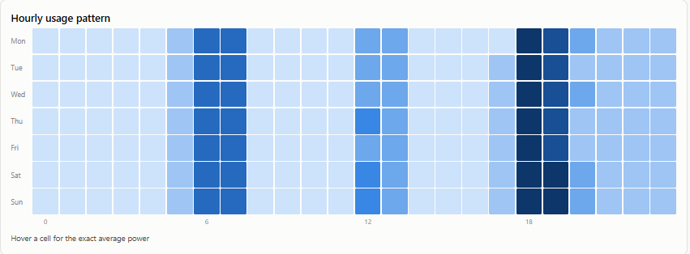
- Hourly usage-pattern heatmap for Site HOUSE-004.

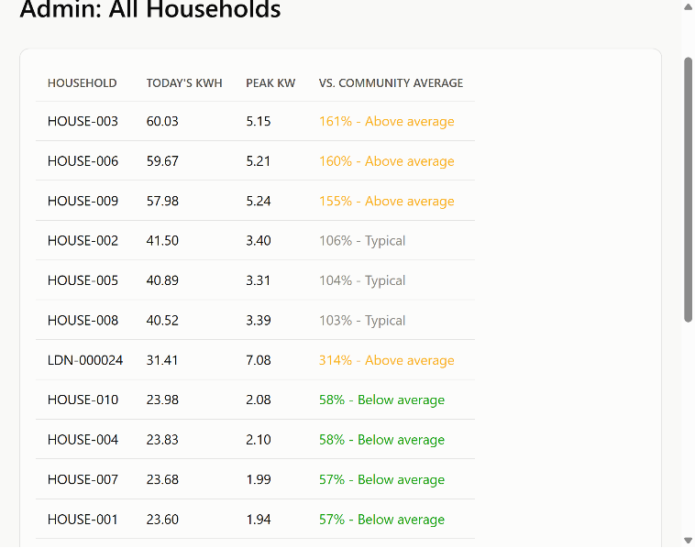
- Admin ranking view across the ten simulated households, ranked by today’s kWh and status versus the whole-community average, from the live dashboard.

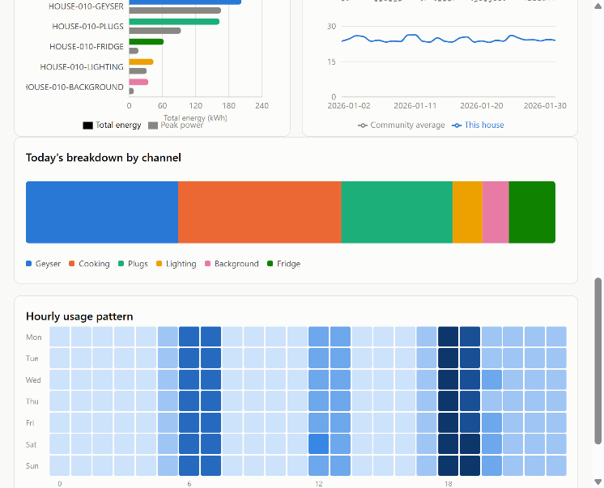
- Load-category breakdown for Site HOUSE-004, from the live dashboard.

Abnormal-Use Warnings
Table III summarises warning performance across 30 injected day and night-level events (20 full-day and 10 overnight-only) per dataset, with thresholds calibrated on dataset A only. In-sample on A, stage 1 (any exceedance of the IQR fence) found 21 of 30 events but also raised 14 false alerts, mostly from natural day-to-day variation in cooking and plug energy. Severity grading and the night rule removed every false alert, at the cost of missing 5 further borderline events (16 of 30 found). The same pattern held on hold-out dataset B: stage 1 found 19 of 30 events with 20 false alerts, and the two-stage rule found 12 of 30 with zero false alerts. The two-stage rule therefore trades recall for precision rather than improving both: it only raises a warning once an exceedance clears the higher severity-1.25 bar or the night floor, which suits a system meant to avoid crying wolf, but it also means some real borderline events, especially smaller night-only ones, go unflagged. Fig. 5 shows the geyser event for Site HOUSE-004, computed from the live system’s own stored daily summaries: 17.73 kWh against a threshold τ of 7.81 kWh (severity 2.27), using the stage 1 rule in (8).

Table 3 WARNING PERFORMANCE PER SITE-CHANNEL-DAY
Dataset / stage | TP | FP | FN | Precision | Recall
A, stage 1 | 21 | 14 | 9 | 0.60 | 0.70
A, stage 2 | 16 | 0 | 14 | 1.00 | 0.53
B, stage 1 | 19 | 20 | 11 | 0.49 | 0.63
B, stage 2 | 12 | 0 | 18 | 1.00 | 0.40
- TP, FP and FN are true positives, false positives and false negatives.
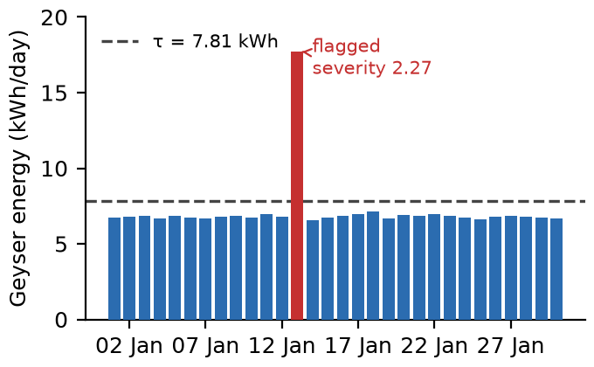
- Daily geyser energy for Site HOUSE-004 with the stage 1 IQR threshold τ, computed live from the dashboard’s own stored daily summaries; the injected event on 13 January is flagged.

Performance and Responsiveness
Ingesting and validating 172,343 raw rows and aligning them to the grid took 173.4 s, and storage with daily summaries took a further 8.6 s, for a total end-to-end processing time of 182.0 s, independently re-measured against an isolated test database rather than the live demo instance. Median query times were 0.04ms for the KPI cards, 0.37 ms for the daily trend, 0.32 ms for load ranking, 0.02 ms for peer comparison and 0.06 ms for alerts. A one-day interval view took 200.6 ms because it reads raw readings. The dashboard showed zero horizontal overflow at all four viewport widths, loaded locally in 41 ms, switched sites in about 12 ms and produced the CSV export. These times exclude network latency.
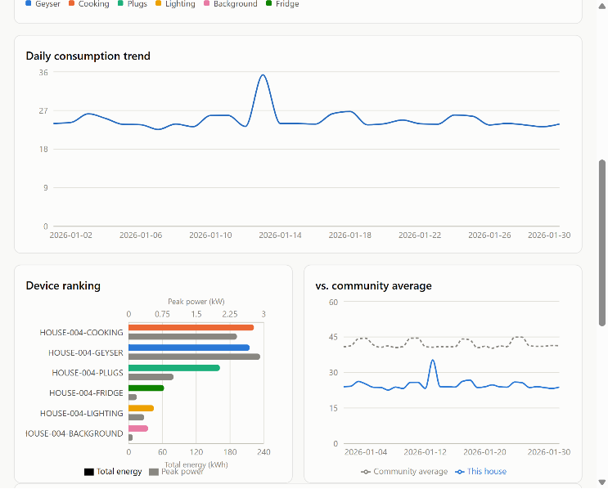
- Dashboard overview for Site HOUSE-004: KPI cards, daily trend, device ranking and community comparison, from the live dashboard.

Compatibility with a Real Device Reading
A reading from a Tuya-ecosystem smart plug (238 V, 551 mA, 87.6 W and 13.21 kWh cumulative) maps directly onto voltage_v,current_a, power_kw and cumulative_energy_kwh. Its implied power factor is 87.6/(238 × 0.551) = 0.67. With the plug-channel assumption of 0.95, rule R6 gives a 29.5 % deviation, well outside the 5 % limit, so this reading would be flagged out_of_range. That is a defensible outcome for a prototype whose per-channel power factor is a single fixed assumption rather than a per-device measurement, since an off-the-shelf smart plug’s real power factor depends on whatever appliance is plugged into it. Power factor should therefore be configurable per device when real data are connected.

Validation Against Public Smart-Meter Data
The pipeline and dashboard were also run, unmodified except for a new whole_house controller-channel type, against ten households from the Low Carbon London smart-meter trial (UK Power Networks), an open CC-BY-licensed public dataset of half-hourly whole-house readings [22]. A 30-day window common to all ten households (2011-12-15 00:00 to 2012-01-13 23:30, UTC) was ingested through the same validation, storage and analytics layers used for the simulated dataset. Because this source reports only whole-house active power at a 30-minute native interval, with no voltage, current or power factor fields, rules R4 and R6 were not applicable and were skipped, and the grid-timestamp check (R2) was configured to the source's own 30-minute interval rather than the simulator's 15-minute one. Validation behaved correctly on genuinely external data: of 14,410 rows, 14,400 were valid and the remaining 10 were a duplicate reading at the same timestamp in every household, a systematic boundary artefact in the source file rather than injected noise, caught by rule R3 without any code change.
Real monthly totals ranged from 134.5 kWh to 839.0 kWh across the ten households, a 6.2× spread, compared with the simulated dataset’s 2.5× spread across its three fixed usage-profile multipliers. With no usage-profile grouping available for these households, a whole-community comparison (Fig. 7, Fig. 8) produced ratios from 0.39 to 3.14, a sharper illustration of the same boomerang-effect risk [7] that motivates within-group comparison as a planned refinement to the whole-community comparison implemented in Section III-D: the highest-use household (Fig. 7) reached 314 % of the community average even though no peer group existed to judge it against. This real-data run supports two conclusions: the ingestion-to-analytics pipeline generalises to a data source it was not designed around, and within-group rather than whole-community comparison matters more, not less, as real household variance grows.
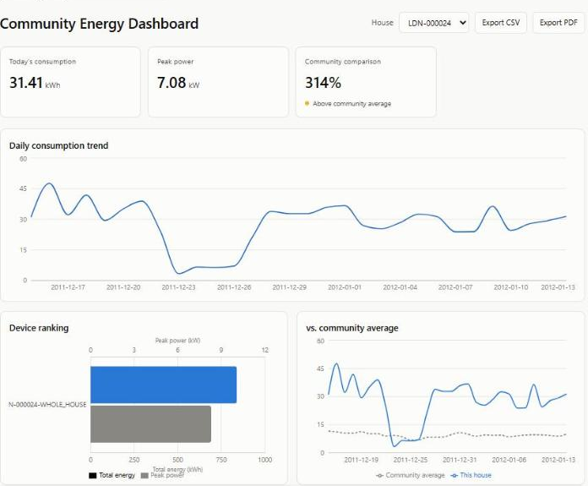
- Dashboard for the highest-use real household (Low Carbon London, site LDN-000024), showing 314% of the community average with no peer-group comparison available.
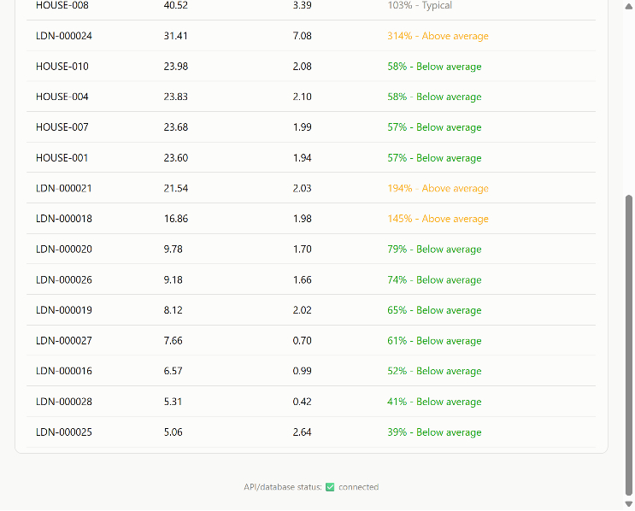
- Admin ranking view across the ten real Low Carbon London households, showing the ratio spread produced by whole-community comparison.

Discussion and Limitations
The validation layer and the calculations behaved as specified, and the results show where simple rules break down. A plain IQR fence is sensitive but noisy, and it misses events that change the timing of use more than the daily total. Adding severity and a time-of-day rule removed the false alerts in the hold-out test, but recall fell as a result, so this is a trade-off rather than a complete fix. Because both datasets come from the same generator, the hold-out result shows generalisation to new events, not to real households.
The main limitations are as follows. Simulated data cannot show behaviour change or live communication reliability. Real faults, such as clock drift, partial records and sensor offsets, are messier than the injected ones. The tariff is flat and illustrative, whereas South African municipalities use block and time-of-use tariffs. Thirty days is too short for a seasonal baseline. PostgreSQL supports concurrent writers, but this evaluation ingested data through a single writer process, so concurrent multi-site ingestion has not been empirically tested. Finally, the interpretation hypothesis cannot be accepted or rejected until the participant study is complete.
A concrete recommendation follows from this limitation: rather than depending on vendor cloud access, each CBi Astute Smart Controller could be re-flashed with custom, open firmware that exposes a lightweight local API and pushes its own readings straight to this system’s ingestion endpoint, tagged by household. This removes the per-site vendor-API approval that this project could not assume, lets each household stream live data directly into the existing validation, storage and analytics layers unmodified, and keeps the dashboard per-household rather than dependent on a shared cloud intermediary.

Conclusion and Future Work
A source-agnostic pipeline and dashboard were built and tested against a simulated smart-controller dataset with known ground truth. Validation caught every injected invalid record, the analytics matched independent recomputation to floating-point precision, short-gap interpolation reduced the mean monthly energy error by roughly 18 % on both datasets, and on unseen events a two-stage warning rule reached full precision at the cost of recall, which fell to 0.40. Pairing peer comparison with each household's own baseline, and reporting it as a neutral status band rather than a numeric leaderboard position, kept the resident-facing comparison from reading as a misleading community-wide ranking, even though the underlying average is drawn from the whole community, and avoided misleading community-wide rankings. The pipeline was additionally validated, unmodified, against ten real households from the public Low Carbon London smart-meter dataset, which confirmed real-data compatibility and sharpened the case for within-group comparison. Future work will complete the SUS and interpretation study, flash CBi Astute controllers with custom firmware exposing a local API to stream live per-household readings directly to the dashboard, extend real-data validation to South African load-research (DEL) data, add block and time-of-use tariffs, and test interpretable forecasting as an extension to the warning layer.

References
- Statistics South Africa, “General Household Survey 2024,” Pretoria, South Africa, 2025. [Online]. Available: https://www.statssa.gov.za/publications/P0318/. Accessed: Nov. 4, 2026.
- Eskom, “Smart meter programme,” Eskom Distribution, 2026. [Online]. Available: https://www.eskom.co.za/distribution/smart-meters/. Accessed: Nov. 4, 2026.
- S. Darby, “The effectiveness of feedback on energy consumption: A review for DEFRA of the literature on metering, billing and direct displays,” Environmental Change Institute, University of Oxford, Oxford, U.K., 2006. [Online]. Available: https://www.e3tnw.org/research/energy/downloads/smart-metering-report.pdf. Accessed: Nov. 4, 2026.
- C. Fischer, “Feedback on household electricity consumption: A tool for saving energy?,” Energy Efficiency, vol. 1, no. 1, pp. 79–104, 2008, doi: 10.1007/s12053-008-9009-7.
- B. Karlin, J. F. Zinger, and R. Ford, “The effects of feedback on energy conservation: A meta-analysis,” Psychological Bulletin, vol. 141, no. 6, pp. 1205–1227, 2015, doi: 10.1037/a0039650.
- H. Allcott, “Social norms and energy conservation,” J. Public Economics, vol. 95, no. 9–10, pp. 1082–1095, 2011, doi: 10.1016/j.jpubeco.2011.03.003.
- P. W. Schultz, J. M. Nolan, R. B. Cialdini, N. J. Goldstein, and V. Griskevicius, “The constructive, destructive, and reconstructive power of social norms,” Psychological Science, vol. 18, no. 5, pp. 429–434, 2007, doi: 10.1111/j.1467-9280.2007.01917.x.
- CBI-electric, “About the Astute Smart Controller,” CBi Astute Support Hub, 2026. [Online]. Available: https://support.cbi-lowvoltage.co.za/astute/asc/cbi-astute-smart-controller-asc/. Accessed: Nov. 4, 2026.
- W. Abrahamse, L. Steg, C. Vlek, and T. Rothengatter, “A review of intervention studies aimed at household energy conservation,” J. Environmental Psychology, vol. 25, no. 3, pp. 273–291, 2005, doi: 10.1016/j.jenvp.2005.08.002.
- K. Ehrhardt-Martinez, K. A. Donnelly, and J. A. Laitner, “Advanced metering initiatives and residential feedback programs: A meta-review for household electricity-saving opportunities,” American Council for an Energy-Efficient Economy, Washington, DC, USA, 2010. [Online]. Available: https://www.aceee.org/research-report/e105. Accessed: Nov. 4, 2026.
- J. Kelly and W. Knottenbelt, “The UK-DALE dataset, domestic appliance-level electricity demand and whole-house demand from five UK homes,” Scientific Data, vol. 2, Art. no. 150007, 2015, doi: 10.1038/sdata.2015.7.
- D. Murray, L. Stankovic, and V. Stankovic, “An electrical load measurements dataset of United Kingdom households from a two-year longitudinal study,” Scientific Data, vol. 4, Art. no. 160122, 2017, doi: 10.1038/sdata.2016.122.
- W. Toussaint and D. Moodley, “Clustering residential electricity consumption data to create archetypes that capture household behaviour in South Africa,” South African Computer Journal, vol. 32, no. 2, 2020, doi: 10.18489/sacj.v32i2.845.
- M. J. Ritchie, J. A. A. Engelbrecht, and M. J. Booysen, “A data-driven household electricity synthesiser for South Africa using enveloped sum of Gaussians,” Energy for Sustainable Development, vol. 70, pp. 93–105, 2022, doi: 10.1016/j.esd.2022.07.008.
- G. W. Hart, “Nonintrusive appliance load monitoring,” Proc. IEEE, vol. 80, no. 12, pp. 1870–1891, Dec. 1992, doi: 10.1109/5.192069.
- M. R. Asghar, G. Dán, D. Miorandi, and I. Chlamtac, “Smart meter data privacy: A survey,” IEEE Commun. Surveys Tuts., vol. 19, no. 4, pp. 2820–2835, 2017, doi: 10.1109/COMST.2017.2720195.
- C. Beckel, L. Sadamori, T. Staake, and S. Santini, “Revealing household characteristics from smart meter data,” Energy, vol. 78, pp. 397–410, 2014, doi: 10.1016/j.energy.2014.10.025.
- Republic of South Africa, Protection of Personal Information Act 4 of 2013. Pretoria, South Africa: Government Printer, 2013. [Online]. Available: https://www.gov.za/documents/protection-personal-information-act. Accessed: Sept. 6, 2026.
- L. Sweeney, “k-anonymity: A model for protecting privacy,” Int. J. Uncertainty, Fuzziness and Knowledge-Based Systems, vol. 10, no. 5, pp. 557–570, 2002, doi: 10.1142/S0218488502001648.
- J. W. Tukey, Exploratory Data Analysis. Reading, MA, USA: Addison-Wesley, 1977.
- J. Brooke, “SUS: A ‘quick and dirty’ usability scale,” in Usability Evaluation in Industry, P. W. Jordan, B. Thomas, B. A. Weerdmeester, and I. L. McClelland, Eds. London, U.K.: Taylor & Francis, 1996, pp. 189–194.
- UK Power Networks, “SmartMeter Energy Consumption Data in London Households,” London Datastore, 2015. [Online]. Available: https://data.london.gov.uk/dataset/smartmeter-energy-use-data-in-london-households. Accessed: Oct. 15, 2026.
- S. Bagde, J. M. Netankar, M. D. Mistry, S. S. Sable, and P. S. Farkase, “A web-based energy analysis and monitoring dashboard using IoT for real-time electrical data visualization,” J. Advance and Future Research, vol. 4, no. 4, Apr. 2026, doi: 10.56975/jaafr.v4i4.508604.
- Y. Himeur, K. Ghanem, A. Alsalemi, F. Bensaali, and A. Amira, “Artificial intelligence based anomaly detection of energy consumption in buildings: A review, current trends and new perspectives,”Applied Energy, vol. 287, Art. no. 116601, 2021, doi: 10.1016/j.apenergy.2021.116601.
- A. M. Al-Ghaili, Z.-A. Ibrahim, S. A. Shah Hairi, F. A. Rahim, H. Baskaran, N. A. Mohd Ariffin, and H. Kasim, “A review of anomaly detection techniques in advanced metering infrastructure,” Bulletin of Electrical Engineering and Informatics, vol. 10, no. 1, pp. 266–273, 2021, doi: 10.11591/eei.v10i1.2026.
- D. I. Jurj, L. Czumbil, B. Bârgăuan, A. Ceclan, A. Polycarpou, and D. D. Micu, “Custom outlier detection for electrical energy consumption data applied in case of demand response in block of buildings,” Sensors, vol. 21, no. 9, Art. no. 2946, 2021, doi: 10.3390/s21092946.
- A.-W. O. Muhammed, V. Oisamoje, H. E. Amhenrior, E. M. J. Evbogbai, V. K. Abanihi, L. O. Bello, and C. C. Obasi, “Design and implementation of an IoT based home energy monitoring system,” in Proc. 5th Int. Conf. Information Technology for Education and Development (ITED), Abuja, Nigeria, 2022, doi: 10.1109/ITED56637.2022.10051192.
- M. I. Mohamed Ariff, N. A. Abdul Halim, M. N. Abdullah, S. Ahmad, M. Mohamad, and A. Z. Azmi, “Development and evaluation of a smart home energy management system using internet of things and real-time monitoring,” International Journal of Electrical and Computer Engineering, vol. 15, no. 4, pp. 3977–3985, 2025, doi: 10.11591/ijece.v15i4.pp3977-3985.

