Falguni Ahmed Sharna

1507065

nursing home management system

Project Overview :

This database emulates a nursing home, where every patient is supervised by his/her doctor and assigned to a cabin. Every cabin has a corresponding nurse.

Database Overview:

The database contains the following tables:

1. Doctor : This table contains id, name, degree, special field, visiting time, doctor's fee, contact, patient count and the account balance of the doctors. Id is primary key. Contact is unique. Patient count increases for a doctor when a patient is inserted and the doctor assigned for the patient.

2. Nurse : This table contains id, name, experience and salary of a nurse. Id is primary key. When data about a nurse is inserted into the nurse table her initial experience becomes zero and an initial salary is inserted. But when experience increases, salary also increases.

3. Cabin: This table contains cabin_no, floor, cabin category, vacancy, cabin cost, assigned_nurse for the cabin. Cabin_no is the primary key. Assigned_nurse is the foriegn key from the nurse table.

4. Patient: This table contains id, name, age, cabin, doctor's id, contact, birthday, admission_date, releasing_date of a patient. Id is the primary key. Age is calculated from the birthday and admission_date. Cabin and doctor's id is the foreign key from cabin and doctor table accordingly.

Database Schema Diagram :

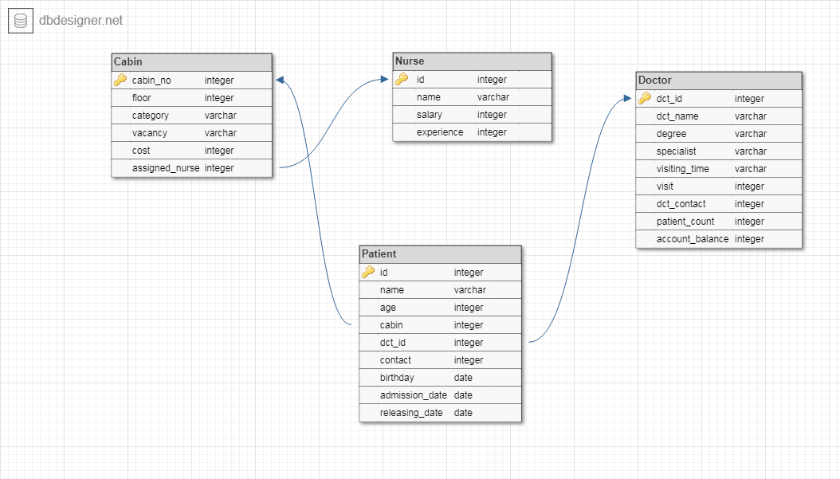

Functionality and Design:

Triggers:

1.Trigger Name: "in_nurse"

Description: When a new nurse is inserted this trigger sets intial experience = 0 and initial salary = 5000 for the nurse;

2.Trigger Name: "up_nurse"

Description: When the experience of a nurse increases, this trigger increases the salary of the nurse.

3.Trigger Name: "up_cabin"

Description: Every cabin has an assigned_nurse. If a nurse is deleted then this trigger assign another nurse in that cabin.

4.Trigger Name: "count_pat"

Description: When a patient is inserted, this trigger increases the patient count of the assigned_doctor.

5.Trigger Name: "cabin_up"

Description: When a patient is admitted in a cabin, this trigger updates the vacancy status of the cabin as "Booked" and when the patient is released, updates the vacancy status of the cabin as "Vacant".

6.Trigger Name: "age"

Description: This trigger calculates the age of a patient from his/her birthday and admission_date and updates the 'age' column of the patient.

7.Trigger Name: "d_acc"

Description: This trigger calculates the total stay of a patient in the nursing home and check the assigned doctor's per day fee. Then it calculates the doctor's bill and updates the doctor's account balance.

Functions and Procedures:

1. Function name: "read"

Description: This function reads the data from a 'Nurse.csv' file, and inserts the data in the nurse table.

2. Procedure name: "allPayment"

Description: This procedure calculates the cabin bill, doctor's bill and total bill for a patient.

3. Function name: "getPatientCharge"

Description: This function call the "allPayment" procedure and writes the cabin bill, doctor's bill and total bill for every released patient in a file.

Cursors:

1. Cursor Name: "cur_doct"

Description: This cursor prints all informations about "Neuro Surgeon".

1. Cursor Name: "cur_pat"

Description: This cursor prints patient's name with his/her corresponding doctor's name and corresponding nurse's name.

1. Cursor Name: "cur_pc"

Description: This cursor prints information of each doctor from every department whose patient count is maximum in that department.

1. Cursor Name: "cur_bill"

Description: This cursor prints cabin bill, doctor's bill and total bill for all released patient.

Summary:

This database project was an attempt to represent a nursing home database. This project was designed to cover all the basic features for a nursing home database system. But for real life scenerios, this system should include more features. But as a beginner to database system design or database concepts in general, I have tried my best to cover all basic necessary ideas in this project.