INDEX

SR.NO TITLE

- ABSRACT
- NTRODUCTION
- WHY PLAGIARISM OCCUR ?
- EXISTING SOFTWARE
- INTRODUCTION TO OUR PLAGIARISM DETECTOR
- HOW IT WORKS
- CNCLUSION
- REFERENCES

PlagaTool: A Plagiarism detection Tool for Project Synopsis.

Abstract
Research is an original and systematic investigation undertaken to discover new facts and information about a phenomenon. This article is discussed about the plagiarism, Students,Research Scholar and Teachers can check research work through our software namely Plagio. Our software checks plagiarized work more efficiently than other softwares .It is less time consuming and affordable to everyone.

Introduction:
Plagiarism involves copying material, either word from word or as a paraphrase, from anything ranging from books, to internet sites, course notes, oral or visual presentations, lab reports, computer assignments, or artistic works. Plagiarism does not refer to words alone — it can also refer to copying images, graphs, algorithms, tables, and ideas. A “presentation”means more than written work: it means any method by which you submit work to your instructor. Even translating the work of another person into another language without citation is plagiarism.Plagiarism means taking the words and thoughts of others (their ideas, concepts, images,sentences, and so forth) and using them as if they were your own, without crediting the author or citing the source.
Plagiarism includes reproducing someone else’s work, whether it be published article, chapter of a book, a paper from a friend or some file, or whatever. Plagiarism also includes the practice of employing another person to alter or revise the work which a student submits as his/her own, whoever that other person may be. Students may discuss assignments among themselves or with an instructor or tutor, but when the actual work is done, it must be done by the student, and the student alone.
WHY MIGHT PLAGIARISM OCCUR ?
There are many reasons why scholars and students plagiarize, for example:
1.When a student is not fully aware of what plagiarism is.
2. When a student does not fully understand the conventions required in academic writing.
3. It can be a panic response to poor time management when an essay deadline is looming.
4. If a student feels a desperate need not to be seen as a failure and so copies to try to ensure ‘success’.
5. It can be a response to different academic traditions.
6. It can be a response to information overload and the ease with which text can be cut and pasted from the other electronic documents or pages on the Internet.
7. It can be an attempt not to displease a tutor.

EXISTING SOFTWARES FOR PLAGIARISM CHECKING:
- TURNITIN : (www.turnitin.com) — In 1998 it was founded by four UC Berkeley students, it provides originality checking, online grading, and peer review into a single service, many of Institutions and Universities using Turnitin to improve the quality of theory research. Turnitin is paid software for the duplicity checking of the thesis, dissertations, articles and research papers.
- PLAGIARISM CHECKER: (www.smallseotools.com) — It is a simple tool for students,scholars, content creators, SEO experts and websites owners to check whether their work has been copied by others.
- Glatt Plagiarism Services :(www.plagiarism.com) — The Glatt Plagiarism Screening Program is the first comprehensive computer software program specifically designed for detecting plagiarism. The procedure assumes that each person has an individual style of writing, i.e.,writing styles are as unique as fingerprints.
- VIPER: (www.scanmyessay.com) — It scans over 10 billion resources has an easy to use interface and highlights areas of plagiarism.

INTRODUCING OUR PLAGIARISM DETECTOR “PlagaTool”:
PlagaTool — The best ever fee plagiarism detection tool. In this tool user can just upload his/her project synopsis or document and then click on search and you get the analysis report regarding the uploaded document. plagaTool is free online plagiarism checking tool is a great benefit to people of any occupation.

This is how our Tool wiil appear :
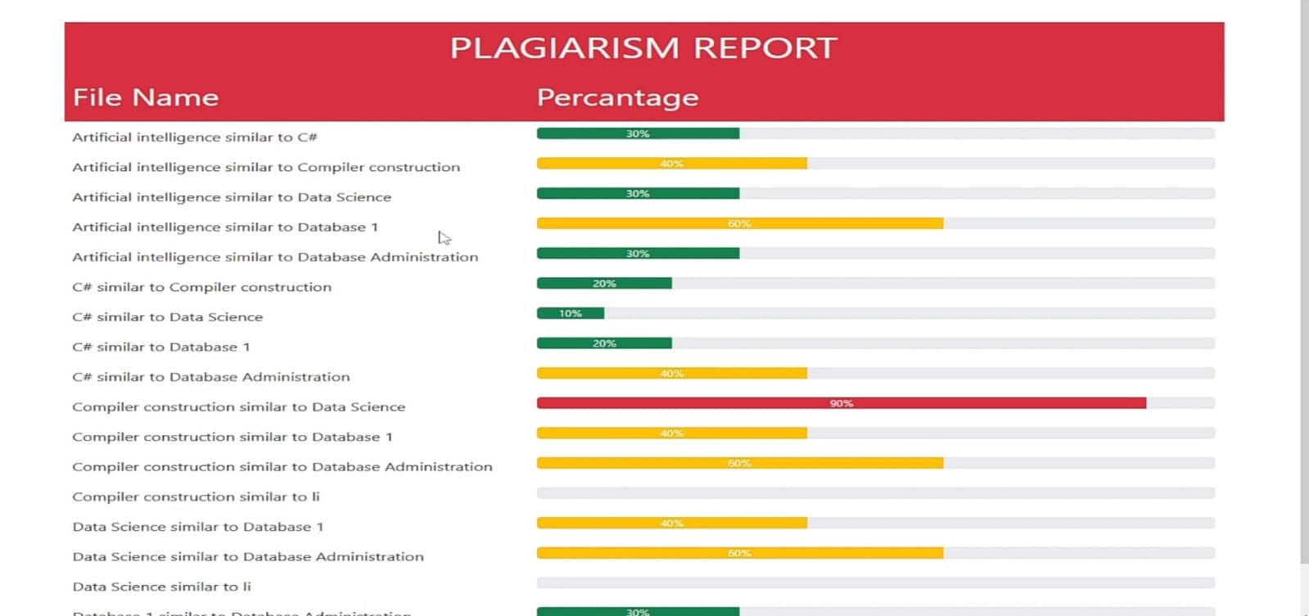

Below Diagram shows the Architecture of PlagaTool:

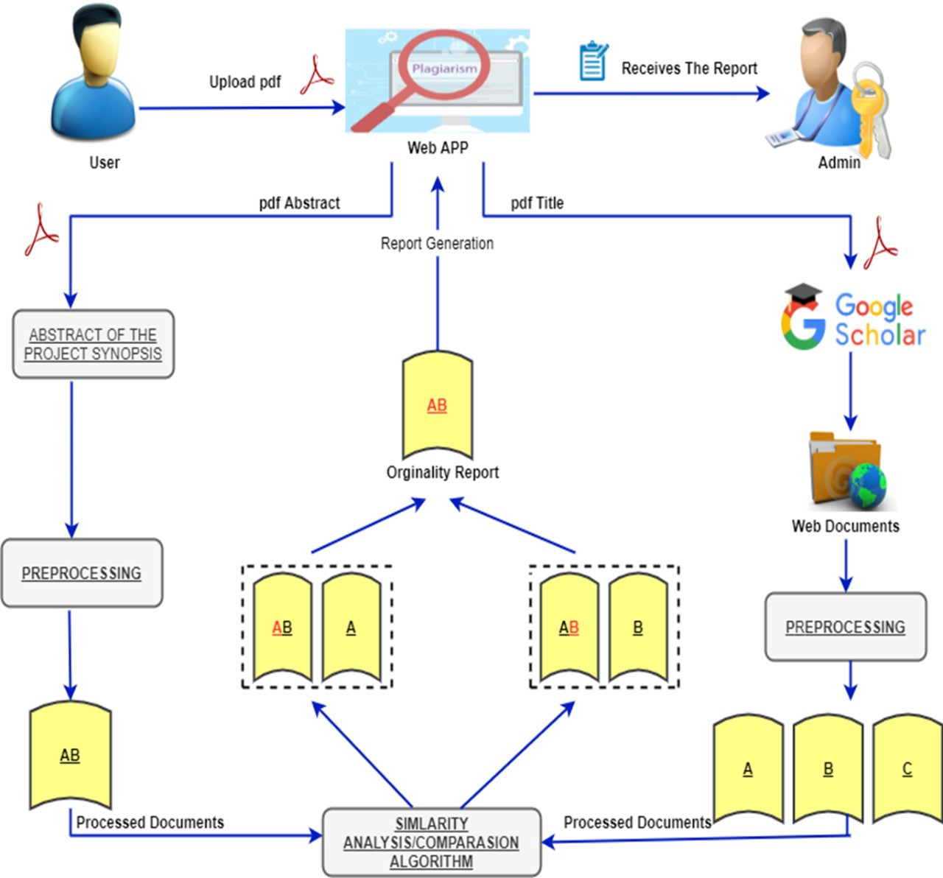

CONCLUSION:
To check the authenticity of the final year project synopsis or research papers and thesis it is always a challenging part. Literature theft occurs also in past years but nobodies know about that. This is the era of Information technology, computers are the most important discovery of the 20th century, and with the discovery of internet it became more powerful. Now many things we got online. They are easy to use, anybody can click the button and get the relevant information, but with the advantage of ICT there are some disadvantage also, anybody can use these online information to their documents. To check all this literature theft our plagiarism detection software(“PLAGATOOL”) is must for every institutions and Universities.

REFERENCES :
https://medium.com/mietcrie/plagio-a-plagiarism-detection-tool-for-project-synopsis-c6be0aed6fc3
YOUTUBE : CHANNEL - CODESTAR TECHNOLOGIES

21

