# AIVERSE APP

## A project report submitted in partial fulfillment of the requirement for the Award of the Degree of

**BACHELOR OF ENGINEERING**

## in

**COMPUTER SCIENCE AND ENGINEERING**

***by***

## DHRUVA SHARMA (160721733008)

## FAREEHA ALI (160721733015)

***Under the Guidance of***

## Mr. T. Vijay Kumar, Assistant Professor, Dept. of CSE

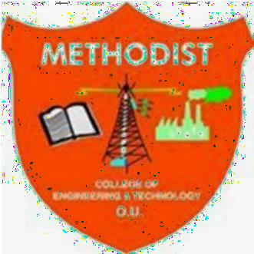

**Department of Computer Science and Engineering**

**Methodist College of Engineering and Technology,**

**King Koti, Abids, Hyderabad-500001.**

**2023-2024**

# Methodist College of Engineering and Technology, King Koti, Abids, Hyderabad-500001.

**Department of Computer Science and Engineering**

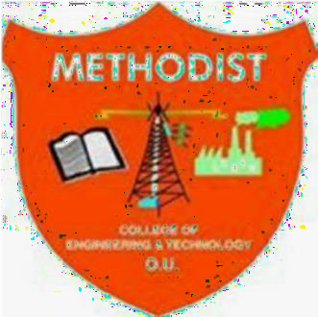

# DECLARATION BY THE CANDIDATES

We, **Dhruva Sharma (160721733008), Fareeha Ali (160721733015)** students of Methodist College of Engineering and Technology, pursuing Bachelor’s degree in Computer Science and Engineering, hereby declare that this project report entitled “**AIverse App",** carried out under the guidance of **Mr. T. Vijay Kumar** submitted in partial fulfillment of the requirements for the degree of Bachelor of Engineering in Computer Science. This is a record work carried out by us and the results embodied in this project have not been reproduced/copied from any source.

### Dhruva Sharma (160721733008)

**Fareeha Ali (160721733015)**

# Methodist College of Engineering and Technology, King Koti, Abids, Hyderabad-500001.

**Department of Computer Science and Engineering**

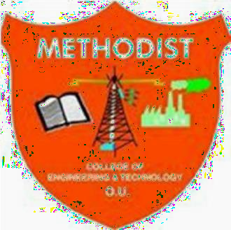

# CERTIFICATE BY THE SUPERVISOR

This is to certify that this project report entitled “**AIverse App**” being submitted *by* **Dhruva Sharma (160721733008), Fareeha Ali (160721733015)** submitted in partial fulfillment of the requirements for the degree of Bachelor of Engineering in Computer Science and Engineering, during the academic year 2023-2024, is a bonafide record of work carried out by them.

**Mr. T. Vijay Kumar,**

Assistant Professor

Date:

# Methodist College of Engineering and Technology, King Koti, Abids, Hyderabad-500001.

**Department of Computer Science and Engineering**

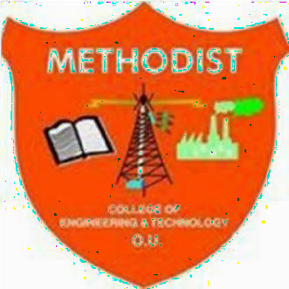

# CERTIFICATE BY THE HEAD OF THE DEPARTMENT

This is to certify that this project report entitled “**AIverse App”** by **Dhruva Sharma (160721733008), Fareeha Ali (160721733015)** submitted in partial fulfillment of the requirements for the degree of Bachelor of Engineering in Computer Science and Engineering of the Osmania University, Hyderabad, during the academic year 2023-2024, is a bonafide record of work carried out by them.

### Dr.P.Lavanya,

Professor & Head of the Department

**DATE:**

# ACKNOWLEDGEMNTS

We would like to express our sincere gratitude to my project guide **Mr. T. Vijay Kumar, Assistant Professor,** for giving us the opportunity to work on this topic. It would never be possible for us to take this project to this level without her innovative ideas and her relentless support and encouragement.

We would like to thank our project coordinator **Dr. Praveen Kumar, Assistant Professor,** who helped us by being an example of high vision and pushing towards greater limits of achievement.

Our sincere thanks to **Dr.P.Lavanya, Professor** and **Head of the Department of Computer Science and Engineering,** for her valuable guidance and encouragement which has played a major role in the completion of the project and for helping us by being an example of high vision and pushing towards greater limits of achievement.

We would like to express a deep sense of gratitude towards the **Dr. Prabhu G Benakop, Principal, Methodist College of Engineering and Technology,** for always being an inspiration and for always encouraging us in every possible way.

We would like to express a deep sense of gratitude towards the **Dr. Lakshmipathi Rao, Director, Methodist College of Engineering and Technology,** for always being an inspiration and for always encouraging us in every possible way.

We are indebted to the Department of Computer Science & Engineering and Methodist College of Engineering and Technology for providing us with all the required facility to carry our work in a congenial environment. We extend our gratitude to the CSE Department staff for providing us to the needful time to time whenever requested.

We would like to thank our parents for allowing us to realize our potential, all the support they have provided us over the years was the greatest gift anyone has ever given us and also for teaching us the value of hard work and education. Our parents have offered us with tremendous support and encouragement, thanks to our parents for all the moral support and the amazing opportunities they have given us over the years.

**TABLE OF CONTENTS**

**Table Of Contents…………………………………………………………….i-ii**

**Abstract………………………………………………………………………...iii**

1. **Introduction………………………………………………………….…….01**
2. **Literature Survey……………………………………………………….02-03**
   1. Survey description……………………………………………...02
   2. Existing Idea……………………………………………………03
   3. Proposed Idea…………………………………………………..03
3. **Design Analysis……………………………………………………….….04-09**
   1. System Architecture……………………………………………04
   2. UML Diagrams……………………………………………….05-09
      1. Use Case Diagram……………………………………………06
      2. Sequence Diagram……………………………………………07
      3. Activity Diagram……………………………………………..08
      4. State Chart Diagram………………………………………….09
4. **Feasibility Study………………………………………………………….10**
   1. Operational Feasibility…………………………………………10
   2. Economic Feasibility…………………………………………...10
   3. Technological Feasibility……………………………………....10
5. **Implementation………………………………………………………….11-12**
   1. Selection of AI tools……………………………………………11
   2. Creation of the App structure………………………………….11-12
   3. Linking the App and AI tools…………………………………..12
6. **Graphical User Interface……………………………………………….13-14**
   1. Overview……………………………………………………….13
   2. GUI of AIverse……………………………………………….13-14
7. **Testing…………………………………………………………………...15-16**
   1. Unit Testing…………………………………………………….15
   2. Integrated Testing………………………………………………15
   3. System Testing…………………………………………………16
   4. Acceptance Testing…………………………………………….16

**Conclusion……………………………………………………………………17**

**References……………………………………………………………………18**

**Appendix…………………………………………………………………….19-23**

* A: Sample Code……………………………………………………19-20
* B: Hardware & Software Requirements…………………………..…21
* C: Technology Used………………………………………………..22-23

**ABSTRACT**

AIverse: Your Ideal Companion for Everyday Efficiency!

Unlock the Power of AI with our cutting-edge Android app, which was carefully developed in Android Studio using Kotlin. Our mission? To revolutionize daily tasks by offering a variety of AI tools and resources at your fingertips. But wait, there's more! We curate a universe of AI tools covering education, videos, literature, and beyond. Our easy-to-use interface ensures a seamless experience, making complex tasks as simple as a click. Why us? While open-source solutions exist, our app goes the extra mile. Along with flexibility, we hand-pick effective free AI tools. Furthermore, we also provide the features and limitations associated with each AI tool so you can choose the one that best suits your requirements.

1. **INTRODUCTION**

Artificial Intelligence (AI) and its innovative tools have become a game-changer in our rapidly evolving society. Before the arrival of AI, tasks that demanded human intelligence were restricted to human capabilities. However, with the introduction of AI, a new era unfolded, marked by machines emulating human-like thinking processes.

Prior to AI becoming widely used, activities could only be completed by humans through physical labor. Automating complicated operations felt like a far-off dream. The concept of autonomously learning, adapting, and making judgments by machines was a vision that had the potential to completely change how we viewed everyday tasks and problem-solving.

In the modern day, artificial intelligence has not only entered our lives but also assimilated into society. The effects are significant. Automating routine processes with AI tools has freed up human resources to work on more strategic and creative projects. Efficiency has increased across a range of businesses as a result of the ability to do tasks that formerly took hours in a fraction of the time.

The introduction of AI has spread through our daily lives, from personalized recommendations on streaming platforms to advanced medical diagnostics. The convenience of virtual assistants and the accuracy of AI-powered predictions have become integral parts of our routines. AI's ability to process vast amounts of data enables it to make informed decisions, enhancing our decision-making processes.

In the professional sphere, AI has revolutionized the way we work. It has become an indispensable tool in fields such as finance, healthcare, marketing, and more. Automation of repetitive tasks has allowed professionals to focus on tasks that require critical thinking and creativity. AI has not replaced jobs but has instead redefined roles, creating a symbiotic relationship between human intelligence and machine efficiency.

The journey from conceptualizing AI to its integration into society has been transformative. AI has not only eased our daily burdens but has also elevated our capabilities. As we continue to explore the potential of AI and its tools, the collaboration between human ingenuity and artificial intelligence promises a future where innovation knows no bounds.

**2. LITERATURE SURVEY:**

**2.1 SURVEY DESCRIPTION**

The purpose of this literature survey was to investigate various AI tools and the user engagement with these AI tools. With the rapid advancements in Artificial Intelligence (AI), it is crucial to understand user’s knowledge, attitudes, and experiences related to AI tools. This survey aimed to gather insights that contributed to the development of effective strategies for finding efficient AI tools and enhancing user engagement with them.

The survey began with an exploration of various AI tools across several categories along with user’s awareness about them. By assessing numerous AI tools, the survey helped in identification of the features and limitations of each of these tools. It also examined user’s perceptions and attitudes towards AI to identify any preconceived notions or biases that may influence their engagement with AI tools.

Furthermore, the survey delves into the frequency and extent of usage of these AI tools, providing valuable insights into the level of engagement with AI features. It also looked into user feedback regarding their experience and satisfaction with AI tools, including their perceived benefits and challenges.

In addition to understanding user experiences, the survey explored factors that may influence user adoption and engagement with AI tools. It examined the role of user interface and design in facilitating or hindering user engagement. Trust and privacy concerns related to AI tools were also assessed, as these factors can significantly impact user acceptance and engagement. Moreover, user’s perceptions of the accuracy and reliability of AI tools was investigated to identify potential barriers in engagement.

The survey addressed the importance of user education and training in effectively engaging with AI tools. It explored user’s needs in terms of education and training resources to enhance their AI literacy and enable more meaningful engagement with AI features.

The findings from this literature survey provided a comprehensive understanding of AI tools and their user engagement. These insights contributed to the development of user-centric app. By understanding user’s knowledge, attitudes, and experiences, we were able to create more user-friendly and accessible app containing efficient AI tools that cater to the needs and preferences of target audience.

In conclusion, this literature survey assisted in investigating numerous AI tools along with their features and limitations. By assessing user’s awareness, experiences, and perceptions, this survey provided valuable insights into the factors influencing use of AI tools. Ultimately, this research facilitated the creation of an app that is user-centric, accessible, and capable of delivering effective AI tools across various categories.

**2.2 EXISTING IDEA**

There are few websites that provide suggestion for various AI tools like,

* TopAiTools.in
* Zapier.com
* Insidr.ai, etc.

But the problem with these websites is that,

* Some of them won’t suggest AI tools as per categories.
* Some might not specify if tools are free or not.
* They do not specify what are the limitations of the AI tools that are free.

**2.3 PROPOSED IDEA**

AIverse app tries to address these problems by,

* Providing free AI tools based on categories.
* All the AI tools suggested in the app are tried-and-tested to provide best choices.
* These is also a list of features and limitations of each AI tool.
* Users can make a selection as per their needs.

The main idea is to provide set of free and efficient AI tool options to the users along with their features and limitations so that the user can make a selection as per their needs. It makes sure that the user doesn’t have to spend a lot of time exploring tools to check if they are free or not, and if they are free then do they work efficiently or not. This ultimately reduces frustration, saves times and ensures that user has a pleasant experience.

**3. DESIGN ANALYSIS**

**3.1 SYSTEM ARCHITECTURE**

A system architecture is the conceptual model that defines the structure, behavior, and more views of a system. An architecture description is a formal description and representation of a system, organized in a way that supports reasoning about the structures and behaviors of the system.

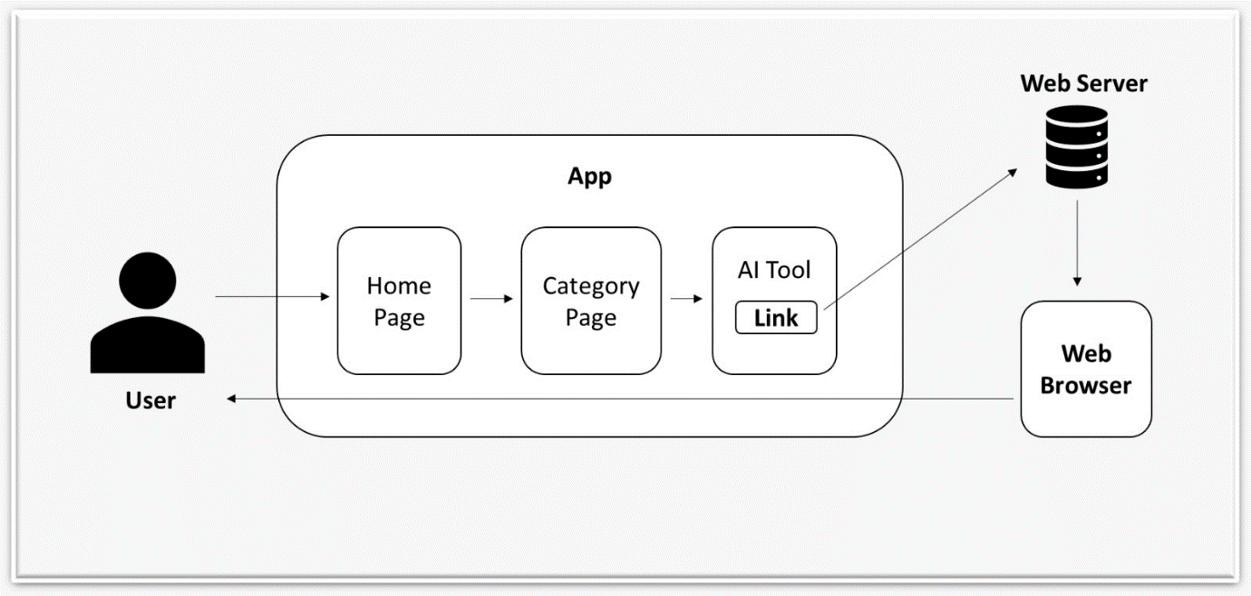

*Fig-3.1 System Architecture*

**3.2 UML DIAGRAMS**

A UML diagram is a way to visualize systems and software using Unified Modeling Language (UML). Software engineers create UML diagrams to understand the designs, code architecture, and propose implementation of complex software systems. UML diagrams are also used to model workflows and business processes.

UML is a way of visualizing a software program using a collection of diagrams. The notation has evolved from the work of Grady Booch, James Rumbaugh, Ivar Jacobson, and the Rational Software Corporation to be used for object-oriented design, but it has since been extended to cover a wider variety of software engineering projects. Today, UML is accepted by the Object Management Group (OMG) as the standard for modeling software development.

There are two subcategories of UML diagrams: structural diagrams and behavioral diagrams.

* **Structural diagrams** depict a static view or structure of a system. It is widely used in the documentation of software architecture. It embraces class diagrams, composite structure diagrams, component diagrams, deployment diagrams, object diagrams, and package diagrams. It presents an outline for the system. It stresses the elements to be present that are to be modeled.
* **Behavioral diagrams** portray a dynamic view of a system or the behavior of a system, which describes the functioning of the system. It includes use case diagrams, state diagrams, and activity diagrams. It defines the interaction within the system, how all the components interact with each other and with other systems or users.

**3.2.1 USE CASE DIAGRAM**

* A use case diagram is a dynamic or behavior diagram in UML. Use case diagrams model the functionality of a system using actors and use cases.
* Use cases are a set of actions, services, and functions that the system needs to perform.
* In this context, a "system" is something being developed or operated, such as a web site or app. The "actors" are people or entities operating under defined roles within the system.
* Use case diagrams are valuable for visualizing the functional requirements of a system that will translate into design choices and development priorities.
* They also help identify any internal or external factors that may influence the system and should be taken into consideration.

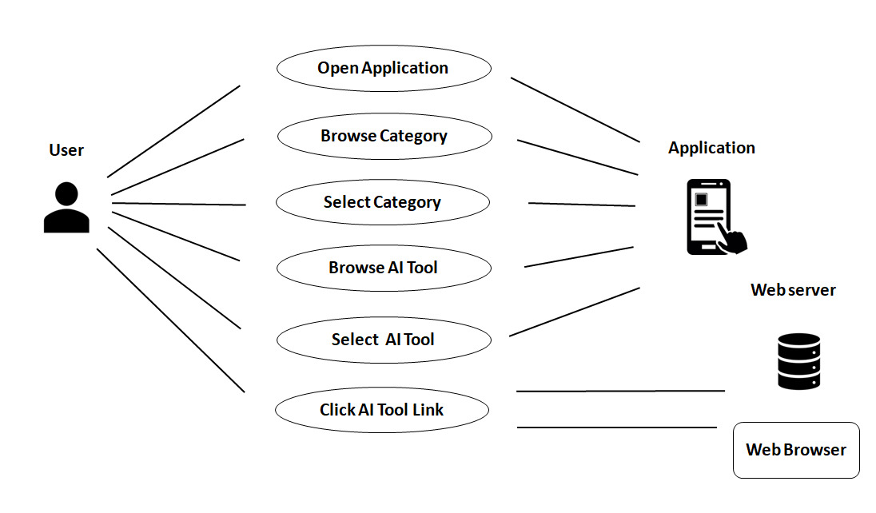

*Fig-3.2.1 Use Case Diagram*

**3.2.2 SEQUENCE DIAGRAM**

* Sequence diagrams describe interactions among classes in terms of an exchange of messages over time. They're also called event diagrams.
* A sequence diagram is a good way to visualize and validate various runtime scenarios.
* These can help to predict how a system will behave and to discover responsibilities a class may need to have in the process of modeling a new system.

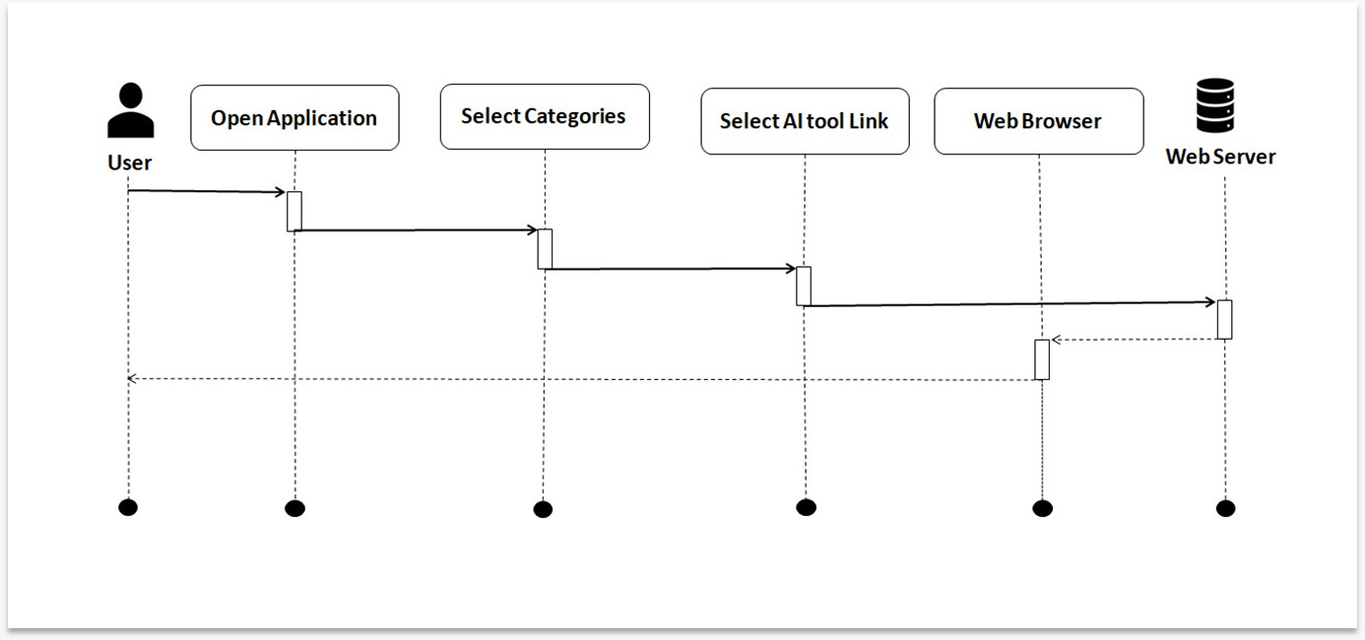

*Fig-3.2.2 Sequence Diagram*

**3.2.3 ACTIVITY DIAGRAM**

* An activity diagram visually presents a series of actions or flow of control in a system similar to a flowchart or a data flow diagram.
* Activity diagrams are often used in business process modeling. They can also describe the steps in a use case diagram.
* Activities modeled can be sequential and concurrent. In both cases an activity diagram will have a beginning (an initial state) and an end (a final state).

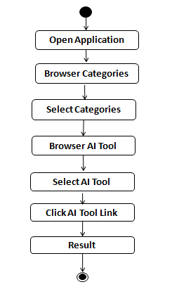

*Fig-3.2.3 Activity Diagram*

**3.2.4 STATE CHART DIAGRAM**

* A state diagram shows the behavior of classes in response to external stimuli.
* Specifically, a state diagram describes the behavior of a single object in response to a series of events in a system.
* Sometimes it's also known as a Harel state chart or a state machine diagram.
* This UML diagram models the dynamic flow of control from state to state of a particular object within a system.

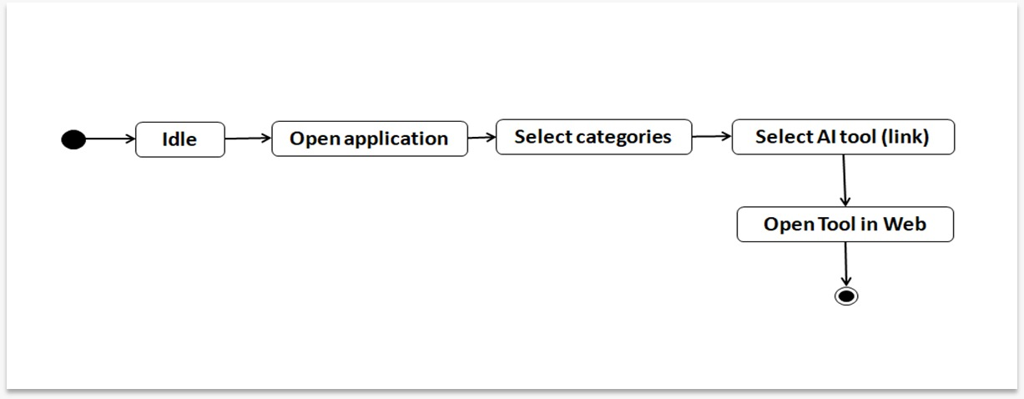

*Fig-3.2.4 State Chart Diagram*

**4. FEASIBILITY STUDY**

A feasibility study is an assessment of the practicality of a proposed plan or project. A feasibility study analyzes the viability of a project to determine whether the project is likely to succeed or not. The study is also designed to identify potential issues and problems that could arise while pursuing the project.

Three key considerations involved in the feasibility analysis are

* Operational Feasibility
* Economic Feasibility
* Technical Feasibility

**4.1 OPERATIONAL FEASIBILITY**

The operational feasibility assessment focuses on the degree to which the proposed project fits in with the existing business environment and objectives about the development schedule, delivery date, corporate culture and existing business processes.

Although this project was something new for us (an android app), it was operationally feasible as we were able to quickly get started and finish it up in given timeline of the semester, once we were clear about the end goal of what we want the app to look like and function things were swift.

**4.2 ECONOMIC FEASIBILITY**

Economic analysis could also be referred to as cost/benefit analysis. In economic analysis the procedure is to determine the benefits and savings that are expected from a candidate system and compare them with costs. If benefits outweigh costs, then the decision is made to design and implement the system.

This project was economically feasible considering the fact that for attaining this stage or version of the app we didn’t require anything outside of what we already had. However, for the development of further versions of the app there might be some cost associated, but the benefits will still outweigh the costs.

**4.3 TECHNICAL FEASIBILITY**

It considers the technical requirements of the proposed project. The technical requirements are then compared to the technical capability of the organization. The systems project is considered technically feasible if the internal technical capability is sufficient to support the project requirements.

In terms of technical feasibility, the project AIverse was feasible in regards with hardware and software requirements, but we had to learn the basics of XML and Kotlin in order to work with Android Studio and develop the app.

**5. IMPLEMENTATION**

The implementation of AIverse basically consisted of three stages:

* Selection of AI tools
* Creation of the App structure
* Linking the App and AI tools

**5.1 SELECTION OF AI TOOLS**

The selection of AI tools began with creating a list of categories for AI tools. The final list consisted of 10 categories.

These categories were:

* Ask Anything (General)
* Code Generation
* Code Translation
* Content Writing
* Creating Document
* Document Analyzer
* Image Generation
* Recommendations
* Rewriting and Summarization
* Video Generation

Once the categories were finalized, we started with the exploration of AI tools in each category.

After going through numerous of them we ended up with 3 AI tools in each category that were free and efficient.

We tried and tested each one of them in order to identify their features as well as limitations.

**5.2 CREATION OF THE APP STRUCTURE**

Now that we had categories and AI tools finalized, it was time to start developing the app.

We first created a simple sketch (medium-fidelity) of what we wanted the app structure to look like with the basic views and components.

The app structure contained following:

* The Home Page – containing list of categories
* The Category Page – containing 3 AI tools for that category
* The AI Tool Page – containing the AI tool link along with features and limitations

Using Android Studio, we began developing the AIverse app. We used XML for frontend and Kotlin for backend. Starting with the home page, once that was done, we moved towards creating each category page and finally we created all the AI tool pages.

After the frontend of all the pages were created, we started with backend connectivity for the pages. With that the basic app structure was developed.

**5.3 LINKING THE APP AND AI TOOLS**

Now that the list of AI tools and basic structure of the app was finished, it was time to link the app with the AI tools.

One by one we added links for all the AI tools to their respective AI tool page with the help of XML and Kotlin.

Once all of this was done, AIverse app was finally ready.

**6. GRAPHICAL USER INTERFACE**

**6.1 OVERVIEW**

A Graphical User Interface (GUI) is a digital interface in which a user interacts with graphical components such as icons, buttons, and menus. In a GUI, the visuals displayed in the user interface convey information relevant to the user, as well as actions that they can take.

In a GUI, visual elements represent actions users can take, objects that users can manipulate, and other information relevant to the user. Some common visual elements are:

* Buttons, which users may click or tap to initiate an action
* Toolbar and ribbons, essentially groups of buttons
* Icons, small images that represent information or interactive components
* Menus, lists of clickable items
* Scrollbars, for scrolling down the page

The ultimate purpose of GUIs is to allow humans to interact with a device’s underlying code by separating us from the technical details and presenting a simplified interface to the user. This process is called abstraction, and is a key concept when designing and building interfaces.

**6.2 GUI OF AIVERSE**

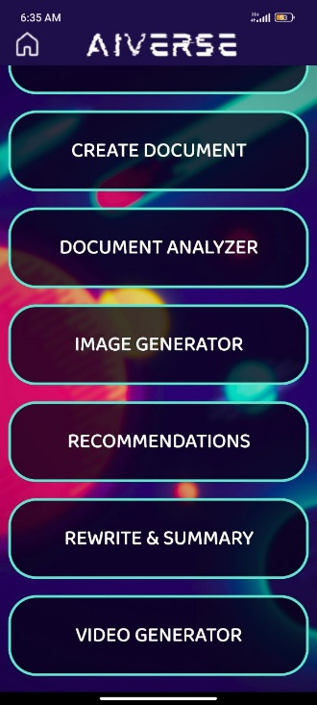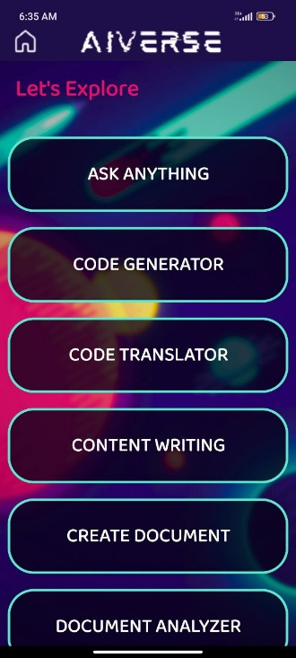

**Home Page**

It consists of 10 buttons for each of the 10 categories, when clicked will take the user to respective category page.

*Fig-6.2.1 and 6.2.2 Home Page*

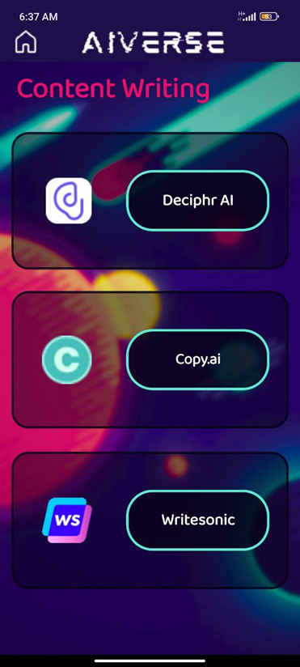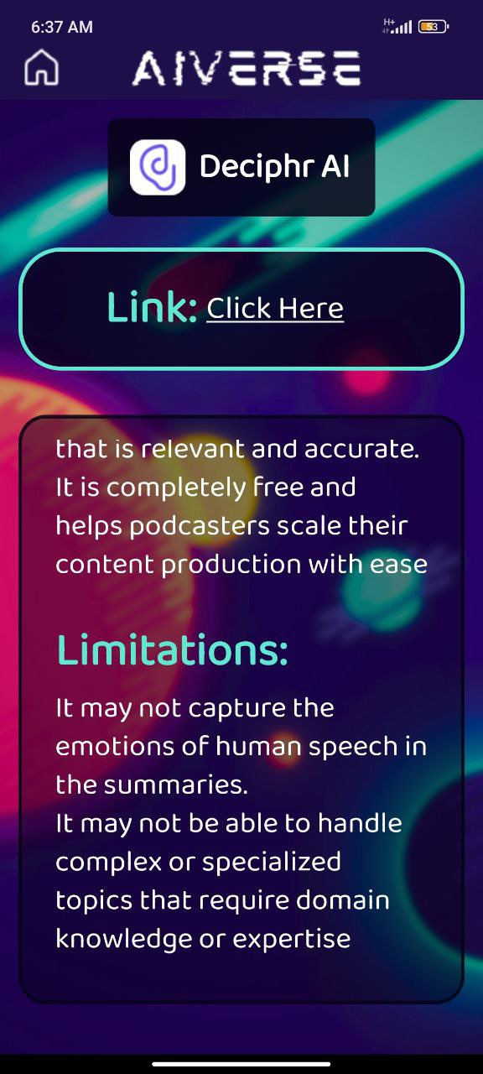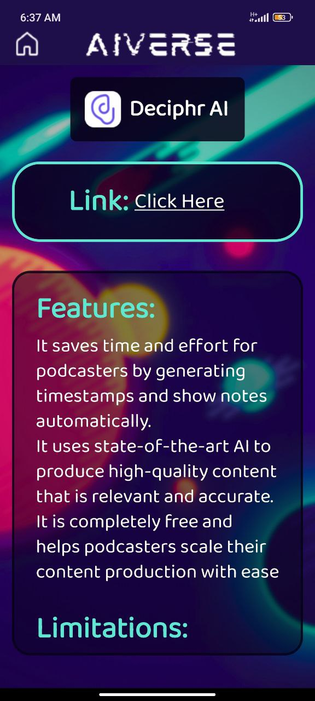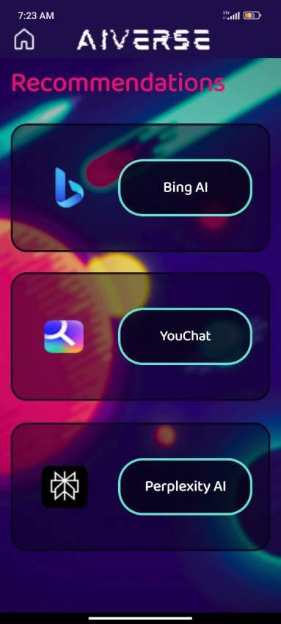

AI Tool Page

It consists of AI tool icon and name, along with it’s link, when clicked will open the AI tool in the browser.

It also contains features and limitations of that AI tool.

Category Page

It consists of name of the category on top, followed by 3 AI tools of that category.

AI tools have their respective icons and labelled buttons, when clicked will take the user to respective AI tool page.

*Fig-6.2.3 Content Writing Page*

*Fig-6.2.5 and 6.2.6 Deciphr AI Page*

*Fig-6.2.4 Recommendations Page*

**7. TESTING**

Testing is a method to assess the functionality of the software program. The process checks whether the actual software matches the expected requirements and ensures the software is bug-free. The purpose of software testing is to identify the errors, faults, or missing requirements in contrast to actual requirements. It mainly aims at measuring the specification, functionality, and performance of a software program or application.

Testing can be stated as the process of verifying and validating whether a software or application is bug-free, meets the technical requirements as guided by its design and development, and meets the user requirements effectively and efficiently.

Software Testing levels that were applied to test AIverse app:

* Unit Testing
* Integration Testing
* System Testing
* Acceptance Testing

**7.1 UNIT TESTING**

Unit testing is a type of software testing that focuses on individual units or components of a software system. The purpose of unit testing is to validate that each unit of the software works as intended and meets the requirements. Unit testing is typically performed by developers, and it is performed early in the development process before the code is integrated and tested as a whole system.

Unit tests are automated and are run each time the code is changed to ensure that new code does not break existing functionality. Unit tests are designed to validate the smallest possible unit of code, such as a function or a method, and test it in isolation from the rest of the system. This allows developers to quickly identify and fix any issues early in the development process, improving the overall quality of the software and reducing the time required for later testing.

**7.2 INTEGRATED TESTING**

Integration testing is the process of testing the interface between two software units or modules. It focuses on determining the correctness of the interface. The purpose of integration testing is to expose faults in the interaction between integrated units. Once all the modules have been unit-tested, integration testing is performed.

Integration testing is a software testing technique that focuses on verifying the interactions and data exchange between different components or modules of a software application. The goal of integration testing is to identify any problems or bugs that arise when different components are combined and interact with each other. Integration testing is typically performed after unit testing and before system testing. It helps to identify and resolve integration issues early in the development cycle, reducing the risk of more severe and costly problems later on.

**7.3 SYSTEM TESTING**

System testing is a type of software testing that evaluates the overall functionality and performance of a complete and fully integrated software solution. It tests if the system meets the specified requirements and if it is suitable for delivery to the end-users. This type of testing is performed after the integration testing and before the acceptance testing.

System Testing is a type of software testing that is performed on a complete integrated system to evaluate the compliance of the system with the corresponding requirements. In system testing, integration testing passed components are taken as input. The goal of integration testing is to detect any irregularity between the units that are integrated together. System testing detects defects within both the integrated units and the whole system. The result of system testing is the observed behavior of a component or a system when it is tested. System Testing is carried out on the whole system in the context of either system requirement specifications or functional requirement specifications or in the context of both. System testing tests the design and behavior of the system and also the expectations of the customer.

**7.4 ACCEPTANCE TESTING**

Acceptance testing is formal testing based on user requirements and function processing. It determines whether the software is conforming specified requirements and user requirements or not. It is conducted as a kind of Black Box testing where the number of required users involved test the acceptance level of the system. It is the fourth and last level of software testing.

User Acceptance Testing (UAT) is a type of testing, which is done by the customer before accepting the final product. Generally, UAT is done by the customer (domain expert) for their satisfaction, and check whether the application is working according to given business scenarios, real-time scenarios.

In this, we concentrate only on those features and scenarios which are regularly used by the customer or mostly user scenarios for the business or those scenarios which are used daily by the end-user or the customer.

**CONCLUSION**

In conclusion, AIverse not only stands as a promising application with a robust technological foundation and a user-centric approach but also distinguishes itself in the crowded landscape of AI resources. While various open-source platforms offer an array of links and information about AI tools, AIverse takes a step further by curating and integrating the most efficient free AI tools along with their functionalities and drawbacks into a seamless app-based experience. The commitment to regular updates ensures that users have access to the latest and most relevant AI tools, custom-tailored to simplify tasks at their fingertips.

**REFERENCES**

1. <https://www.investopedia.com/terms/f/feasibility-study.asp#:~:text=A%20feasibility%20study%20is%20a,profit%20to%20justify%20the%20investment>.
2. <https://osarome.blogspot.com/2011/10/1-technical-feasibility-2-operational.html>
3. <https://en.wikipedia.org/wiki/Feasibility_study#:~:text=Operational%20feasibility%20is%20the%20measure,analysis%20phase%20of%20system%20development>.
4. <https://blog.hubspot.com/website/what-is-gui#:~:text=A%20graphical%20user%20interface%20(GUI,actions%20that%20they%20can%20take>.
5. <https://miro.com/diagramming/what-is-a-uml-diagram/>
6. <https://www.javatpoint.com/uml-diagrams>
7. <https://www.smartdraw.com/use-case-diagram/>
8. <https://www.smartdraw.com/sequence-diagram/>
9. <https://www.smartdraw.com/activity-diagram/>
10. <https://www.smartdraw.com/state-diagram/>
11. <https://www.geeksforgeeks.org/software-testing-basics/>
12. <https://www.geeksforgeeks.org/unit-testing-software-testing/>
13. <https://www.geeksforgeeks.org/software-engineering-integration-testing/>
14. <https://www.geeksforgeeks.org/system-testing/>
15. <https://www.javatpoint.com/acceptance-testing>
16. <https://aitoptools.com/>
17. <https://topai.tools/>
18. <https://www.futuretools.io/>
19. <https://chat.openai.com/>
20. <https://www.bing.com/search?q=Bing+AI&showconv=1&FORM=hpcodx>
21. <https://poe.com/>
22. <https://www.perplexity.ai/>
23. <https://www.youtube.com/watch?v=PxRNg05P3bM>
24. <https://iask.ai/>
25. <https://findmyaitool.com/>
26. <https://www.javatpoint.com/android-studio>
27. <https://www.techtarget.com/whatis/definition/Kotlin>
28. <https://www.androidauthority.com/introduction-to-xml-968598/>

**APPENDIX**

**A: SAMPLE CODE**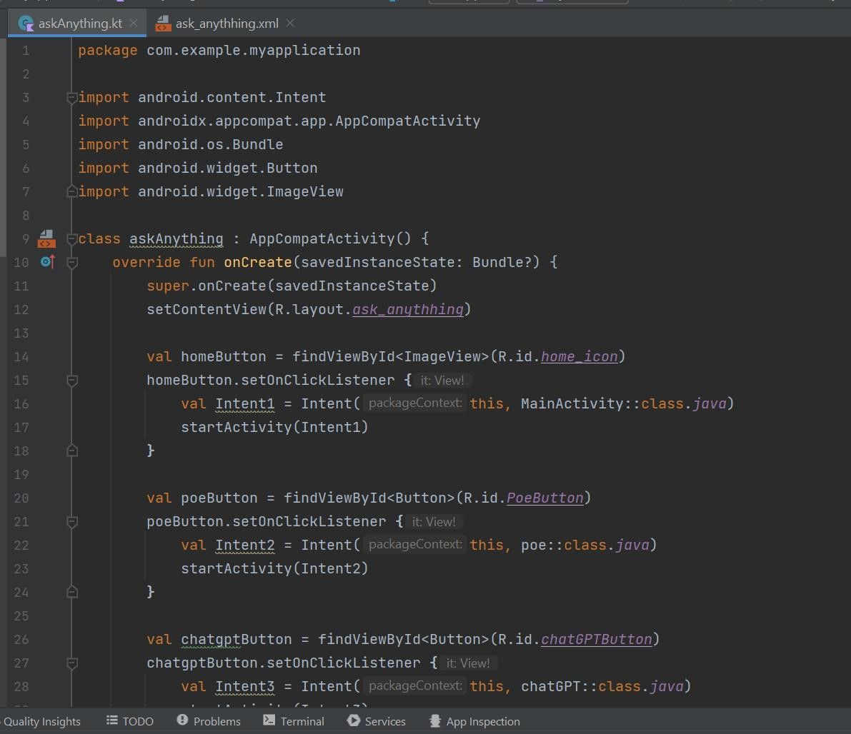

*askAnything.kt*

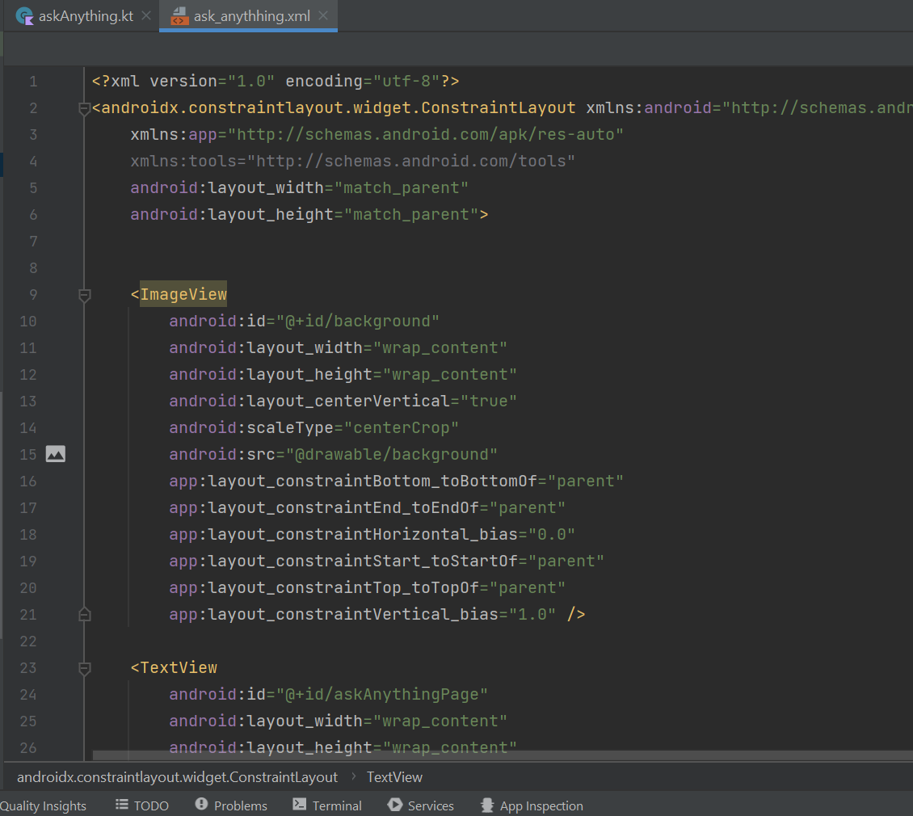

*ask_anything.xml*

**B: HARDWARE & SOFTWARE REQUIREMENTS**

**Hardware Requirements**

RAM : 8GB

Storage : 16GB

**Software Requirements**

Operating System : Windows, Android OS

Software (IDE) : Android Studio

Technology : Kotlin, XML

**C: TECHNOLOGY USED**

**Android Studio**

Android Studio is the official Integrated Development Environment (IDE) for Android app development, providing a comprehensive and user-friendly platform for developers. It is built on the foundation of IntelliJ IDEA's powerful code editor and developer tools, ensuring a robust and efficient development experience. Introduced at the Google I/O conference in May 2013, Android Studio underwent an early access preview from version 0.1 before reaching its first stable release in December 2014 with version 1.0.

The IDE is equipped with a flexible Gradle-based build system, facilitating project management, and a fast, feature-rich emulator for testing applications across various Android devices. It offers a unified environment, enabling developers to create applications seamlessly for all Android devices. Notable features include Live Edit for real-time updates to composable on emulators and physical devices, code templates, GitHub integration, and extensive testing tools.

Since May 7, 2019, Kotlin has been Google's preferred language for Android application development within Android Studio, although the IDE continues to support other programming languages. With built-in support for Google Cloud Platform, C++ and NDK support, as well as lint tools to identify and address various issues, Android Studio stands as a comprehensive and indispensable tool for the efficient creation, testing, and deployment of Android apps.

**Kotlin**

Kotlin is a statically typed, general-purpose programming language developed by JetBrains, that has built world-class IDEs like IntelliJ IDEA, PhpStorm, Appcode, etc. It was first introduced by JetBrains in 2011 and is a new language for the JVM. Later sponsored by Google, announced as one of the official languages for Android Development in 2017.

Kotlin is an object-oriented language, and a “better language” than Java. It was originally designed to improve the Java programming language and is often used in conjunction with Java. Despite being the preferred development language of Android, Kotlin's interoperability with Java has led it to be used with many application types.

It stands out for its interoperability with Java, sharing the same bytecode and enabling smooth integration. It goes beyond just compatibility, allowing compilation into JavaScript or LLVM for versatile use. Safety is a core focus, with features designed to prevent common errors, especially null pointer exceptions. In terms of clarity, Kotlin streamlines syntax, offering a more concise code-writing experience, ultimately saving developers time and increasing productivity.

Developers use Kotlin for Android and other mobile platforms, including Apple iOS, Apple watch OS and Linux.

Kotlin is used mainly for Android mobile app development. Besides Android apps, Kotlin is also useful for the following:

1. Full-stack web development. Developers use Kotlin for JavaScript to translate Kotlin lines of code into JavaScript for front-end web development. This approach lets them use the same code on the front and back ends.
2. Data science: Kotlin is often used for data science tasks, such as building data pipelines and putting machine learning models into production. Jupyter and Zeppelin, two popular data science tools used with Java, also support Kotlin.

**XML (Extensible Markup Language)**

XML plays a fundamental role in Android Studio, the official Integrated Development Environment (IDE) for Android app development. In Android Studio, XML is extensively used to define and structure the user interface (UI) of Android applications offering a lightweight and scalable approach that doesn't burden layouts.

XML is employed to create layout files that specify the arrangement and appearance of UI elements such as buttons, text views, and input fields. These layout files, written in XML, serve as blueprints for the visual presentation of the app.

Unlike languages like C#, C++, Java, Kotlin, or Python, which handle dynamic interactions, XML is a markup language primarily utilized for static user interfaces and data layouts. Derived from Standard Generalized Markup Language (SGML).XML doesn't have predefined tags instead, developers implement and define them.

Data binding, another aspect where XML plays a significant role, enables the direct connection of UI components to the app's data model. This simplifies data synchronization, fostering a seamless interaction between the user interface and underlying data sources.

XML's influence also extends to styles and themes, providing a consistent visual identity for the application. Developers leverage XML to define the aesthetic attributes that govern the overall look and feel, ensuring a cohesive user experience.

Overall, XML in Android Studio emerges as a versatile and indispensable tool, contributing to the comprehensive and efficient development of Android applications.