**Project: 2**

**Serial Transmit of Temperature**

**Course: EN605.715**

**Date: 9/14/2019**

**Principal Investigators:**

**Josh Lowe**

**Nora Karsten**

**Zach Richard**

**Requirements:**

The requirements we derived for this project were to use an arduino with a Round Robin with Interrupts design to serially capture temperature. The temperature will be captured at a rate of 10s, and then transmitted across a serial bus, along with the time. This data will be exported into a file as comma separated values.

**Equipment Used:**

* Arduino Yun
* TMP 36 Temperature Sensor
* Red LED
* Button
* 2 10K Resistors
* Development PC

**Design:**

Hardware

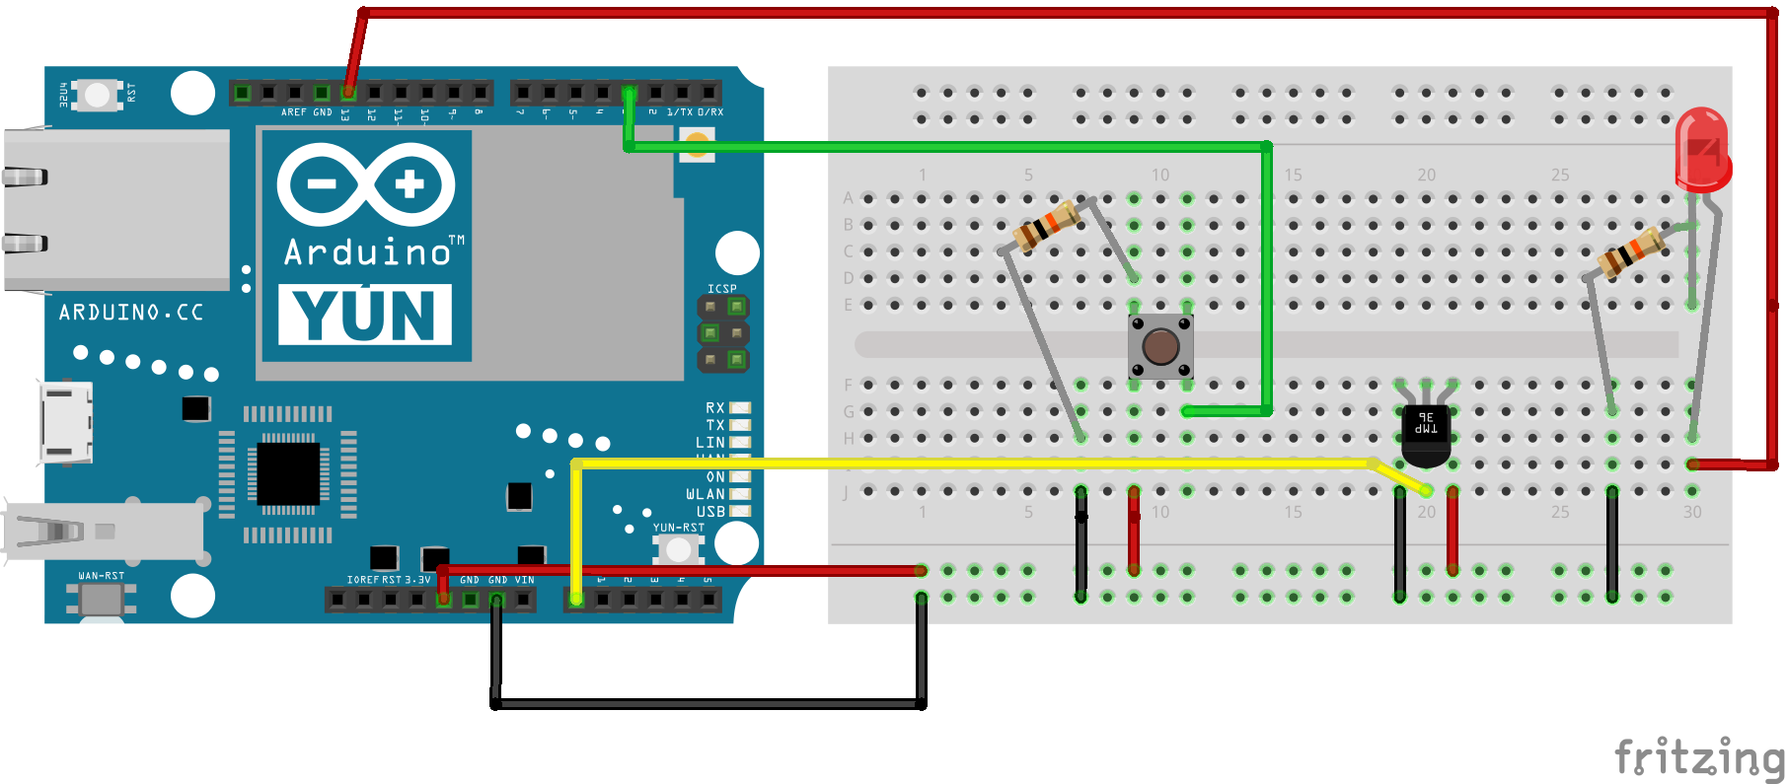

Software

<https://github.com/Fall-2019-EN605-715-Baltimore-Group/Project2-TemperatureSensor>

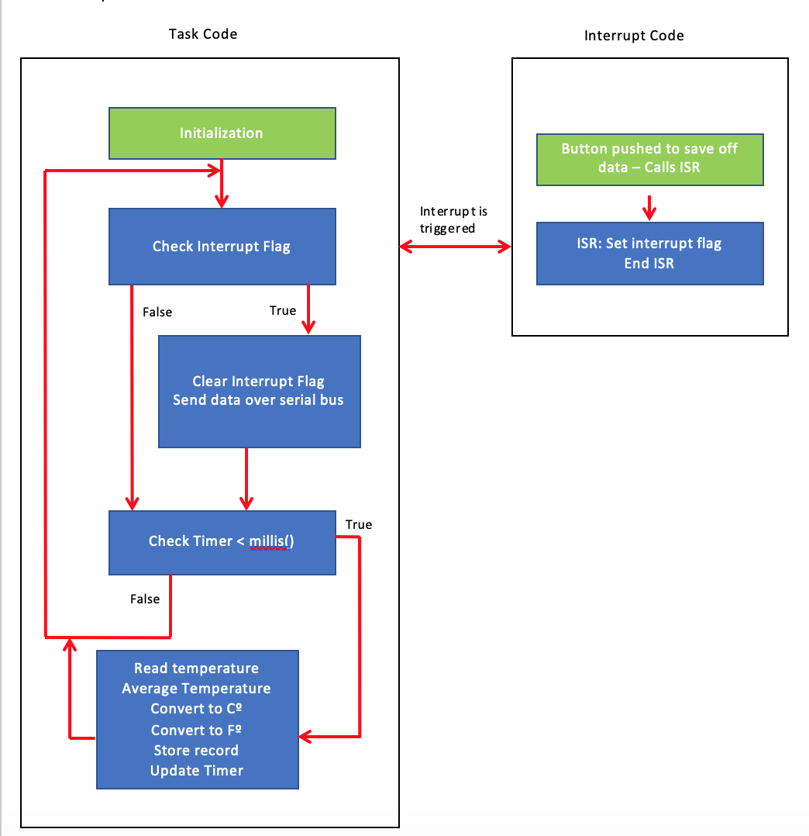

**Demo Photos & Video**

[**https://www.youtube.com/watch?v=QKhkw-z7GBg&feature=youtu.be**](https://www.youtube.com/watch?v=QKhkw-z7GBg&feature=youtu.be)

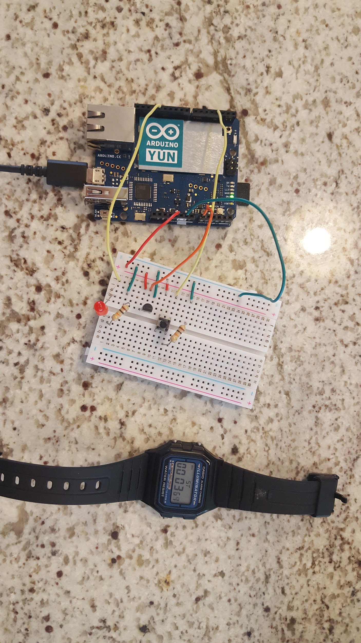

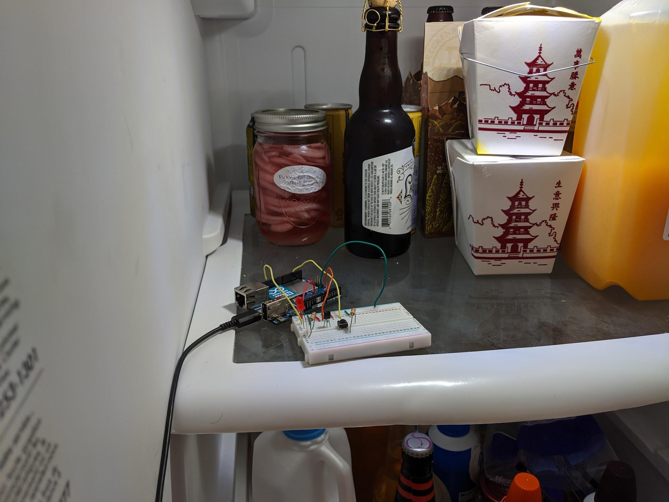

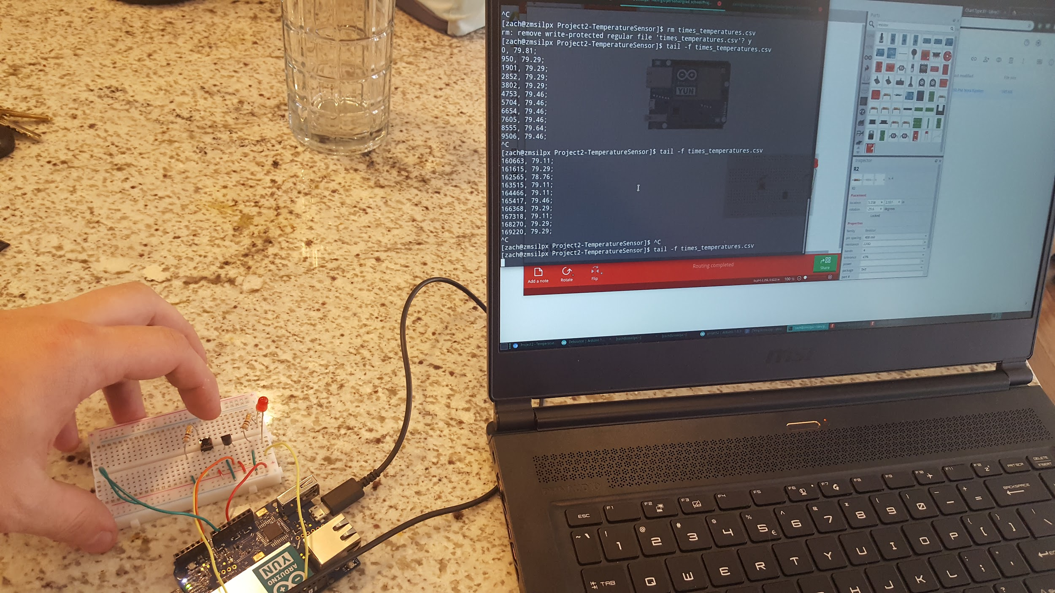

**Data Captured**

