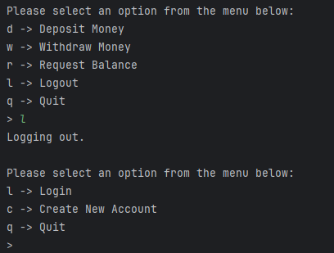

Sample user data, including example above:

Example of errors

