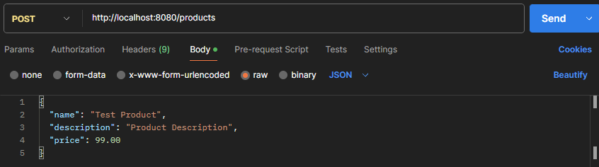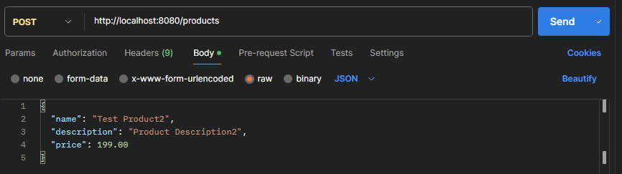

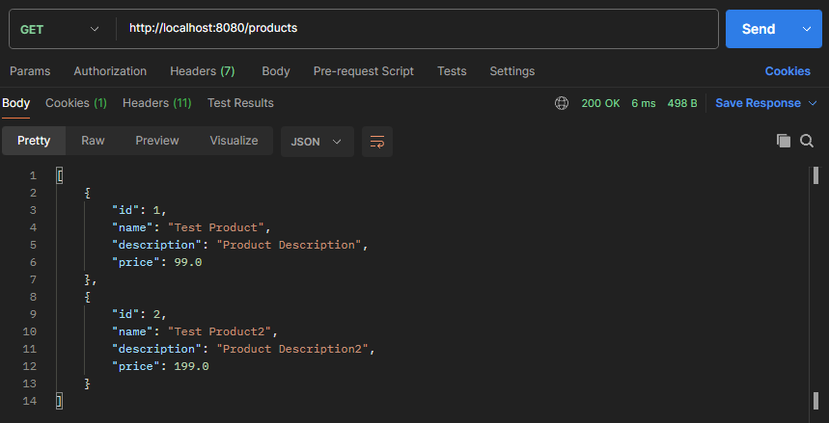

I’ve added the necessary logic in “product controller” to add entries into the database

The database schema is set up, Orders contains a payment_id and product_id

