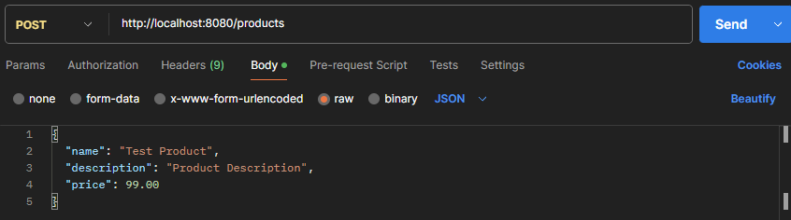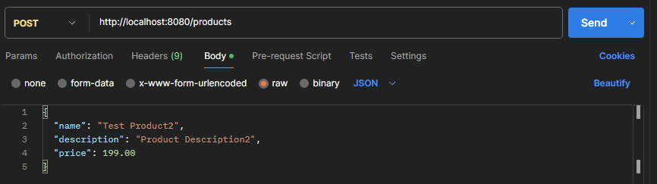

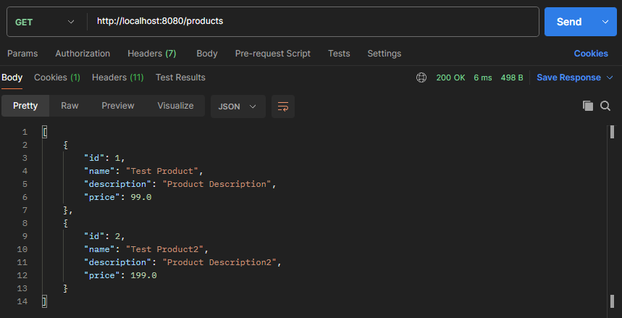

I’ve added the necessary logic in “product controller” to add entries into the database

