1. Unzip the projects into a directory
2. Start IJ and open the projects.
3. Build the project:
4. Make sure dblib.jar and mssql-jdbc.7.2.1.jre.8.jar are exported to project asg1.
5. Select JDK 1.8
6. Click Build Project
7. Run the Client:

* Click on the Add Configuration button next to the build tool.
* Click the “+” button
* Choose Application In the dialog
* Type “asgclient” in the Name field
* Click “…” for main class >> Client

1. Explore the application:
2. You are expected to see this screen shot when you successfully start running this project.

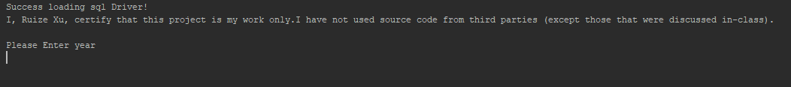

1. After typing in the years and semesters (S or F), the system will show you the following information.

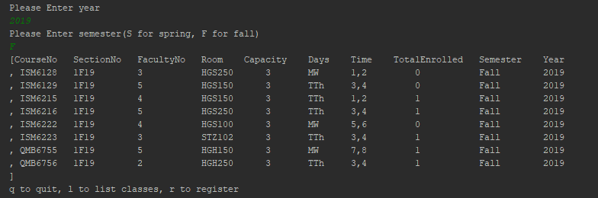

1. Continue to see a student enrolled courses by typing in the student number.

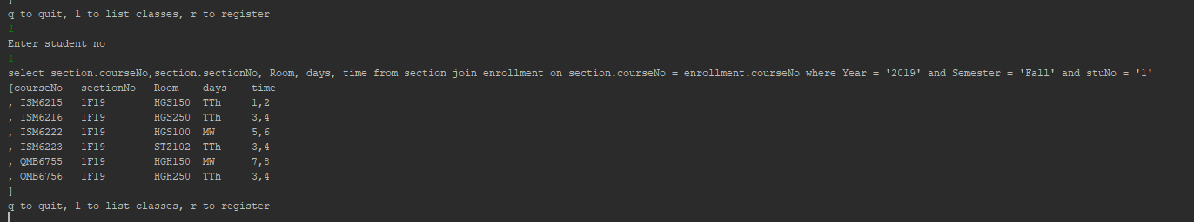

1. After finishing checking, you can exit the system by typing in “q”.