Deliverable 2: Data Understanding & Profiling

KNIME Workflow
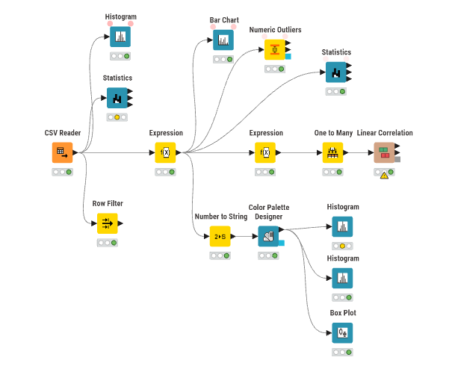
The CSV Reader loads heart.csv (918 rows, 12 columns). The top branch runs Statistics and a histogram on the raw data. The Expression node turns the impossible zeros into missing values, and everything after it (statistics, outliers, charts, correlation) uses that cleaned version.

Data Dictionary
Column | Meaning
Age | Age in years
Sex | M or F
ChestPainType | TA = typical angina, ATA = atypical angina, NAP = non-anginal pain, ASY = asymptomatic (no chest pain)
RestingBP | Resting blood pressure (mm Hg)
Cholesterol | Serum cholesterol (mg/dL)
FastingBS | 1 if fasting blood sugar > 120 mg/dL, else 0
RestingECG | Resting ECG result: Normal, ST (ST-T wave abnormality), LVH (thickened left ventricle)
MaxHR | Max heart rate reached during the exercise test
ExerciseAngina | Chest pain during exercise (Y/N)
Oldpeak | How much the ST segment of the ECG drops during exercise compared to rest. Higher means the heart is not getting enough blood. Negative means it went up instead
ST_Slope | Direction of the ST segment at peak exercise. Up is normal, Flat and Down are signs of heart disease
HeartDisease | Target: 1 = heart disease, 0 = normal

Missing Values
The Statistics node on the raw data shows 0 missing values for every column. But the raw Cholesterol histogram has a big bar at 0, and the Row Filter found 172 rows with Cholesterol = 0 and 1 row with RestingBP = 0. Nobody can have a cholesterol or blood pressure of 0, so these are really missing values that were filled in with 0.
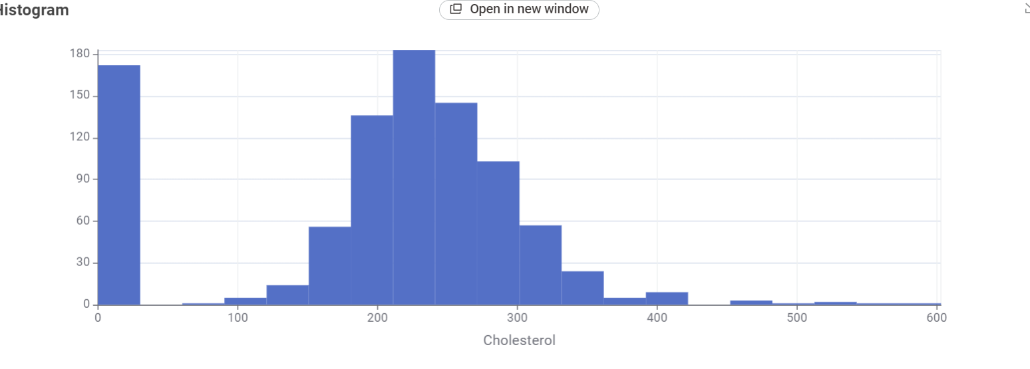
We used an Expression node to replace these zeros with missing values:
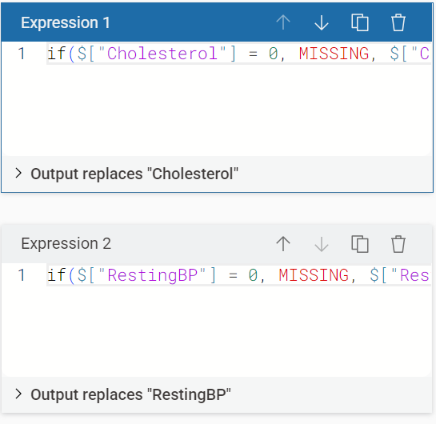
After this, Statistics shows 172 missing in Cholesterol (18.7%) and 1 in RestingBP (0.1%).

Data Audit Table
Numbers are from the Statistics node after the zeros were set to missing. With the zeros still in, Cholesterol had a mean of 198.8, median 223 and std dev 109.4, so the zeros were throwing it off a lot.
Feature | Mean | Median | Std Dev | % Missing
Age | 53.51 | 54 | 9.43 | 0%
RestingBP | 132.54 | 130 | 18.00 | 0.11%
Cholesterol | 244.64 | 237 | 59.15 | 18.74%
FastingBS | 0.23 | 0 | 0.42 | 0%
MaxHR | 136.81 | 138 | 25.46 | 0%
Oldpeak | 0.89 | 0.6 | 1.07 | 0%
HeartDisease | 0.55 | 1 | 0.50 | 0%
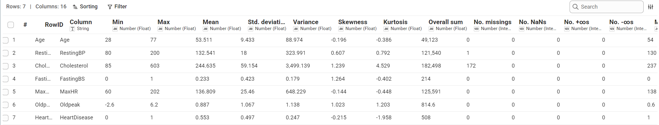

Distributions
Histograms for Age, RestingBP, Cholesterol, MaxHR and Oldpeak:
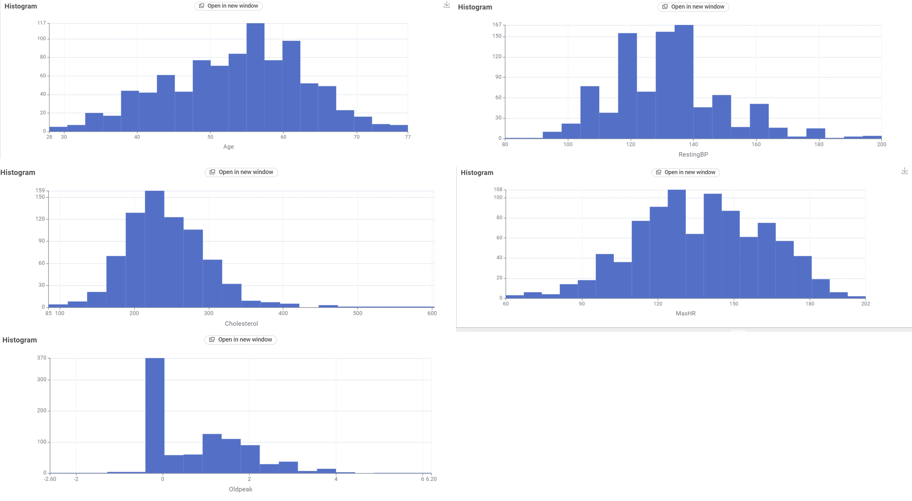
Box plots:
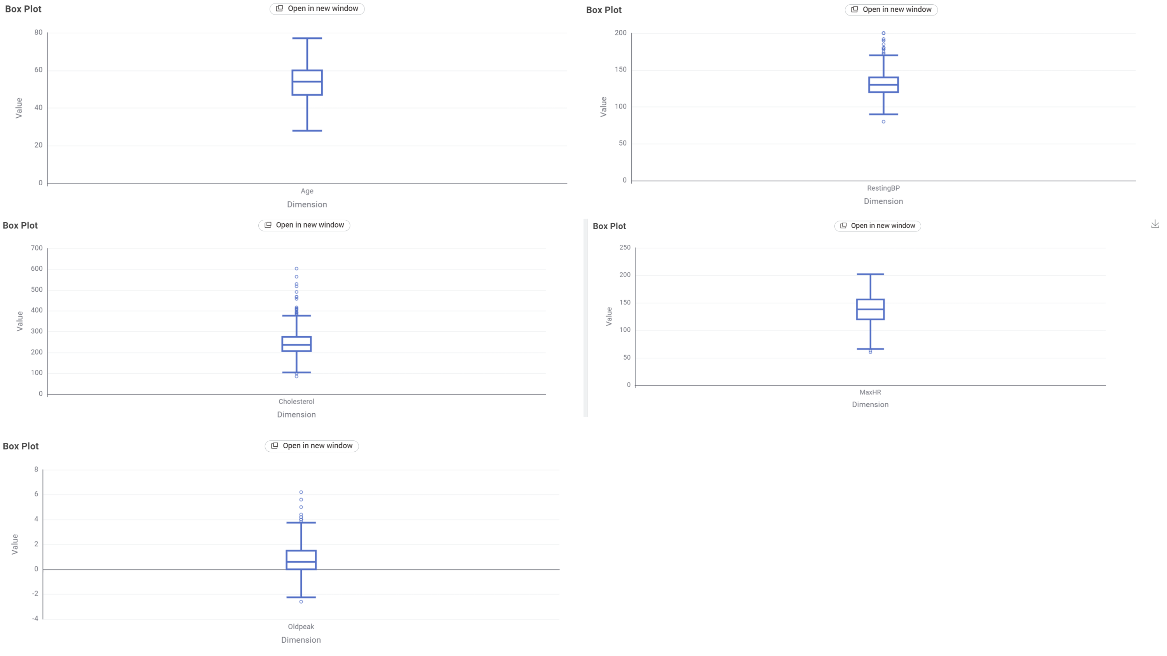
Outlier counts from the Numeric Outliers node (IQR, 1.5):
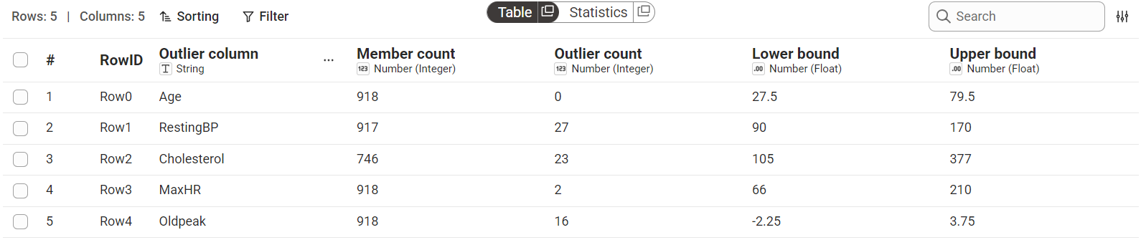
- Age and MaxHR look close to normal (skew -0.20 and -0.14). Age has no outliers and MaxHR has 2 low ones.
- Cholesterol is right skewed (1.24) with 23 outliers, going all the way up to 603.
- Oldpeak is right skewed (1.02) with 16 outliers, and a lot of values are exactly 0.
- RestingBP has 27 outliers, mostly high values between 170 and 200.

Categorical Features
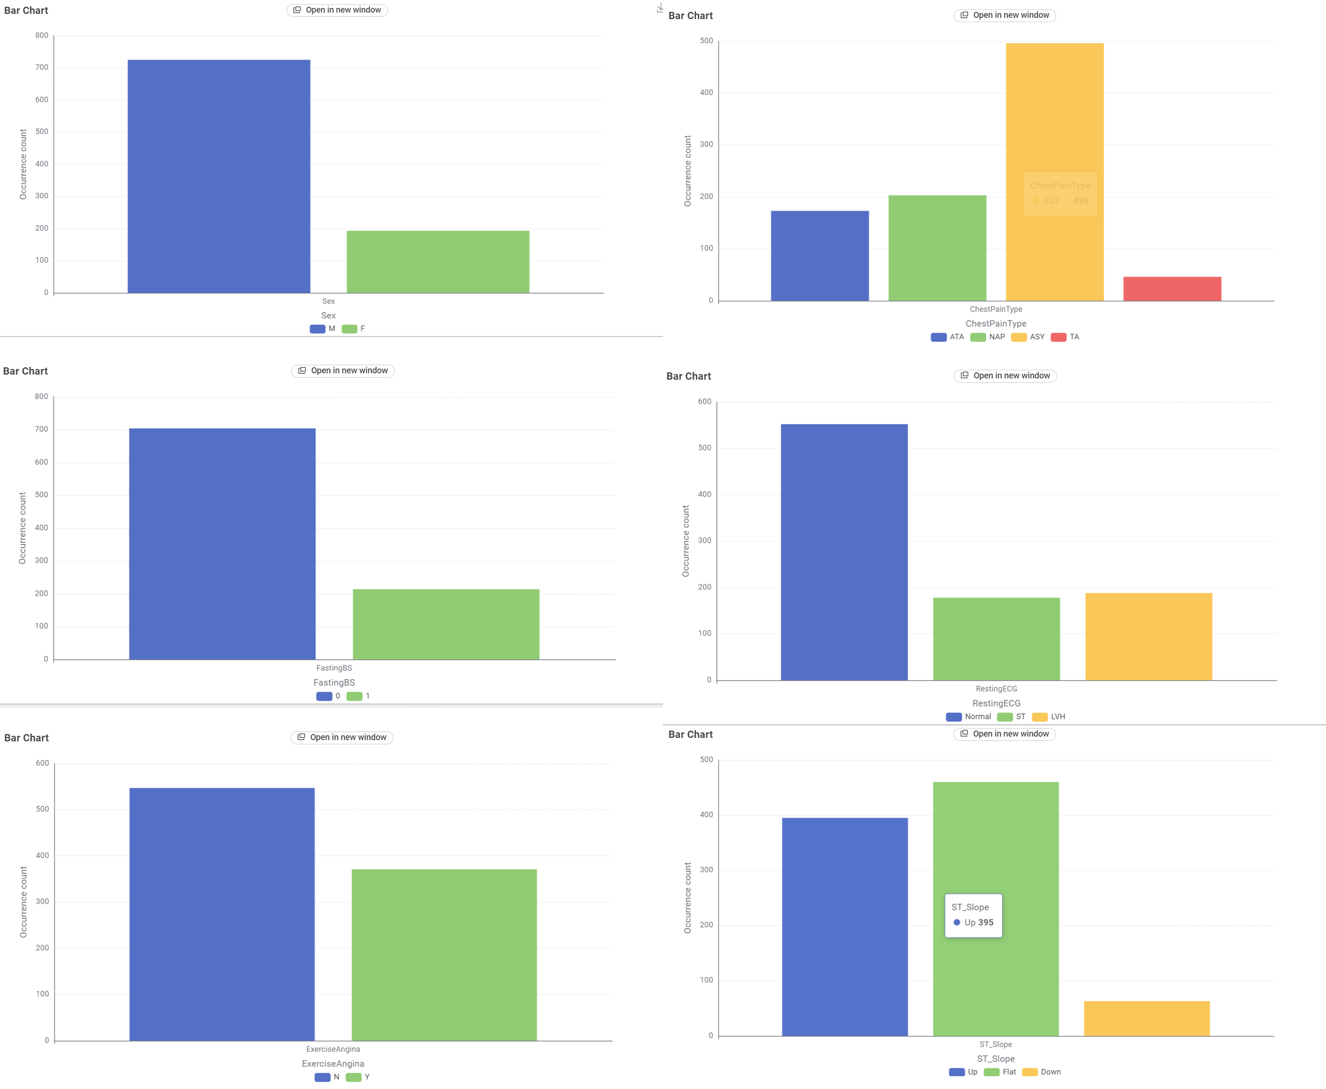
There are a lot more males (725) than females (193). ASY is the most common chest pain type (496), and most patients have a normal resting ECG (552). The Down ST slope is pretty rare (63).

Correlation Matrix
Before running Linear Correlation we turned Sex, ExerciseAngina and ST_Slope into numbers with a second Expression node (M = 1, Y = 1, Up/Flat/Down = 0/1/2), and used One to Many on ChestPainType and RestingECG.
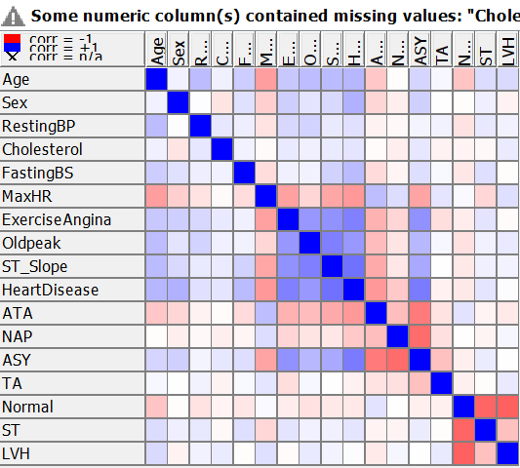
Blue means positive correlation and red means negative. Correlations with HeartDisease:
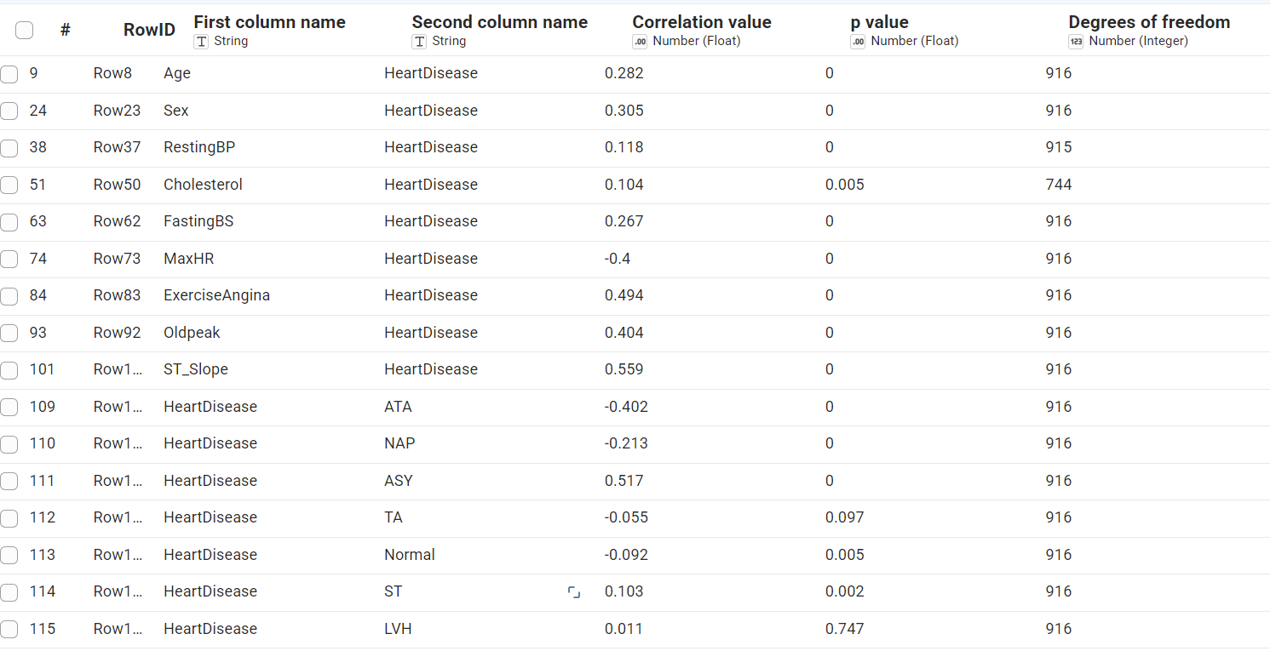
The strongest ones are ST_Slope (0.56), ASY (0.52), ExerciseAngina (0.49), Oldpeak (0.40) and MaxHR (-0.40). RestingBP, Cholesterol and the resting ECG columns are all pretty weak (around 0.1 or less).

Anomaly Log
- 172 zero values in Cholesterol and 1 zero value in RestingBP (set to missing).
- 13 negative Oldpeak values, lowest is -2.6.
- A lot of Oldpeak values are exactly 0.
- Cholesterol goes up to 603, with 23 outliers above the normal range.
- RestingBP has 27 outliers, most of them very high (up to 200).
- MaxHR has 2 very low values (60 and 63) for an exercise test.
- Only 193 of 918 patients (21%) are female.

