Bharat Choithani
A1 1814011

Sign Up:

<?php
if(isset($_POST['email']))
{
$cookie_name = "email";
$cookie_value = $_POST['email'];
setcookie($cookie_name, $cookie_value, time() + (86400 * 30), "/"); // 86400 = 1 day
}
?>

<html>
<title>Sign Up</title>
<style>
.error {color: #FF0000;}
body {background-color: lightgreen;}
h1 {color: black;
font-family: verdana;
font-size: 200%;}
p {color: blue;
font-family: verdana;
font-size: 160%;}
p1 {color: green;
font-family: courier;
font-size: 160%;}
input[type=text] {
border: 2px solid blue;
border-radius: 4px;
}
input[type=email] {
border: 2px solid blue;
border-radius: 4px;
}
input[type=password] {
border: 2px solid blue;
border-radius: 4px;
}
input[type=number] {
border: 2px solid blue;
border-radius: 4px;
}
input[type=submit] {
background-color: darkgreen;
border: none;
color: white;
padding: 15px 32px;
text-align: center;
text-decoration: none;
display: inline-block;
font-size: 16px;
margin: 4px 2px;
cursor: pointer;
}
div {
background-color: lightgreen;
width: 500px;
border: 15px solid green;
padding: 50px;
margin: 20px;
}
</style>
<body>

<?php
$fnameErr = "";
$lnameErr = "";
$emailErr = '';
$passwordErr = '';
$confirmpasswordErr = "";
$genderErr = '';
$ageErr = '';

if(isset($_POST['fname']))
{
if(preg_match("/^([a-zA-Z']+)$/",$_POST['fname']))
{
$fnameErr = " ";
}
else
{
$fnameErr = 'Enter your correct first name';
}
}

if(isset($_POST['lname']))
{
if(preg_match("/^([a-zA-Z']+)$/",$_POST['lname']))
{
$lnameErr = " ";
}
else
{
$lnameErr = 'Enter your correct last name';
}
}

if(isset($_POST['email']))
{
if(!filter_var($_POST['email'], FILTER_VALIDATE_EMAIL))
{
$emailErr = "Invalid email format";
}
else
{
$emailErr = ' ';
}
}

if(isset($_POST['password']))
{
if (empty($_POST["password"]))
{
$passwordErr = "Enter correct password";
}
else
{
$passwordErr = ' ';
}

if ($_POST["password"] != $_POST['confirm_password'])
{
$confirmpasswordErr = "Enter correct password";
}
else
{
$confirmpasswordErr = ' ';
}
}

if(isset($_POST['gender']))
{
if (empty($_POST["gender"]))
{
$genderErr = "Select a field";
}
else
{
$genderErr = ' ';
}
}

if(isset($_POST['age']))
{
if (empty($_POST["age"]))
{
$ageErr = "Enter your age";
}
else
{
$ageErr = ' ';
}
}

if($fnameErr == " " && $lnameErr == " " && $emailErr == ' ' && $passwordErr == ' ' && $confirmpasswordErr == " " && $genderErr == ' ' && $ageErr == ' ')
{
header("Location: http://localhost/programs/login.php");
}

?>

<img src="auction2.png" width="200" height="150">
<center><h1 style="color:white">Enter your details</h1></center>
<center>
<div>
<form method = "post" action="<?php echo htmlspecialchars($_SERVER["PHP_SELF"]);?>">
<br>
<img src="user.png" width="100" height="75">
<br><br><br>
Enter your first name : <input type="text" name="fname"><span class="error">*<?php echo $fnameErr;?></span>
<br><br>
Enter your last name : <input type="text" name="lname"><span class="error">*<?php echo $lnameErr;?></span>
<br><br>
Enter your email : <input type="email" name="email"><span class="error">*<?php echo $emailErr;?></span>
<br><br>
Enter your password : <input type="password" name="password"><span class="error">*<?php echo $passwordErr;?></span>
<br><br>
Confirm password : <input type="password" name="confirm_password"><span class="error">*<?php echo $confirmpasswordErr;?></span>
<br><br>
<input type="radio" name="gender" value="female">Female
<input type="radio" name="gender" value="male">Male
<span class="error">* <?php echo $genderErr;?></span>
<br><br>
Enter your age : <input type="number" name="age" min="18" max="100"><span class="error">*<?php echo $ageErr;?></span>
<br><br>
<input type="submit" name = "submit" >
</form>
</div>
</center>

</body>
</html>

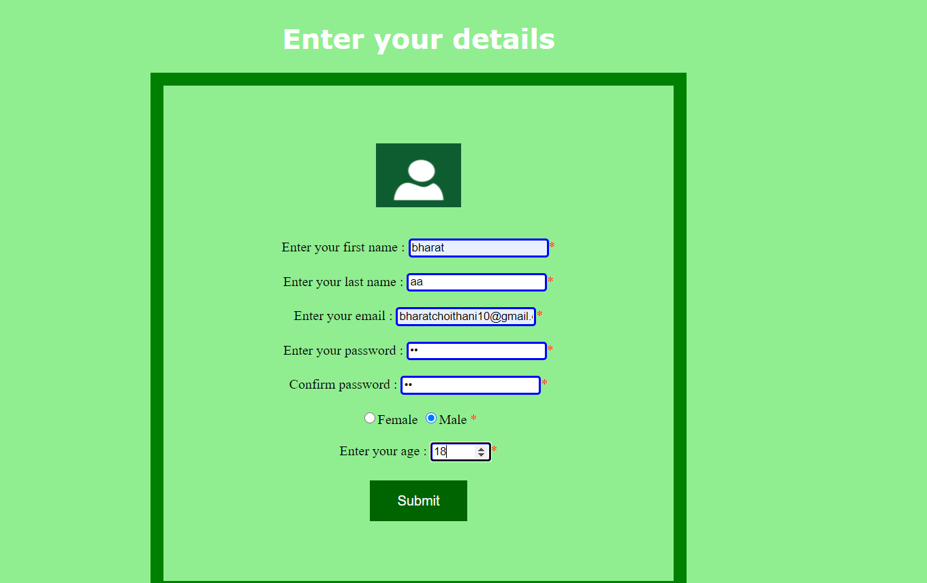

Login:

<html>
<title>Login</title>
<style>
.error {color: #FF0000;}
body {background-color: lightgreen;}
h1 {color: black;
font-family: verdana;
font-size: 200%;}
p {color: blue;
font-family: verdana;
font-size: 160%;}
p1 {color: green;
font-family: courier;
font-size: 160%;}
input[type=text] {
border: 2px solid blue;
border-radius: 4px;
}
input[type=email] {
border: 2px solid blue;
border-radius: 4px;
}
input[type=password] {
border: 2px solid blue;
border-radius: 4px;
}
input[type=number] {
border: 2px solid blue;
border-radius: 4px;
}
input[type=submit] {
background-color: darkgreen;
border: none;
color: white;
padding: 15px 32px;
text-align: center;
text-decoration: none;
display: inline-block;
font-size: 16px;
margin: 4px 2px;
cursor: pointer;
}
div {
background-color: lightgreen;
width: 500px;
border: 15px solid green;
padding: 50px;
margin: 20px;
}
</style>
<body>

<?php
$cookie_name = 'email';
if(!isset($_COOKIE[$cookie_name]))
{
echo "Cookie named '" . $cookie_name . "' is not set!";
}
else
{
echo "Cookie '" . $cookie_name . "' is set!<br>";
echo "Value is: " . $_COOKIE[$cookie_name];
}

$emailErr = '';
$passwordErr = '';

if(isset($_POST['email']))
{
if(!filter_var($_POST['email'], FILTER_VALIDATE_EMAIL))
{
$emailErr = "Invalid email format";
}
else
{
$email = $_POST['email'];
}
}

if(isset($_POST["password"]))
{
if (empty($_POST["password"]))
{
$passwordErr = "Enter correct password";
}
else
{
$password = $_POST["password"];
}
}

?>

<img src="auction2.png" width="200" height="150">
<center><h1 style="color:white">Enter your login details</h1></center>
<center>
<div>
<form method = "post" action="<?php echo htmlspecialchars($_SERVER["PHP_SELF"]);?>">
<br>
<img src="user.png" width="100" height="75">
<br><br><br>
Enter your email : <input type="email" name="email"><span class="error">*<?php echo $emailErr;?></span>
<br><br>
Enter your password : <input type="password" name="password"><span class="error">*<?php echo $passwordErr;?></span>
<br><br>
<input type="submit" name = "submit" >
</form>
</div>
</center>

</body>
</html>

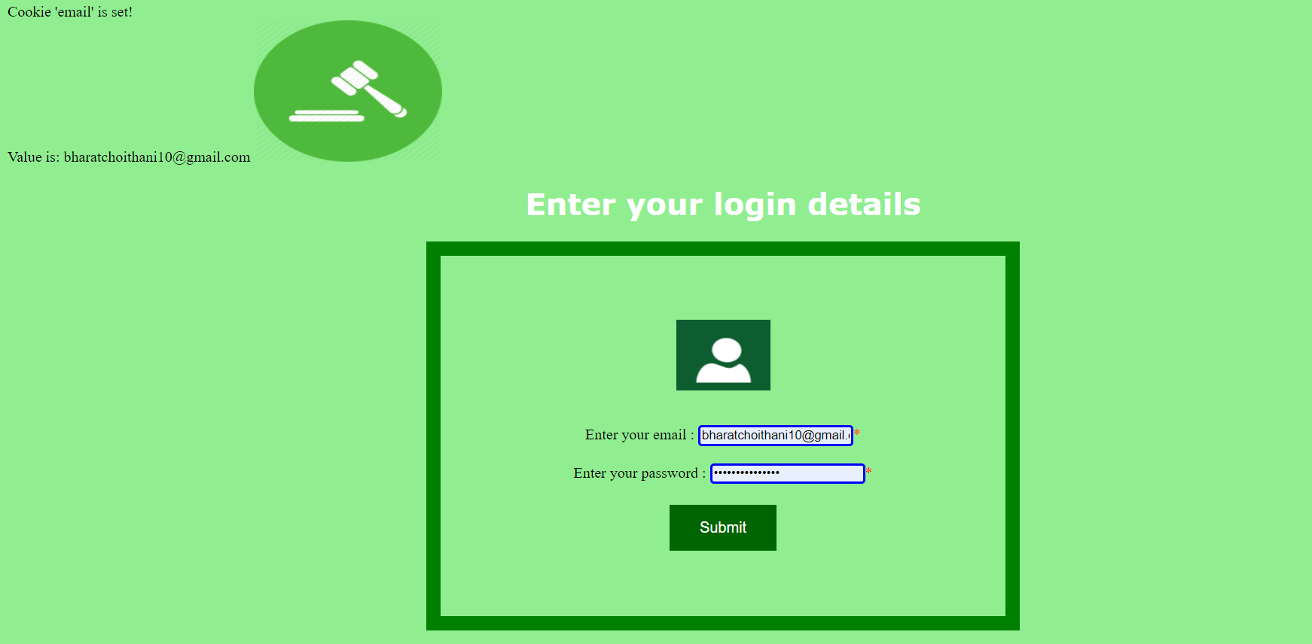

Cookie:

