Multimedia Lab Final Project

*LA02*

Group C

- Nathanael William Boentoro / 2301853413

- Kevin Christian Surya / 2301852171

- Michael Adriel Darmawan / 2301854170

**How to Operate the Application**

Once the app is running, an opening animation will be played. There is an audio button in every page at the bottom left corner to turn on or pause background music. To start the app, click on the start button (colored red) to go the navigation menu.

“Menu” button will go to the Menu page where list of mochis that are sold are displayed. Click on the right or left green arrow to navigate the menu page. To order the mochi, users can directly go to the official website by clicking on the orange “Order Now” button at the bottom mid of the page. There is also clickable home button at the bottom right corner to go to the navigation menu.

“Mocha Making Tutorial” button will go to the video tutorial page. The video should load for a couple seconds. From there, the video can be controlled (pause/play, Fullscreen, volume, etc.) using video controls provided by the HTML5 component. To go back to the navigation menu, click on the home button at bottom right corner of the page.

“About Us” button will go the last page which is the “about us” page where information of the company is shown. There are 3 social media icons at the bottom in which when clicked, they will redirect to the corresponding official social media platform. Use home button to go back to the navigation page.

**Hidden Creativities**

- Mochi Collection & Social Media were cut into separate images and converted to png (for transparent background) using Photoshop.

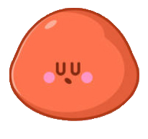

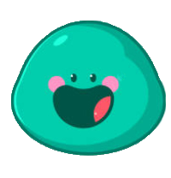

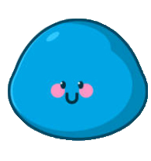

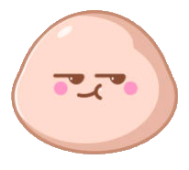

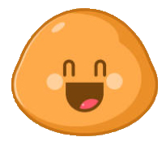

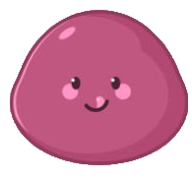







- “Limited Edition” and “Prev & Next” icons are made manually in adobe animate using shapes and lines with slicing technique (shapes or objects will be sliced if the two of them have different color)



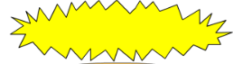



**References**

=====Image====

Mochi Collection: <https://www.freevectors.net/free-vectors/mochi>

Pink Mochi: <https://www.biggerbolderbaking.com/homemade-mochi-ice-cream/>

Chocolate Mochi: <https://muchbutter.com/chocolate-mochi-ice-cream/>

Green Tea Mochi: <https://cookpad.com/uk/recipes/4762379-mochi-matcha-green-tea-ice-cream>

Kacang Merah Mochi: <https://www.finedininglovers.com/recipes/dessert/japanese-mochi>

Vanilla Mochi: <https://www.haibunda.com/moms-life/20200711134232-76-151043/cara-membuat-mochi-es-krim-kenyal-dan-lembut>

Shop Location: <https://mochidoki.com/blogs/the-mochidoki-journal/introducing-the-new-mochidoki-store>

=====Icon======

Audio: <https://lovepik.com/image-401207825/cartoon-hand-drawn-creative-sound-icon.html>

Social Media: <https://www.pikpng.com/pngvi/hbhxmh_facebook-twitter-instagram-logo-png-logo-facebook-instagram-youtube-png-clipart/>

======Audio & Video======

Mochi Tutorial (video): <https://www.youtube.com/watch?v=EmwGaqjMJkM>

Fun BGM Loop (Background Music): <https://www.melodyloops.com/moods/funny/>

*All assets are contained in a separate attached folder.