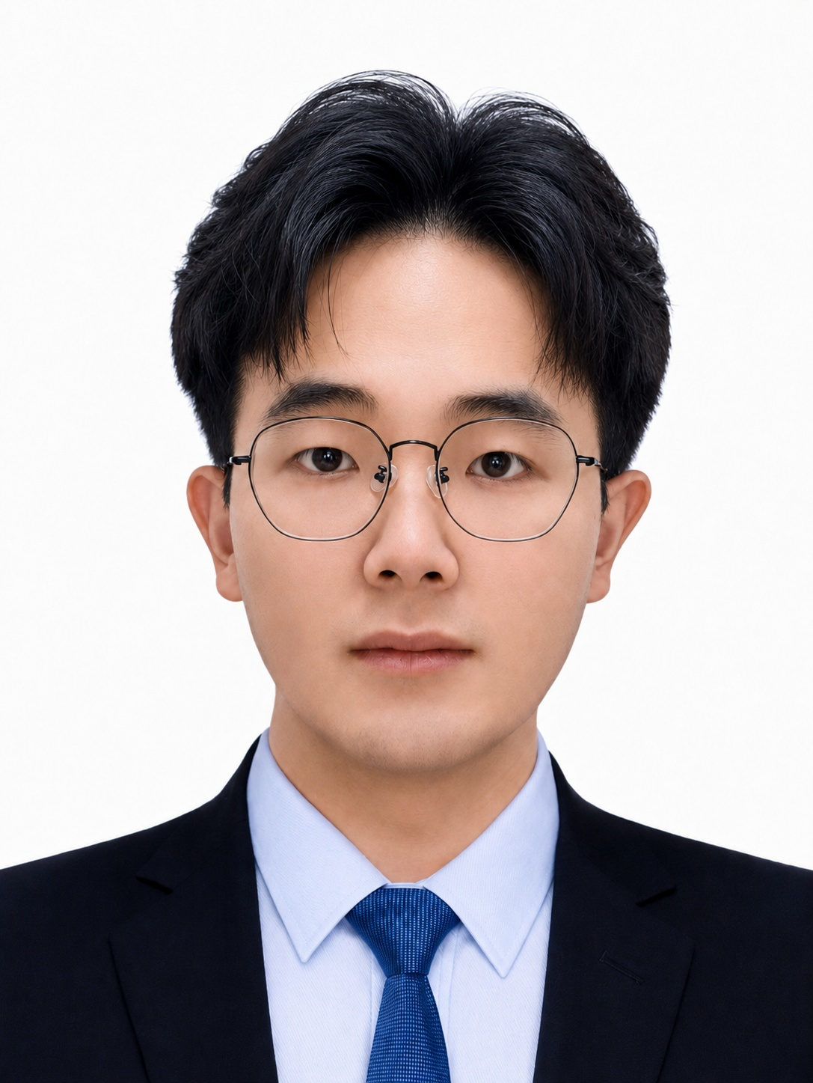
Zheao Li (李哲鳌)
Wireless Communications Research and Algorithm Development
Email: zheao001@e.ntu.edu.sg | Tel: (+86)-15950522552, (+65)-98997027

PROFILE
- Ph.D. candidate at Nanyang Technological University EEE School, expected to graduate in Dec. 2026.
- Author of 11 first‑author IEEE papers and 9 patents, with research spanning: MIMO‑OFDM, reconfigurable intelligent surface (RIS), stacked intelligent metasurfaces (SIM), wave-domain computing and signal processing, multiuser multiple access, channel measurement and modeling, AI-based predictive channel modeling, and optimization algorithms.

EDUCATION
- Nanyang Technological University (NTU), Singapore | Supervisor: Prof. Chau Yuen |  | 01/2024-present
Ph.D. in Electrical & Electronic Engineering (Expected Dec 2026) |  |  | GPA: 4.50/5.00
Dissertation Topic: SIM‑Enhanced Wideband MIMO‑OFDM Communication Systems
- Southeast University (SEU), China | Supervisor: Prof. Cheng-Xiang Wang |  | 09/2020-06/2023
M.Sc. in Information & Communication Engineering |  |  | GPA: 3.96/4.00
Thesis: Research on AI‑Based 6G Space-Time-Frequency Predictive Channel Modeling
- Southeast University (SEU), China | Graduated with Distinction |  | 08/2016-06/2020
B.Eng. in Information Engineering |  |  | GPA: 3.68/4.00
- The University of California, Irvine (UCI), USA | Supervisor: Prof. Ahmed M. Eltawil |  | 06/2019-09/2019
UCInspire Summer Research in Electrical Engineering and Computer Science School |  |  | GPA: 4.00/4.00

RESEARCH EXPERIENCE
- Wideband MIMO and SIM Wave-Domain Processing, School of Electrical and Electronic Engineering, NTU |  |  | 01/2024-present
- Investigate SIM-enhanced wideband MIMO-OFDM and multiuser OFDM-IM systems, wideband beamforming, and OFDMA design trade-offs. Research published in IEEE TWC, TVT, GLOBECOM, and APWCS.
- Study SIM-enabled wideband MU-MIMO OFDM transceiver and wave-domain computing. Transmitter conference paper accepted at GLOBECOM 2026; related journal manuscripts under review at IEEE TWC, TCOM, and WCM.
- AI-Based 6G Predictive Channel Modeling, School of Information Science and Engineering, SEU |  |  | 09/2020-12/2023
- Conducted research on space-time-frequency predictive channel modeling, studying large-scale wireless channel characteristics and theoretical models.
- Investigated channel prediction and scatterer-density-based predictive models. Co-developed an AI modeling framework spanning space, time, frequency, and scenarios; contributed IEEE TVT and VTC papers and patent filings.

EMPLOYMENT & INTERNSHIPS
- Teaching Assistant, School of Electrical and Electronic Engineering, NTU |  |  | 01/2024-present
- Assist in delivering lectures, conducting tutorial sessions, and facilitating classroom discussions to reinforce key concepts.
- Conduct lab sessions, explaining theoretical and practical concepts, demonstrating coding or experimental procedures, and ensuring students can apply their knowledge effectively.
- Research Assistant, Pervasive Communication Research Center, PML |  |  | 07/2021-12/2023
- Participated in projects about Channel Characteristics and Theoretical Channel Modelling for Large-Scale Wireless Communications under the guidance of Prof. Cheng-Xiang Wang.
- Introduce an AI-based predictive channel modeling architecture, covering the space-time-frequency domains.
- Dean Assistant, School of Information Science and Engineering, SEU |  |  | 07/2021-06/2023
- Participated in the research-related work of the school and helped Dean with various kinds of projects.
- Be responsible for assisting Dean in several tasks that support the basic research activities.
- SW Engineer Intern, Research and Development Department, Siemens Power Automation Ltd. (SPA) |  |  | 11/2019-06/2020
- Executed test solution implementation and test system integration and verification.
- Improved test system performance constantly, by focusing on test system stability and reliability.
- Research Intern, Laboratory of DC Power Grid Sciences and Technology, Institute of Electrical Engineering, Chinese Academy of Sciences (IEECAS) |  |  | 09/2018-10/2018
- Achieved serial debugging software programming and implementation to build the network.
- Tested the transmission efficiency and rate by the force control configuration software.

PUBLICATIONS
- Journal papers (8):
- Z. Li, J. An, and C. Yuen*, “Stacked intelligent metasurfaces-enhanced MIMO OFDM wideband communication systems,” IEEE Trans. Wireless Commun., vol. 25, pp. 9608-9622, Jan. 2026.
- Z. Li, J. An, and C. Yuen*, “Stacked intelligent metasurface-enhanced wideband multiuser MIMO OFDM-IM communications,” IEEE Trans. Wireless Commun., vol. 25, pp. 21040-21055, July. 2026.
- Z. Li, J. An, and C. Yuen*, “A fully wave-domain wideband MU-MIMO OFDM transmitter via stacked intelligent metasurfaces,” IEEE Trans. Wireless Commun., Under R2 review, June 2026.
- Z. Li, J. An, and C. Yuen*, “SIM-enabled wave-domain processing in MIMO-OFDM receivers: Architecture, modeling, and validation,” IEEE Trans. Commun., Under R1 review, Aug. 2026.
- Z. Li, C.-X. Wang*, C. Huang*, J. Huang, J. Li, W. Zhou, and Y. Chen, “A GAN-GRU based space-time predictive channel model for 6G wireless communication systems,” IEEE Trans. Veh. Technol., vol. 73, no. 7, pp. 9370-9386, July 2024.
- H Niu, J An, E Shi, Z Li, L Gan, J Zhang, S Chatzinotas, C Yuen*, “Stacked intelligent metasurfaces for next-generation wireless signal processing: A comprehensive survey,” IEEE O. J. Comm. Soc., doi: 10.1109/OJCOMS.2026.3729450.
- Z. Wang, X. Ma, X. Peng, Z. Li, J. Liu, Y. Guan, and C. Yuen*, "Robust beamforming design for STAR-RIS aided RSMA network with hardware impairments," IEEE Trans. Veh. Technol., doi: 10.1109/TVT.2025.3620378, Oct. 2025.
- C. Huang*, C.-X. Wang*, Z. Li, Z. Qian, W. Zhou, Y. Miao, “A frequency-domain predictive channel model for 6G wireless MIMO systems based on deep learning,” IEEE Trans. Commun., vol. 72, no. 8, pp. 4887-4902, Aug. 2024.
- W. Zhou, C.-X. Wang*, C. Huang*, Z. Li, Z. Qian, Z. Lv, and Y. Chen, “Channel scenario extensions, identifications, and adaptive modeling for 6G wireless communications,” IEEE Internet Things J., vol. 11, no. 5, pp. 7285-7308, March, 2024.
- Conference papers (8):
- Z. Li, J. An, and C. Yuen*, “Baseband-free wideband MU-MIMO OFDM via stacked intelligent metasurfaces,” accepted in IEEE GLOBECOM’26, Macau, China, Dec. 2026.
- Z. Li, J. An, and C. Yuen*, “Fundamental trade-off in stacked intelligent metasurface assisted OFDMA systems,” in Proc. IEEE GLOBECOM’25, Taipei, Taiwan, Dec. 2025, pp. 2378-2383.
- Z. Li, J. An, and C. Yuen*, “Stacked intelligent metasurfaces for fully-analog wideband beamforming design,” in Proc. IEEE VTS APWCS’24, Singapore, Aug. 2024, pp. 1-5.
- Z. Li, C.-X. Wang*, C. Huang*, L. Yu, J. Li, and Z. Qian, “A novel scatterer density-based predictive channel model for 6G communications,” in Proc. IEEE VTC’23-Spring, Florence, Italy, June 2023, pp. 1-5.
- Z. Li, C.-X. Wang*, J. Huang*, W. Zhou, and C. Huang, “A GAN-LSTM based AI framework for 6G wireless channel prediction,” in Proc. IEEE VTC’22-Spring, Helsinki, Finland, June 2022, pp. 1-5.
- Z. Li, Z. Jiang*, and J. Huang, "Automatic modulation classification based on the improved AlexNet," in Proc. IEEE IWCMC’21, Harbin, China, June 2021, pp. 2068-2073.
- Y. Li, J. Huang, Z. Li, G. Ding, C.-X. Wang, and C. Yuen*, “A novel general channel model for double-SIM assisted 6G wireless communications,” accepted in IEEE GLOBECOM’26, Macau, China, Dec. 2026.
- Z. Qian, Z. Li, W. Zhou, C. Huang, J. Huang, and C.-X. Wang*, “6G Wireless channel scenario extensions and characteristics analysis,” in Proc. IEEE VTC’23-Spring, Florence, Italy, June 2023, pp. 1-5, accepted for publication.
- Patents (9):
- C.-X. Wang, Z. Li, C. Huang et al. PREDICTIVE CHANNEL MODELING METHOD BASED ON ADVERSARIAL NETWORK AND LONG SHORT-TERM MEMORY NETWORK: PCT/CN2023/082379. 2024-9-14.
- C.-X. Wang, Z. Li, C. Huang et al. NOVEL SCATTERER DENSITY-BASED PREDICTIVE CHANNEL MODELING METHOD: U.S. Patent Application 18/816,784. 2025-3-6.
- C.-X. Wang, Z. Li, C. Huang et al. PREDICTIVE CHANNEL MODELING METHOD BASED ON GENERATIVE ADVERSARIAL NETWORK AND LONG SHORT-TERM MEMORY ARTIFICIAL NEURAL NETWORK: U.S. Patent Application 18/564,273. 2024-8-1.
- C.-X. Wang, Z. Li, J. Huang, W. Zhou, C. Huang. A GAN-LSTM based predictive channel model for 6G wireless communication systems. Chinese patent, CN202210214717.0, CN114584230B.
- C.-X. Wang, Z. Li, L. Yu, C. Huang, J. Huang, Z. Qian. A machine learning based space-time domain channel model for 6G wireless communication systems. Chinese patent, CN202211189126.9, CN115694697B.
- C.-X. Wang, Z. Li, C. Huang*, L. Yu, J. Li, and Z. Qian. A novel scatterer density-based predictive channel model for 6G communications. Chinese patent, CN202311097011.1, CN117155494A.
- C. Huang, C.-X. Wang, Z. Li, Z. Qian, W. Zhou, H. Chang, and L. Xin. A deep learning-based predictive channel modeling method and related devices. Chinese patent, CN202211685853.4, CN116032398A.
- C.-X. Wang, W. Zhou, C. Huang, Z. Li, Z. Qian. Channel scenario extensions, identifications, and adaptive modeling for 6G wireless communications. Chinese patent, CN202211604035.7, CN116070130A.
- C.-X. Wang, W. Zhou, C. Huang, Z. Li, Z. Qian, Z. Lv. A scenario adaptive channel modeling method based on 6G global coverage scenario identifications. Chinese patent, CN202211603711.9, CN116346262A.
- Conference proposal (1):
- C.-X. Wang, Z. Li, C. Huang, and J. Li. Research on 6G space-time predictive channel modeling. 1st Meeting of IMT-2030 6G Standards Wireless Technology Working Group, 2023.04.08.

LEADERSHIP & PROFESSIONAL ACTIVITIES
- Vice-President, NTU EEE Graduate Student Club, 2026 ‑ present
- Director, Student Integration and Orientation Department, NTU EEE Graduate Student Club, 2025 ‑ 2026
- Newsletter Manager, NTU Graduate Student Association, 2024 ‑ Present
- Reviewer for journal and conference papers, IEEE TWC, TCOM, TMC, VTC, ICC, GLOBECOM

AWARDS & HONORS
- Awards:
Dean Merit Award, NTU College of Engineering  First Prize, Academic Poster Presentation, NTU Graduate Research Showcase 2026  Second Prize, Academic Poster Presentation, NTU Graduate College Postgraduate Research Day 2026  HUAWEI Award, Student Thesis Pitch Competition, 2025 IEEE 6G Summit  Third Prize, Outstanding Academic Papers, the National Postdoctoral Young Scientist and Technological Talents Yangzijiang Forum |  |  | 09/2026  03/2026  03/2026  12/2025  08/2022
Third Prize, 16th Challenge Cup in Jiangsu Province, China |  |  | 06/2019
Outstanding Award, 16th Challenge Cup at SEU |  |  | 04/2019
First Prize & Best Individual Award, 5th Excellence Competition at SEU |  |  | 12/2018
Outstanding Award, 12th Smart Car Competition at SEU |  |  | 04/2018
First Prize, 7th Innovation Experience Competition at SEU |  |  | 11/2017
- Honors & Scholarship:
Certificate of NTU University Teaching for Teaching Assistants  NTU Research Scholarship, Singapore |  |  | 04/2025  11/2023
Postgraduate Academic Scholarship, Three times (top 10% at SEU) |  |  | 09/2020-2022
“82 Alumni of Radio Department” Scholarship for Distinguished Students (top 1% at SEU) |  |  | 06/2020
Merit Student for Outstanding Students, Twice (top 10% at SEU) |  |  | 12/2018&11/2019
“Iron Shoulder” Scholarship for Distinguished Students (top 1% at SEU) |  |  | 06/2019
Advanced Scholarship for Student Work (top 5% at SEU) |  |  | 04/2019
Excellent Member of the Chinese Communist Youth League (top 1% at SEU) |  |  | 05/2018
Advanced Scholarship for Artistic Activities (top 5% at SEU) |  |  | 12/2017&12/2019

