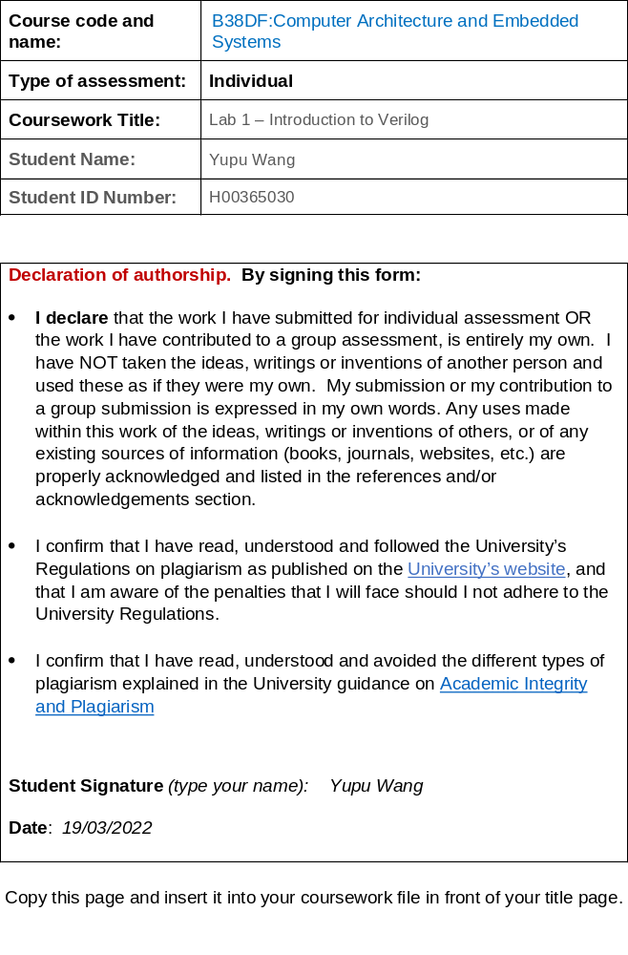

B38DF Lab 1 Report Template

PRINT NAME: ………Yupu Wang……… Matriculation No: ………H00365030(20012100012) ………

Complete the following sections:

- Section 7 Checking the Simulation Result
Does the actual truth table found from simulation match the intended truth table on page 5? 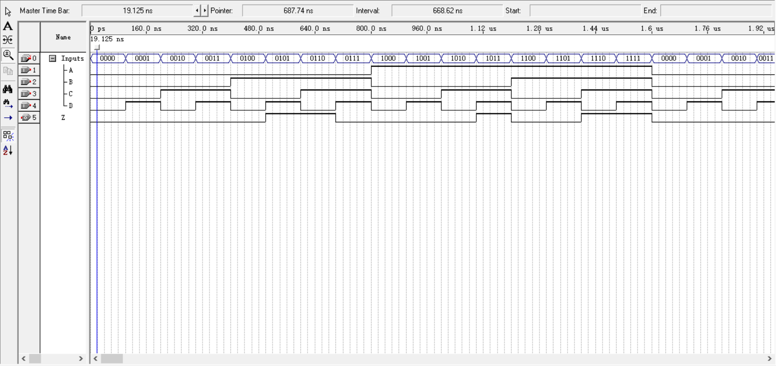

Through the above simulation, we can get the truth table:

A | B | C | D | Z
0 | 0 | 0 | 0 | 0
0 | 0 | 0 | 1 | 0
0 | 0 | 1 | 0 | 0
0 | 0 | 1 | 1 | 0
0 | 1 | 0 | 0 | 0
0 | 1 | 0 | 1 | 1
0 | 1 | 1 | 0 | 1
0 | 1 | 1 | 1 | 0
1 | 0 | 0 | 0 | 0
1 | 0 | 0 | 1 | 0
1 | 0 | 1 | 0 | 0
1 | 0 | 1 | 1 | 1
1 | 1 | 0 | 0 | 0
1 | 1 | 0 | 1 | 0
1 | 1 | 1 | 0 | 1
1 | 1 | 1 | 1 | 1

We know that the actual truth table found from simulation matches the intend truth table on Page 5.

- Section 8 Modifying the Logic Function
Your K-map and your derived logic expression derived should be shown below
We know the truth table as follows:

A | B | C | D | Z
0 | 0 | 0 | 0 | 1
0 | 0 | 0 | 1 | 1
0 | 0 | 1 | 0 | 1
0 | 0 | 1 | 1 | 1
0 | 1 | 0 | 0 | 1
0 | 1 | 0 | 1 | 1
0 | 1 | 1 | 0 | 1
0 | 1 | 1 | 1 | 1
1 | 0 | 0 | 0 | 0
1 | 0 | 0 | 1 | 0
1 | 0 | 1 | 0 | 0
1 | 0 | 1 | 1 | 1
1 | 1 | 0 | 0 | 1
1 | 1 | 0 | 1 | 0
1 | 1 | 1 | 0 | 1
1 | 1 | 1 | 1 | 0

Hence, we can get the K-map and the logic expression:
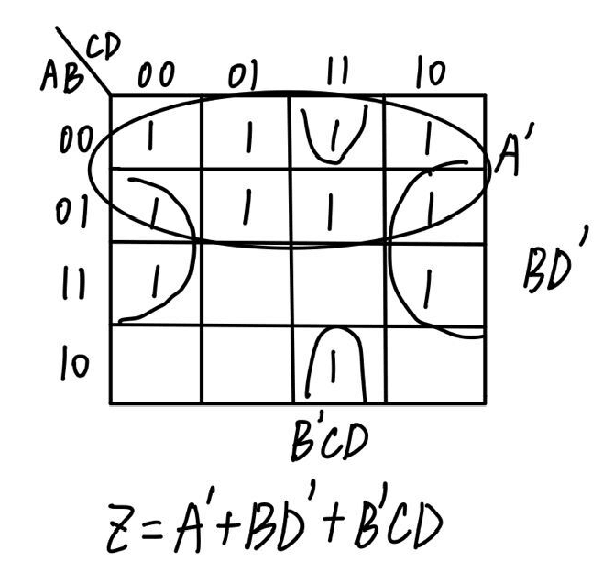

- Modified Verilog Source file
(i)Give verilog code for the correct logic expression.
Verilog code for the correct logic expression:

Z=(~A) | (B & ~D) | (~B & C & D);

(ii)Is this structural or behavioural representation?

This is structural representation. Because it describes functions defined using basic components such as inverters, multiplexers, adders, decoders and basic logic gates. It’s different from the behavioural representation, which describes the function of a set of concurrent algorithms.

(iii)Give your modified source file.

Modified source file:
module lab1(A,B,C,D,Z); //declare module name as lab1 with inputs/outputs A,B,C,D and Z

input A,B,C,D;
output Z;

reg Z; //value of z is assigned in an 'always' block, so we declare it as data type ‘reg

always @ (A,B,C,D) //always block , generates signals based on (A,B,C,D)
begin //marks start of code in the always block.

Z=(~A) | (B & ~D) | (~B & C & D); // Z assigned value of logic function specified.
// ~ means 'NOT' or 'inverse', & means AND, | means OR
end //marks end of code in the always block. Equivalent to } in C programming

endmodule

- Simulator Waveforms for 3 above.
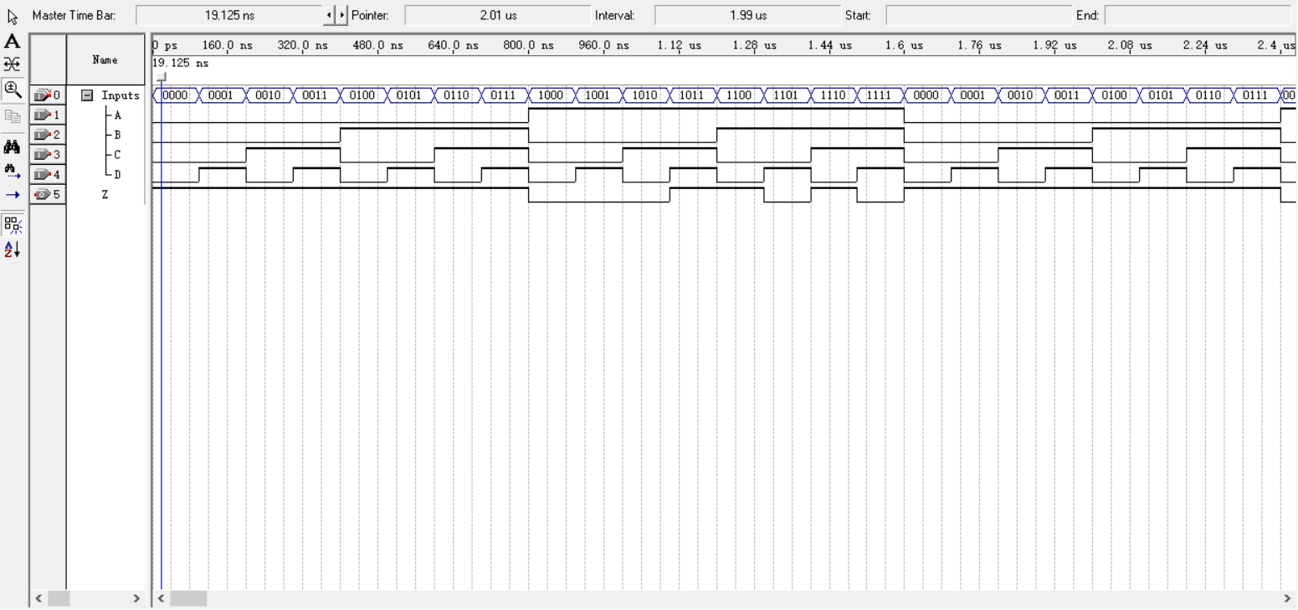

- Verilog code for Section 10.
module lab2 (A,B,W,X,Y,Z);
input A,B;
output W,X,Y,Z;

reg W,X,Y,Z;
always @ (A,B)
begin
if ((A==0) & (B==0))
begin
W=0;
X=0;
Y=0;
Z=0;
end

else if((A==0) & (B==1))
begin
W=0;
X=0;
Y=1;
Z=1;
end

else if((A==1) & (B==0))
begin
W=1;
X=1;
Y=0;
Z=0;
end

else if((A==1) & (B==1))
begin
W=1;
X=0;
Y=0;
Z=1;
end
end
endmodule

- Simulator Waveforms for 5 above.
