Condensed Suite
Language Theory 2019-2020
AMIARD Landry

• Alphabet Ac = {0, 1, 2, 3, 4, 5, 6, 7, 8, 9, +, -, b, $)

• Regular expression Rc = f ⁺ $ ( ( ( ( +⁺ + -⁺ ) f ⁺ ) + 0⁺ ) b )⁺

f = (0 + 1 + 2 + 3 + 4 + 5 + 6 + 7 + 8 + 9)

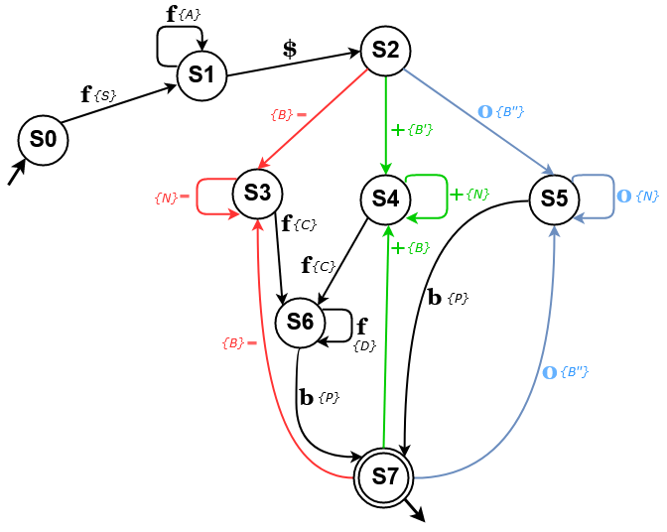
• Automaton Uc :

Actions are square bracketed

• Actions :

Intro :base = 0 ; counter = 0 : diff = 0 ; sign = 1 ;
S : base = int(symbol) ;
A : base = base x 10 + int(symbol) ;
B : counter = 1 ;
sign = -1 ;
B’ : counter = 1 ;
sign = 1 ;
B’’ : counter = 1 ;
sign = 1 ;
diff = 0 ;
N : counter = counter + 1 ;
C : diff = int(symbol) ;
D : diff = diff x 10 + int(symbol) ;
P : print(calcul_to_string(base, sign, diff, counter) ;

