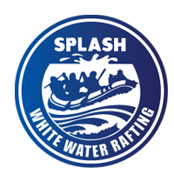

**White Water Rafting Website Plan**

**Planning Document - About Us Page**

|  |
| --- |
|  |

# Site Name

White Water Rafting

# Site Purpose

The purpose of this website is to promote White Water Rafting adventures, share company information, showcase available trips, and allow potential clients to contact the business for reservations and inquiries.

# Target Audience

Adventure seekers, nature lovers, families, and tourists looking for a thrilling and safe rafting experience.

# Domain Name Suggestion

www.whitewaterraftingadventures.com

# Coolors Color Palette URL

https://coolors.co/055a05-f4a261-264653-e9c46a

# Branding

The site uses a natural and adventurous color palette to reflect the outdoor experience and convey trust and excitement.

## Color Scheme

|  |  |  |
| --- | --- | --- |
| Purpose | Color Name | Hex Value |
| Primary | Forest Green | #055a05 |
| Secondary | Desert Orange | #f4a261 |
| Accent 1 | Deep Blue | #264653 |
| Accent 2 | Sand Yellow | #e9c46a |

## Typography

Headings Font: Playfair Display

Body Font: Rubik

# Navigation Structure

• Home  
• About Us  
• Trips  
• Contact Us

# Wireframe Layout

The diagram below illustrates the layout of the 'About Us' page structure:

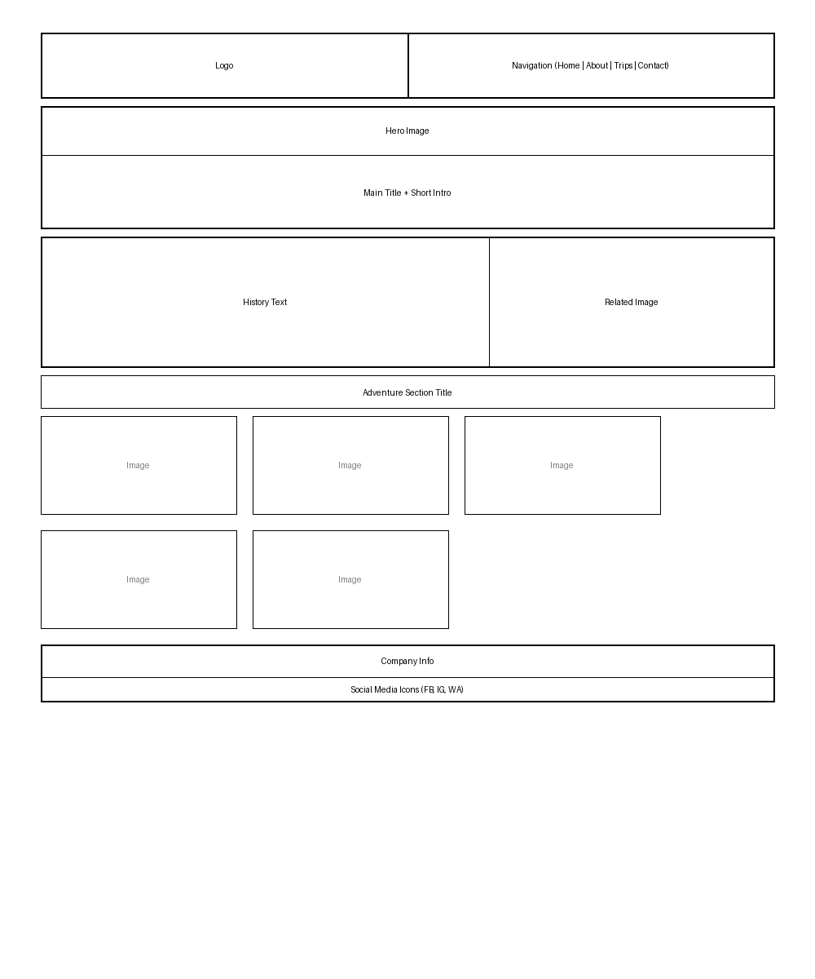

# Footer Details

The footer contains the company name, copyright information, and social media icons linking to Facebook, Instagram, and WhatsApp.