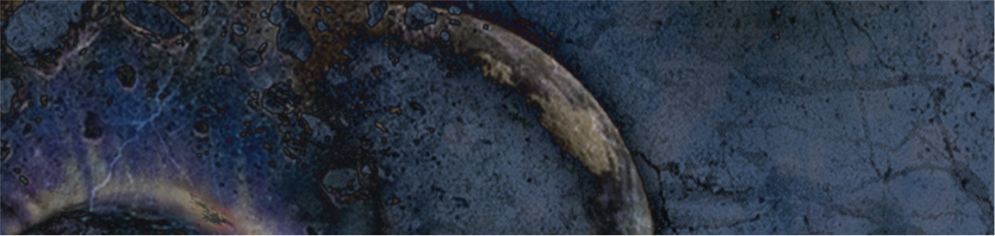

PROMOTIONAL MATERIALS

Version 1.0

BA Game Development

GAM340

Gareth Lewis

|  |  |
| --- | --- |
|  | Introduction For this assessment you will create a series of promotional materials that will aid you in your graduate job-hunting activities.  This assignment is formed of several parts:   1. **Create** a short form resume that will:    1. Highlight your key skills and abilities with respect to your desired field    2. Leverage professional insights to enhance your personal brand;    3. Project your professionalism and/or creativity;    4. Emphasise your professional practice. 2. **Create** a professional profile a suitable social media platform, e.g. Linkedin.com, that will:    1. Enable you to create meaningful connections with other creative professionals    2. Allow you to post your academic, creative and professional experience highlights    3. Share your thoughts and opinions with others    4. Find jobs    5. Funnel interested people to your professional website content      1. **Create** a professional website that will demonstrate and showcases:    1. Your portfolio work    2. your individual academic, professional and self-directed work    3. your roles on the various group projects you have been involved with during your time at Falmouth.  Part APart BPart C Part C is a **single summative submission**. This work is **individual** and will be assessed on a **criterion-referenced** basis. Please refer to the marking rubric at the end of this document for further detail.  To complete Part C, revise the MUD based on the feedback you have received. Then, upload it to the LearningSpace. Ensure that you include the readme.md document containing the design that you developed in Part A. Please note, the LearningSpace will only accept a single .zip file.  You will receive **formal feedback** from your **tutor** three weeks after the final submission deadline. Additional GuidanceFAQWhat is the deadline for this assignment?Falmouth University policy states that deadlines must only be specified on the MyFalmouth system.What should I do to seek help?You can email your tutor for informal clarifications. |

# Marking Rubric

|  |  |  |  |  |  |  |  |  |  |  |
| --- | --- | --- | --- | --- | --- | --- | --- | --- | --- | --- |
| **Learning Outcome Name** | **Learning Outcome Description** | **Criteria** | **Weighting** | **Clear Fail** | **Near Pass** | **3rd** | **2:2** | **2:1** | **1st** | **>1st** |
| **Website** | | | | | | | | | | |
| Process/Practice | Construct quality assets using industry-standard workflows in the specialism. | Designed to showcase student specialisations and experience | 20% |  | Website cannot be loaded on popular browsers Website is little more than a landing page Website does not contain student material | Website contains arbitrary work with no real explanation of what the work is and why it has been included | Website contains somewhat arbitrary work with no real explanation of what the work is and/or why it has been included | Website contains generally good quality work with some explanation of the work and its development | Website contains generally good quality work with reasonably detailed / meaningful explanation of the work and its development | Website contains high quality student work which is well curated with good textual descriptions next to work to explain rationale behind their inclusion, the work undertaken and the approach performing the work / issues encountered |
| Creative approach taken to designing and presenting the materials | 5% |  | Website has little or no content Website feels like content has be arbitrarily dumped onto it Missing content | Website has no overall style and work feels haphazard and generally thrown in  Site navigation is difficult and/or troublesome | Website has some aesthetic / style but is not consistent  Site navigation is generally difficult and/or troublesome | Website has a clear aesthetic, but student work tends to jibe.  Site navigation isn’t difficult but could be smoother | Website has a good aesthetic throughout the entire site Much of the work presented gives the impression of fitting within the aesthetic, as if it has been chosen specifically  Site navigation feels good | Website has a good aesthetic throughout the entire site. Each piece of student work gives the impression of fitting within the aesthetic, as if it has been chosen specifically  Site navigation is good / natural |
| Materials are well targeted and relevant to the student’s employment aims | 15% |  | No relationship between website content and student aims (through resume and/or LinkedIn profile) | There is a marginal relationship between student employment aims and materials presented | There is some relationship between student employment aims and materials presented, though much material presented has no relevance | There is a clear relationship between student employment aims and materials presented | There is a strong relationship between student employment aims and materials presented.  The website builds on content from resume and LinkedIn profile | There is a very strong relationship between student employment aims and materials presented  The website builds on content from resume and LinkedIn profile and all sources successfully reference each other |
| Industry/  Implement | Produce assets in correspondence with relevant methodological practice. | Professional approach to self-marketing in evidence | 10% |  | Evidence of unprofessional or unethical approaches to self-marketing (swearing, inappropriate content, potentially liable content, misappropriation of copyright materials) | Website comes across as the product of a fairly immature developer | Website comes across as fairly competent with only a few ‘features’ that suggest an immature developer | Website is professional, giving the air of modesty and a desire to develop as a professional | Website gives the impression of being developed by an early stage professional developer that is keen to develop their skills and expertise | Website gives the impression of being developed by an early stage professional developer that is aware that they are at the beginning of a life-long journey of professional development |
| Learning Outcome Name | Learning Outcome Description | Criteria | Weighting | Clear Fail | Near Pass | 3rd | 2:2 | 2:1 | 1st | >1st |
| **Resume** | | | | | | | | | | |
| Process/Practice | Construct quality assets using industry-standard workflows in the specialism. | Materials are well presented | 10% |  | Extremely poorly laid out resume with little or no useful content.  Many spelling and grammatical errors  Excessively long or short | Resume contains many spelling and/or grammatical errors, layout is poor (no / few paragraphs, generally a wall of text) | Resume contains some spelling and/or grammatical errors, layout is patchy and content is generally poor with potentially important details missing | Resume is fairly well-written with few spelling, grammar or layout errors | Resume is well-written with no obvious spelling, grammar or layout errors | Resume is well-written and creates a genuine sense of interest |
| Industry/  Implement | Produce assets in correspondence with relevant methodological practice. | Materials are well targeted and relevant to the student’s employment aims | 20% |  | No noticeable relationship between resume content and employment aims | Slight cohesion between employment aims and resume content | Some cohesion between employment aims and resume content | Reasonable cohesion between employment aims and resume content | Good cohesion between resume content and employment aims | Strong cohesion between employment aims and resume content |
| **Social Media Profile** | | | | | | | | | | |
| Process/Practice | Construct quality assets using industry-standard workflows in the specialism. | Designed to showcase student specialisations and experience | 15% |  | Empty or very sparsely populated profile | Profile contains a small amount of content / detail that details specialisations and/or experience | Profile contains some content / detail that details specialisations and/or experience | Profile contains a fair amount of content that highlights and details specialisations and experience | Profile contains significant content that highlights and details specialisations and experience | Profile contains significant content that highlights and details specialisations and experience and is interesting to read |
| Industry/  Implement | Produce assets in correspondence with relevant methodological practice. | Professional approach to self-marketing in evidence | 5% |  | Empty or very sparsely populated profile  Profile is not professional | Some self-marking evident which may include some of:  -presentation/show casing work,  -network building, beyond course mates  - engaging with relevant professionals  - positively engaging in professional posts | Some self-marking evident which includes most of:  -presentation/show casing work,  -network building, beyond course mates  -engaging with relevant professionals  -positively engaging in professional posts | Much self-marketing evident.  Some evidence of building a personal brand. | Much self-marketing evident with clear evidence of building a personal brand.  Some evidence of community building / recruitment interest | Much self-marketing evident some evidence of building a personal brand.  Engagement from recruiters has resulted in interviews / job offers |