

COMP140 – Workshop Week 2

Version 1.0

Individual Creative Computing Project COM140

Brian McDonald

**Exercise 1: Controller Research (10 – 15mins)**

For this exercise, you should finish off the controller research from Week 1

Review the Shake that Button Website- https://shakethatbutton.com/ & Past alt.ctrl.GDC entries

* Pick 3 games and note down the following information in a Google Doc or similar
  + Name
  + URL
  + Screenshot
  + Brief description
  + What you find interesting about it

This should be completed in a Google Doc or similar, please keep this for next week.

**Exercise 2: Controller Design Feedback (Ongoing through the workshop)**

During the workshop, please seek feedback for your controller/game/experience design. This can feed into the Week 3 formative deadline.

**Exercise 3: Design and Develop a Platformer (3hrs est.)**

Based on your research on S**ingle Responsibility Principle** and **Open Closed Principle** work has pairs to design and develop a platformer based on the following image

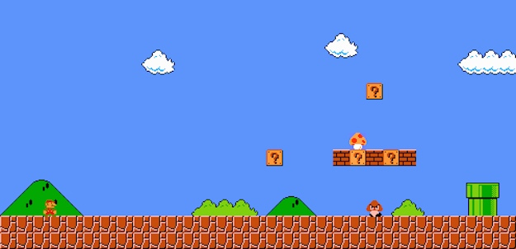

You are not designing Mario, but you are using this as template.

1. In **pairs or groups of three** you should design the key classes and relationships that would be in the platformer
   1. We are not forcing you to use any formal notation but UML is suggested
   2. Please think about the classes, variables and functions that can support the game
   3. This should be written into a technical spec document and shared between you all
2. As individuals, please implement the platformer in Unity3D.
   1. Please use the following assets in your game - <https://kenney.nl/assets?s=platformer>
   2. Please try and complete this before your class in **Week 3**