

COMP140 – Workshop Week 3

Version 1.0

Individual Creative Computing Project COM140

Brian McDonald

**Exercise 1: Controller Proposal Writing**

For this exercise, you should review the **Assignment Brief 2** and write a **1 page** proposal for a novel controller

1. describe the game design that will form the basis for your interface;
2. illustrate basic research into electronic component and physical form
3. factors for controllers;
4. analyse the design of the controller in detail;
5. list the key electronic components of your controller
6. and list the key user stories

This will ensure you are ready for the proposal reviews this week!

**Exercise 2: Complete Mario Platformer**

**Complete the Exercise from week 2, see below for a reminder**.

Based on your research on S**ingle Responsibility Principle** and **Open Closed Principle** work has pairs to design and develop a platformer based on the following image

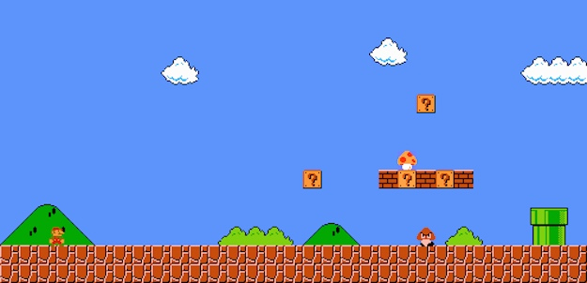

You are not designing Mario, but you are using this as template.

1. In **pairs or groups of three** you should design the key classes and relationships that would be in the platformer
   1. We are not forcing you to use any formal notation but UML is suggested
   2. Please think about the classes, variables and functions that can support the game
   3. This should be written into a technical spec document and shared between you all
2. As individuals, please implement the platformer in Unity3D.
   1. Please use the following assets in your game - <https://kenney.nl/assets?s=platformer>
   2. Please try and complete this before your class in **Week**3