1. **Target Shooting**An accurate target-shooting rifle has been calibrated to hit the centre of a target at a long-distance indoor rifle range. While facing the target, the marksman rotates the gun through 90° anticlockwise about the line between the gun and the target. He takes aim and fires. In which sector of the target does the bullet land?

Exercises may include some modified questions from:

Povey, T 2015, *Professor Povey’s Perplexing Problems*, Oneworld Publications, London UK

1. **The Unflinching Aviator**The Unflinching Aviator flies from West Island to East Island in a straight line, making a track along the ground running due west to east. There is a steady and uniform[1] wind with speed $v_{w}$, directed with a compass bearing of 30°[2]. At the top speed of the plane, the aviator makes a speed over the ground of $\frac{3v_{w}}{2}$ and the journey takes exactly one hour.
   1. If the wind speed is unchanged, what is the minimum time it takes the aviator to make the return journey?
   2. If he relies on ‘dead reckoning’[3], what compass bearing should he fly at?

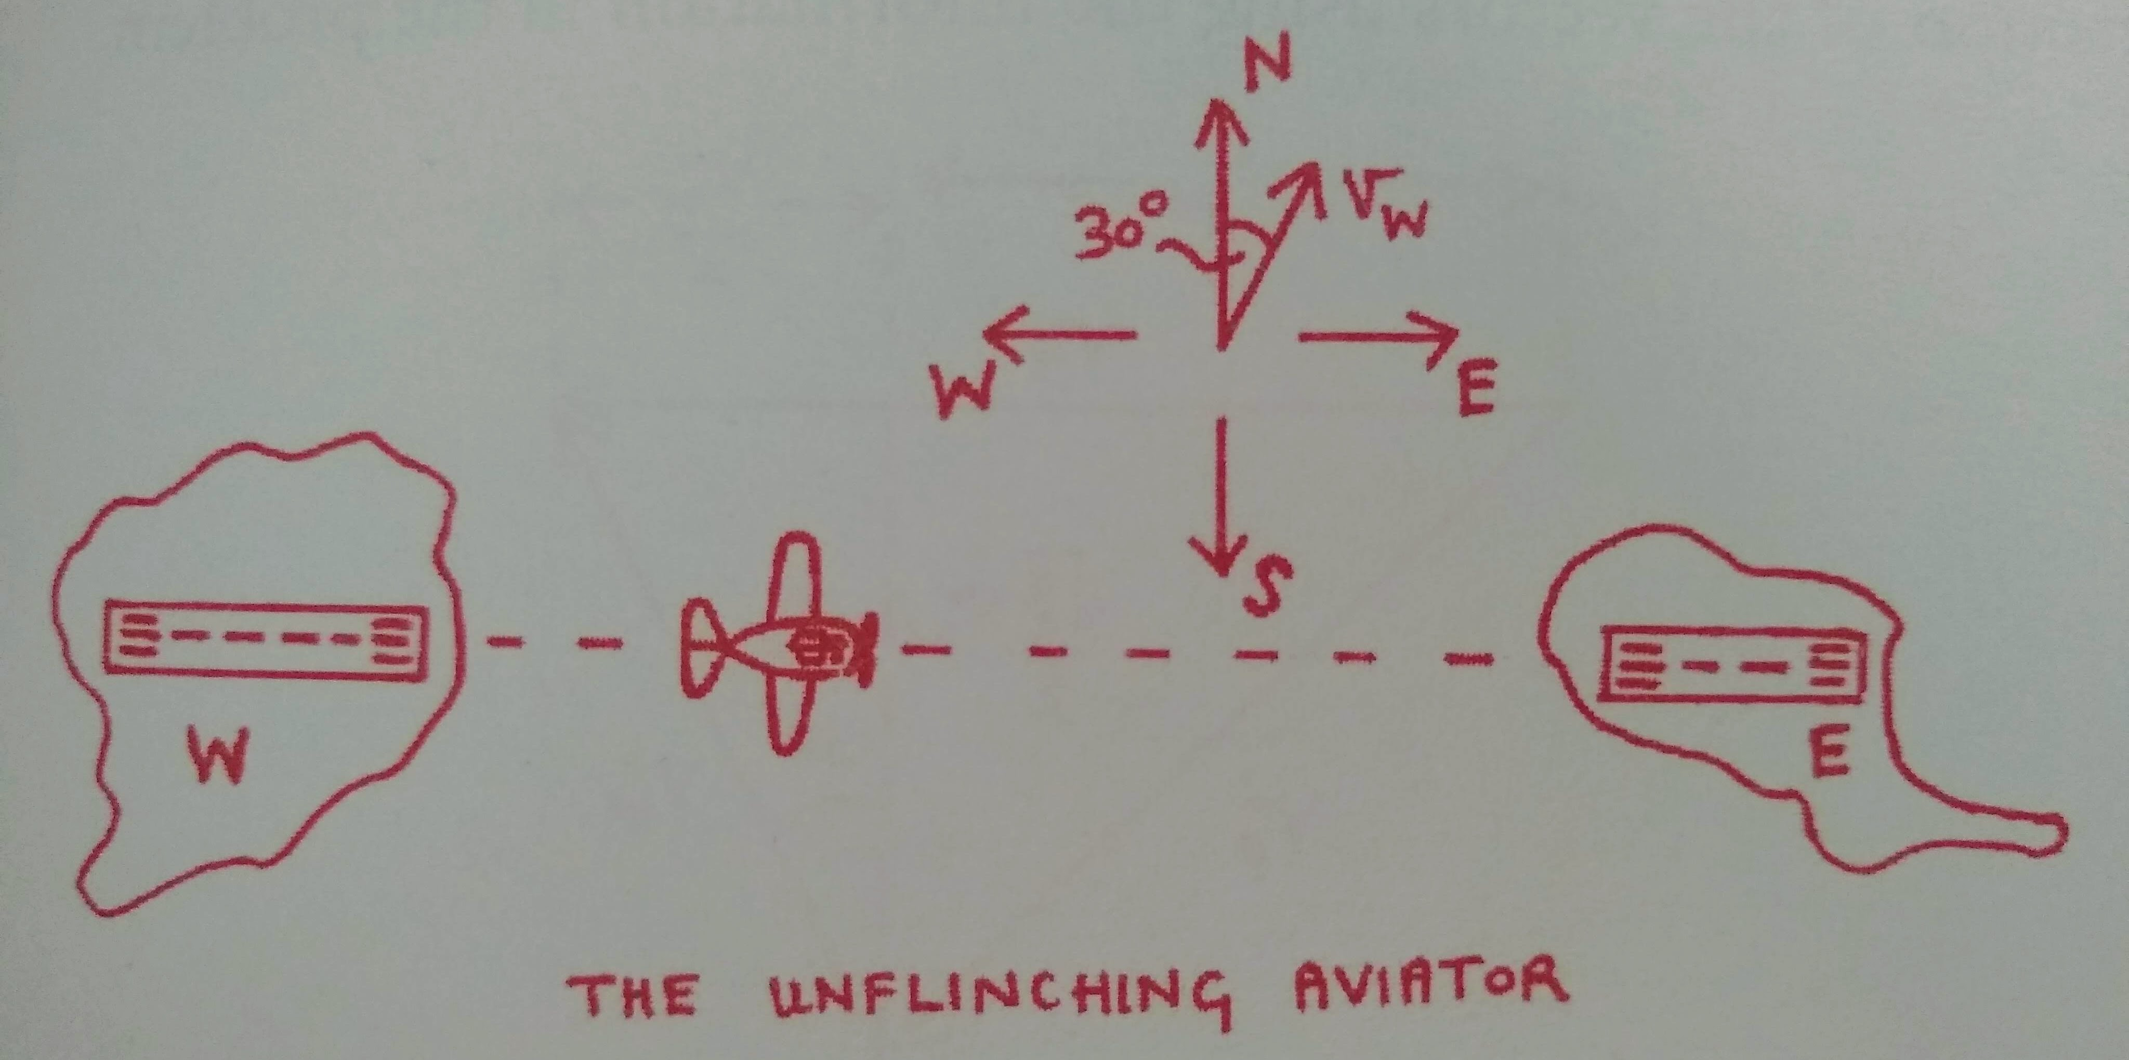

1. **Professor Lazy**Professor Lazy lives on a long, straight road 4km due east of his college, and refuses to go into college unless the wind is blowing from the east. When it blows at 10ms-1 he can cover the 4km distance in 300s:
   * The first 2km is down a gentle hill of constant gradient, and he travels at a breakneck speed of  
     20ms-1 on his frictionless penny-farthing (or as he calls it, his ‘ordinary’).
   * The second 2km is on flat ground and he travels at exactly 10ms-1.

The bicycle is, in fact, not particularly ordinary as the professor has removed the pedals and its motion is due to wind power alone. Professor Lazy will not contemplate returning home until the wind blows at 20ms-1 from the west. When this happens, how long will it take him to get home? Assume that:

* In each phase of his journey, the professor reaches his terminal velocity quickly compared with the overall length of his trip.
* The wind blows parallel to the ground both on the flat and on the slope.  
    
  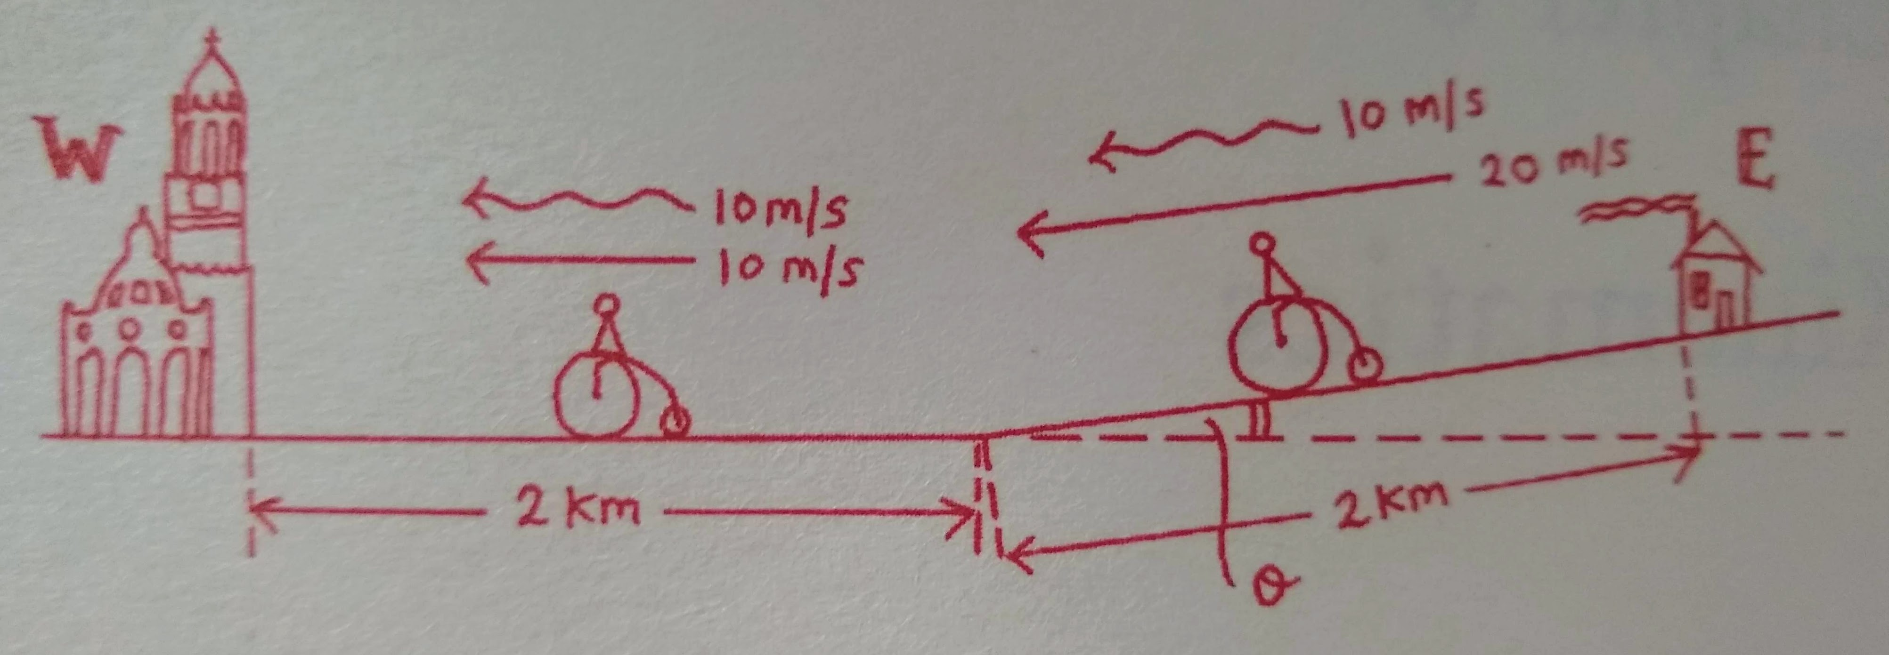

1. “Steady and uniform” means unchanging in both space and time; you may treat it as a constant vector.
2. Compass bearings are measured clockwise from North.
3. “Dead reckoning” is an ancient navigation technique that relies on determining the current position and planning a future course based on previous locations and speed, without accounting for changes in wind or other environmental conditions: <https://www.brighthubengineering.com/seafaring/60461-what-is-dead-reckoning/>