# Introduction

This week’s question is an exercise in computing vector directions in different spaces, i.e. relative to different viewpoints. The question is 2D but the process is the same for any number of dimensions.

# Shooting at cells

1. The spaceship from week 5 has been upgraded! Instead of only firing straight ahead, you can now specify the direction in which to shoot as a unit vector. To help you know where to aim, a sensor has also been fitted, which represents the viewable area of space (that you can see in the game window) as a 2D $m×n$ grid with each cell referenced by its grid coordinates:  
   . 0 1 2 3 4 5 6 7…..   
     
     
   The sensor returns the grid coordinates of all cells that contain at least part of an asteroid, as shown on the right of the diagram above; for the best chance of a hit, you should aim towards the centre of the cell. How would you calculate the shot direction vector to input to your weapons system,

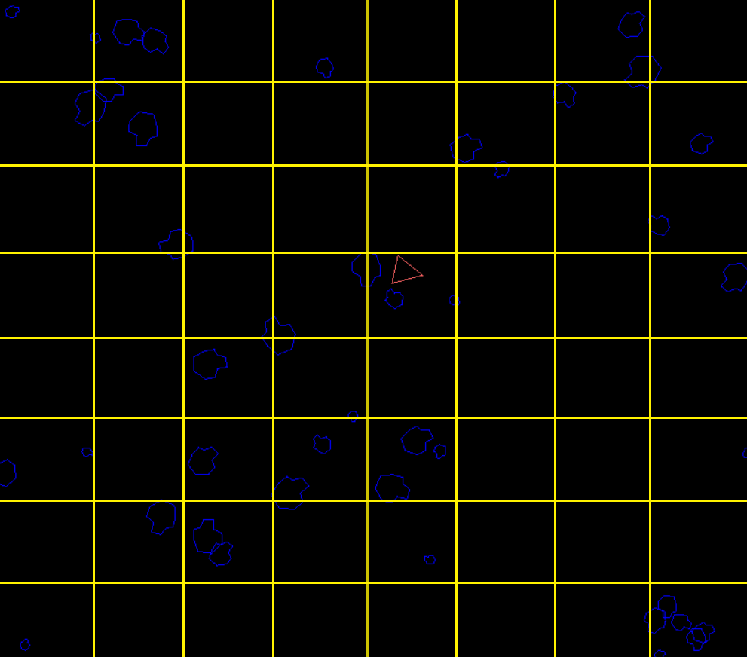

0

1

2

3

4

5

6

7

Grid size: 7 x 7  
  
Occupied cells:  
[0, 0]  
[1, 0]  
[3, 0]  
[6, 0]  
[7, 0]  
[0, 1]  
[1, 1]  
…  
  
Target cell: [7, 3]  
Target point: ???

* 1. In screen-space coordinates?
  2. Relative to the ship’s gun’s local coordinates, in which the $y$-axis points in the direction the ship is facing and the origin is at the front vertex of the ship?  
     Hint: make sure you include details of how to calculate the screen-space position of the centre of a cell. You can assume the transform of the gun in world coordinates is known.