# Introduction

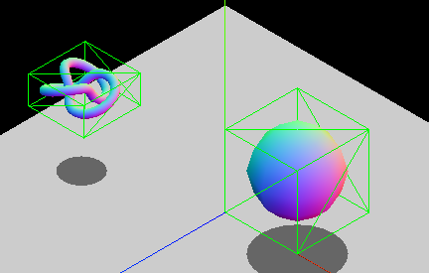

Some bounding boxes, from <https://developer.mozilla.org/en-US/docs/Games/Techniques/3D_collision_detection>

The exercises below are concerned with the 3D [axis aligned bounding box](https://www.gamasutra.com/view/feature/131833/when_two_hearts_collide_.php) (AABB) of an object, which is the smallest box that entirely contains a geometric object whilst keeping its edges aligned with the coordinate axes. An AABB is defined by its minimum and maximum vertices, $p_{min}$ and $p_{max}$, whose coordinates correspond to the minimum points, or vertices, of an object. AABBs are commonly used to accelerate the collision detection process.

You may find the Symbolab [matrix multiplication calculator](https://www.symbolab.com/solver/matrix-multiply-calculator) useful for finding/checking your results.

# Tasks

1. Consider an object whose shape is defined by the set of five points (7, 11, -5), (2, 3, 8), (-3, 3, 1), (-5, -7, 0) and (6, 3, 4).
   1. What are the extents of the AABB, $p_{min}$ and $p_{max}$, for these five points?
   2. Determine the centre point $c$ of the AABB.
   3. Multiply the five points by the following matrix (a 45° rotation about the $z$-axis): $$\left(\begin{matrix}0.707 & -0.707 & 0 \\ 0.707 & 0.707 & 0 \\ 0 & 0 & 1\end{matrix}\right)$$
   4. What is the AABB of these transformed points?
   5. What is the AABB we get by transforming the original AABB, defined by the points in part (a), instead of the five object points? How does it compare to the AABB of the transformed points found in part (d)?
2. In the week 5 lecture, an algorithm was presented for finding the intersection of two AABBs in 2D; the extension to 3D is a simple matter, but there are more shapes we might want to deal with. Describe (in English and/or pseudocode) how one might test for the following intersections, giving an example of when each might be used:
   1. Two AABBs.
   2. A plane and an AABB.
   3. A ray (line) and an AABB.

Exercises may include some modified questions from  
Dunn, F & Parberry, I 2011, *3D Math Primer for Graphics and Game Development*, CRC Press, Boca Raton, FL