# COMP270: 3D Computational Geometry Worksheet 2

1. A quaternion **q** to rotate through an angle *θ* is written as $q= \left[\begin{matrix}w & v\end{matrix}\right]=\left[\begin{matrix}\cos\left(\frac{θ}{2}\right) & \sin\left(\frac{θ}{2}\right)\end{matrix}\hat{n}\right]$.
   1. Construct a quaternion to rotate 30° about the x-axis.
   2. What is the magnitude of this quaternion?
   3. What is its conjugate, **q\***?
   4. Assume the quaternion is used to rotate points from object space to world space. What would the position of the point **p** = (0.5, -0.7, 2.3) be under this rotation?
2. Compute a quaternion that performs twice the rotation of the quaternion $\left[\begin{matrix}0.965 & \left(\begin{matrix}0.149 & -0.149 & 0.149\end{matrix}\right)\end{matrix}\right]$.
3. Consider the quaternions: $$a=\left[\begin{matrix}0.233 & \left(\begin{matrix}0.060 & -0.257 & -0.935\end{matrix}\right)\end{matrix}\right] \\ b=\left[\begin{matrix}-0.752 & \left(\begin{matrix}0.286 & 0.374 & 0.459\end{matrix}\right)\end{matrix}\right]$$ 
   1. Compute the dot product **a∙b**.
   2. Compute the quaternion product **ab**.
   3. Compute the difference from **a** to **b**.
4. An object initially had its axes and origin coincident with the world axes and origin. It was first rotated 30° about the y-axis, and then -22° about the world x-axis.
   1. What is the matrix that can be used to transform column vectors from object space to world space?
   2. What about the matrix to transform vectors from world space to object space?
   3. Express the object’s z-axis using world coordinates.
5. Construct a 4x4 matrix to translate by $\left(\begin{matrix}4 \\ 2 \\ 3\end{matrix}\right)$.
6. Construct a 4x4 matrix to rotate 20° about the x-axis and then translate by $\left(\begin{matrix}4 \\ 2 \\ 3\end{matrix}\right)$.
7. Construct a matrix to translate by $\left(\begin{matrix}4 \\ 2 \\ 3\end{matrix}\right)$ and then rotate 20° about the x-axis.
8. An *axis aligned bounding box (AABB)* is the smallest box whose edges are aligned with the coordinate axes that entirely contains a geometric object, defined by its minimum and maximum vertices **p**min and **p**max. AABBs are commonly used to accelerate the collision testing process.  
   Describe (in English and/or pseudocode) how one might test for the following intersections, giving an example of when each might be used:
   1. Two AABBs.
   2. A plane and an AABB.
   3. A ray (line) and an AABB.

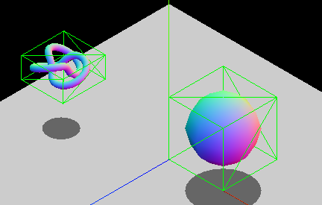

*Some bounding boxes, from* [*https://developer.mozilla.org/en-US/docs/Games/Techniques/3D_collision_detection*](https://developer.mozilla.org/en-US/docs/Games/Techniques/3D_collision_detection)