

Optimisation Workshop 1

Version 1.0

Specialisms in Creative Computing

COMP280

Author: Brian McDonald

# Workshop 1 – Optimisation Process

In this workshop you will be exploring the optimization process in terms of your own project.

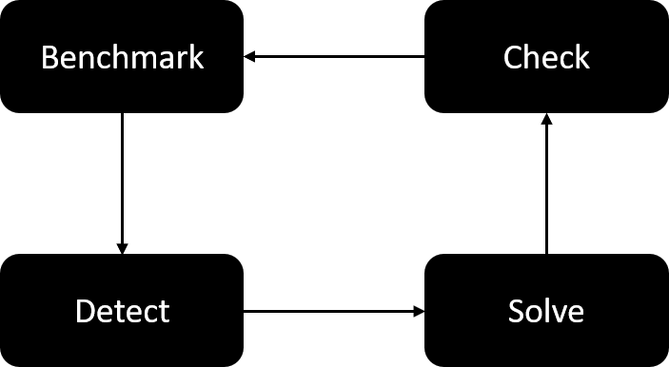

To complete the workshop please follow these tasks:

1. Select a project to optimize
2. Run the profiler and benchmark performance, record some of the stats from the profiler
3. Find a bottleneck using the profiler output, please post this into the Teams Chat for the session
4. Carry out some research to find out why this bottleneck is occurring
5. Post the results of this research into the chat
6. Make changes to your project to eliminate the bottleneck
7. Rerun the profiler to see if your changes have been successful, compare your results to the benchmark in (2)

If you finish this task before the end of the workshop, please consider moving onto the worksheet task which can be found here:

<https://learningspace.falmouth.ac.uk/mod/resource/view.php?id=114234>