COMP270 Week 5 Exercise Sheet: Newtonian Mechanics

Note: for the following exercises, assume that the acceleration due to gravity, g, is 9.81m/s2 acting straight downwards, and there is no air resistance or other force acting upon the objects.
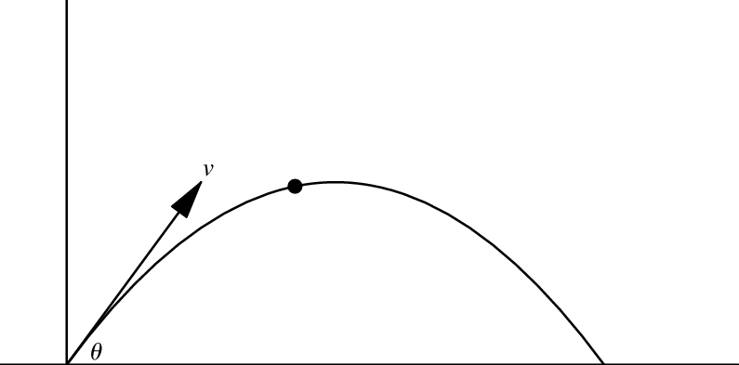
p0
u

- A projectile is launched with an initial speed of 30m/s, with an angle of inclination of θ = 40° from the initial position p0 = (0m, 2.5m).
  - What is the initial velocity u in vector form?
  - At what time will the projectile reach its apex (highest point)?
  - What are the coordinates of the projectile at the apex?
  - How long will it take for projectile to come back to an altitude of y = 2.5m?
  - What will the horizontal displacement be at this time?
  - For how long is the projectile in the air before it hits the ground?
  - Find the values for the projectile’s
    - final velocity, v, and
    - final horizontal displacement, sx’
when it hits the ground.
- A ball is thrown from ground level so that it just clears a wall that is 3m high. If the initial speed of the ball is 20m/s, find the angle of projection.
- A ball is thrown vertically upwards with a speed of 21m/s.
  - In which direction is the ball travelling after 3 seconds?
  - What is the total distance it has travelled in this time?
- A stone is thrown vertically upwards with a speed of 7m/s, and one second later, a second stone is thrown vertically upwards from the same point with the same speed.
Find the height at which the two stones collide.

Reference
Splitting vectors into components: https://www.physicsclassroom.com/Class/vectors/u3l1e.cfm
Aside: proof(s) that -1 x -1 = 1: http://mathforum.org/dr.math/faq/faq.negxneg.html

