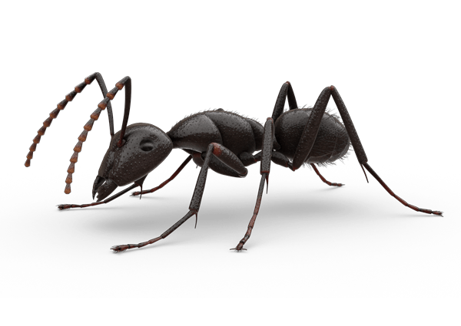
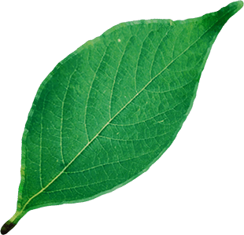
- An ant starts at one vertex of a solid cube with side length 1. Calculate the distance of the shortest route the ant can take to the furthest vertex from the starting point.
$$\sqrt{13}$$
$$\sqrt{20}$$
$$\sqrt{29}$$
- Find the area of this triangle:
Hint: the area of a triangle is given by $\frac{1}{2}base×height$
Exercises may include some modified questions from:
Southall, E & Pantaloni, V 2017, Geometry Snacks, Tarquin, St Albans UK
Povey, T 2015, Professor Povey’s Perplexing Problems, Oneworld Publications, London UK
Povery
- If the outer circle in the diagram below is a unit circle (i.e. radius 1), find the radius of the smallest circle.
- What is the volume of the largest cube that fits entirely within a sphere of unit volume?
Hint: remember that the volume of a sphere is given by $\frac{4}{3}πr^{3}$
- What is the area of an $n$-sided regular polygon inscribed within a circle of radius $r$?
$$n=5$$
$$n=4$$
$$n=3$$
- A straight tree trunk has a circular cross section of radius $n$, where $n$ is an integer. A second straight, circular tree trunk has radius $m$, where $m$ is also an integer. Both tree trunks rest on the (level, horizontal) ground, adjacent and parallel to one another.
  - Derive the general condition relating the radii of the two trunks that permits their centres to be an integer distance $d$ apart when the circumferences touch.
  - Give the three smallest solutions for $n$ when $m=1$.
  - Give a general solution for $n$ and $m$.
$$2m$$
$$2n$$
$$d$$

