This worksheet is split into two sections: Part A is a set of “traditional” maths questions to complete without a computer, while Part B involves using code to answer the same or similar questions. You can complete either section first, or swap between them; you may find that tackling the same problem using a different approach enhances your understanding of it.

Part A
Answer the following questions using pen(cil) and (graph) paper.
Pro tip: show your working – diagrams can be helpful!

- For each of the pairs of vectors below, evaluate their dot product using the algebraic definition:
$$a∙b= x_{a}x_{b}{ + y}_{a}y_{b}$$and check the result against your answers to question 3 of part A of last week’s exercises using the identity
$$a∙b=\left\|a\right\|\left\|b\right\|\cos{θ}$$
  - $a=\left({3 \atop \sqrt{3}}\right)$ and $b=\left({1 \atop √3}\right)$
  - $a=\left({3 \atop 3}\right)$ and $b=\left({-2 \atop 2}\right)$
- Write down any two vectors that are (i) parallel and (ii) perpendicular to:
  - $\left({1 \atop 1}\right)$
  - $\left({-1 \atop -1}\right)$
  - $\left({1 \atop 2}\right)$
  - $\left({0 \atop 0}\right)$
Verify that your answers are correct using the dot product.
- Compute the following matrix products:
  - $\left({\begin{matrix}1 & -2\end{matrix} \atop \begin{matrix}5 & 0\end{matrix}}\right)\left({\begin{matrix}-3 & 7\end{matrix} \atop \begin{matrix}4 & \frac{1}{3}\end{matrix}}\right)$
  - $\left({\begin{matrix}6 & -7\end{matrix} \atop \begin{matrix}-4 & 5\end{matrix}}\right)\left({3 \atop 3}\right)$
  - $\left({\begin{matrix}-3 & -2\end{matrix} \atop \begin{matrix}5 & 4\end{matrix}}\right)\left({-2\begin{matrix} & -1\end{matrix} \atop \begin{matrix}2\frac{1}{2} & 1\frac{1}{2}\end{matrix}}\right)$
  - $\left({\begin{matrix}1 & 0\end{matrix} \atop \begin{matrix}0 & 1\end{matrix}}\right)\left({\begin{matrix}a & b\end{matrix} \atop \begin{matrix}c & d\end{matrix}}\right)$
  - $\left(\begin{matrix}3 & 3\end{matrix}\right)\left({\begin{matrix}6 & -7\end{matrix} \atop \begin{matrix}-4 & 5\end{matrix}}\right)$

What do you notice about (c)? How about (b) and (e)?
Exercises may include some modified questions from
Dunn, F & Parberry, I 2011, 3D Math Primer for Graphics and Game Development, CRC Press, Boca Raton, FL

- Describe the transformation represented by each of the following matrices.
Hint: consider what happens when they are applied to the basis vectors $\left({1 \atop 0}\right)$ and $\left({0 \atop 1}\right)$

  - $\left({\begin{matrix}0 & 1\end{matrix} \atop \begin{matrix}-1 & 0\end{matrix}}\right)$
  - $\left({\begin{matrix}\frac{\sqrt{2}}{2} & -\frac{\sqrt{2}}{2}\end{matrix} \atop \begin{matrix}\frac{\sqrt{2}}{2} & \frac{\sqrt{2}}{2}\end{matrix}}\right)$
  - $\left({\begin{matrix}2 & 0\end{matrix} \atop \begin{matrix}0 & 2\end{matrix}}\right)$
  - $\left({\begin{matrix}4 & 0\end{matrix} \atop \begin{matrix}0 & 7\end{matrix}}\right)$
  - $\left({\begin{matrix}-1 & 0\end{matrix} \atop \begin{matrix}0 & 1\end{matrix}}\right)$
  - $\left({\begin{matrix}0 & 2\end{matrix} \atop \begin{matrix}-2 & 0\end{matrix}}\right)$
- Match each of the following figures (1-4) with their corresponding transformations as applied to the figure on the left:

  - $\left({\begin{matrix}1 & 0\end{matrix} \atop \begin{matrix}0 & -1\end{matrix}}\right)$
  - $\left({\begin{matrix}2.5 & 0\end{matrix} \atop \begin{matrix}0 & 2.5\end{matrix}}\right)$
  - $\left({\begin{matrix}-\frac{\sqrt{2}}{2} & -\frac{\sqrt{2}}{2}\end{matrix} \atop -\begin{matrix}\frac{\sqrt{2}}{2} & \frac{\sqrt{2}}{2}\end{matrix}}\right)$
  - $\left({\begin{matrix}1.5 & 0\end{matrix} \atop \begin{matrix}0 & 2.0\end{matrix}}\right)$
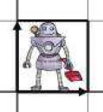
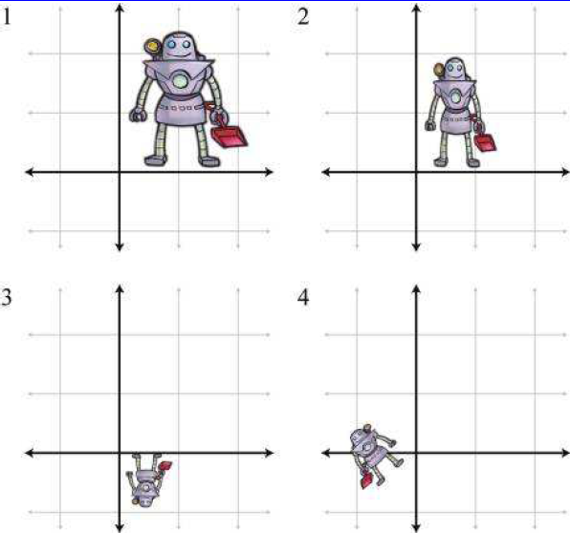
Figures taken from 3D Math Primer for Graphics and Game Development,
Fletcher Dunn and Ian Parberry, CRC Press

- Compute the inverses of the matrices in question 4 using the formula
$${\left(\begin{matrix}a & b \\ c & d\end{matrix}\right)}^{-1}=\frac{1}{ad-bc}\left(\begin{matrix}d & -b \\ -c & a\end{matrix}\right)$$
What transformation does each inverse represent?
- You may have noticed that a class of transformation is missing from the examples above: translation. This requires the use of homogeneous coordinates, where the point $(x, y)$ is represented by $(x, y, 1)$ so that it can be multiplied by a 3x3 matrix, $\left(\begin{matrix}1 & 0 & t_{x} \\ 0 & 1 & t_{y} \\ 0 & 0 & 1\end{matrix}\right)$.
  - Write the displacement from the origin to the point $(-1, 3)$ as a homogeneous column vector.
  - Write down the homogeneous matrix to describe a 2D translation of 1 unit in the $x$ direction and 2 units in $y$, and apply it to the vector in part (a).
  - Combine your matrix from part (b) with an appropriate rotation matrix to represent the following transformation:
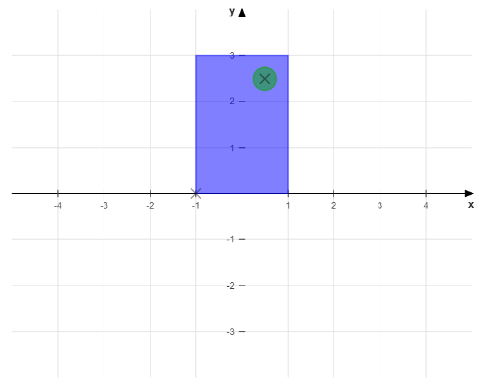→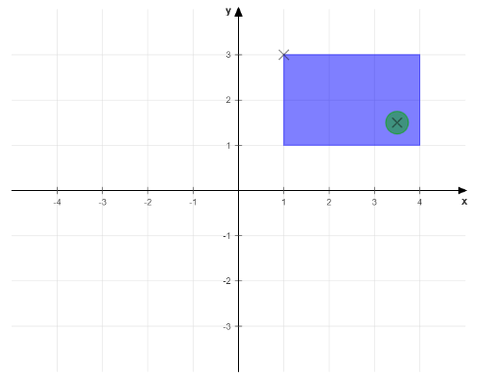
What happens if you reverse the order in which you combine the matrices?
  - What transformation would you need to apply to rotate the shape through 180° about the centre of the green dot (marked with a cross) in its top right corner, leaving the dot’s position fixed? Express your answer as a single matrix.

Part B
We’re going to carry on using the same program as before for this section; make sure you have completed at least the first two questions from part B of last week’s exercises, as you’ll need the functionality in order to do this week’s (the answers are available on LearningSpace if you need them).

Note: you’ll need to uncomment the relevant function calls in Scene::setup() to be able to complete the exercises.

- The dot product is an extremely useful operation for checking vector directions.
  - Implement the dot product formula in Vector2::dot(); you can check the answers it gives against your own for question 1 of part A.
  - The function Scene::week3_exercise1() creates a random set of vectors; edit the code to only display ones that are pointing in roughly the same direction (within a range of 180°).
  - Can you narrow the range even further, e.g. to only display vectors at an angle of less than 45° from any other vector shown?
- Being able to find the normalised, unit vector that isolates the direction from the length is also useful.
  - Implement the formula for computing the unit (normalised) vector in Vector2::normalised().
Hint: you can make use of one of the functions you implemented last week.
  - The function Scene::week3_exercise2() creates two random vectors. Add code to compute (and draw) the projection of the first vector onto the second.
Hint: you may find it helpful to break the computation into stages, displaying results at each point.
- The file Matrix22.h contains a class, Matrix22, to represent a 2×2 matrix; again, some of the functions are unfinished. The matrix components are represented by variables mij, where i is the row and j is the column number.
  - Complete the implementation by adding the following operations:
    - Multiplication with another Matrix22 in Matrix22::operator*().
    - Multiplication with a Vector2 in the relevant operator*() function in Vector2.h.
    - Computing the inverse matrix in Matrix22::inverse().
  - Use the Matrix22 class to apply the transformations in questions 4-6 of part A to the objects created in Scene::week3_exercise3() (and/or any others you care to add); also try combining these matrices by multiplying them in different orders. Does the order matter for all combinations? Can you explain why/why not?
Hint: the matrices from 4a and 4e have been added to get you started, but you’ll need to create the rest yourself.

- The translations required in question 7 of part A cannot be computed using the Vector2 and Matrix22 classes, as they only represent objects in $R^{2}$. There are partially-implemented homogeneous version in Vector2h.h and Matrix22h.h, which can be converted to/from the original classes to allow the full set of transformations to be applied.
  - Complete the implementations for the two homogeneous classes, Vector2h and Matrix22h, by finishing the following functions:
    - Multiplication with another Matrix22h in Matrix22h::operator*().
    - Multiplication with a Vector2h in the relevant operator*() function in Vector2h.h.
  - Use these classes to test the transformation matrices in question 7 of part A (the code for this has been started in Scene::week3_exercise3()).
- Bonus exercise: the update() method in the Application class is called during the main run loop; see if you can animate the objects by updating their transforms in this function.
Hint: you’ll need to add functions that the Application can call to affect the objects, which you’ll need to keep track of after they’ve been created.

