COMP270: 2D Matrices
Part A
- Compute the following matrix products:
What do you notice about (c)? And about (b) and (e)?
- Describe the transformation represented by each of the following matrices (hint: consider what happens when they are applied to the basis vectors and ):
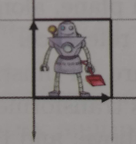
- Match each of the following figures (1-4) with their corresponding transformations as applied to the figure to the right:

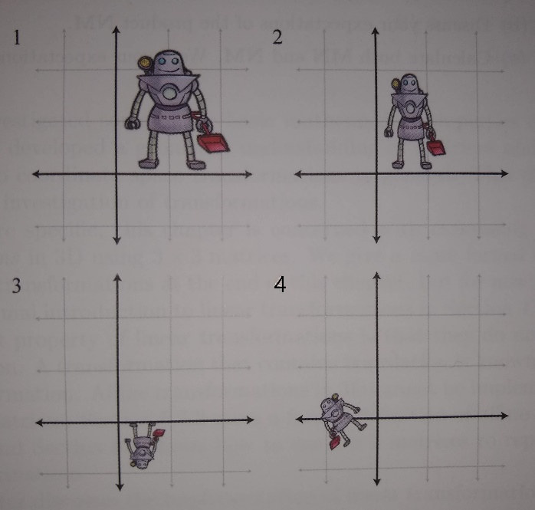
- Compute the inverses of the matrices in question 2 using the formula

What transformation does each inverse represent?
- You may have noticed that a class of transformation is missing from the examples above: translation. This requires the use of homogeneous coordinates, where the point (x, y) is represented by (x, y, 1) so that it can be multiplied by a 3x3 matrix, .
  - Write the displacement from the origin to the point (-1, 3) as a homogeneous column vector.
  - Write down the homogeneous matrix to describe a 2D translation of 1 unit in the x direction and 2 units in y, and apply it to the vector in part (a).
  - Combine your matrix from part (b) with an appropriate rotation matrix to represent the following transformation:
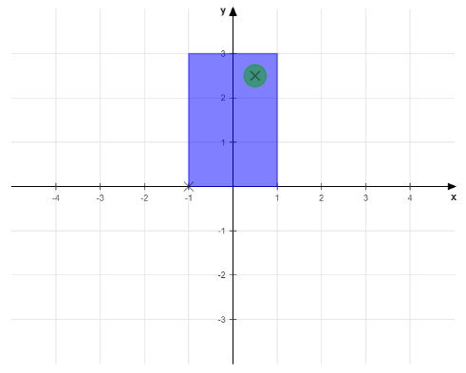 →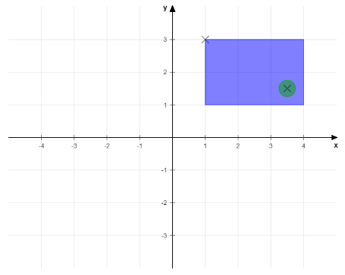
What happens if you reverse the order of the transformations?
- A bus travels along a straight road, heading east-north-east through the origin, observed by Alex, who is standing two units east and one unit south of the origin.
If the x-axis points east and the y-axis, north:
  - Write the direction of the bus as a unit vector (magnitude 1).
[Hint: (proof here)]
  - Write the displacement of Alex from the origin as a vector .
  - Use the dot product to determine how far from the origin the bus has travelled when it is closest to Alex.
Part B
The Visual Studio solution ‘2019-20-comp270-04-workshop’ is a basic setup for drawing points and lines/vectors, with classes to represent 2D vectors and matrices, which you can use to either check or help you figure out the answers for this and the previous worksheet. Download the solution, run it and briefly review the method Application::addObjects() before carrying out the following:
- Implement the formulae for the following Matrix22 operations:
  - Multiplication with another Matrix22 in Matrix22::operator*().
  - Multiplication with a Vector2 in the relevant operator*() function in Vector2.h.
  - Computing the inverse matrix in Matrix22::inverse().
Test your implementations with the values from questions 1 – 4 in Part A above, applying the matrix transformations to objects in Application::addObjects().
- The translations required in question 5 of Part A cannot be computed using the Vector2 and Matrix22 classes as they stand, so we have the homogeneous versions, Vector2h and Matrix22h, which can be converted to/from the original classes to allow the full set of transformations to be applied.
Complete the implementations for the two homogeneous classes and test them with the values in question 6 (and any of your own you’d like to try).
- Back to vectors now:
  - Implement the dot product formula in Vector2::dot() and use it to complete the section in addObjects() to answer questions 8 and 9 from the previous worksheet, displaying points x that are:
    - Visible to/in front of the NPC
    - Invisible to/behind the NPC
  - Implement the formula for computing the unit (normalised) vector in Vector2::normalised() and use it to help with/check your answer to question 6 in Part A.
- Bonus exercise: The update() method in Application is called during the main run loop; see if you can animate the objects by updating their transformations in this function.
Reference/Further reading:
3D Math Primer for Graphics and Game Development (Chapter 4), Fletcher Dunn and Ian Parberry, CRC Press
https://www.khanacademy.org/math/linear-algebra

