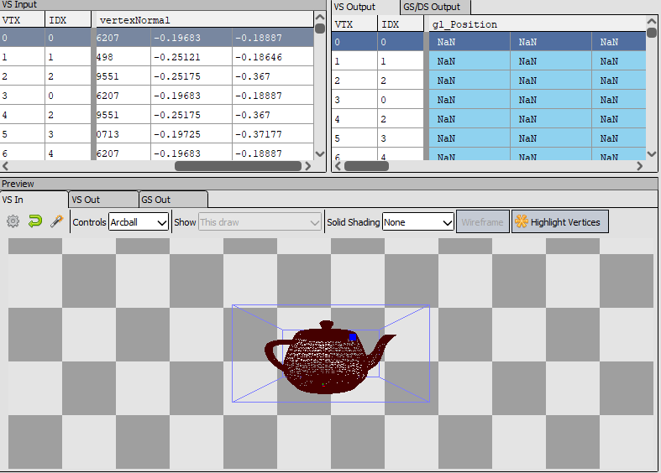

Having not-a-number values for position, that’s why it’s not showing up. Mesh is loading in, but not showing up due to nan values.

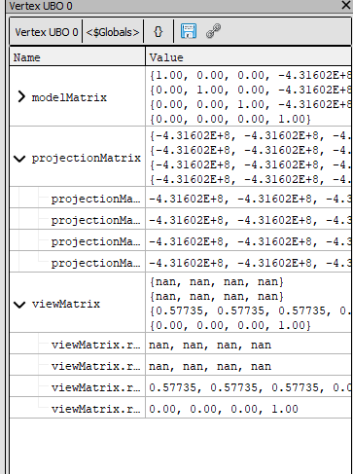

The view matrix also has not-a-number values, as well as projection matrix’s broken values. This is probably because of values set in Camera.cpp.

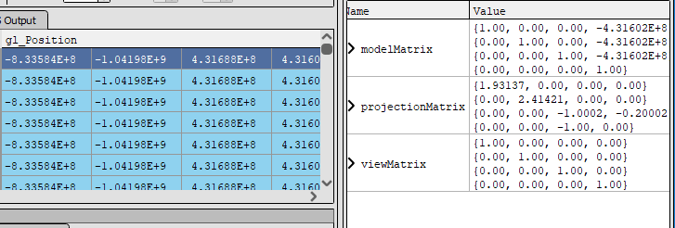

Projection’s values were broken due to normalizing zero value. After changing cameraTarget value, projection matrix became normal, but something is still wrong with model matrix. Also broken values in gl_Position. Also projection matrix was commented, which was a mistake from me.

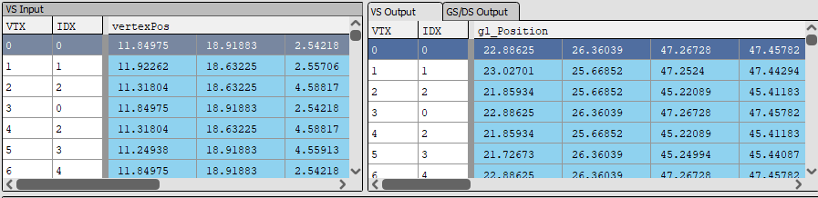

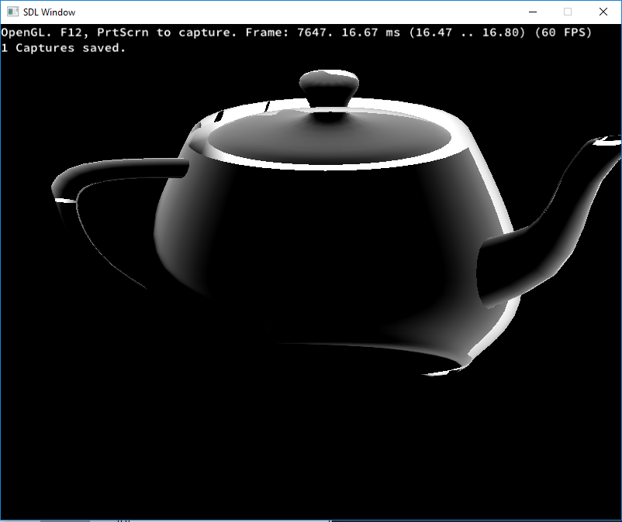

Position of the camera was also commented, which gave bad values for model matrix from previous screen shots

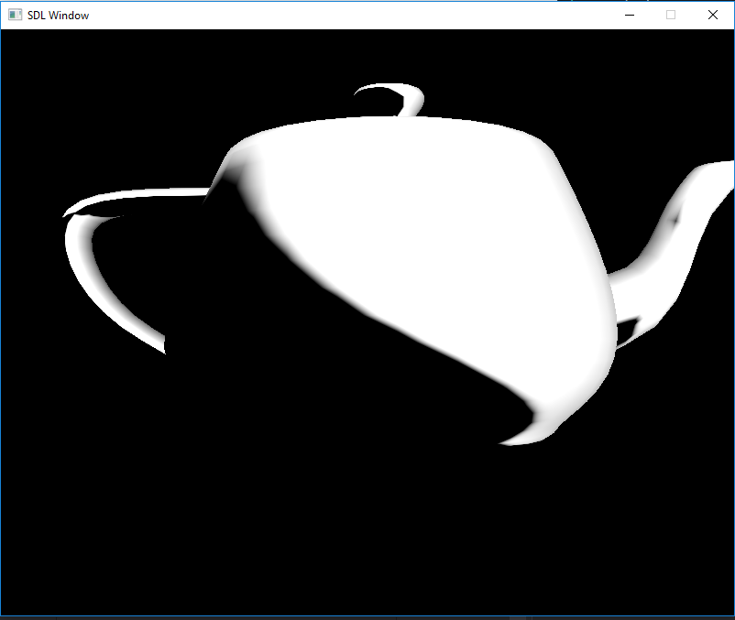

GL_DEPTH_TEST and GL_CULL_FACE were disabled… This screen shot shows it with both enabled.

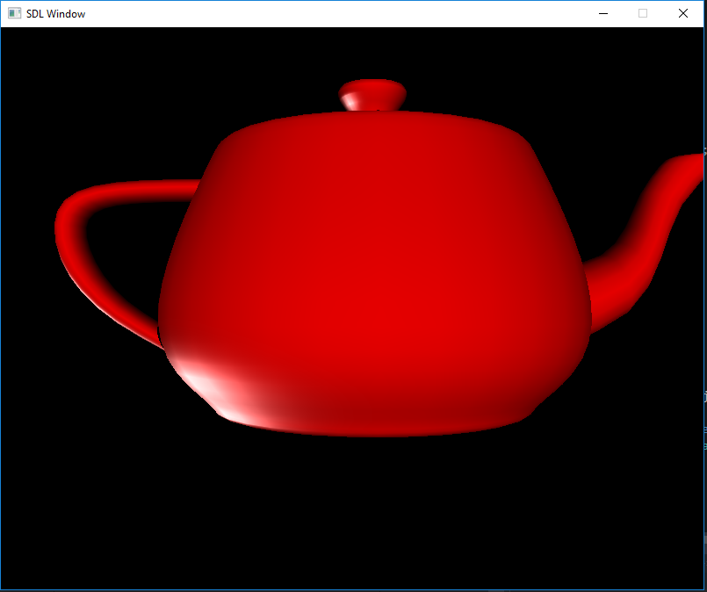

With lighting (ambient, diffuse, specular)

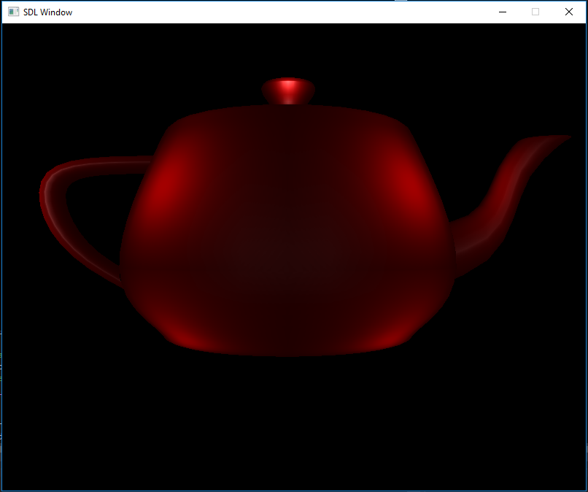

Latest version with lighting.