Optimising Monq

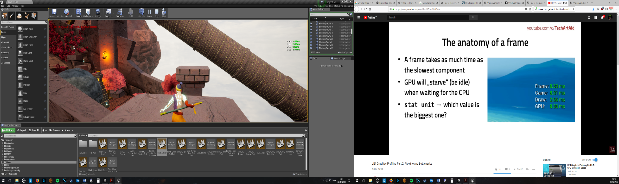For comp 350 I propose optimising MONQ. This is a third person platformer puzzle game, which uses the Unreal engine. Recently I ported the game from 4.14 to 4.18 and though this improved a few issues there are still many left to fix.

Currently the game runs at ~45 fps on an I7 3770K with a GTX 780.

To begin with I need to find where the bottleneck is, from the picture to the left we can see that the Frame, Game and GPU are quite similar in number so the issue could be any one of them.

To find any issues with the CPU for this project I will be using the unreal in-editor profiler, this will tell me the current points where the CPU is slowing down.

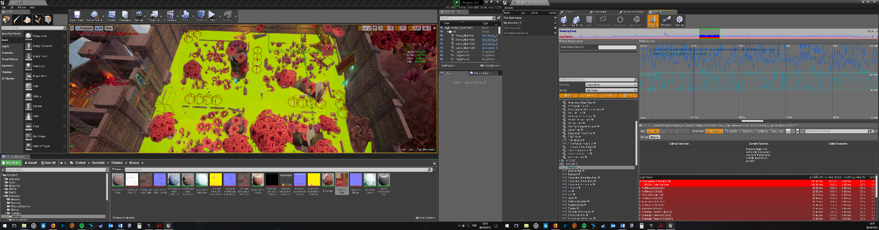From the initial use of the profiler the issue seems to be the CPU waiting for tasks to complete, this leads me to believe that either the GPU or a code issue. As the GPU time is relatively close to the Game time then it is probably the game Code.

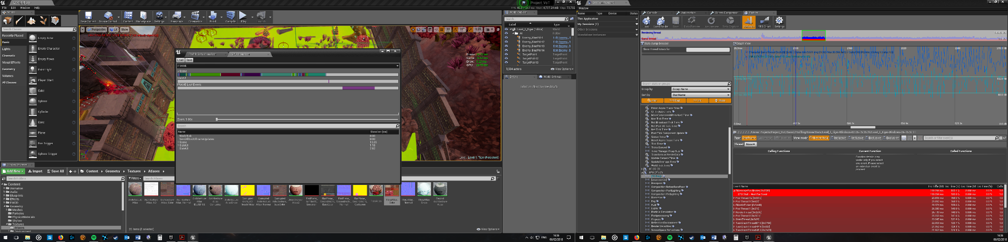

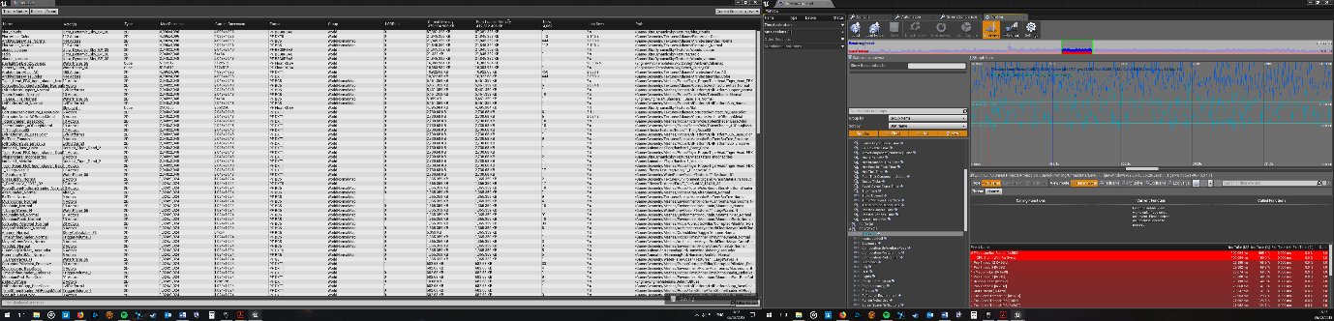Two other tools that can be used are the GPU profiler and the statistics profiler right and left picture respectively. The Statistics profiler can be used to view the stats of every object used in the game including the textures used, you can see how large the original texture is and how large the texture is when used ingame. The GPU profiler can be used to see each TYPE of object that is rendered and its GPU cost.