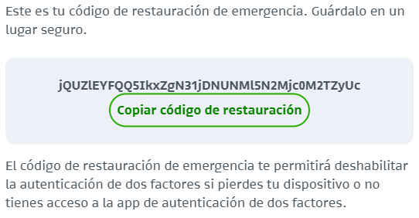

jQUZlEYFQQ5IkxZgN31jDNUNMl5N2Mjc0M2TZyUc