AMES HOUSING REGRESSION PROJECT REPORT
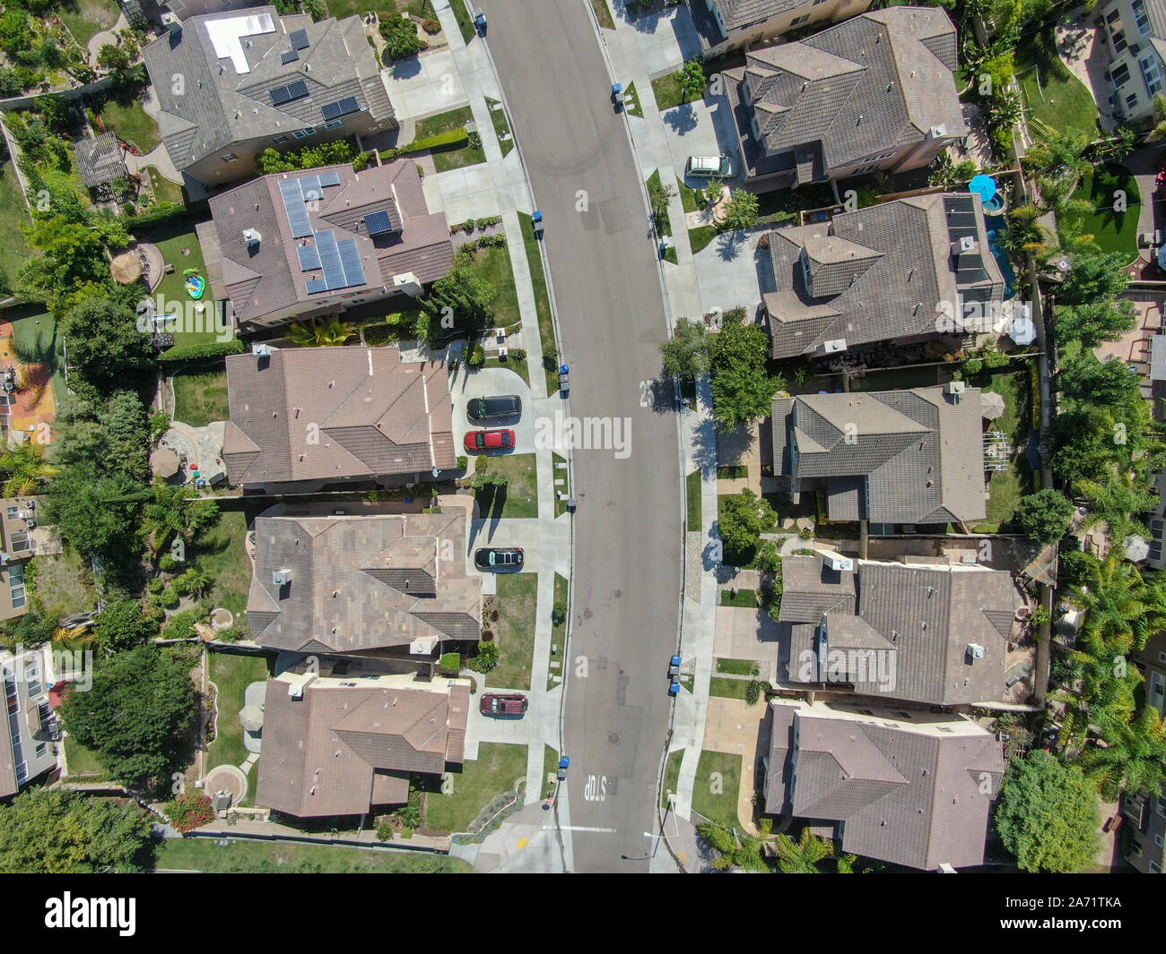

By
Group 4
Emmanuel Falonipe

Dataset & Context

Source: Residential home sales in Ames, Iowa (2006–2010), collected by Dean De Cock as a teaching dataset.
Scope: 80+ explanatory features (physical characteristics, quality/condition, location, amenities) and target SalePrice.
Problem: Predict sale price (regression) to help buyers, agents, planners, lenders, and researchers make data-driven decisions.
Key Stakeholders:
- Home Buyers (fair pricing)
- Real-estate Agents (competitive pricing strategies)
- City Planners (trend analysis)
- Mortgage Lenders (risk assessment)
- Data Practitioners (modeling practice)

2. Wrangling Recipe (MLOS)

Column Deletions (18 total)
Category | Columns
Location & Identifiers | Alley, Street, Utilities, PID
Basement & Porch Features | BsmtFin_SF_2, BsmtFin_Type_2, Low_Qual_Fin_SF, 3Ssn_Porch
Structure & Quality | Overall_Cond, Heating, Roof_Matl, Kitchen_AbvGr
Amenities & Miscellaneous | Misc_Feature, Misc_Val, Pool_QC, Fence
Sale Timing & Garage | Mo_Sold, Garage_Area

Intermediate Saves
- AmesHousingWrangled.csv
- AmesHousingWrangled1.csv
- AmesHousing_Updated.csv

Feature Engineering
House_Age = 2025 − Year_Built

Missing-Value Imputation
Column Group | Imputation
Lot_Frontage | median
Mas_Vnr_Type | None
Mas_Vnr_Area | 0
Bsmt_Qual, Bsmt_Cond, Bsmt_Exposure, BsmtFin_* | No Bsmt
Bsmt SF & Bath fields | 0
Garage_Type, Garage_Finish, Garage_Qual, Garage_Cond | No_Garage
Garage_Yr_Blt, Garage_Cars | 0
Fireplace_Qu | No_Fireplace
Electrical | SBrkr

Feature Definition & Input Selection
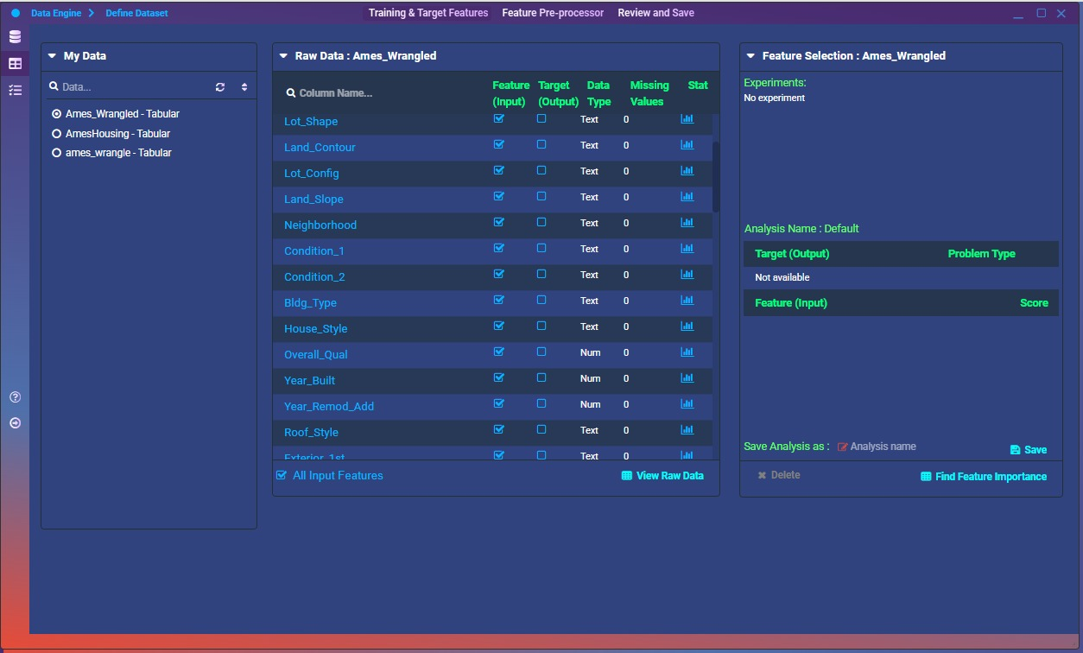
In this step we confirm which columns will serve as model inputs and which one is our target. After importing the fully‑wrangled CSV (Ames_Wrangled), we tick every remaining feature under Feature (Input), and mark SalePrice as our Target (Output). Notice that all text‑based variables (e.g. Lot_Shape, Neighborhood, Bldg_Type, etc.) have zero missing values from our prior imputation. This ensures that every input column is ready for the next phase of numeric encoding.

Training & Validation Split
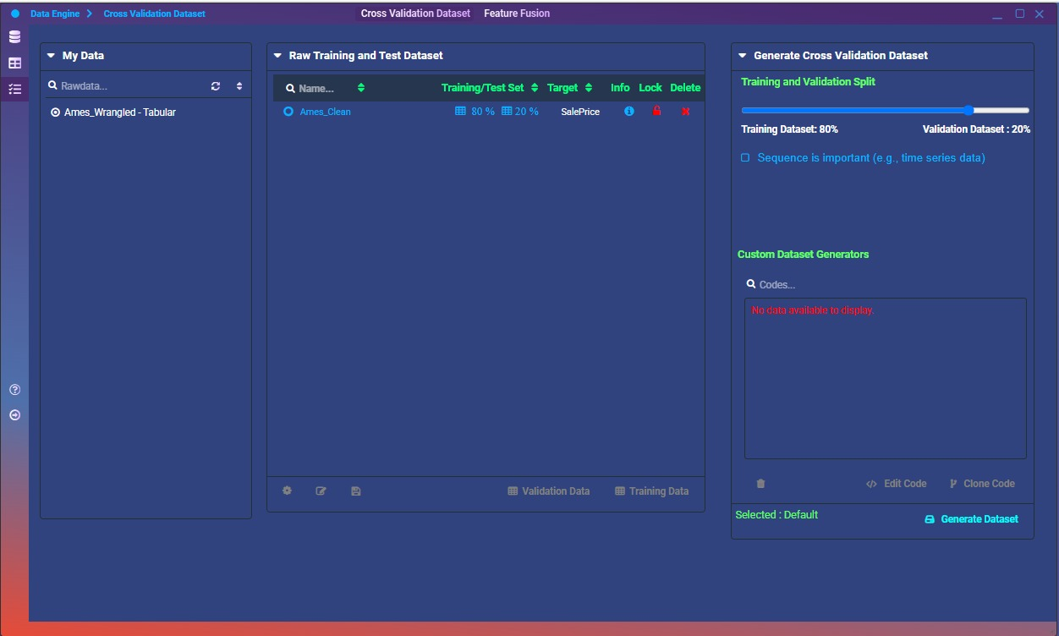
Here we generate a reproducible train/validation split directly in MLOS. We allocate 80 % of the rows for training and 20 % for validation, locking the split so it won’t shift on reruns. This separation lets us evaluate model generalization on unseen data without leaking information from the training set, giving a reliable estimate of out‑of‑sample performance.

Model Training & Versioning
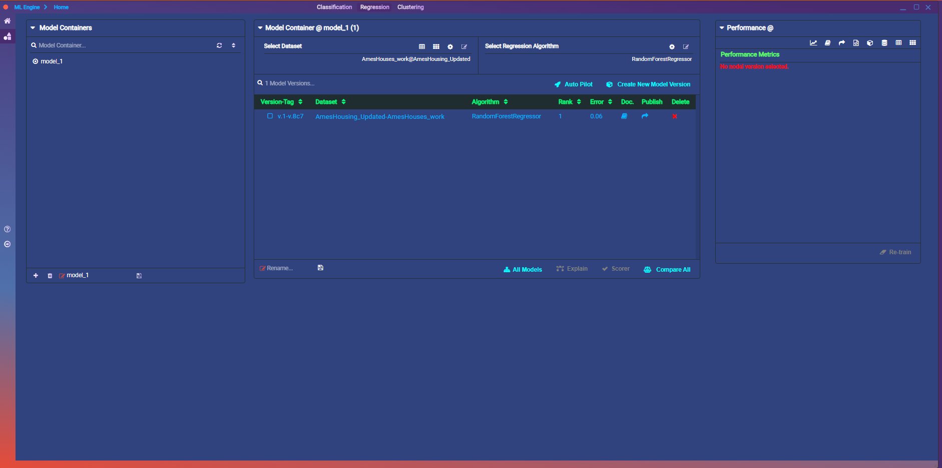
Once our preprocessed dataset (AmesHousing_Updated) was ready, we moved into the ML Engine to train and version our model:

Model Container
We created a container named model_1 to encapsulate all experiments for reproducibility.

Dataset Selection
The fully wrangled and encoded AmesHousing_Updated table serves as the input for modeling.

Algorithm Choice
We selected RandomForestRegressor, a robust ensemble method well‑suited for tabular data.

Versioning & Metrics
- Version Tag: v.1-v-8c7
- Error (RMSE): 0.06 (on the held‑out validation set, corresponding to ~6% average deviation in scaled sale price)
- Rank: 1 (indicating this is currently our top performing version)

Exploratory Plots in the Wrangler
We used the Wrangler’s built‑in visualization tools to explore key bivariate relationships:

GrLivArea vs. SalePrice (Scatter Plot)
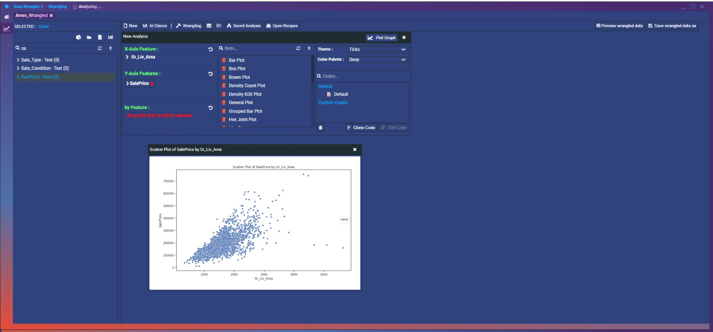
Confirms the strong positive correlation between living area and sale price, with larger homes generally commanding higher values.

OverallQual vs. SalePrice (Box Plot)
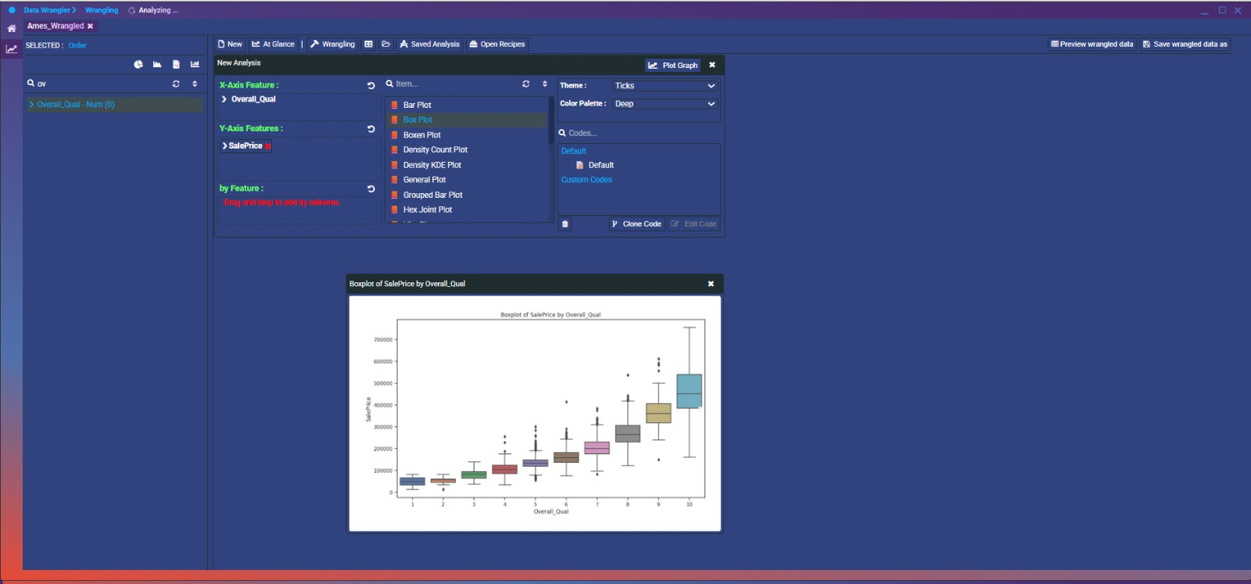
Highlights how increasing overall quality ratings translate to higher median prices and wider price ranges at the top end.
Conclusion & Key Learnings
- Data preparation lays the groundwork.
Cleaning and thoughtfully imputing 80+ features, and pruning 18 low-value ones, ensured our model focused on solid, relevant signals.
- Feature engineering amplifies insights.
Creating House_Age alongside original year fields, and later exploring flags like “Remodeled,” helps the model capture age-related price effects more directly.
- Initial model shows promise.
A Random Forest with an RMSE of 0.06 (≈6% error) on scaled prices gives us confidence we’re on the right track; systematic CV and tuning will only improve it.

