Experiment No: 6
Course Name: | Web Programming Laboratory (216U01L405) | Semester: | IV
Date of Performance: | 30_ / 03_ / 2026__ | DIV/ Batch No: | B1
Student Name: | Kevin Lyeon Dsilva | Roll No: | 16010124078

Title: Develop a PHP application that performs CRUD (Create, Read, Update, Delete) operations.

Aim of the Experiment:
To design and develop a dynamic web application using PHP and MySQL that performs CRUD (Create, Read, Update, Delete) operations on a database.

Objectives for the Experiment:
- Understand and explain the architecture of a PHP–MySQL web application and the role of CRUD operations in database-driven systems.
- Implement Create, Read, Update, and Delete functionalities using PHP and MySQL with proper form handling and database connectivity.
- Analyze and validate user inputs and database transactions to ensure data integrity and error handling (if possible secure from SQL injection).
- Design and develop a functional and user-friendly CRUD-based web application following best practices in modular coding and structured programming.

COs to be achieved:
- Design dynamic web pages using various HTML tags.
- Use CSS to prepare the layout of web pages.
- Apply JavaScript for validation in client-side programming.
- Integrate server-side pages using PHP.
- Apply database operations by integrating SQL queries and session variables.

Books/ Journals/ Websites references:
- Students should write

Software / Tools Required
- XAMPP / WAMP / MAMP
- PHP
- MySQL
- phpMyAdmin
- Code Editor (VS Code / Sublime / Notepad++/ any other)
- Web Browser

Methodology:
- Start XAMPP server.
- Create database and table in phpMyAdmin.
- Establish PHP-MySQL connection.
- Create HTML form for data input.
- Write PHP code for:
  - Insert
  - Fetch
  - Update
  - Delete
- Execute queries.
- Display results.
- Close database connection.

Theory:
A web application is a software system that allows users to interact with data through a browser. In this experiment, a dynamic web application is developed using HTML, PHP, and MySQL to perform CRUD operations.
HTML (HyperText Markup Language) is used to design the structure of web pages and create forms for user input. These forms collect data such as name, email, and course from the user.
PHP (Hypertext Preprocessor) is a server-side scripting language used to process the data submitted through HTML forms. It interacts with the database, executes SQL queries, and generates dynamic content.
MySQL is a relational database management system used to store and manage data efficiently. It supports structured data storage using tables, rows, and columns.
CRUD operations form the backbone of database-driven applications:
- Create: Inserting new records into the database
- Read: Retrieving and displaying records
- Update: Modifying existing records
- Delete: Removing records
The communication between PHP and MySQL is established using extensions such as mysqli, which enables executing SQL queries and handling results.
When a user submits a form:
- Data is sent to the server using GET or POST method
- PHP receives the data via superglobal variables
- SQL queries are executed
- The database is updated accordingly
- Results are displayed back to the user
This process demonstrates how front-end (HTML/CSS) and back-end (PHP/MySQL) technologies work together to build dynamic web applications.

Problem statement:
Design and implement an application to demonstrate HTML form integration with PHP for data collection and processing and perform the CRUD operations.

Note: Mini Project should start with CRUD operations too.
Note: Ensure all mini project code / work is regularly pushed to Github

Code:
False-Ai/WPL_new
db.php
<?php
$conn = new mysqli("localhost", "root", "", "exp6");

if ($conn->connect_error) {
die("Connection failed: " . $conn->connect_error);
}
?>

Index.php
<?php include 'db.php'; ?>

<!DOCTYPE html>
<html>
<head>
<title>Student CRUD App</title>

<style>
body {
font-family: Arial;
background-color: #f4f6f8;
text-align: center;
}

h2 {
color: #333;
}

.container {
width: 60%;
margin: auto;
background: white;
padding: 20px;
border-radius: 10px;
box-shadow: 0px 0px 10px gray;
}

input {
width: 80%;
padding: 8px;
margin: 5px;
}

button {
padding: 10px 20px;
background: #28a745;
color: white;
border: none;
cursor: pointer;
}

button:hover {
background: #218838;
}

table {
width: 100%;
margin-top: 20px;
border-collapse: collapse;
}

th, td {
padding: 10px;
border: 1px solid #ddd;
}

th {
background: #007bff;
color: white;
}

a {
text-decoration: none;
padding: 5px 10px;
color: white;
border-radius: 5px;
}

.edit {
background: orange;
}

.delete {
background: red;
}
</style>
</head>

<body>

<div class="container">

<h2>Student Management System</h2>

<form method="POST">
<input type="text" name="name" placeholder="Enter Name" required><br>
<input type="email" name="email" placeholder="Enter Email" required><br>
<input type="text" name="course" placeholder="Enter Course" required><br>
<button type="submit" name="submit">Add Student</button>
</form>

<?php
if (isset($_POST['submit'])) {
$name = $_POST['name'];
$email = $_POST['email'];
$course = $_POST['course'];

$conn->query("INSERT INTO students (name, email, course)
VALUES ('$name','$email','$course')");
}
?>

<table>
<tr>
<th>ID</th>
<th>Name</th>
<th>Email</th>
<th>Course</th>
<th>Action</th>
</tr>

<?php
$result = $conn->query("SELECT * FROM students");

while ($row = $result->fetch_assoc()) {
echo "<tr>
<td>{$row['id']}</td>
<td>{$row['name']}</td>
<td>{$row['email']}</td>
<td>{$row['course']}</td>
<td>
<a class='edit' href='update.php?id={$row['id']}'>Edit</a>
<a class='delete' href='delete.php?id={$row['id']}'>Delete</a>
</td>
</tr>";
}
?>

</table>

</div>

</body>
</html>

Update.php
<?php include 'db.php';

$id = $_GET['id'];
$result = $conn->query("SELECT * FROM students WHERE id=$id");
$row = $result->fetch_assoc();
?>

<!DOCTYPE html>
<html>
<head>
<title>Update Student</title>

<style>
body {
font-family: Arial;
background-color: #f4f6f8;
text-align: center;
}

.box {
width: 40%;
margin: auto;
background: white;
padding: 20px;
margin-top: 50px;
border-radius: 10px;
box-shadow: 0px 0px 10px gray;
}

input {
width: 80%;
padding: 8px;
margin: 10px;
}

button {
padding: 10px 20px;
background: #007bff;
color: white;
border: none;
}
</style>
</head>

<body>

<div class="box">
<h2>Update Student</h2>

<form method="POST">
<input type="text" name="name" value="<?php echo $row['name']; ?>"><br>
<input type="email" name="email" value="<?php echo $row['email']; ?>"><br>
<input type="text" name="course" value="<?php echo $row['course']; ?>"><br>
<button name="update">Update</button>
</form>

<?php
if (isset($_POST['update'])) {
$name = $_POST['name'];
$email = $_POST['email'];
$course = $_POST['course'];

$conn->query("UPDATE students
SET name='$name', email='$email', course='$course'
WHERE id=$id");

header("Location: index.php");
}
?>

</div>

</body>
</html>

Delete.php
<?php
include 'db.php';

$id = $_GET['id'];

$sql = "DELETE FROM students WHERE id=$id";

if ($conn->query($sql)) {
header("Location: index.php");
} else {
echo "Delete failed!";
}
?>

Output / Screenshot:
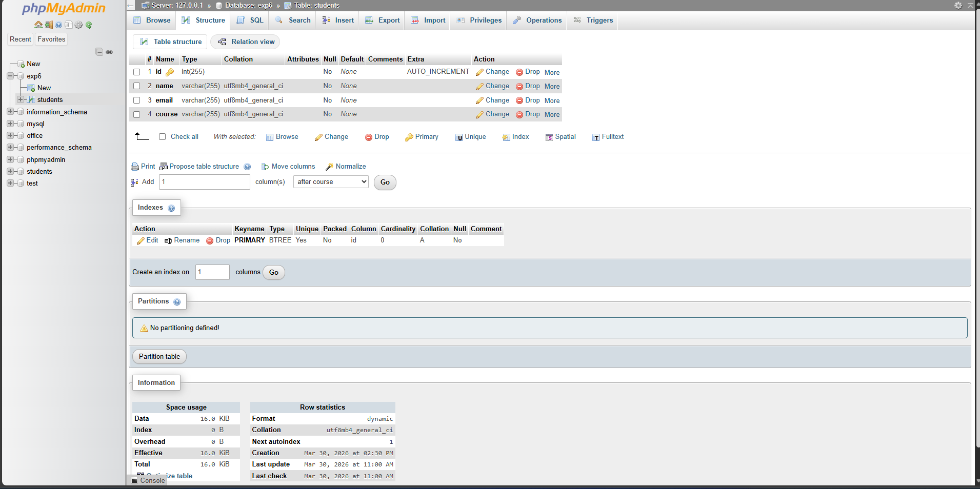
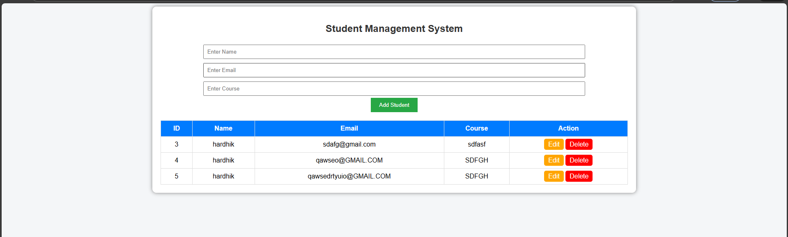

Post Lab Subjective/Objective type Questions:
- What is the role of mysqli or PDO in PHP?
Both mysqli (MySQL Improved) and PDO (PHP Data Objects) are PHP extensions used to connect and interact with databases.
They allow executing SQL queries, fetching data, and handling database errors.
PDO supports multiple database systems, while mysqli is specific to MySQL.

- What is the difference between GET and POST methods in PHP?
In PHP, the GET and POST methods are used to send data from a client (browser) to the server, but they work differently. The GET method appends the data to the URL, making it visible in the address bar, and has a size limitation of about 2000 characters. It is less secure and is generally used for retrieving or fetching data, such as search queries or bookmarking pages. On the other hand, the POST method sends data within the request body, keeping it hidden from the URL and allowing larger amounts of data to be sent. POST is more secure than GET and is typically used for submitting forms that insert, update, or delete data in a database. Essentially, GET is for reading or retrieving data, while POST is for sending or modifying data on the server.

- Explain the flow of data when a user submits a form to insert a record into the database.
When a user fills out a form and submits it, the data flow follows these steps: First, the browser sends the form data to the server using either the GET or POST method. The PHP script on the server receives this data through the $_GET or $_POST superglobal arrays. The script then validates the input to ensure it is correct and safe. After validation, PHP constructs an SQL INSERT query to add the record to the database. Using a database connection (via mysqli or PDO), the script executes the query. If the insertion is successful, the server sends a response back to the browser, often displaying a confirmation message or redirecting the user to a page showing the updated list of records. This process ensures that user input is safely stored in the database.

- Write a PHP code snippet to establish a database connection using mysqli.
<?php
$host = "localhost"; // Database server
$user = "root"; // Database username
$password = ""; // Database password
$database = "crud_db"; // Database name

// Create connection
$conn = new mysqli($host, $user, $password, $database);

// Check connection
if ($conn->connect_error) {
die("Connection failed: " . $conn->connect_error);
}
echo "Connected successfully";
?>

- Modify the Update functionality to allow partial record updates instead of updating all fields.
<?php
include 'db.php';
$id = $_GET['id'];
$result = $conn->query("SELECT * FROM students WHERE id=$id");
$row = $result->fetch_assoc();

if (isset($_POST['update'])) {
// Use existing values if input is empty
$name = !empty($_POST['name']) ? $_POST['name'] : $row['name'];
$email = !empty($_POST['email']) ? $_POST['email'] : $row['email'];
$course = !empty($_POST['course']) ? $_POST['course'] : $row['course'];

$sql = "UPDATE students SET name='$name', email='$email', course='$course' WHERE id=$id";
if ($conn->query($sql)) {
header("Location: index.php");
} else {
echo "Error updating record: " . $conn->error;
}
}
?>

- Propose enhancements to extend your CRUD application (e.g., authentication, pagination, search functionality, REST API integration).
The basic CRUD application can be enhanced in several ways to make it more robust, secure, and user-friendly:
Authentication and Authorization – Add login and role-based access control so that only authorized users can add, update, or delete records.
Pagination – Display large datasets in pages to improve performance and usability.
Search Functionality – Allow users to search for records by name, email, or course.
Input Validation and Sanitization – Enhance security by validating and sanitizing user input to prevent SQL injection and XSS attacks.
REST API Integration – Expose CRUD operations via a RESTful API for use with mobile apps or other web services.
Responsive and Modern UI – Use frameworks like Bootstrap or Tailwind CSS for better user experience across devices.
Export and Import – Allow exporting data to CSV or Excel and importing records from files for easy management.
Logging and Audit Trail – Keep track of who performed what operations for accountability.
These enhancements make the CRUD application more professional and suitable for real-world usage.

Conclusion and Discussion:
The experiment successfully demonstrated the development of a dynamic web application using PHP and MySQL to perform CRUD operations. The integration of HTML forms with PHP enabled efficient data collection and processing, while MySQL ensured structured data storage and retrieval.
All four operations—Create, Read, Update, and Delete—were implemented effectively, allowing complete interaction with the database. The application provided a user-friendly interface enhanced with basic CSS styling for better usability.
The experiment also helped in understanding the flow of data between client and server, handling form inputs, and executing SQL queries. Additionally, concepts such as database connectivity and dynamic content generation were reinforced.
Further improvements such as input validation, security using prepared statements, authentication systems, and responsive design can enhance the application for real-world usage.
Overall, the experiment provided practical knowledge of building database-driven web applications and strengthened understanding of full-stack web development concepts.

