SCHOOL OF TECHNOLOGY | 

DATABASE MANAGEMENT SYSTEMS
PROJECT-BASED LEARNING (PBL) REPORT
Small Database Application Development using Java / Python

PROJECT TITLE
GYM MEMBERSHIP AND FITNESS SESSION MANAGEMENT SYSTEM

Program | B.Tech — Computer Science and Engineering
Section | BIC-Tigers-29
Faculty | [Faculty Name]
Date of Submission | [DD-MM-YYYY]
Academic Year | 2026 – 27

Submitted by
Roll Number | Student Name | Mobile | Email ID
25WU0103007 | Aryan Baswapur | [Mobile] | [Email ID]

ACKNOWLEDGEMENT

I express my sincere gratitude to Woxsen University, School of Technology, for providing me with the opportunity to undertake this Project-Based Learning (PBL) activity as part of the Database Management Systems (DBMS) course.
I thank my course faculty, [Faculty Name], for the guidance, suggestions, and support throughout the design and development of this project. The guidance helped me understand the practical application of database concepts such as ER modelling, relational schema design, normalization, SQL, constraints, queries, and database application development.
This PBL activity has strengthened my understanding of DBMS concepts and provided valuable experience in applying them to a real-world problem.

UNDERTAKING

I hereby declare that the project entitled “Gym Membership and Fitness Session Management System”, submitted as part of the Project-Based Learning activity for the Database Management Systems (DBMS) course, is my individual work carried out under the guidance of the course faculty.
I undertake that the project report, database design, SQL scripts, application source code, results, and supporting materials submitted by me have been prepared for academic purposes. Wherever information, ideas, tools, datasets, or other resources have been referred to, appropriate acknowledgement has been provided.
I further undertake that I am responsible for the correctness and authenticity of the work submitted and that I have followed the academic and project guidelines prescribed by the University.

 |  |  |  | Signature
Date | : | [DD-MM-YYYY] | Name: | Aryan Baswapur
Place | : | Woxsen University, Hyderabad | Roll Number: | 25WU0103007
 |  |  | Program: | B.Tech CSE

TABLE OF CONTENTS

Contents | Page No.
Abstract | 8
LIST OF TABLES | 5
LIST OF FIGURES | 6
LIST OF ACRONYMS | 7
1. PROBLEM STATEMENT, SOLUTION STRATEGY AND ER DIAGRAM | 9
1.1 Problem Statement | 9
1.2 Objectives | 9
1.3 Scope and Assumptions | 10
1.4 Proposed Solution Strategy | 10
1.5 Functional Requirements | 11
1.6 Entity-Relationship Diagram (ERD) | 11
1.7 Entity and Relationship Summary | 12
2. LOGICAL DATABASE DESIGN | 14
2.1 Relational Schema | 14
2.2 Keys and Integrity Constraints | 14
2.3 Functional Dependencies | 16
2.4 Normalization up to Third Normal Form (3NF) | 17
2.5 Data Dictionary | 17
2.6 Implementation of Logical Design: DDL and Sample Data | 19
3. APPLICATION DEVELOPMENT USING LOGICAL DATABASE DESIGN | 21
3.1 Application Overview | 21
3.2 Development Environment and Database Connectivity | 21
3.3 Application Modules and Database Mapping | 22
3.4 CRUD Operations | 22
3.5 Business Rules, Validation and Error Handling | 23
3.6 Reports and Database Operations | 24
3.7 Application Screens | 25
3.8 Testing and Results | 28
4. CONCLUSION | 30
4.1 Limitations and Future Enhancements | 30
5. REFERENCES | 31
6. APPENDICES | 32

LIST OF TABLES

Table No. | Table Title | Page No.
Table 1 | Scope and Assumptions | 10
Table 2 | Proposed Solution Strategy | 10
Table 3 | Functional Requirements | 11
Table 4 | Entity and Relationship Summary | 12
Table 5 | Relational Schema | 14
Table 6 | Keys and Integrity Constraints | 14
Table 7 | Normalization Status up to 3NF | 17
Table 8 | Data Dictionary | 18
Table 9 | Database Implementation Environment | 19
Table 10 | Application Development Environment | 21
Table 11 | Application Module-to-Database Mapping | 22
Table 12 | CRUD Operations | 22
Table 13 | Business Rules, Validation and Error Handling | 23
Table 14 | Reports and Database Operations | 25
Table 15 | Test Cases | 28

LIST OF FIGURES

Figure No. | Figure Title | Page No.
Figure 1 | Entity-Relationship Diagram of the Proposed System | 12
Figure 2 | Data Entry: Registering a Member in the Prototype Console | 26
Figure 3 | Display: Committed Member Row Traced into the Schema | 26
Figure 4 | Transaction Processing: Subscription Rolled Back on a Failed Payment | 27
Figure 5 | Business Rule: Booking Rejected by the Class-Capacity Trigger | 27
Figure 6 | Report Output: Class Attendance and Trainer Load from MySQL | 28

LIST OF ACRONYMS

Acronym | Expansion
1NF / 2NF / 3NF | First / Second / Third Normal Form
ACID | Atomicity, Consistency, Isolation, Durability
BCNF | Boyce–Codd Normal Form
BMI | Body Mass Index
CRUD | Create, Read, Update, Delete
DBMS | Database Management System
DDL | Data Definition Language
DML | Data Manipulation Language
ER / ERD | Entity–Relationship / Entity–Relationship Diagram
FD | Functional Dependency
FK | Foreign Key
IEEE | Institute of Electrical and Electronics Engineers
PBL | Project-Based Learning
PK | Primary Key
SQL | Structured Query Language
UQ | Unique (constraint)
UPI | Unified Payments Interface

ABSTRACT

Fitness centres that keep members, subscriptions, trainers, classes, attendance, payments and equipment in registers and spreadsheets routinely fail to enforce membership expiry and class capacity, and cannot answer questions that span several kinds of record. This project designs and implements a relational database for gym membership and fitness session management that enforces these rules inside the database itself. Requirements were analysed into four user roles and fourteen entities, modelled as an Entity–Relationship diagram, converted into a relational schema and normalised to Third Normal Form. The schema is implemented in MySQL 8 with primary key, foreign key, unique, not-null, check and default constraints; triggers enforce the active-subscription, class-capacity and trainer-overlap rules, and stored procedures record subscriptions, payments and renewals as atomic transactions. Interconnected sample data in every table supports views and queries for active and expired members, class attendance, trainer load, equipment maintenance, renewals and revenue. A JavaScript prototype demonstrates registration, subscription, booking and check-in against the same rules, and twenty-three positive and negative test cases executed on MySQL produced the expected results. The outcome is a reliable, rule-enforcing database on which a fitness centre’s daily operations can be built.

KEYWORDS
Keywords: Relational Database, Gym Membership Management, ER Diagram, Normalization, MySQL Triggers, JavaScript

CHAPTER 1

PROBLEM STATEMENT, SOLUTION STRATEGY AND ER DIAGRAM

1.1 Problem Statement
Small and mid-sized fitness centres record members, plans, payments, trainer assessments, class timetables, bookings, attendance and equipment servicing in paper registers and spreadsheets kept at the front desk. The people affected are the administrator who plans memberships and reviews revenue, the front-desk staff who register members and take bookings, the trainers who run classes and assess members, and the members themselves. The existing process fails in three recurring ways. Expiries slip by, because nothing stops a member whose plan has lapsed from booking a class. Classes overbook and timetables clash, because two staff members can each give away the last seat without seeing the other’s entry, and a trainer can be timetabled into two classes at once. Records are scattered, so a question such as “which active members have not attended in thirty days?” cannot be answered without manual cross-checking. These are the classic drawbacks of file-processing systems: redundancy, inconsistency, difficult access and integrity rules that live only in people’s habits [1].
A database application is therefore needed in which every fact is stored once, related records are linked through keys, the centre’s business rules are declared alongside the data and checked by the database on every write, and the operational reports are produced directly by SQL queries.

1.2 Objectives
- Design an ER model covering all fourteen entities of the brief and convert it into a relational schema normalised to 3NF, stating the functional dependencies of every relation.
- Implement the schema in MySQL 8 with PRIMARY KEY, FOREIGN KEY, UNIQUE, NOT NULL, CHECK and DEFAULT constraints, and enforce the five business rules of the brief: active subscription required, class-capacity limits, no trainer overlap, non-negative assessment values and valid renewal dates.
- Automate subscription, payment and renewal recording as atomic transactions, and mark lapsed subscriptions as expired every day.
- Generate the six required reports — active and expired members, class attendance, trainer load, equipment maintenance, renewals and revenue — through views and queries over realistic sample data.
- Validate the design with at least twenty positive and negative test cases executed on the database, and demonstrate the core front-desk flows in a JavaScript application.

1.3 Scope and Assumptions
Table 1 sets the boundary of the system and the assumptions on which the design rests.
Table 1. Scope and Assumptions
Item | Description
In Scope | Members, plans, subscriptions, payments and renewals; trainers, fitness assessments and workout programmes; classes, weekly schedules, bookings and attendance; equipment and maintenance; operational reports.
Out of Scope / Exclusions | Online payment processing (payments are recorded, not processed); biometric or card-based entry; multi-branch operation; staff payroll; a member-facing mobile application.
Assumptions | Single branch, so rooms and trainers are not shared across locations. A member holds at most one active subscription at a time; history is kept as earlier subscription rows. A booking is for a recurring weekly session and has at most one attendance record. Payments are recorded when received at the desk by UPI, card or cash.

1.4 Proposed Solution Strategy
The solution moves every rule that the manual process fails to enforce into the database, so that it holds whichever screen or person writes the data; the application validates input for usability, but the database is the final authority. Table 2 summarises the users, modules, workflow, rules and outputs.
Table 2. Proposed Solution Strategy
Solution Element | Project-Specific Description
Primary Users / Roles | Administrator (plans, staff, reports); front desk (registration, subscriptions, payments, bookings, attendance); trainer (assessments, programmes, classes); member (bookings and progress, read-mostly).
Major Application Modules | Membership; subscriptions, payments and renewals; trainers and assessments; workout programmes; class scheduling and booking; attendance; equipment and maintenance; reports.
Proposed Workflow | Register member → subscribe and pay in one transaction → book a scheduled session (subscription and seat checked) → check in and out → renew before expiry. In parallel, trainers record assessments and staff log equipment servicing.
Important Business Rules | Active subscription required to book; class capacity never exceeded; no overlapping trainer slots; non-negative assessment values; renewal end date after the renewal date and subscription end date after its start; one booking per member per session; one attendance per booking.
Expected Reports / Outputs | Active and expired members; class attendance; trainer load; equipment maintenance cost and status; renewals due within seven days; monthly revenue; active members inactive for thirty days.

1.5 Functional Requirements
The functional requirements derived from the brief and the user roles are listed in Table 3.
Table 3. Functional Requirements
Req. ID | Functional Requirement | Remarks / Priority
FR-01 | Register, search, view and update members with a unique phone number and e-mail. | High
FR-02 | Define membership plans with duration and price. | High
FR-03 | Create a subscription and record its payment in a single transaction. | High
FR-04 | Renew a subscription, extending its end date and recording the renewal payment. | High
FR-05 | Mark subscriptions whose end date has passed as expired automatically. | Medium — daily event
FR-06 | Maintain trainers and assign each class to one trainer. | High
FR-07 | Record member fitness assessments and workout programmes. | Medium
FR-08 | Schedule weekly class sessions without trainer clashes. | High
FR-09 | Book a member into a session only with an active subscription and a free seat. | High
FR-10 | Record check-in and check-out for each booking. | High
FR-11 | Record equipment, its status and its maintenance history with costs. | Medium
FR-12 | Generate the operational reports listed in Table 2. | High

1.6 Entity-Relationship Diagram (ERD)
Figure 1 shows the approved ER diagram, built on the entity–relationship model of Chen [2]. Each box lists the primary key (PK), foreign keys (FK) and principal attributes of an entity; boxes with a dashed border are associative entities that resolve a many-to-many relationship, and every line is labelled with its cardinality. Participation is total on the child side of every relationship — a Subscription, Payment, Registration or Attendance row cannot exist without its parent, because the foreign key is NOT NULL — and partial on the parent side: a Member may exist without any subscription, and a Class without any booking.
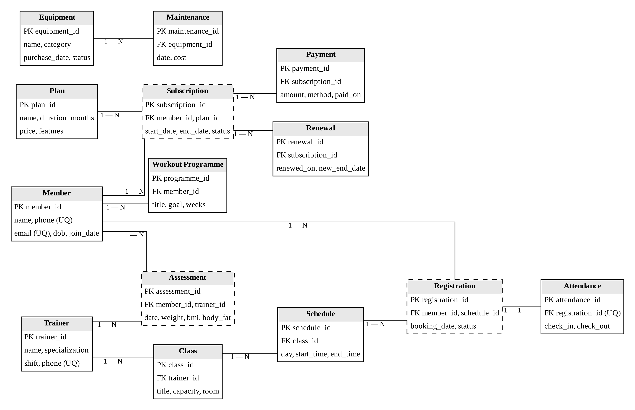
Figure 1. Entity-Relationship Diagram of the Proposed System

1.7 Entity and Relationship Summary
Table 4 summarises the fourteen entities and the relationships that connect them.
Table 4. Entity and Relationship Summary
Entity / Relationship | Major Attributes / Cardinality | Purpose / Rule
Member | member_id; name, phone (UQ), email (UQ), dob, join_date | A person registered with the centre.
Plan | plan_id; name (UQ), duration_months, price, features | Membership product: Monthly, Quarterly, Annual, Trial.
Subscription | subscription_id; member_id, plan_id, start_date, end_date, status | Associative: a member’s purchase of a plan for a period.
Payment | payment_id; subscription_id, amount, method, paid_on | Money received against a subscription.
Renewal | renewal_id; subscription_id, renewed_on, new_end_date | Extension of an existing subscription.
Trainer | trainer_id; name, specialization, shift, phone (UQ) | Staff member who runs classes and assessments.
Assessment | assessment_id; member_id, trainer_id, date, weight, bmi, body_fat | Associative: a trainer’s measurement of a member.
Workout Programme | programme_id; member_id, title, goal, weeks | Training plan prescribed to a member.
Class | class_id; trainer_id, title, capacity, room | Type of group session and its seat limit.
Schedule | schedule_id; class_id, day, start_time, end_time | Weekly timetable slot of a class.
Registration | registration_id; member_id, schedule_id, booking_date, status | Associative: a member’s booking of a session.
Attendance | attendance_id; registration_id (UQ), check_in, check_out | The actual visit for a booking.
Equipment | equipment_id; name, category, purchase_date, status | Asset on the gym floor.
Maintenance | maintenance_id; equipment_id, date, cost | A servicing event for an equipment item.
Member — Plan (via Subscription) | M : N | At most one active subscription per member.
Subscription — Payment, Renewal | 1 : N | Payments and renewals reference an existing subscription.
Member — Trainer (via Assessment) | M : N | Assessment values must be non-negative.
Member — Workout Programme | 1 : N | Each programme belongs to one member.
Trainer — Class — Schedule | 1 : N, 1 : N | A trainer’s sessions must not overlap.
Member — Schedule (via Registration) | M : N | Active subscription and a free seat required; one booking per session.
Registration — Attendance | 1 : 1 | At most one attendance record per booking.
Equipment — Maintenance | 1 : N | Maintenance cost must be non-negative.

CHAPTER 2

LOGICAL DATABASE DESIGN

2.1 Relational Schema
Each entity in Figure 1 became one relation with a single-column surrogate primary key, and each relationship became a foreign key in the relation on its “many” side, following the relational model of Codd [3]. Table 5 lists the fourteen relations; primary keys are underlined and foreign keys are marked with #.
Table 5. Relational Schema
S.No. | Table Name | Purpose
1 | Member(member_id, name, phone, email, dob, join_date) | Registered members
2 | Plan(plan_id, name, duration_months, price, features) | Membership plans
3 | Subscription(subscription_id, #member_id, #plan_id, start_date, end_date, status) | Plan purchased by a member
4 | Payment(payment_id, #subscription_id, amount, method, paid_on) | Payments received
5 | Renewal(renewal_id, #subscription_id, renewed_on, new_end_date) | Subscription renewals
6 | Trainer(trainer_id, name, specialization, shift, phone) | Trainers
7 | Assessment(assessment_id, #member_id, #trainer_id, date, weight, bmi, body_fat) | Fitness assessments
8 | Workout_Programme(programme_id, #member_id, title, goal, weeks) | Training plans
9 | Class(class_id, #trainer_id, title, capacity, room) | Group classes
10 | Schedule(schedule_id, #class_id, day, start_time, end_time) | Weekly class slots
11 | Registration(registration_id, #member_id, #schedule_id, booking_date, status) | Class bookings
12 | Attendance(attendance_id, #registration_id, check_in, check_out) | Visits per booking
13 | Equipment(equipment_id, name, category, purchase_date, status) | Gym equipment
14 | Maintenance(maintenance_id, #equipment_id, date, cost) | Equipment servicing

2.2 Keys and Integrity Constraints
Table 6 lists every key and integrity constraint by table. Constraint names in parentheses are those reported by MySQL when a constraint is violated.
Table 6. Keys and Integrity Constraints
Table Name | Key / Constraint | Attribute(s) | Business Rule Enforced
Member | Primary Key | member_id (AUTO_INCREMENT) | Unique identity of a member
Member | Unique | phone; email | No two members share a contact
Member | Not Null | name, phone, email, join_date | Mandatory identification
Member | Default | join_date = CURRENT_DATE | Join date recorded automatically
Member | Check | phone matches ^[0-9]{10}$; dob < join_date | Valid 10-digit phone; plausible birth date
Plan | Primary Key / Unique | plan_id / name | Plan names are not repeated
Plan | Check | duration_months > 0; price >= 0 | Positive duration; non-negative price
Subscription | Primary Key | subscription_id | Unique subscription
Subscription | Foreign Key | member_id → Member; plan_id → Plan (ON DELETE RESTRICT) | History cannot be orphaned
Subscription | Default | status = 'ACTIVE' | New subscriptions start active
Subscription | Check | end_date > start_date (chk_dates) | Valid subscription dates
Payment | Foreign Key | subscription_id → Subscription (ON DELETE CASCADE) | Payment belongs to a subscription
Payment | Default | paid_on = CURRENT_DATE | Payment date recorded automatically
Payment | Check | amount >= 0 (chk_amount) | Non-negative payment
Renewal | Foreign Key | subscription_id → Subscription (ON DELETE CASCADE) | Renewal extends a subscription
Renewal | Check | new_end_date > renewed_on (chk_renewal_dates) | Valid renewal dates
Trainer | Unique / Check | phone; phone matches ^[0-9]{10}$ | Unique, valid trainer contact
Assessment | Foreign Key | member_id → Member (CASCADE); trainer_id → Trainer (RESTRICT) | Measurement by a known trainer
Assessment | Check | weight >= 0, bmi >= 0, body_fat 0–100 (chk_assessment_values) | Non-negative assessment values
Workout_Programme | Foreign Key / Check | member_id → Member (CASCADE); weeks > 0 | Programme of positive length
Class | Foreign Key | trainer_id → Trainer (ON DELETE RESTRICT) | Every class has a trainer
Class | Check | capacity > 0 (chk_capacity) | Positive seat limit
Schedule | Foreign Key | class_id → Class (ON DELETE CASCADE) | Slot belongs to a class
Schedule | Unique | (class_id, day, start_time) | A class slot is not entered twice
Schedule | Check | end_time > start_time | Valid session time
Registration | Foreign Key | member_id → Member; schedule_id → Schedule (RESTRICT) | Bookings keep their history
Registration | Unique | (schedule_id, member_id) | One booking per member per session
Registration | Default | booking_date = CURRENT_DATE; status = 'BOOKED' | Booking defaults
Attendance | Foreign Key + Unique | registration_id → Registration (CASCADE) | One attendance per booking (1 : 1)
Attendance | Check | check_out IS NULL OR check_out > check_in | Valid visit times
Equipment | Default | status = 'ACTIVE' | New equipment is in service
Maintenance | Foreign Key / Check | equipment_id → Equipment (CASCADE); cost >= 0 | Non-negative maintenance cost

Every table also has a single-column primary key, and every foreign key is declared NOT NULL. Rules that compare a row with other rows — the active-subscription requirement, the class-capacity limit and trainer non-overlap — cannot be written as CHECK constraints, because a MySQL CHECK may reference only the columns of the row being written [4]. They are enforced by BEFORE triggers that raise an error with SIGNAL, the approach to multi-row assertions described by Elmasri and Navathe [5], and are presented with the other validations in Section 3.5.

2.3 Functional Dependencies
The functional dependencies that hold in each relation are listed below; the left-hand side of every dependency is a candidate key.
- Member: member_id → name, phone, email, dob, join_date; phone → member_id; email → member_id.
- Plan: plan_id → name, duration_months, price, features; name → plan_id.
- Subscription: subscription_id → member_id, plan_id, start_date, end_date, status.
- Payment: payment_id → subscription_id, amount, method, paid_on.
- Renewal: renewal_id → subscription_id, renewed_on, new_end_date.
- Trainer: trainer_id → name, specialization, shift, phone; phone → trainer_id.
- Assessment: assessment_id → member_id, trainer_id, date, weight, bmi, body_fat.
- Workout_Programme: programme_id → member_id, title, goal, weeks.
- Class: class_id → trainer_id, title, capacity, room.
- Schedule: schedule_id → class_id, day, start_time, end_time; (class_id, day, start_time) → schedule_id.
- Registration: registration_id → member_id, schedule_id, booking_date, status; (schedule_id, member_id) → registration_id.
- Attendance: attendance_id → registration_id, check_in, check_out; registration_id → attendance_id.
- Equipment: equipment_id → name, category, purchase_date, status.
- Maintenance: maintenance_id → equipment_id, date, cost.
Three dependencies found in early drafts would have violated 3NF and were removed by decomposition: plan_id → plan name, price in a draft Subscription that copied plan details; trainer_id → trainer name in a draft Class; and a draft Registration that held check-in times, mixing visit facts with booking facts.

2.4 Normalization up to Third Normal Form (3NF)
All attributes are atomic, so every relation is in 1NF. Every primary key is a single column, so no partial dependency can exist and every relation is in 2NF; in the two relations with a composite candidate key (Schedule and Registration), no non-key attribute depends on part of that key. No non-key attribute depends on another non-key attribute, so every relation is in 3NF — each non-key attribute depends on “the key, the whole key, and nothing but the key” [6]. Because every determinant in Section 2.3 is a candidate key, the relations also satisfy BCNF [1]. Table 7 records the status and the decompositions applied.
Table 7. Normalization Status up to 3NF
Relation Name | 1NF | 2NF | 3NF | BCNF | Remarks / Decomposition
Member | Yes | Yes | Yes | Yes | phone and email are additional candidate keys
Plan | Yes | Yes | Yes | Yes | name is a candidate key
Subscription | Yes | Yes | Yes | Yes | Plan name and price moved to Plan (removed plan_id → price)
Payment | Yes | Yes | Yes | Yes | Single key; no transitive dependency
Renewal | Yes | Yes | Yes | Yes | Separated from Subscription to keep renewal history
Trainer | Yes | Yes | Yes | Yes | phone is a candidate key
Assessment | Yes | Yes | Yes | Yes | Resolves the Member–Trainer M : N relationship
Workout_Programme | Yes | Yes | Yes | Yes | Single key; no transitive dependency
Class | Yes | Yes | Yes | Yes | Trainer details moved to Trainer (removed trainer_id → name)
Schedule | Yes | Yes | Yes | Yes | (class_id, day, start_time) is a candidate key
Registration | Yes | Yes | Yes | Yes | Check-in/out moved to Attendance; (schedule_id, member_id) candidate key
Attendance | Yes | Yes | Yes | Yes | registration_id is a candidate key (1 : 1)
Equipment | Yes | Yes | Yes | Yes | Single key; no transitive dependency
Maintenance | Yes | Yes | Yes | Yes | Separated from Equipment to keep service history

2.5 Data Dictionary
Table 8 is the data dictionary for all fourteen tables (71 attributes). PK = primary key, FK = foreign key, UQ = unique, NN = not null.
Table 8. Data Dictionary
Table | Attribute | Data Type | Key / Constraint | Description
Member | member_id | INT | PK, AUTO_INCREMENT | Surrogate identity
Member | name | VARCHAR(80) | NN | Full name
Member | phone | CHAR(10) | NN, UQ, CHECK digits | Mobile number
Member | email | VARCHAR(120) | NN, UQ | E-mail address
Member | dob | DATE | CHECK < join_date | Date of birth (optional)
Member | join_date | DATE | NN, DEFAULT today | Date of joining
Plan | plan_id | INT | PK, AUTO_INCREMENT | Surrogate identity
Plan | name | VARCHAR(40) | NN, UQ | Plan name
Plan | duration_months | TINYINT | NN, CHECK > 0 | Length of the plan
Plan | price | DECIMAL(10,2) | NN, CHECK >= 0 | Price in ₹
Plan | features | VARCHAR(200) | — | What the plan includes
Subscription | subscription_id | INT | PK, AUTO_INCREMENT | Surrogate identity
Subscription | member_id | INT | FK → Member, NN | Subscriber
Subscription | plan_id | INT | FK → Plan, NN | Plan purchased
Subscription | start_date | DATE | NN | First valid day
Subscription | end_date | DATE | NN, CHECK > start_date | Last valid day
Subscription | status | ENUM | NN, DEFAULT 'ACTIVE' | ACTIVE, EXPIRED or CANCELLED
Payment | payment_id | INT | PK, AUTO_INCREMENT | Surrogate identity
Payment | subscription_id | INT | FK → Subscription, NN | Subscription paid for
Payment | amount | DECIMAL(10,2) | NN, CHECK >= 0 | Amount in ₹
Payment | method | ENUM | NN | UPI, CARD or CASH
Payment | paid_on | DATE | NN, DEFAULT today | Payment date
Renewal | renewal_id | INT | PK, AUTO_INCREMENT | Surrogate identity
Renewal | subscription_id | INT | FK → Subscription, NN | Subscription renewed
Renewal | renewed_on | DATE | NN, DEFAULT today | Date of renewal
Renewal | new_end_date | DATE | NN, CHECK > renewed_on | Extended end date
Trainer | trainer_id | INT | PK, AUTO_INCREMENT | Surrogate identity
Trainer | name | VARCHAR(80) | NN | Full name
Trainer | specialization | VARCHAR(60) | NN | Area of expertise
Trainer | shift | ENUM | NN | MORNING or EVENING
Trainer | phone | CHAR(10) | NN, UQ, CHECK digits | Mobile number
Assessment | assessment_id | INT | PK, AUTO_INCREMENT | Surrogate identity
Assessment | member_id | INT | FK → Member, NN | Member assessed
Assessment | trainer_id | INT | FK → Trainer, NN | Assessing trainer
Assessment | date | DATE | NN, DEFAULT today | Assessment date
Assessment | weight | DECIMAL(5,2) | NN, CHECK >= 0 | Weight in kg
Assessment | bmi | DECIMAL(5,2) | NN, CHECK >= 0 | Body mass index
Assessment | body_fat | DECIMAL(5,2) | CHECK 0–100 | Body-fat percentage
Workout_Programme | programme_id | INT | PK, AUTO_INCREMENT | Surrogate identity
Workout_Programme | member_id | INT | FK → Member, NN | Member it is for
Workout_Programme | title | VARCHAR(80) | NN | Programme name
Workout_Programme | goal | VARCHAR(60) | — | Training goal
Workout_Programme | weeks | TINYINT | NN, CHECK > 0 | Duration in weeks
Class | class_id | INT | PK, AUTO_INCREMENT | Surrogate identity
Class | trainer_id | INT | FK → Trainer, NN | Trainer in charge
Class | title | VARCHAR(60) | NN | Class name
Class | capacity | SMALLINT | NN, CHECK > 0 | Seat limit per session
Class | room | VARCHAR(30) | NN | Studio or floor
Schedule | schedule_id | INT | PK, AUTO_INCREMENT | Surrogate identity
Schedule | class_id | INT | FK → Class, NN | Class scheduled
Schedule | day | ENUM | NN | MON to SUN
Schedule | start_time | TIME | NN | Session start
Schedule | end_time | TIME | NN, CHECK > start_time | Session end
Registration | registration_id | INT | PK, AUTO_INCREMENT | Surrogate identity
Registration | member_id | INT | FK → Member, NN | Member booked
Registration | schedule_id | INT | FK → Schedule, NN | Session booked
Registration | booking_date | DATE | NN, DEFAULT today | Date of booking
Registration | status | ENUM | NN, DEFAULT 'BOOKED' | BOOKED or CANCELLED
Attendance | attendance_id | INT | PK, AUTO_INCREMENT | Surrogate identity
Attendance | registration_id | INT | FK → Registration, NN, UQ | Booking attended
Attendance | check_in | DATETIME | NN | Arrival time
Attendance | check_out | DATETIME | CHECK > check_in | Departure time (NULL until exit)
Equipment | equipment_id | INT | PK, AUTO_INCREMENT | Surrogate identity
Equipment | name | VARCHAR(60) | NN | Equipment name
Equipment | category | VARCHAR(30) | NN | Cardio, Strength, Free weights
Equipment | purchase_date | DATE | NN | Date purchased
Equipment | status | ENUM | NN, DEFAULT 'ACTIVE' | ACTIVE, UNDER_MAINTENANCE, OUT_OF_SERVICE
Maintenance | maintenance_id | INT | PK, AUTO_INCREMENT | Surrogate identity
Maintenance | equipment_id | INT | FK → Equipment, NN | Item serviced
Maintenance | date | DATE | NN, DEFAULT today | Service date
Maintenance | cost | DECIMAL(10,2) | NN, CHECK >= 0 | Cost in ₹

2.6 Implementation of Logical Design: DDL and Sample Data
The logical design was implemented in MySQL Community Server 8.0, the first release series in which CHECK constraints are enforced rather than parsed and ignored [4]. Table 9 summarises the implementation; the complete script is listed in Appendix A.
Table 9. Database Implementation Environment
Item | Details
DBMS | MySQL Community Server 8.0 with the InnoDB storage engine
DBMS Version | 8.0.46 (script verified); any 8.0.16 or later
Number of Tables | 14 tables, plus 7 views, 4 triggers, 3 stored procedures, 1 scheduled event and 3 secondary indexes
Sample Data | 397 rows: Member 48, Plan 4, Subscription 52 (30 active, 18 expired, 4 cancelled), Payment 54, Renewal 9, Trainer 6, Assessment 28, Workout_Programme 14, Class 9, Schedule 24, Registration 68, Attendance 51, Equipment 12, Maintenance 18. Dates are relative to CURDATE() so the data stays current.

The representative DDL below shows Subscription and Payment, which together use every kind of constraint: foreign keys with referential actions, CHECK constraints, an ENUM with a DEFAULT, and an expression default.
CREATE TABLE Subscription (
subscription_id INT AUTO_INCREMENT PRIMARY KEY,
member_id INT NOT NULL,
plan_id INT NOT NULL,
start_date DATE NOT NULL,
end_date DATE NOT NULL,
status ENUM('ACTIVE','EXPIRED','CANCELLED')
NOT NULL DEFAULT 'ACTIVE',
CONSTRAINT fk_sub_member FOREIGN KEY (member_id)
REFERENCES Member(member_id) ON DELETE RESTRICT ON UPDATE CASCADE,
CONSTRAINT fk_sub_plan FOREIGN KEY (plan_id)
REFERENCES Plan(plan_id) ON DELETE RESTRICT ON UPDATE CASCADE,
CONSTRAINT chk_dates CHECK (end_date > start_date)
);

CREATE TABLE Payment (
payment_id INT AUTO_INCREMENT PRIMARY KEY,
subscription_id INT NOT NULL,
amount DECIMAL(10,2) NOT NULL,
method ENUM('UPI','CARD','CASH') NOT NULL,
paid_on DATE NOT NULL DEFAULT (CURRENT_DATE),
CONSTRAINT fk_pay_sub FOREIGN KEY (subscription_id)
REFERENCES Subscription(subscription_id) ON DELETE CASCADE,
CONSTRAINT chk_amount CHECK (amount >= 0)
);

The sample records were chosen so that every report returns meaningful rows: active and expired members, one member with no subscription, one class filled exactly to capacity, members who have not attended for thirty days, and payments spread across several months. Loading the data also exercises the rules: all 68 bookings passed both booking triggers and all 24 schedule slots passed the trainer-overlap trigger. An excerpt follows.
INSERT INTO Member (member_id, name, phone, email, dob, join_date) VALUES
(41, 'Priya Naidu', '9845012345', 'priya.naidu@example.com',
'1998-07-21', CURDATE() - INTERVAL 340 DAY),
(43, 'Pritha Sen', '9831045678', 'pritha.sen@example.com',
'2000-09-30', CURDATE() - INTERVAL 577 DAY),
(48, 'Sneha Reddy', '9701122334', 'sneha.reddy@example.com',
'2001-01-27', CURDATE() - INTERVAL 24 DAY);

INSERT INTO Subscription
(subscription_id, member_id, plan_id, start_date, end_date, status)
VALUES
(47, 43, 1, CURDATE() - INTERVAL 577 DAY,
CURDATE() - INTERVAL 547 DAY, 'EXPIRED'),
(48, 41, 3, CURDATE() - INTERVAL 340 DAY,
CURDATE() + INTERVAL 25 DAY, 'ACTIVE');

CHAPTER 3

APPLICATION DEVELOPMENT USING LOGICAL DATABASE DESIGN

3.1 Application Overview
The application gives the front desk, trainers and administrator a single interface to the gym_db database for registration, subscription with payment, class booking, check-in and reporting. At the current stage the application layer is a browser-based JavaScript prototype console that mirrors the gym_db schema, sample data and rules. For each operation it shows the SQL statement, evaluates every NOT NULL, type, UNIQUE, CHECK, foreign-key and trigger condition in the order MySQL applies them, and then shows where the row is stored or why it was rejected, with the corresponding MySQL error code.
The prototype runs entirely in the browser and is not yet connected to the MySQL server. All results reported in Table 15 were therefore obtained by executing the statements directly on the MySQL 8 database. Connecting the existing screens to MySQL through a Node.js data-access layer is the remaining implementation work (Section 4.1).

3.2 Development Environment and Database Connectivity
Table 10 lists the development environment. Connectivity is designed around parameterised statements: user input is always passed as bound parameters and never concatenated into SQL text, and every database error is caught and mapped to a readable message (Table 13).
Table 10. Application Development Environment
Item | Details
Programming Language | JavaScript (ES2022) for the prototype console; Node.js for the planned database-connected layer
DBMS | MySQL Community Server 8.0 (script and tests verified on 8.0.46)
IDE / Framework / GUI Toolkit | Visual Studio Code; HTML5 and CSS3 user interface; MySQL Workbench and the mysql command-line client
Database Connector / Driver | mysql2 for Node.js with prepared statements (planned for the connected build)
Operating Environment | Windows laptop for development; MySQL server on localhost
Repository Link | [Repository link]

3.3 Application Modules and Database Mapping
Table 11 maps each application module to the tables it uses and the operations it performs. The prototype currently implements the Membership, Subscription and Payment, Booking and Attendance screens; the other modules are complete in the database (procedures, triggers and views) and their screens are in progress.
Table 11. Application Module-to-Database Mapping
Module / Screen | Purpose | Tables Used | Main Operations
Membership | Register, search and edit members | Member | INSERT, SELECT (name index), UPDATE
Subscription and Payment | Sell a plan and take payment | Subscription, Payment, Plan | CALL sp_subscribe (transaction)
Renewal | Extend a subscription | Renewal, Subscription, Payment | CALL sp_renew_subscription (transaction)
Trainer and Assessment | Maintain trainers; record assessments | Trainer, Assessment | INSERT, SELECT, UPDATE
Workout Programme | Prescribe training plans | Workout_Programme | INSERT, SELECT, UPDATE, DELETE
Class Scheduling | Define classes and weekly slots | Class, Schedule | INSERT, UPDATE (overlap triggers)
Booking | Book a member into a session | Registration; reads Subscription, Schedule, Class | INSERT (two triggers); status UPDATE to cancel
Attendance | Check members in and out | Attendance, Registration | INSERT check_in; UPDATE check_out
Equipment and Maintenance | Track assets and servicing | Equipment, Maintenance | INSERT, UPDATE status, DELETE
Reports | Operational reports | Views listed in Table 14 | SELECT

3.4 CRUD Operations
Table 12 shows where each CRUD operation is performed and the evidence for it in this report.
Table 12. CRUD Operations
Operation | Application Feature / Screen | Table(s) Affected | Evidence
Create | Register member (prototype); subscribe and pay (sp_subscribe) | Member; Subscription, Payment | Figure 2; TC-01, TC-06
Read / Search | Member table display; report views | Member; all report views | Figure 3, Figure 6; Table 14
Update | Edit member phone; renewal extends the end date | Member; Subscription, Renewal, Payment | TC-05, TC-11
Delete / Controlled Removal | Delete a maintenance entry; member deletion blocked while history exists; bookings cancelled by status | Maintenance; Member; Registration | TC-23, TC-22

3.5 Business Rules, Validation and Error Handling
Validation happens in two layers. The application checks input format (required fields, ten-digit phone, valid dates) before sending a request, so that common mistakes get an immediate message; the database remains the final authority and rejects anything that breaks a constraint or trigger, whatever its source. Operations that write several rows run as transactions whose error handler issues ROLLBACK, so that a failure part-way leaves no partial data, in line with the atomicity property of transactions [7]. Destructive actions are guarded by foreign keys with ON DELETE RESTRICT, so a member with subscription or booking history cannot be deleted. Table 13 lists each rule, how it is implemented and the evidence.
Table 13. Business Rules, Validation and Error Handling
Rule / Validation | How Implemented | Evidence / Message
Active subscription required | BEFORE INSERT trigger trg_active_subscription on Registration | TC-15: “No active subscription for this member”
Class-capacity limit | Trigger trg_class_capacity; locks the class row with SELECT … FOR UPDATE so concurrent bookings cannot both take the last seat | TC-14, Figure 5: “Class is full”
No trainer overlap | Triggers trg_trainer_overlap (insert) and trg_trainer_overlap_upd (update) using an interval-overlap test | TC-19: “Trainer already has a class in this time slot”
Non-negative assessment values | CHECK chk_assessment_values | TC-21: ERROR 3819
Valid renewal and subscription dates | CHECK chk_renewal_dates; CHECK chk_dates | TC-12, TC-08: ERROR 3819
One active subscription per member | sp_subscribe counts active rows under a row lock before inserting | TC-07: “Member already has an active subscription”
No duplicate booking or check-in | UNIQUE (schedule_id, member_id); UNIQUE registration_id | TC-16, TC-17: ERROR 1062
Atomic subscription and payment | Transaction with an EXIT HANDLER that issues ROLLBACK | TC-09, Figure 4: subscription row undone
Input format | NOT NULL; CHAR(10) phone with a digits-only CHECK; form checks in the prototype | TC-03, TC-04: ERROR 1048, 1406

The class-capacity trigger below shows the pattern shared by the three multi-row rules: it reads other rows, and raises SQLSTATE 45000 before the new row is written if the rule would be broken.
CREATE TRIGGER trg_class_capacity
BEFORE INSERT ON Registration
FOR EACH ROW FOLLOWS trg_active_subscription
BEGIN
DECLARE booked INT;
DECLARE cap INT;
SELECT c.capacity INTO cap
FROM Schedule s JOIN Class c ON c.class_id = s.class_id
WHERE s.schedule_id = NEW.schedule_id
FOR UPDATE;
SELECT COUNT(*) INTO booked FROM Registration
WHERE schedule_id = NEW.schedule_id AND status = 'BOOKED';
IF cap IS NOT NULL AND booked >= cap THEN
SIGNAL SQLSTATE '45000' SET MESSAGE_TEXT = 'Class is full';
END IF;
END

Renewal writes three rows, so it runs as one transaction: if any statement fails, the handler rolls all of them back and passes the error to the application (validation lines omitted).
CREATE PROCEDURE sp_renew_subscription(IN p_sub INT, IN p_months INT,
IN p_amount DECIMAL(10,2), IN p_method VARCHAR(4))
BEGIN
DECLARE v_end DATE;
DECLARE v_new DATE;
DECLARE EXIT HANDLER FOR SQLEXCEPTION BEGIN ROLLBACK; RESIGNAL; END;
-- (input validation omitted)
START TRANSACTION;
SELECT end_date INTO v_end FROM Subscription
WHERE subscription_id = p_sub FOR UPDATE;
SET v_new = GREATEST(v_end, CURDATE()) + INTERVAL p_months MONTH;
INSERT INTO Renewal (subscription_id, renewed_on, new_end_date)
VALUES (p_sub, CURDATE(), v_new);
UPDATE Subscription SET end_date = v_new, status = 'ACTIVE'
WHERE subscription_id = p_sub;
INSERT INTO Payment (subscription_id, amount, method, paid_on)
VALUES (p_sub, p_amount, p_method, CURDATE());
COMMIT;
END

3.6 Reports and Database Operations
Each required report is defined as a view, so that the application, the dashboard and ad-hoc queries all read the same definition. Table 14 lists the reports, the SQL concepts each one uses and the output obtained on the sample data; Figure 6 shows two of them as returned by MySQL, and the remaining outputs are reproduced in Appendix C.
Table 14. Reports and Database Operations
Report / Operation | SQL / Database Concept Used | Application Output
Active and expired members | View v_member_status with correlated EXISTS subqueries; LEFT OUTER JOIN member listing | 30 active, 17 expired, 1 with no subscription
Class attendance | View v_class_attendance: four-table join, COUNT, GROUP BY | Booked vs attended per session; HIIT Monday 18:00 is 15/15 booked, 80% attended
Trainer load | View v_trainer_load: LEFT JOIN, COUNT DISTINCT, SUM, GROUP BY | 3 to 5 weekly sessions per trainer
Equipment maintenance | View v_equipment_maintenance: LEFT JOIN, SUM, MAX, GROUP BY | Services, total cost and last service; two items out of service
Renewals due | View v_renewals_due over v_active_members using DATEDIFF | 6 members whose plan ends within 7 days
Revenue | View v_monthly_revenue: SUM, COUNT, GROUP BY month | Receipts and revenue per month
Inactive members | Nested NOT IN subquery over Registration joined with Attendance | 4 active members with no visit in 30 days
Expiry control | Procedure sp_expire_subscriptions run daily by event ev_expire_daily | Lapsed subscriptions marked EXPIRED

3.7 Application Screens
Figures 2 to 5 show the prototype console. Figure 2 shows data entry for a new member with the checks MySQL will run; Figure 3 shows the committed row traced into the schema and displayed in the Member table; Figure 4 shows a subscription transaction rolled back because its payment broke a CHECK constraint; and Figure 5 shows a booking rejected by the class-capacity trigger. Figure 6 shows report output from the MySQL database.
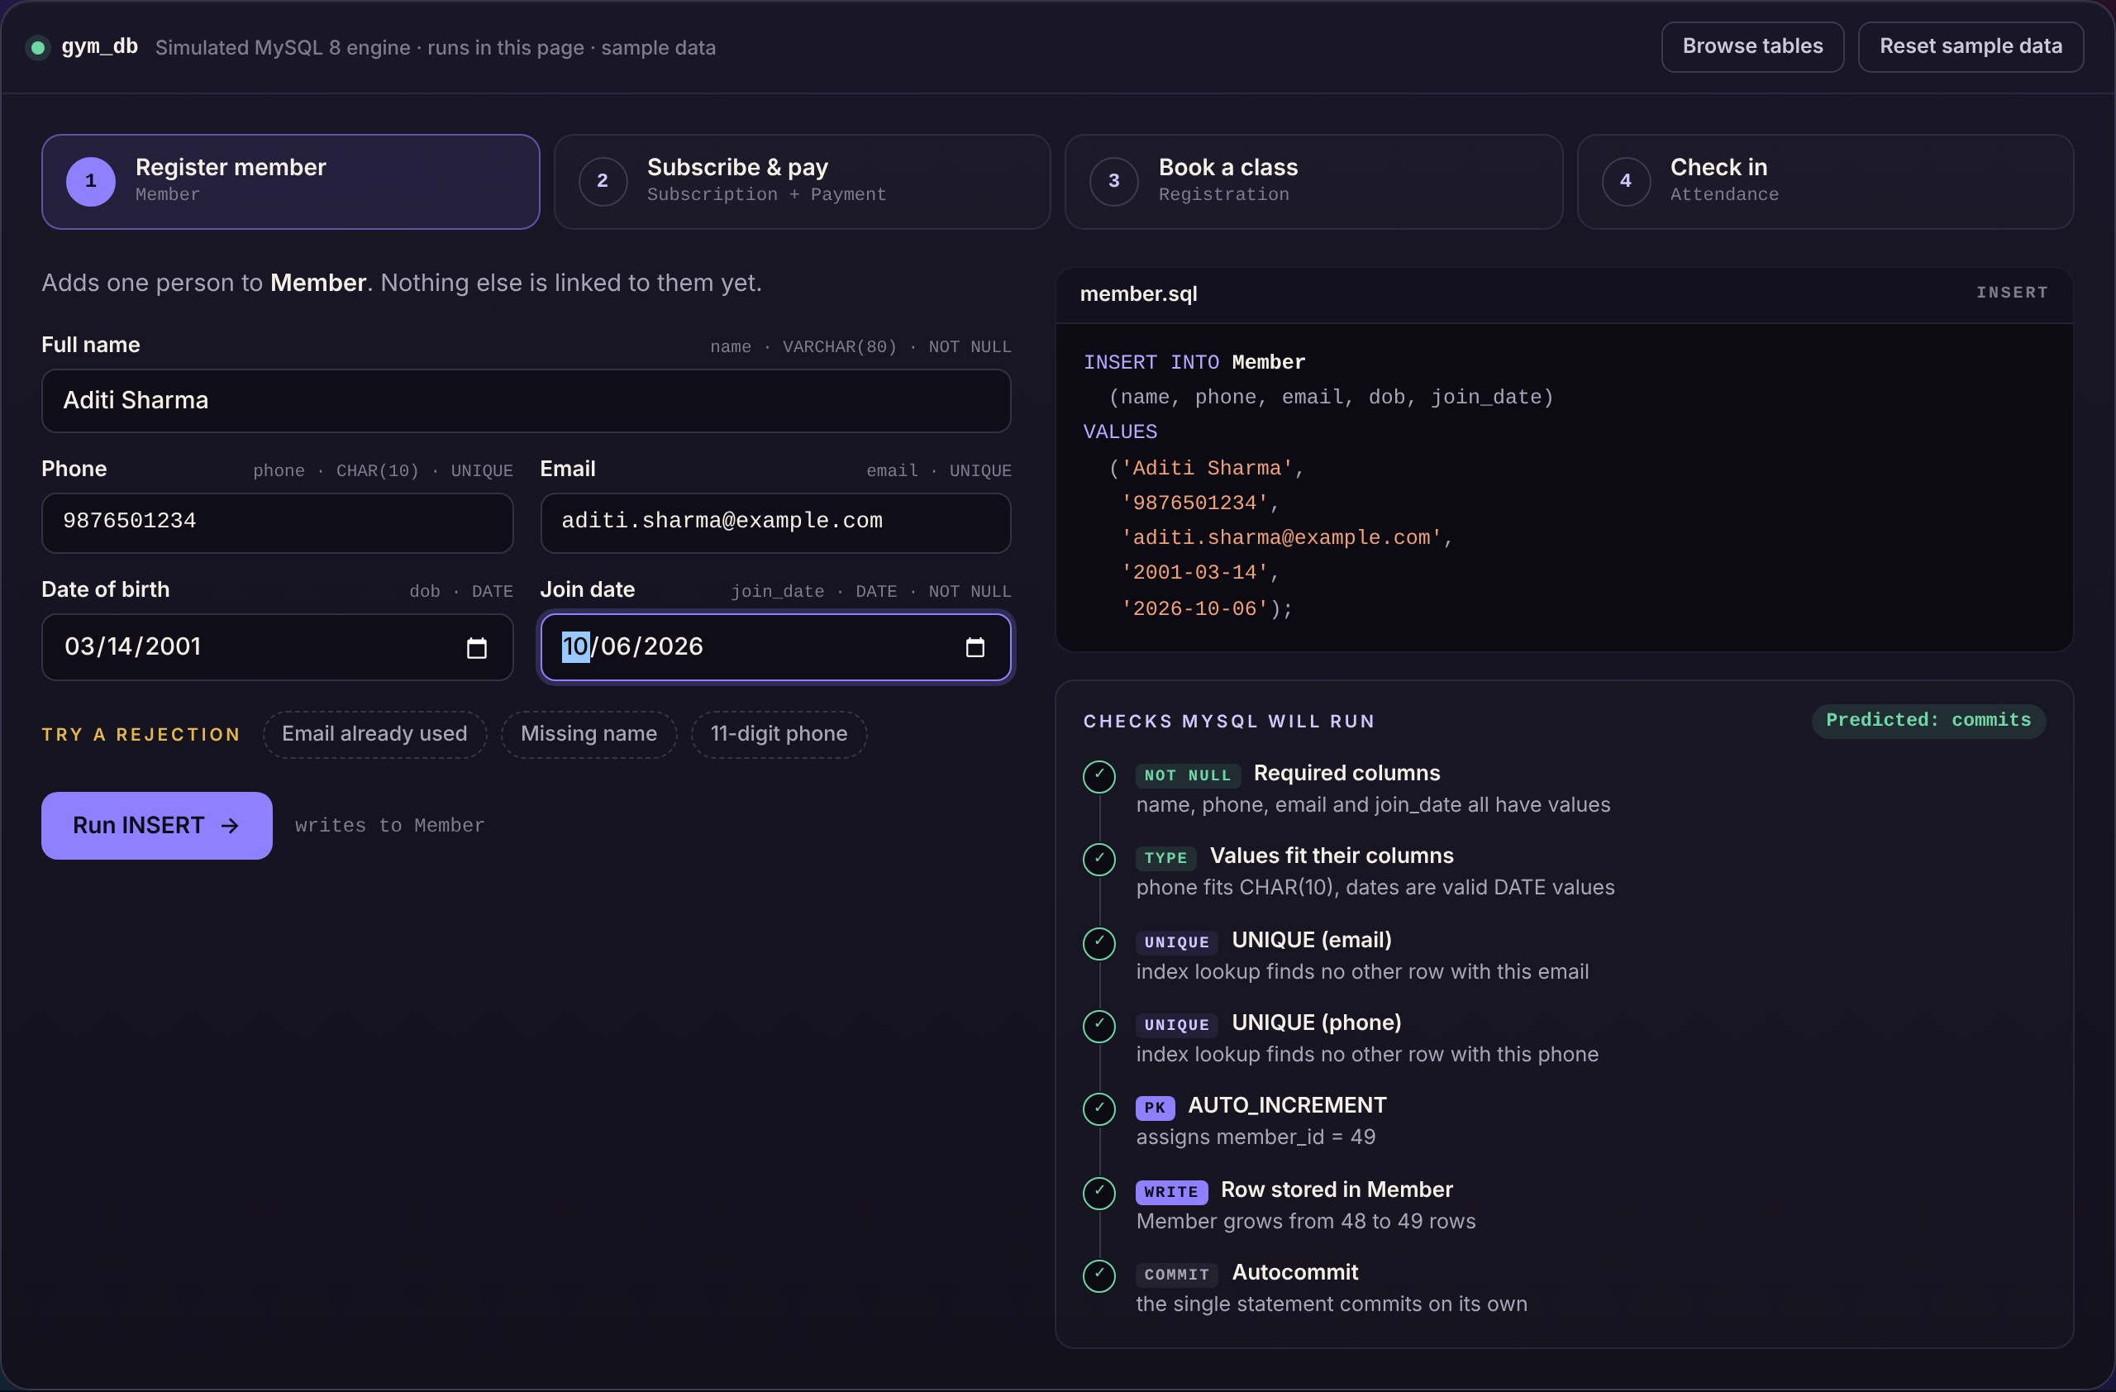
Figure 2. Data Entry: Registering a Member in the Prototype Console
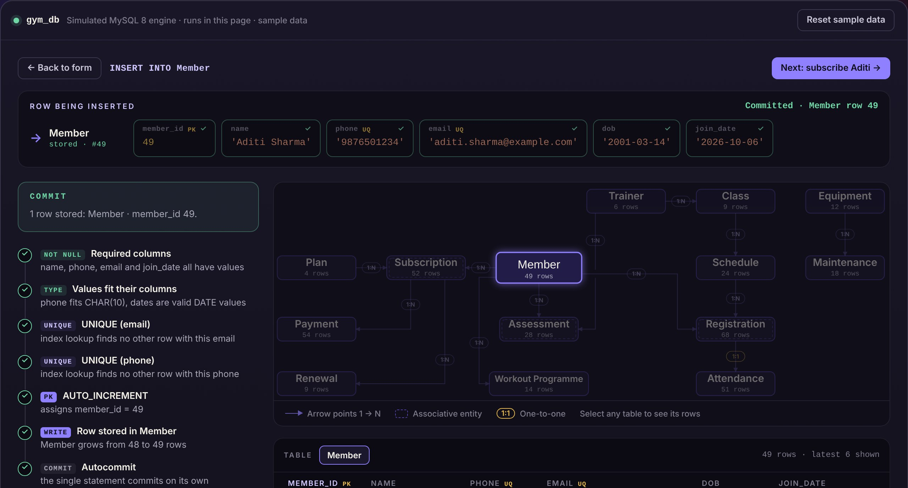
Figure 3. Display: Committed Member Row Traced into the Schema
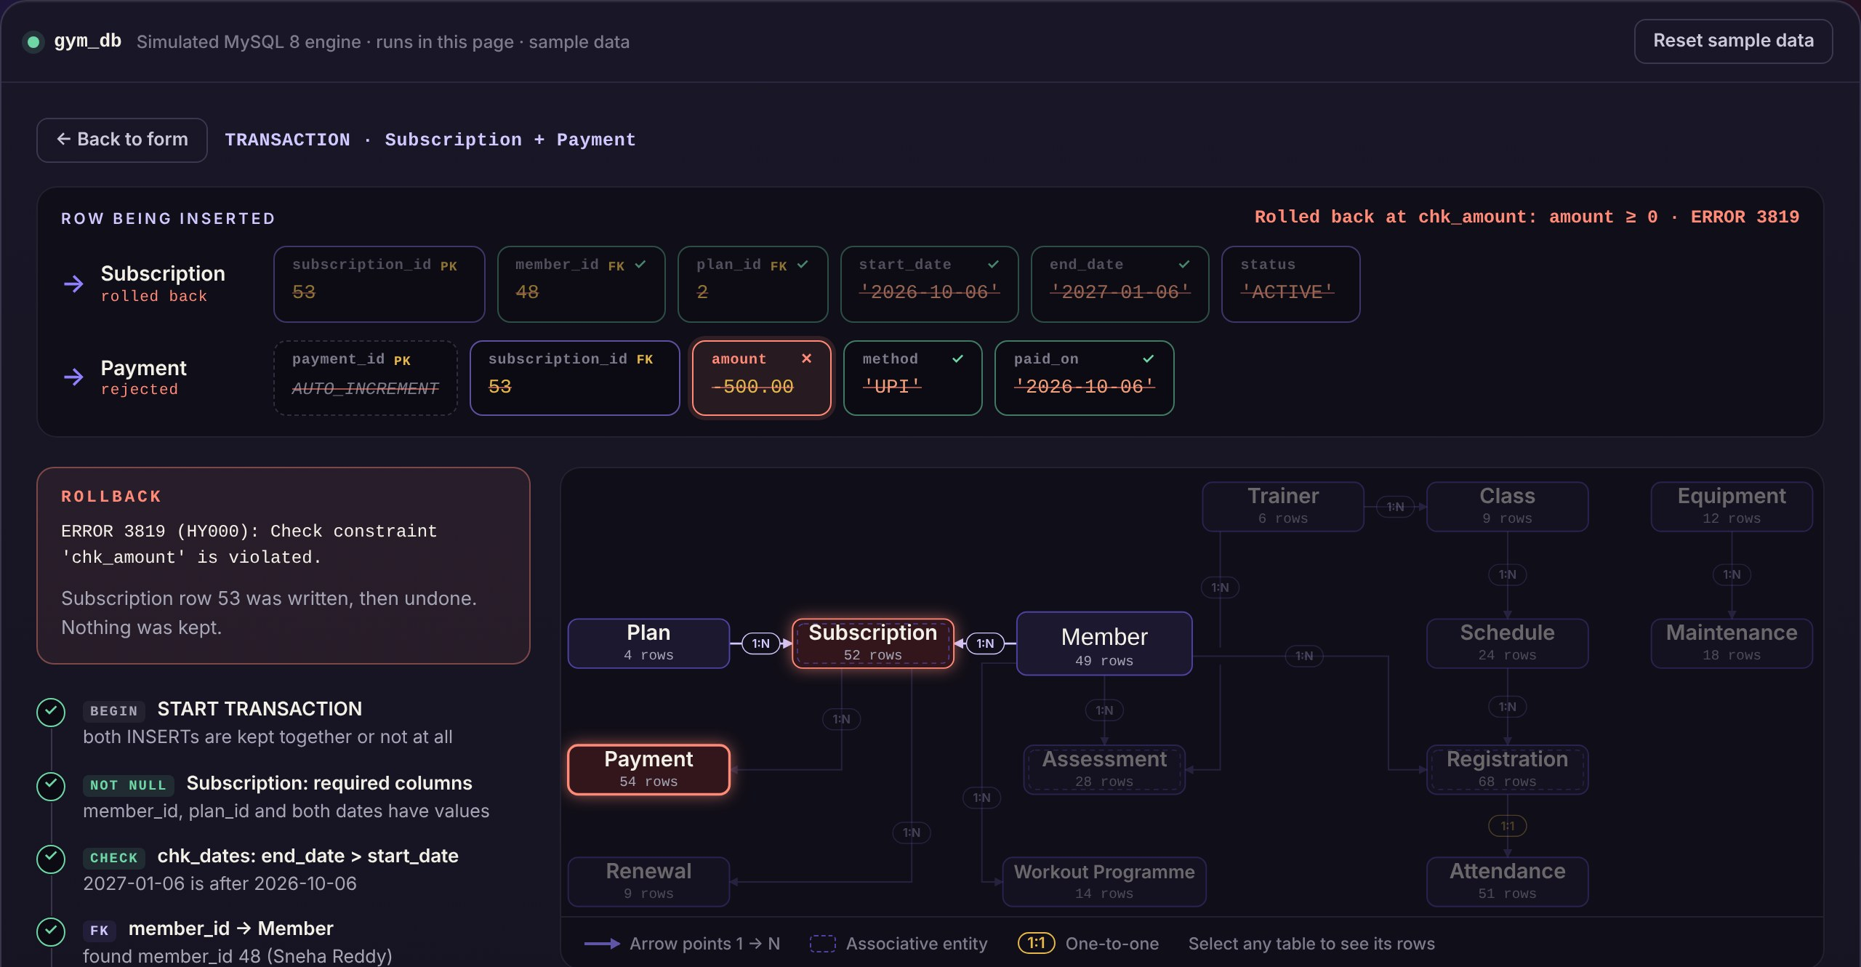
Figure 4. Transaction Processing: Subscription Rolled Back on a Failed Payment
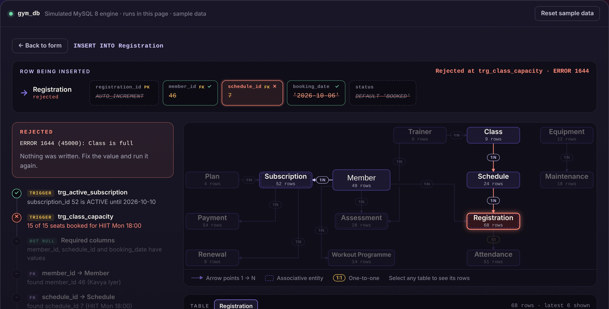
Figure 5. Business Rule: Booking Rejected by the Class-Capacity Trigger
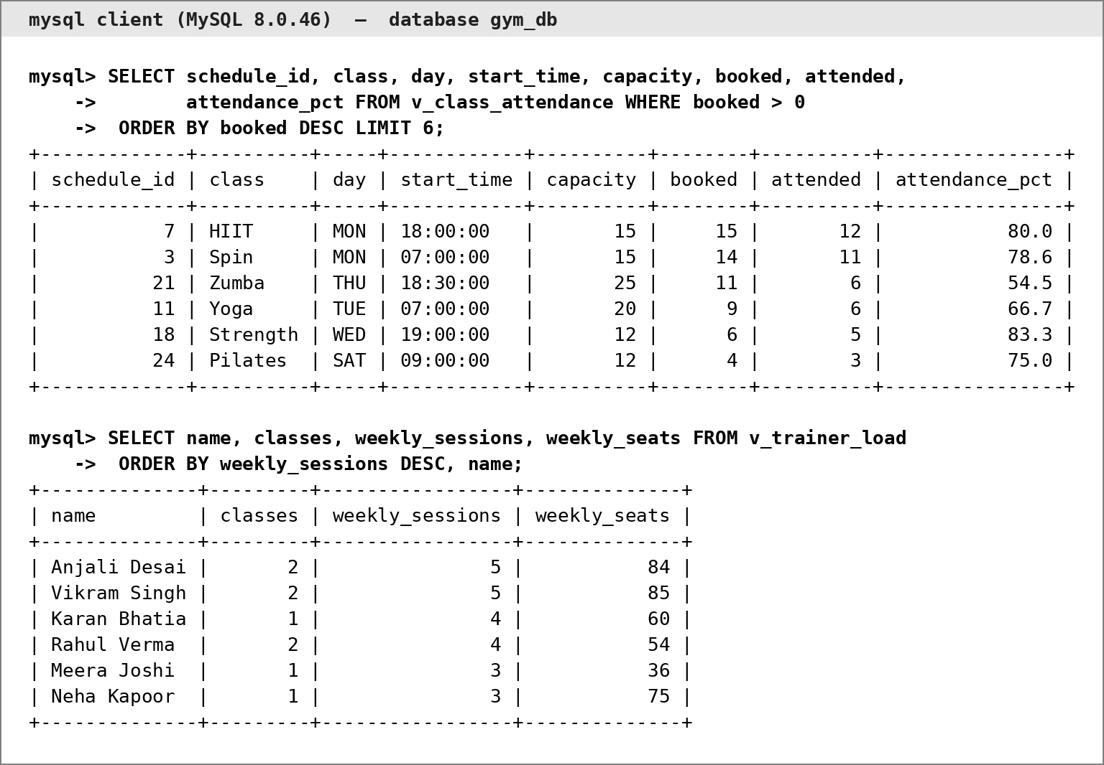
Figure 6. Report Output: Class Attendance and Trainer Load from MySQL

3.8 Testing and Results
Each rule was tested by trying to break it. Table 15 lists 23 test cases — 7 positive and 16 negative — executed in sequence on a freshly loaded gym_db in MySQL 8.0.46 on 8 October 2026. The actual result is the outcome or error returned by MySQL; the statements are supplied with the script (Appendix A).
Table 15. Test Cases
Test ID | Feature | Input / Action | Expected Result | Actual Result | Status
TC-01 | Membership | Register new member with valid details | Row inserted | Committed; member_id 49 | Pass
TC-02 | Membership | Register with an e-mail already in use | Rejected (UNIQUE) | ERROR 1062 duplicate key uq_member_email | Pass
TC-03 | Membership | Register with the name left blank | Rejected (NOT NULL) | ERROR 1048 Column 'name' cannot be null | Pass
TC-04 | Membership | Register with an 11-digit phone number | Rejected (CHAR(10)) | ERROR 1406 Data too long for column 'phone' | Pass
TC-05 | Membership | Update phone of member 49 | One row updated | 1 row updated | Pass
TC-06 | Subscription | CALL sp_subscribe(48, 2, 'UPI') | Subscription and payment committed | Committed; subscription 53, payment 55 | Pass
TC-07 | Subscription | Subscribe member 41, who already has an active plan | Rejected by procedure | ERROR 1644 Member already has an active subscription | Pass
TC-08 | Subscription | Insert subscription with end date before start date | Rejected (CHECK chk_dates) | ERROR 3819 chk_dates violated | Pass
TC-09 | Payment | Subscription + payment of -500 in one transaction | Both rows rolled back | ERROR 3819 chk_amount; subscription rows 53 → 53 | Pass
TC-10 | Subscription | Subscription for non-existent member 999 | Rejected (FOREIGN KEY) | ERROR 1452 foreign key fk_sub_member fails | Pass
TC-11 | Renewal | CALL sp_renew_subscription(52, 1, 1500, 'UPI') | End date extended; renewal and payment stored | End date 2026-10-12 → 2026-11-12 | Pass
TC-12 | Renewal | Renewal whose new end date precedes the renewal date | Rejected (CHECK) | ERROR 3819 chk_renewal_dates violated | Pass
TC-13 | Booking | Book member 44 into Pilates SAT 09:00 (4/12 booked) | Row inserted | Committed; registration 69, seats 5/12 | Pass
TC-14 | Booking | Book member 46 into HIIT MON 18:00 (15/15 booked) | Rejected by capacity trigger | ERROR 1644 Class is full | Pass
TC-15 | Booking | Book member 43 (subscription expired) into Yoga | Rejected by subscription trigger | ERROR 1644 No active subscription for this member | Pass
TC-16 | Booking | Book member 41 into a session already booked | Rejected (composite UNIQUE) | ERROR 1062 duplicate key uq_sched_member | Pass
TC-17 | Attendance | Second check-in for registration 61 | Rejected (UNIQUE, 1:1) | ERROR 1062 duplicate key uq_att_registration | Pass
TC-18 | Attendance | Check-out earlier than check-in | Rejected (CHECK chk_checkout) | ERROR 3819 chk_checkout violated | Pass
TC-19 | Scheduling | Add HIIT MON 18:30-19:15 (trainer busy 18:00-18:45) | Rejected by overlap trigger | ERROR 1644 Trainer already has a class in this time slot | Pass
TC-20 | Scheduling | Add HIIT FRI 07:00-07:45 (trainer free) | Row inserted | Committed; schedule_id 25 | Pass
TC-21 | Assessment | Record assessment with weight -60 | Rejected (CHECK) | ERROR 3819 chk_assessment_values violated | Pass
TC-22 | Membership | Delete member 41, who has subscriptions | Rejected (FK RESTRICT) | ERROR 1451 parent row has child rows | Pass
TC-23 | Maintenance | Delete maintenance record 1 | One row deleted | 1 row deleted | Pass

All 23 test cases passed. Valid operations were committed, and every invalid operation was rejected by the specific constraint, trigger or procedure intended for it, with nothing written. The two transactional cases confirm atomicity: in TC-09 the subscription row written by the first statement was removed when the payment failed, and in TC-11 the renewal, the extended end date and the payment were stored together. The results show that the database correctly enforces all five business rules of the brief and the additional integrity rules of the design.

CHAPTER 4

CONCLUSION
This project addressed the failures of register- and spreadsheet-based gym administration — lapsed members booking classes, overbooked sessions, clashing trainer timetables and records that cannot be queried together. Fourteen entities were modelled in an ER diagram, converted into a relational schema and normalised to 3NF (and BCNF), and implemented in MySQL 8 with keys, CHECK and DEFAULT constraints, four triggers for the multi-row rules, three transactional procedures, a daily expiry event, seven report views and three secondary indexes. Interconnected sample data and twenty-three test cases executed on MySQL confirm that every business rule of the brief is enforced by the database itself, and the JavaScript prototype demonstrates the core front-desk flows against the same rules.
The main learning outcome was deciding where each rule belongs: single-row conditions are cheap and reliable as CHECK constraints, whereas conditions that read other rows need triggers or transactional procedures, and stating that reasoning makes the design both easier to defend and easier to test.

4.1 Limitations and Future Enhancements
- Application connectivity. The prototype runs in the browser and is not yet connected to MySQL. The next step is a Node.js data-access layer (mysql2, prepared statements) behind the existing screens, followed by the trainer, renewal, maintenance and report screens.
- Booking granularity. A booking refers to a recurring weekly slot rather than a dated session, so each booking can be attended only once. A dated Session entity between Schedule and Registration would support repeated weekly attendance.
- Re-activated bookings. Capacity is checked when a booking is inserted; changing a cancelled booking back to BOOKED by UPDATE bypasses that check, which a BEFORE UPDATE trigger would close.
- Access control and scale. The design assumes one branch and a single database account. Role-based MySQL accounts with GRANT privileges, multi-branch support, automatic renewal reminders and online payments are realistic enhancements.

REFERENCES
- A. Silberschatz, H. F. Korth, and S. Sudarshan, Database System Concepts, 7th ed. New York, NY, USA: McGraw-Hill Education, 2020.
- P. P.-S. Chen, “The entity-relationship model—Toward a unified view of data,” ACM Trans. Database Syst., vol. 1, no. 1, pp. 9–36, Mar. 1976, doi: 10.1145/320434.320440.
- E. F. Codd, “A relational model of data for large shared data banks,” Commun. ACM, vol. 13, no. 6, pp. 377–387, Jun. 1970, doi: 10.1145/362384.362685.
- Oracle Corporation, MySQL 8.0 Reference Manual. Accessed: Oct. 8, 2026. [Online]. Available: https://dev.mysql.com/doc/refman/8.0/en/
- R. Elmasri and S. B. Navathe, Fundamentals of Database Systems, 7th ed. Boston, MA, USA: Pearson, 2016.
- W. Kent, “A simple guide to five normal forms in relational database theory,” Commun. ACM, vol. 26, no. 2, pp. 120–125, Feb. 1983, doi: 10.1145/358024.358054.
- J. Gray and A. Reuter, Transaction Processing: Concepts and Techniques. San Mateo, CA, USA: Morgan Kaufmann, 1993.

APPENDICES

APPENDIX A - COMPLETE DATABASE SCRIPT
The complete script is submitted as 25WU0103007_Aryan_Baswapur_gym_db.sql. Running it on MySQL 8.0.16 or later rebuilds gym_db from nothing:
mysql -u root -p < 25WU0103007_Aryan_Baswapur_gym_db.sql

The script is organised in four parts:
- Part 1 — Schema: the fourteen tables of Table 5 with every constraint of Table 6, and the secondary indexes idx_mem_name, idx_sub_end and idx_pay_paid.
- Part 2 — Rules and views: triggers trg_active_subscription, trg_class_capacity, trg_trainer_overlap and trg_trainer_overlap_upd; procedures sp_subscribe, sp_renew_subscription and sp_expire_subscriptions; event ev_expire_daily; and the seven report views.
- Part 3 — Sample data: the 397 rows of Table 9, inserted in an order that passes every constraint and trigger.
- Part 4 — Report queries: the queries behind Table 14.
The test cases of Table 15 are supplied as 25WU0103007_Aryan_Baswapur_gym_db_tests.sql; run them on a freshly loaded database with mysql --force, so that the expected errors of the negative cases do not stop the run.

APPENDIX B - APPLICATION SOURCE CODE
Prototype console: single-file HTML, CSS and JavaScript application, submitted as gym_db_prototype.html. Repository: [Repository link].

APPENDIX C - ADDITIONAL TEST DATA AND OUTPUTS
The outputs below were produced by the report queries of Part 4 on the freshly loaded sample data (8 October 2026). Dates move with CURDATE(), so the values change when the script is loaded on another day.
R1. Active and expired members (v_member_status)
+-------------------+---------+
| membership_status | members |
+-------------------+---------+
| ACTIVE | 30 |
| EXPIRED | 17 |
| NO SUBSCRIPTION | 1 |
+-------------------+---------+

R2. Members 41–48 with current plan (LEFT OUTER JOIN)
+-----------+----------------+--------------------+------------+
| member_id | name | plan | end_date |
+-----------+----------------+--------------------+------------+
| 41 | Priya Naidu | Annual | 2026-11-02 |
| 42 | Prithvi Rao | Quarterly | 2026-11-16 |
| 43 | Pritha Sen | - no active plan - | NULL |
| 44 | Prithika M. | Monthly | 2026-10-21 |
| 45 | Arjun Mehta | Quarterly | 2026-12-03 |
| 46 | Kavya Iyer | Monthly | 2026-10-12 |
| 47 | Rohan Kulkarni | - no active plan - | NULL |
| 48 | Sneha Reddy | - no active plan - | NULL |
+-----------+----------------+--------------------+------------+

R5. Equipment maintenance (v_equipment_maintenance)
+--------------+-------------------+-------------------+----------+------------+--------------+
| equipment_id | name | status | services | total_cost | last_service |
+--------------+-------------------+-------------------+----------+------------+--------------+
| 11 | Rowing machine #2 | OUT_OF_SERVICE | 5 | 11250.00 | 2026-09-24 |
| 5 | Spin bike #2 | UNDER_MAINTENANCE | 4 | 6050.00 | 2026-06-04 |
| 9 | Spin bike #6 | OUT_OF_SERVICE | 2 | 3350.00 | 2026-10-05 |
| 7 | Rowing machine #1 | ACTIVE | 2 | 3000.00 | 2026-05-30 |
| 8 | Treadmill T-200 | ACTIVE | 3 | 2650.00 | 2026-09-29 |
| 1 | Treadmill T-100 | ACTIVE | 1 | 1500.00 | 2026-01-17 |
| 2 | Elliptical E-20 | ACTIVE | 1 | 1500.00 | 2026-07-20 |
+--------------+-------------------+-------------------+----------+------------+--------------+

R6. Renewals due within seven days (v_renewals_due)
+-----------+------------------+-----------+------------+-----------+
| member_id | name | plan | end_date | days_left |
+-----------+------------------+-----------+------------+-----------+
| 2 | Ishita Sharma | Monthly | 2026-10-10 | 2 |
| 46 | Kavya Iyer | Monthly | 2026-10-12 | 4 |
| 9 | Nikhil Chowdary | Quarterly | 2026-10-13 | 5 |
| 10 | Pooja Menon | Quarterly | 2026-10-13 | 5 |
| 17 | Abhinav Malhotra | Quarterly | 2026-10-14 | 6 |
| 16 | Nandini Naidu | Monthly | 2026-10-15 | 7 |
+-----------+------------------+-----------+------------+-----------+

R7. Revenue for the last six months (v_monthly_revenue)
+---------+----------+----------+
| month | receipts | revenue |
+---------+----------+----------+
| 2026-09 | 10 | 22500.00 |
| 2026-08 | 11 | 49000.00 |
| 2026-07 | 7 | 28000.00 |
| 2026-06 | 1 | 1500.00 |
| 2026-05 | 4 | 26000.00 |
| 2026-04 | 4 | 8500.00 |
+---------+----------+----------+

R8. Active members with no attendance in 30 days (nested subquery)
+-----------+---------------+------------+
| member_id | name | phone |
+-----------+---------------+------------+
| 3 | Rohit Rao | 9318779284 |
| 6 | Meghana Patel | 9530250960 |
| 7 | Karthik Nair | 9887581578 |
| 42 | Prithvi Rao | 9900123456 |
+-----------+---------------+------------+

