Woxsen University
School of Technology
B.Tech — Computer Science and Engineering
PROJECT BASED LEARNING REPORT
Gym Membership and Fitness Session Management System
(Design and Implementation of a Relational Database Management System for Gym Membership and Fitness Session Management, built using MySQL 8 and JavaScript)
Course Code: | _______________
Course Name: | Database Management Systems
Semester: | _______________
Academic Year: | 2026 – 27
Submitted by:
Name: | Aryan Baswapur
Roll Number: | 3007
Section: | BIC-Tigers-29
Under the Guidance of:
Faculty Name: | _______________________
Designation: | _______________
Department of Computer Science and Engineering
October, 2026

DECLARATION
I hereby declare that the project titled “Gym Membership and Fitness Session Management System”, submitted in partial fulfilment of the requirements of the course Database Management Systems, is an original work carried out by me individually under the guidance of the faculty member named on the title page.
I confirm that this work has not been submitted, in part or in full, for the award of any degree, diploma, or other academic qualification in this or any other institution.
All sources of information used in this report — including textbooks, reference manuals, technical documentation and software tools used during development — have been properly acknowledged and cited in the references section, as per the university’s referencing standards.
I further declare that the plagiarism percentage in this report is within the permissible limit prescribed by the institution, and that the accompanying database script, sample data and application were designed, integrated and tested by me as part of this course.

Place: Woxsen University
Date: _______________
______________________________
Signature of the Candidate
Name: Aryan Baswapur
Roll Number: 3007
CERTIFICATE
This is to certify that the project titled “Gym Membership and Fitness Session Management System” is a bonafide work carried out by Mr. Aryan Baswapur (Roll No: 3007, Section: BIC-Tigers-29), student of B.Tech — Computer Science and Engineering, during the academic year 2026–27, in partial fulfilment of the requirements of the course Database Management Systems, under my supervision and guidance.
The project designs a relational database from requirements through an Entity–Relationship model, normalises it to Third Normal Form, implements it in MySQL 8 with keys, CHECK constraints, triggers, views and indexes, and exercises it through a JavaScript application layer.
To the best of my knowledge, the work reported herein does not form part of any other project or dissertation on the basis of which a degree or an award has been conferred on an earlier occasion by any other candidate.

Place: Woxsen University
Date: _______________
______________________________
Guide Signature
Name of the Guide: _______________
Designation: _______________
ACKNOWLEDGEMENT
I would like to express my sincere gratitude to the faculty of the Department of Computer Science and Engineering, Woxsen University, for their consistent encouragement and guidance throughout the course of this project.
I am particularly thankful to my project guide, whose feedback across the three project reviews shaped the work from a set of requirements into a normalised schema and a working prototype. Their insistence on justifying every design decision — why an entity is a table, why a rule is a CHECK and not a trigger — is reflected throughout this report.
I am also grateful to the mentors and peers who attended the review presentations and asked the questions that exposed weak points in the early design, in particular around class capacity, trainer clashes and subscription expiry.
Finally, I thank the authors of the textbooks and reference manuals listed at the end of this report, which provided the theoretical grounding for the design.

— Aryan Baswapur
ABSTRACT
Gym Membership and Fitness Session Management System is a relational database application built as the Project Based Learning assignment for the Database Management Systems course. Fitness centres that rely on paper registers and spreadsheets repeatedly fail in three ways: memberships expire without anyone noticing, popular classes are overbooked, and member, trainer, payment and equipment records are scattered across files that cannot be queried together.
The project addresses these failures by moving the rules into the database itself. Requirements were analysed into four user roles and fourteen principal entities — members, plans, subscriptions, payments, renewals, trainers, assessments, workout programmes, classes, schedules, registrations, attendance, equipment and maintenance. The Entity–Relationship model was converted into a relational schema and normalised to Third Normal Form, with functional dependencies stated for every relation.
The schema is implemented in MySQL 8 with primary keys, foreign keys, UNIQUE, NOT NULL, CHECK and DEFAULT constraints. Single-row rules such as non-negative assessment values and valid renewal dates are enforced by CHECK constraints, while multi-row rules — active subscription required, class-capacity limits and no trainer overlap — are enforced by BEFORE INSERT triggers. Subscriptions and their payments are written inside one transaction so that a failed payment rolls the subscription back. Secondary indexes support the most frequent searches.
The database is populated with interconnected sample data across all fourteen tables and exercised by a query set covering joins, aggregates, nested subqueries and views for active and expired members, class attendance, trainer load, equipment maintenance, renewals and revenue. A JavaScript prototype console demonstrates the core flows — registering a member, subscribing and paying, booking a class and checking in — and shows each constraint and trigger accepting or rejecting a row. Fifteen functional test cases were executed against the prototype and all produced the expected result.
TABLE OF CONTENTS
Preliminary Pages i–vii
Declaration ii
Certificate iii
Acknowledgement iv
Abstract v
List of Figures vii
List of Tables vii
1. Introduction 1
1.1 Background 1
1.2 Motivation and Relevance 1
1.3 Scope and Organisation of the Report 2
2. Problem Statement and Objectives 3
2.1 Problem Definition 3
2.2 Objectives 3
2.3 Users and Functional Requirements 4
2.4 Constraints and Assumptions 4
3. Literature Review 5
3.1 Prior Work 5
3.2 Comparative Analysis 6
4. Methodology and System Design 7
4.1 Development Approach and Architecture 7
4.2 Conceptual Design and ER Diagram 7
4.3 Relational Schema and Normalisation 8
4.4 Data Dictionary 9
4.5 Business Rules 10
5. Implementation 11
5.1 Database Script Organisation 11
5.2 DDL and Integrity Constraints 11
5.3 Trigger-Enforced Business Rules 12
5.4 Transactions 13
5.5 Sample Data 13
5.6 Queries, Views and Reports 14
5.7 Indexing 15
5.8 Prototype Application 15
6. Results and Discussion 17
7. Conclusion and Future Scope 19
References 20
LIST OF FIGURES
Fig. 4.1 Three-tier architecture of the system 7
Fig. 4.2 Entity–Relationship diagram of gym_db 8
Fig. 5.1 Prototype console — registering a member 15
Fig. 5.2 Transaction rolled back on a failed payment 16
Fig. 5.3 Booking rejected by the class-capacity trigger 16
LIST OF TABLES
Table 2.1 User roles and responsibilities 4
Table 3.1 Comparative analysis of approaches 6
Table 4.1 Relationships and how they are implemented 8
Table 4.2 Functional dependencies and normal form 9
Table 4.3 Data dictionary (excerpt) 10
Table 4.4 Business rules and enforcement mechanism 10
Table 5.1 Sample data by table 13
Table 6.1 Functional test cases and outcomes 17

CHAPTER 1 — INTRODUCTION

1.1 Background
A fitness centre manages far more data than its size suggests. Every member holds a plan, the plan has a price and a duration, the subscription that links the two has a start and an end date, and every renewal and payment must be traced back to it. Alongside the membership side sit trainers, their fitness assessments of members, workout programmes, group classes with fixed capacities, weekly schedules, bookings, attendance at each session, and the equipment on the floor with its maintenance history.
In most small and mid-sized centres this information lives in paper registers and spreadsheets maintained by the front desk. That arrangement works while the centre is small, but three failures appear as soon as it grows. Expiries slip by: nothing stops a member whose plan ended last month from continuing to book classes. Classes overbook: two receptionists can each give away the last seat of a spin class because neither sees the other’s entry. Records scatter: payment details sit in one sheet, attendance in another and assessments in a trainer’s notebook, so a question as simple as “which members have not visited in thirty days?” cannot be answered without manual cross-checking.
A relational database management system addresses each of these failures directly. Data is stored once and linked through keys, rules are declared alongside the data and checked by the engine on every write, and questions that span several kinds of record become a single SQL query. This project applies that approach to a gym, taking the design from requirements through to a working prototype.

1.2 Motivation and Relevance
Educational motivation. The Database Management Systems course covers data models and ER design, the relational model and SQL, normalisation and functional dependencies, and transactions and concurrency. A gym management system exercises every one of these in a single coherent artefact: it needs an ER model with associative entities, a schema that must be normalised, constraints of several kinds, multi-row rules that need triggers, a transaction that must be atomic, and reports that need joins, aggregates and subqueries.
Practical motivation. The rules that a gym actually cares about — an expired member must not book, a full class must not take another booking, a trainer cannot teach two classes at once — are exactly the rules that manual systems fail to enforce. Encoding them in the database means they hold no matter which screen or person writes the data.
Design motivation. A recurring question in database design is where a business rule should live. This project makes that question explicit: each of the five required rules is classified as either a single-row condition that a CHECK constraint can enforce, or a multi-row condition that needs a trigger, and the reasoning is documented so it can be defended.

1.3 Scope and Organisation of the Report
The scope covers the full member lifecycle — registration, plans, subscriptions, payments and renewals — together with trainers, assessments and workout programmes, classes, schedules, bookings and attendance, and equipment with its maintenance. Real payment processing, biometric entry systems and multi-branch operation are outside the scope; payments are recorded, not processed.
The report is organised into seven chapters. Chapter 2 defines the problem, objectives, users and constraints. Chapter 3 reviews related approaches and the database theory the design relies on. Chapter 4 presents the architecture, ER model, normalised schema, data dictionary and business rules. Chapter 5 describes the implementation: DDL, triggers, the transaction, sample data, queries, indexes and the prototype. Chapter 6 reports the test results and assesses each objective, and Chapter 7 concludes and lists the remaining and future work.

CHAPTER 2 — PROBLEM STATEMENT AND OBJECTIVES

2.1 Problem Definition
Fitness centres currently keep member, subscription, trainer, class, attendance, payment and equipment records in disconnected registers and spreadsheets that cannot enforce membership expiry, class capacity or trainer availability, and cannot answer questions that span more than one kind of record. The problem this project addresses is: how can these records be held in a single relational database, normalised to Third Normal Form, such that the centre’s business rules are enforced by the database itself and its operational reports can be produced by SQL queries?
Formally, the system must register members and their subscriptions, record payments and renewals, let trainers record assessments and programmes, schedule classes and accept bookings only from members with an active subscription and only while seats remain, record attendance for each booking, track equipment maintenance, and report on active and expired members, class attendance, trainer load, maintenance, renewals and revenue.

2.2 Objectives
The objectives are set against the course so that each one, when met, also demonstrates a specific part of the syllabus:
- O1 — Conceptual model. Identify the entities, attributes, relationships and user roles, and represent all fourteen principal entities in an ER diagram.
- O2 — Normalised schema. Convert the ER model into a relational schema and normalise it to 3NF, stating the functional dependencies of every relation.
- O3 — Integrity constraints. Implement the schema in MySQL 8 with suitable PRIMARY KEY, FOREIGN KEY, UNIQUE, NOT NULL, CHECK and DEFAULT constraints.
- O4 — Business rules. Enforce the five required rules: active subscription required, class-capacity limits, no trainer overlap, non-negative assessment values and valid renewal dates.
- O5 — Transactions. Record a subscription and its payment atomically, so that neither can exist without the other.
- O6 — Queries and reports. Populate realistic sample data and write joins, aggregates, nested subqueries and views for the six required reports.
- O7 — Indexing. Index the attributes that are searched most often.
- O8 — Application and testing. Provide an application layer that performs the core operations with validation and clear error handling, and test it systematically.

2.3 Users and Functional Requirements
Four user roles interact with the system. Each has its own view of the data, summarised in Table 2.1.
Role | Responsibilities
Administrator | Manages plans, staff, configuration and reports.
Front desk | Registers members, records subscriptions, payments and renewals, books classes and marks attendance.
Trainer | Records assessments and workout programmes; views assigned classes.
Member | Books classes and tracks own progress (read-mostly).
Table 2.1 — User roles and responsibilities.
Underneath these roles the database must support eight functional modules: membership and plans, subscriptions and renewals, trainers and assessments, workout programmes, classes and booking, attendance, equipment and maintenance, and payments and reporting.

2.4 Constraints and Assumptions
The following constraints applied to the project:
- Individual project. All analysis, design, implementation, testing and documentation were carried out by a single student.
- MySQL 8. The database targets MySQL 8.0.16 or later, the first release in which CHECK constraints are enforced rather than parsed and ignored.
- JavaScript application layer. The brief suggests Java or Python for the front end; JavaScript was chosen because the same language serves the browser interface and the data-access layer. The database design, which is the subject of the course, is independent of this choice.
- Synthetic data. All sample data is realistic but invented; no real member information is used.
The following assumptions were made:
- A centre operates from a single branch, so rooms and trainers are not shared across locations.
- A member holds at most one active subscription at a time; history is kept as earlier subscription rows.
- Payments are recorded after they are received at the desk (UPI, card or cash); the system does not act as a payment gateway.

CHAPTER 3 — LITERATURE REVIEW

3.1 Prior Work
3.1.1 Register- and spreadsheet-based administration.
Paper registers and spreadsheets remain common in small fitness centres because they cost nothing and need no training. Their limitations are the classic drawbacks of file-processing systems described by Silberschatz et al.: data redundancy and inconsistency, difficulty in accessing data, integrity rules buried in people’s habits rather than in the system, and concurrent-access anomalies when two staff members update the same sheet [1].
3.1.2 Commercial gym-management platforms.
Commercial software-as-a-service products offer membership billing, class booking and attendance tracking. They solve the operational problem but are subscription-priced, closed, and opaque about how rules are enforced. For a course project their value is as a reference for which features a real centre expects, not as a design to copy.
3.1.3 Entity–Relationship modelling.
Chen’s Entity–Relationship model [3] provides the conceptual vocabulary used in this project: entity sets, relationship sets, cardinality constraints, and the use of associative entities to resolve many-to-many relationships. Subscription, Assessment and Registration in this design are associative entities of exactly this kind.
3.1.4 Normalisation.
Codd’s relational model [4] and the normal forms that followed give a formal test for redundancy. A relation is in Third Normal Form when every non-key attribute depends on the key, the whole key and nothing but the key [7]. Kent’s informal statement of the rule is the one used to check each relation in Section 4.3.
3.1.5 Declarative constraints versus triggers.
The SQL standard defines assertions for rules that span several rows or tables, but MySQL, like most commercial systems, does not implement them. A CHECK constraint in MySQL may reference only columns of the row being written [8]. Rules that must count or compare other rows therefore fall to BEFORE triggers that raise an error with SIGNAL, or to the application layer. Elmasri and Navathe discuss this trade-off between centralised enforcement and application-level checking [2].
3.1.6 Transactions and indexing.
The ACID properties of transactions [6] guarantee that a group of statements either completes in full or leaves no trace. InnoDB, MySQL’s default storage engine, provides these guarantees and stores each table as a B+-tree clustered on its primary key, so secondary indexes are needed only for columns searched by value [8].

3.2 Comparative Analysis
Table 3.1 compares the approach taken in this project with the alternatives on the criteria that matter most to a fitness centre.
Criterion | Paper register | Spreadsheet | Commercial SaaS | This system
Expiry enforced at booking | No | No | Yes | Yes (trigger)
Class capacity enforced | Manual | No | Yes | Yes (trigger)
Trainer clash prevented | Manual | No | Usually | Yes (trigger)
Cross-record reports | No | Partial | Yes | Yes (SQL)
Atomic subscription + payment | No | No | Yes | Yes (transaction)
Rules visible and auditable | N/A | No | No | Yes (DDL)
Cost | Nil | Nil | Recurring | Nil (open source)
Table 3.1 — Comparative analysis of approaches.
The comparison shows that the project occupies a clear niche: it delivers the rule enforcement and reporting of a commercial product while keeping every rule visible in the schema, which is precisely what a database course needs to demonstrate.

CHAPTER 4 — METHODOLOGY AND SYSTEM DESIGN

4.1 Development Approach and Architecture
The project followed a strict dependency chain in which each layer was frozen before the next was built: requirements, ER model, normalised schema, DDL with constraints and triggers, sample data, queries and views, and finally the application. The stages were aligned with the three course reviews, and freezing the schema early avoided cascading rework in every later layer.
The system follows a three-tier architecture, shown in Figure 4.1. The presentation tier renders forms, search and reports in the browser and performs first-line validation. The application tier, written in JavaScript, maps user actions to parameterised SQL, wraps multi-statement operations in transactions, and translates database errors into readable messages. The data tier is the MySQL 8 database gym_db, which holds the tables, constraints, triggers, views and indexes and is the final authority on every rule. The data tier runs MySQL 8 with the InnoDB engine, administered through MySQL Workbench and the command-line client; the upper tiers use JavaScript, HTML5 and CSS3; and the diagrams in this report were drawn with Graphviz.
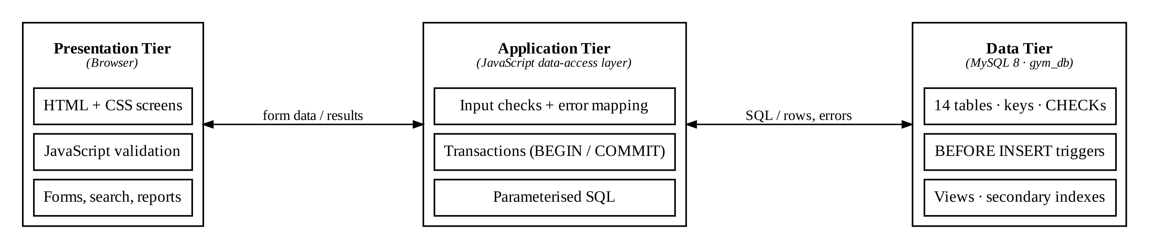
Fig. 4.1 — Three-tier architecture of the system.

4.2 Conceptual Design and ER Diagram
Requirements analysis produced fourteen principal entities, grouped into three domains: membership (Member, Plan, Subscription, Payment, Renewal), training (Trainer, Assessment, Workout Programme, Class, Schedule) and activity and operations (Registration, Attendance, Equipment, Maintenance). The ER diagram in Figure 4.2 is read outward from Member. Boxes with a dashed border are associative entities that resolve a many-to-many relationship: Subscription links Member and Plan, Assessment links Member and Trainer, and Registration links Member and Schedule.
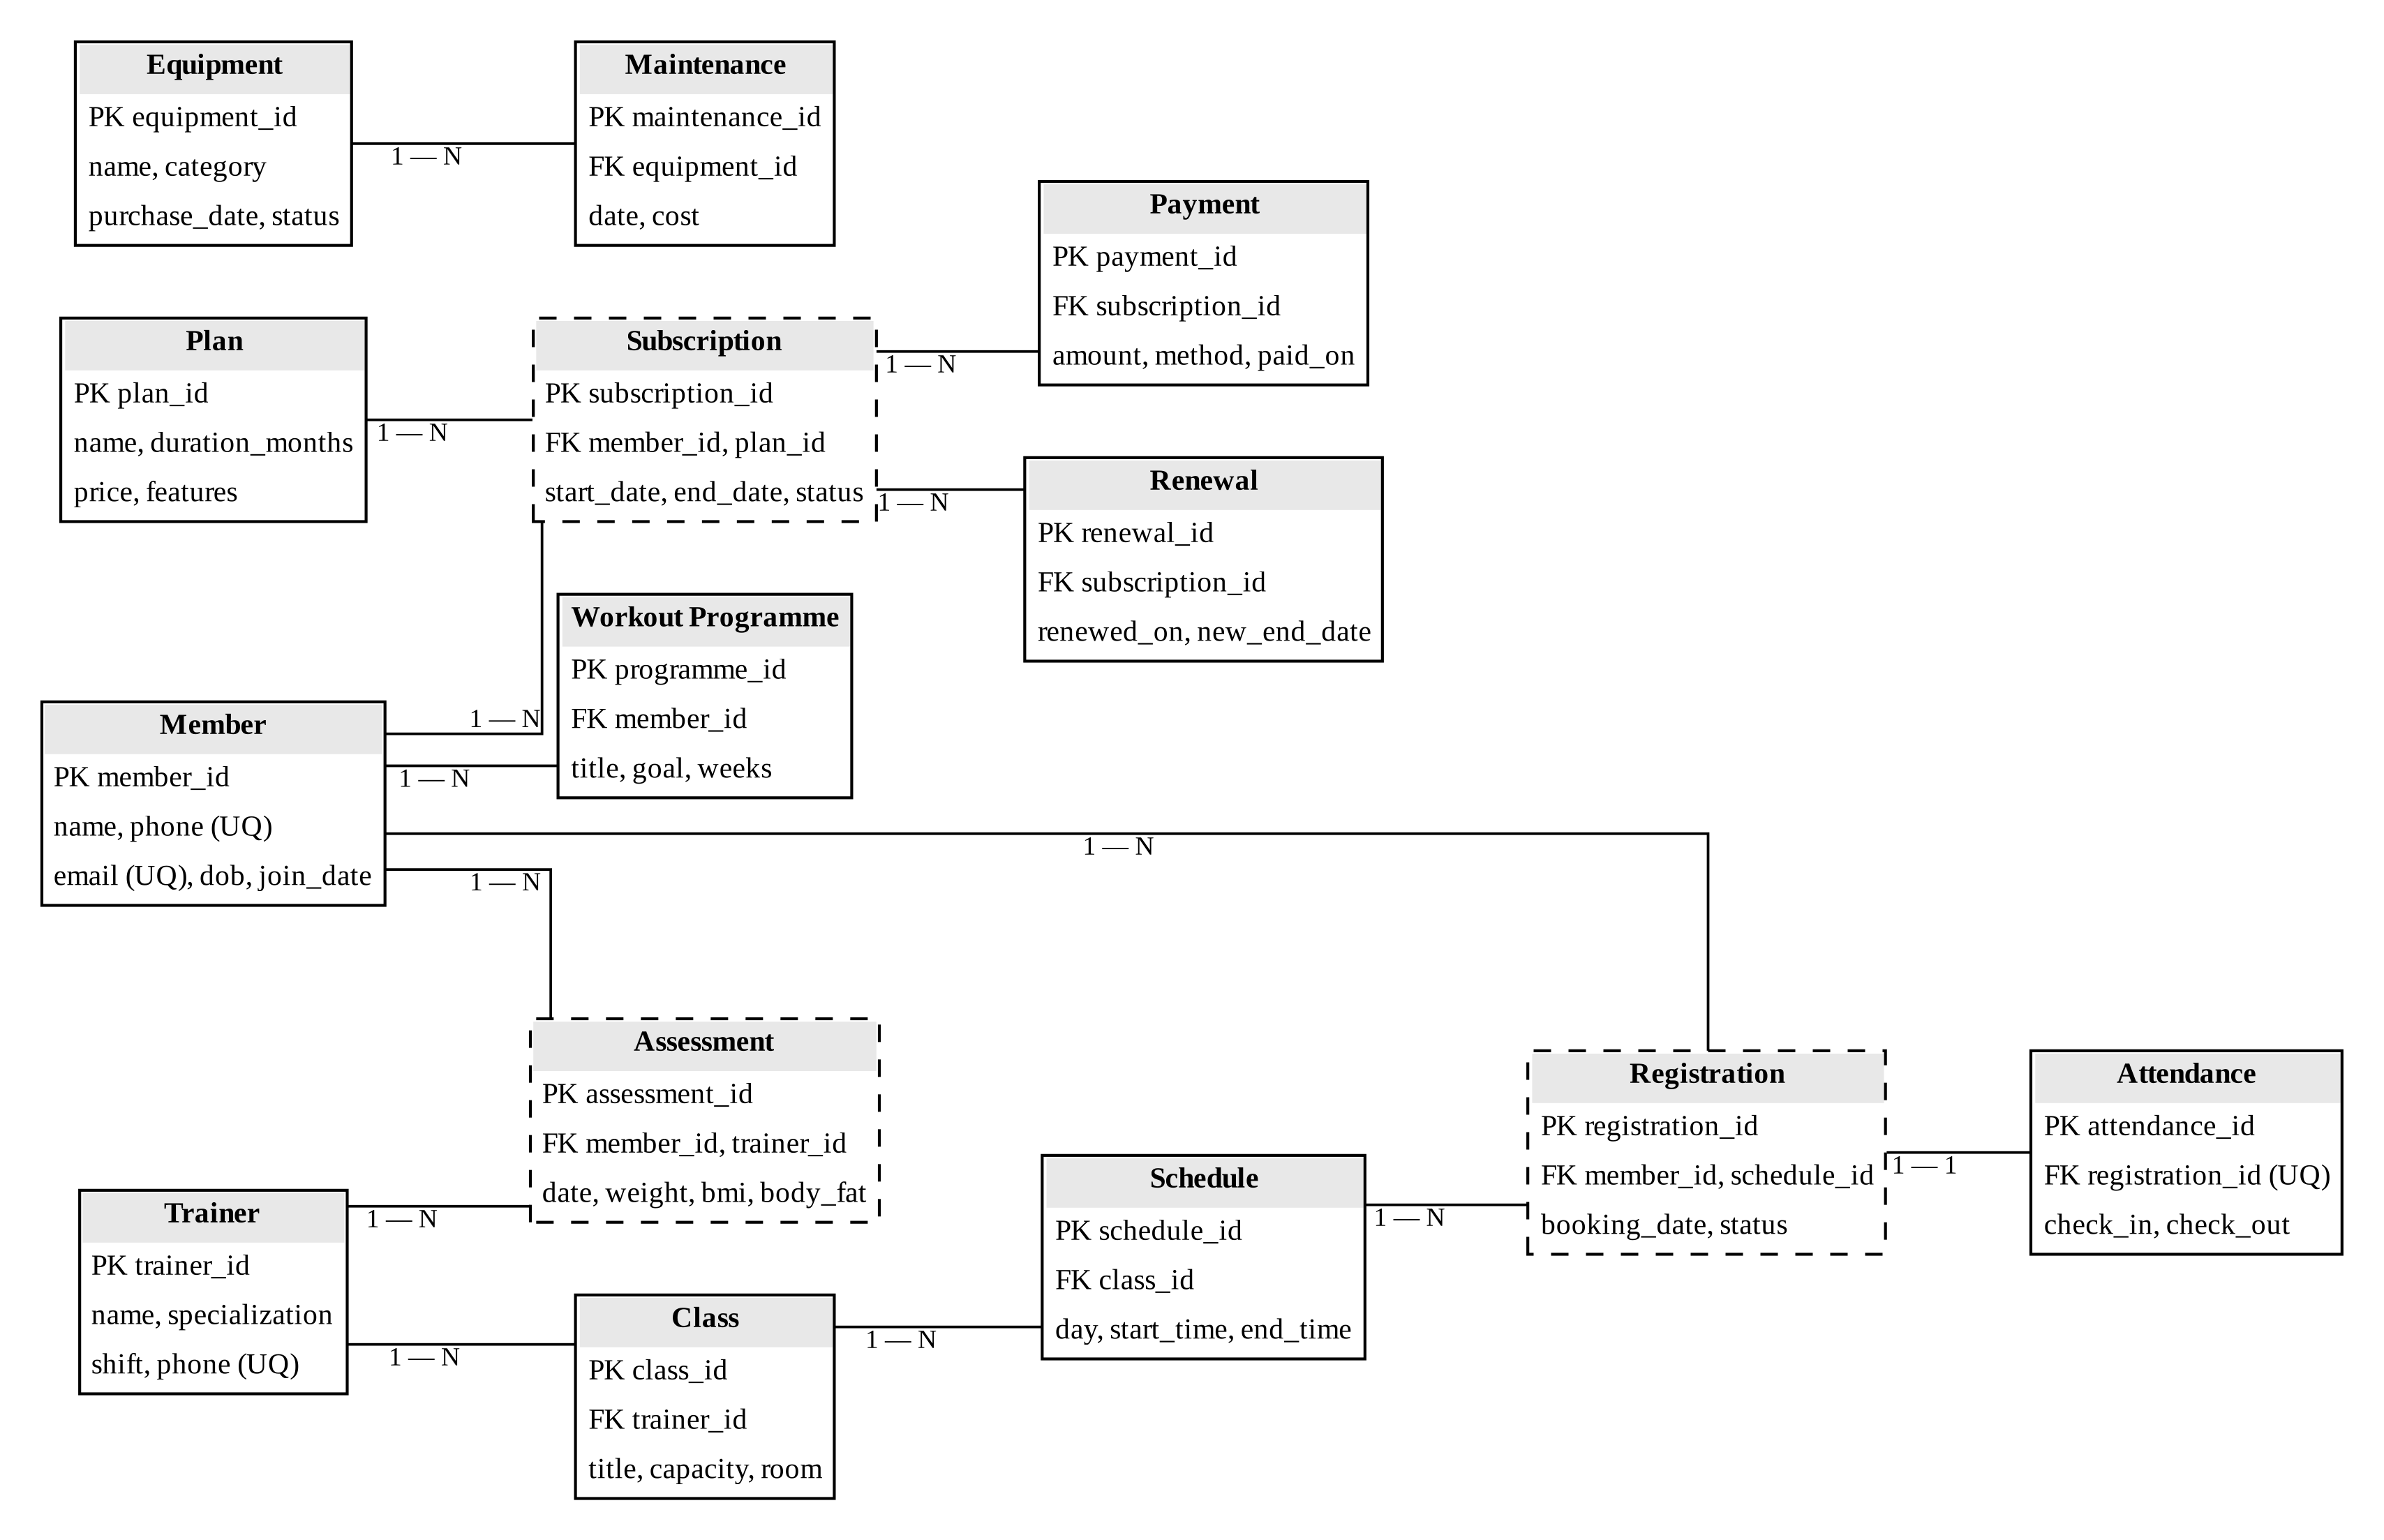
Fig. 4.2 — Entity–Relationship diagram of gym_db (PK = primary key, FK = foreign key, UQ = unique).
Table 4.1 lists each relationship, its cardinality and how it is implemented in the relational schema.
Relationship | Cardinality | Implemented by
Member — Plan (via Subscription) | M : N | Subscription(member_id, plan_id)
Subscription — Payment / Renewal | 1 : N | FK subscription_id in Payment, Renewal
Member — Trainer (via Assessment) | M : N | Assessment(member_id, trainer_id)
Member — Workout Programme | 1 : N | FK member_id in Workout_Programme
Trainer — Class — Schedule | 1 : N : N | FK trainer_id in Class, class_id in Schedule
Member — Schedule (via Registration) | M : N | Registration + UNIQUE(schedule_id, member_id)
Registration — Attendance | 1 : 1 | FK registration_id declared UNIQUE
Equipment — Maintenance | 1 : N | FK equipment_id in Maintenance
Table 4.1 — Relationships and how they are implemented.

4.3 Relational Schema and Normalisation
Each entity became one relation with a single-column surrogate primary key generated by AUTO_INCREMENT, and each relationship became a foreign key, as listed above. Because every primary key is a single column, no relation can contain a partial dependency, so every relation in First Normal Form is automatically in Second Normal Form. The remaining test for Third Normal Form is the absence of transitive dependencies — no non-key attribute may depend on another non-key attribute. Table 4.2 states the dependencies for the principal relations.
Relation | Functional dependencies | Form
Member | member_id → name, phone, email, dob, join_date;  phone → member_id; email → member_id (candidate keys) | 3NF
Plan | plan_id → name, duration_months, price, features | 3NF
Subscription | subscription_id → member_id, plan_id, start_date, end_date, status | 3NF
Payment | payment_id → subscription_id, amount, method, paid_on | 3NF
Class | class_id → trainer_id, title, capacity, room | 3NF
Schedule | schedule_id → class_id, day, start_time, end_time | 3NF
Registration | registration_id → member_id, schedule_id, booking_date, status;  (schedule_id, member_id) → registration_id | 3NF
Attendance | attendance_id → registration_id, check_in, check_out;  registration_id → attendance_id | 3NF
Table 4.2 — Functional dependencies and normal form.
Three transitive dependencies were identified in early drafts and removed by decomposition. A draft Subscription carrying the plan’s name and price had plan_id → price, so plan details were moved to Plan. A draft Class carrying the trainer’s name had trainer_id → trainer_name, so trainer details were moved to Trainer. A draft Registration carrying check-in times mixed booking facts with visit facts, so Attendance was separated and linked one-to-one. In each case the determinant became the key of its own relation, which is the standard 3NF decomposition and is both lossless and dependency-preserving.

4.4 Data Dictionary
The full data dictionary covers all fourteen relations. Table 4.3 shows an excerpt containing the columns that carry the most important constraints.
Table | Column | Type | Constraint | Purpose
Member | member_id | INT | PK, auto-increment | Surrogate identity
Member | email, phone | VARCHAR, CHAR(10) | UNIQUE, NOT NULL | Contact identifiers
Subscription | end_date | DATE | CHECK > start_date | Valid date window
Subscription | status | ENUM | DEFAULT 'ACTIVE' | Active / expired / cancelled
Payment | amount | DECIMAL(10,2) | CHECK ≥ 0 | Non-negative amount
Renewal | new_end_date | DATE | CHECK > renewed_on | Valid renewal date
Class | capacity | SMALLINT | CHECK > 0 | Seat limit for trigger
Assessment | weight, bmi, body_fat | DECIMAL(5,2) | CHECK ≥ 0 | Non-negative metrics
Attendance | registration_id | INT | FK, UNIQUE | One visit per booking
Table 4.3 — Data dictionary (excerpt).

4.5 Business Rules
The five business rules in the brief divide cleanly into two groups. A rule that can be checked using only the columns of the row being written is enforced by a CHECK constraint. A rule that must read other rows cannot be expressed as a CHECK in MySQL and is enforced by a BEFORE INSERT trigger, with the application layer repeating the check to give a friendlier message.
Business rule | Rows involved | Enforced by
Non-negative assessment values | One row | CHECK on Assessment
Valid renewal dates | One row | CHECK on Subscription and Renewal
Active subscription required | Other Subscription rows | Trigger trg_active_subscription
Class-capacity limit | All bookings of a schedule | Trigger trg_class_capacity
No trainer overlap | All schedules of a trainer | Trigger trg_trainer_overlap
Table 4.4 — Business rules and enforcement mechanism.

CHAPTER 5 — IMPLEMENTATION

5.1 Database Script Organisation
The database is delivered as ordered SQL scripts so that it can be rebuilt from nothing in one pass: the schema with all tables and constraints first, then triggers, then sample data, then views and indexes, and finally the query set used for reports. Running the scripts in order on an empty MySQL 8 server reproduces gym_db exactly, which also makes the database straightforward to reset during testing.

5.2 DDL and Integrity Constraints
Listing 5.1 shows representative DDL. The Subscription table demonstrates every kind of constraint in one place: foreign keys to Member and Plan, a CHECK that the end date follows the start date, and an ENUM status with a DEFAULT. Payment carries a non-negative CHECK on its amount and cascades on delete only from its owning subscription.
CREATE TABLE Subscription (
subscription_id INT AUTO_INCREMENT PRIMARY KEY,
member_id INT NOT NULL,
plan_id INT NOT NULL,
start_date DATE NOT NULL,
end_date DATE NOT NULL,
status ENUM('ACTIVE','EXPIRED','CANCELLED')
NOT NULL DEFAULT 'ACTIVE',
CONSTRAINT fk_sub_member FOREIGN KEY (member_id)
REFERENCES Member(member_id),
CONSTRAINT fk_sub_plan FOREIGN KEY (plan_id) REFERENCES Plan(plan_id),
CONSTRAINT chk_dates CHECK (end_date > start_date)
);

CREATE TABLE Payment (
payment_id INT AUTO_INCREMENT PRIMARY KEY,
subscription_id INT NOT NULL,
amount DECIMAL(10,2) NOT NULL,
method ENUM('UPI','CARD','CASH') NOT NULL,
paid_on DATE NOT NULL DEFAULT (CURRENT_DATE),
CONSTRAINT fk_pay_sub FOREIGN KEY (subscription_id)
REFERENCES Subscription(subscription_id) ON DELETE CASCADE,
CONSTRAINT chk_amount CHECK (amount >= 0)
);
Listing 5.1 — Representative DDL for Subscription and Payment.
The same pattern is applied to the remaining tables: CHECK (weight >= 0 AND bmi >= 0 AND body_fat >= 0) on Assessment, CHECK (new_end_date > renewed_on) on Renewal, CHECK (capacity > 0) on Class, CHECK (end_time > start_time) on Schedule, and CHECK (check_out > check_in) on Attendance, where a NULL check-out is permitted until the member leaves.

5.3 Trigger-Enforced Business Rules
Listing 5.2 shows the class-capacity trigger. Before every insert into Registration it counts the existing bookings for the same schedule, reads the class’s capacity through Schedule, and raises SQLSTATE 45000 if the class is already full. Because the trigger fires before the row is written, a rejected booking never reaches the table, and the error message is returned to the application unchanged.
DELIMITER //
CREATE TRIGGER trg_class_capacity
BEFORE INSERT ON Registration
FOR EACH ROW
BEGIN
DECLARE booked INT;
DECLARE cap INT;
SELECT COUNT(*) INTO booked FROM Registration
WHERE schedule_id = NEW.schedule_id AND status = 'BOOKED';
SELECT c.capacity INTO cap
FROM Schedule s JOIN Class c ON s.class_id = c.class_id
WHERE s.schedule_id = NEW.schedule_id;
IF booked >= cap THEN
SIGNAL SQLSTATE '45000' SET MESSAGE_TEXT = 'Class is full';
END IF;
END//
DELIMITER ;
Listing 5.2 — trg_class_capacity, enforcing the class-capacity limit.
The other two multi-row rules follow the same shape. trg_active_subscription, also BEFORE INSERT on Registration and ordered to run first, rejects a booking unless the member has a Subscription row with status ACTIVE whose date range contains the booking date. trg_trainer_overlap, BEFORE INSERT on Schedule, rejects a new slot if the class’s trainer already has another schedule on the same day whose time range overlaps, using the interval test NEW.start_time < s.end_time AND NEW.end_time > s.start_time.

5.4 Transactions
A subscription without its payment, or a payment without its subscription, would leave the database inconsistent. Listing 5.3 therefore writes both inside one transaction, using LAST_INSERT_ID() to link the payment to the subscription just created. If any statement fails — for example the payment amount violates chk_amount — the application issues ROLLBACK and the subscription row written moments earlier is removed as well.
START TRANSACTION;
INSERT INTO Subscription (member_id, plan_id, start_date, end_date)
VALUES (48, 2, '2026-10-06', '2027-01-06');
INSERT INTO Payment (subscription_id, amount, method, paid_on)
VALUES (LAST_INSERT_ID(), 4000.00, 'UPI', CURDATE());
COMMIT; -- or ROLLBACK if either INSERT raises an error
Listing 5.3 — Subscription and payment recorded atomically.

5.5 Sample Data
The sample data is not random. Rows were chosen so that every query in the report set returns a meaningful result: there are both active and expired members for the outer-join report, at least one class filled to capacity to exercise the trigger, members with no attendance in the last thirty days for the subquery, payments spread across several months for the revenue aggregate, and an uneven distribution of classes across trainers so that the load report is not trivial. Table 5.1 summarises the data.
Table | Rows | Design intent
Member | 48 | Mix of active and lapsed members
Plan | 4 | Monthly, Quarterly, Annual, Trial
Subscription | 52 | 30 active, 18 expired, 4 cancelled
Payment · Renewal | 54 · 9 | Spread across months
Trainer | 6 | Across six specialisations
Class · Schedule | 9 · 24 | Includes one full class
Registration · Attendance | 68 · 51 | Some members silent for 30+ days
Assessment · Workout Programme | 28 · 14 | Multiple assessments per member
Equipment · Maintenance | 12 · 18 | Two items out of service
Table 5.1 — Sample data by table.

5.6 Queries, Views and Reports
The query set covers every category required by the brief. Listing 5.4 shows four representative statements: a LEFT OUTER JOIN that lists every member with their current plan or NULL if they have none (active and expired members); an aggregate with GROUP BY for monthly revenue; an aggregate with HAVING for trainer load; and a nested NOT IN subquery for members with no attendance in thirty days.
-- Active and expired members (outer join)
SELECT m.member_id, m.name,
COALESCE(p.name, '- no plan -') AS plan, s.status
FROM Member m
LEFT JOIN Subscription s
ON s.member_id = m.member_id AND s.status = 'ACTIVE'
LEFT JOIN Plan p ON p.plan_id = s.plan_id;

-- Revenue per month (aggregate)
SELECT DATE_FORMAT(paid_on, '%Y-%m') AS month, COUNT(*) AS receipts,
SUM(amount) AS revenue
FROM Payment WHERE paid_on >= CURDATE() - INTERVAL 12 MONTH
GROUP BY month ORDER BY month;

-- Trainer load (aggregate with HAVING)
SELECT t.name, COUNT(c.class_id) AS classes, SUM(c.capacity) AS seats
FROM Trainer t LEFT JOIN Class c ON c.trainer_id = t.trainer_id
GROUP BY t.trainer_id, t.name HAVING classes > 0 ORDER BY classes DESC;

-- Members with no attendance in 30 days (nested subquery)
SELECT m.member_id, m.name, m.phone FROM Member m
WHERE m.member_id NOT IN (
SELECT r.member_id FROM Registration r
JOIN Attendance a ON a.registration_id = r.registration_id
WHERE a.check_in >= CURDATE() - INTERVAL 30 DAY);
Listing 5.4 — Representative report queries.
Reports that are reused across screens are defined as views. v_active_members joins Member, Subscription and Plan and computes DATEDIFF(end_date, CURDATE()) as the days remaining, so the dashboard, the renewals list (members whose days remaining fall below seven) and every “active only” query read from one definition. Class attendance is reported by joining Schedule, Registration and Attendance and grouping by schedule; equipment maintenance by grouping Maintenance on equipment with SUM(cost) and the latest date.
A guiding rule for the query set was to use a subquery when the inner query only filters rows, as with NOT IN above, and a join when the inner table contributes columns to the output.

5.7 Indexing
Primary keys are already clustered B+-tree indexes in InnoDB, and every UNIQUE constraint creates its own index, so duplicate checks on email, phone and (schedule_id, member_id) are index lookups rather than table scans. Three further secondary indexes cover the hottest search paths: idx_mem_name on Member(name) for front-desk search, idx_sub_end on Subscription(end_date) for the expiry and renewals reports, and idx_pay_paid on Payment(paid_on) for the revenue aggregate. Each index speeds reads at a small cost to writes, a trade worth making for a read-heavy front desk.

5.8 Prototype Application
The working prototype is a JavaScript console that runs the four core flows of the front desk — register a member, subscribe and pay, book a class, and check in — against the gym_db schema with the sample data loaded. For each statement it lays out the row being inserted, evaluates every NOT NULL, type, UNIQUE, CHECK, foreign-key and trigger condition in the order MySQL applies them, and then shows where the row lands in the ER model or where and why it was rejected, together with the MySQL error code. Figures 5.1 to 5.3 show the prototype in use; after a successful insert the console also traces the committed row into the ER model and the table inspector.
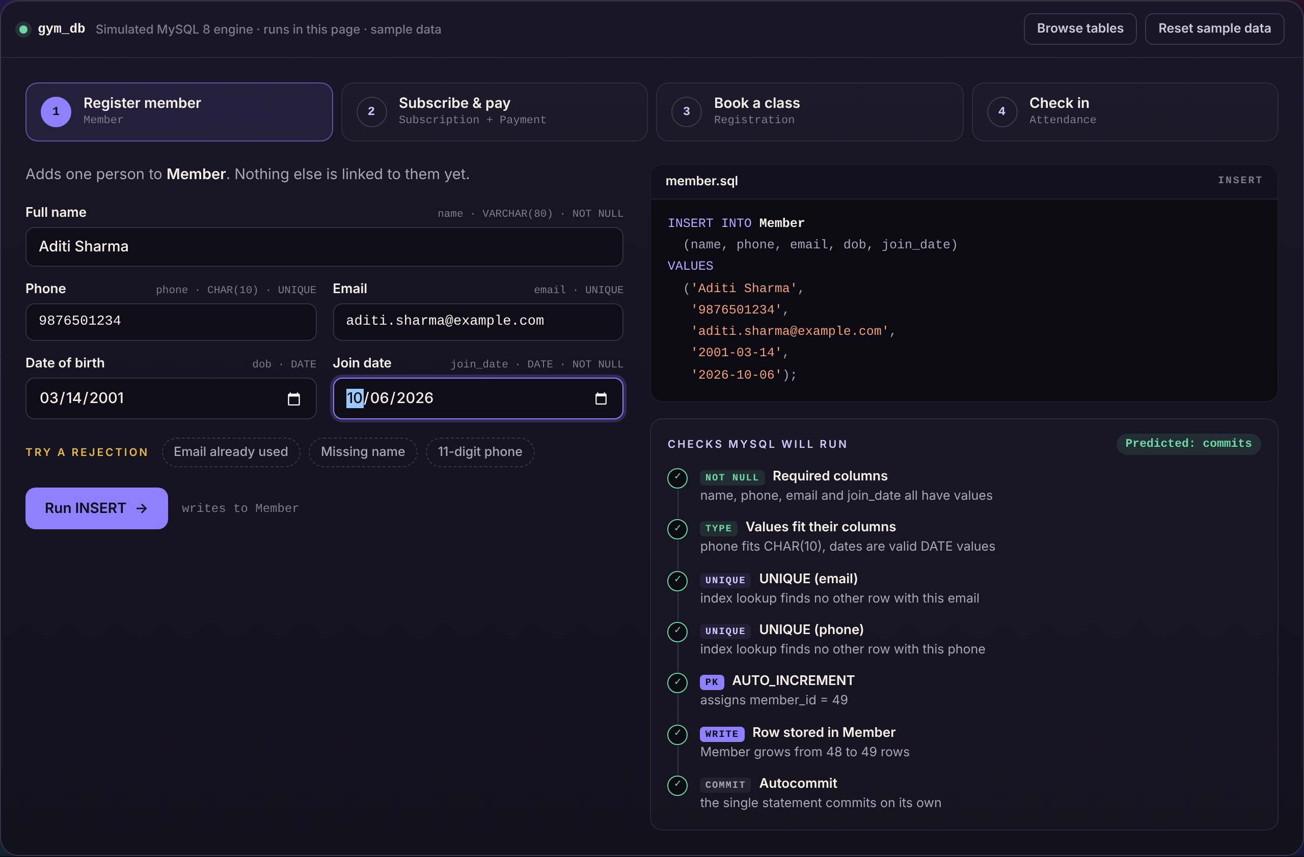
Fig. 5.1 — Prototype console: registering a member, with the INSERT and the checks MySQL will run.
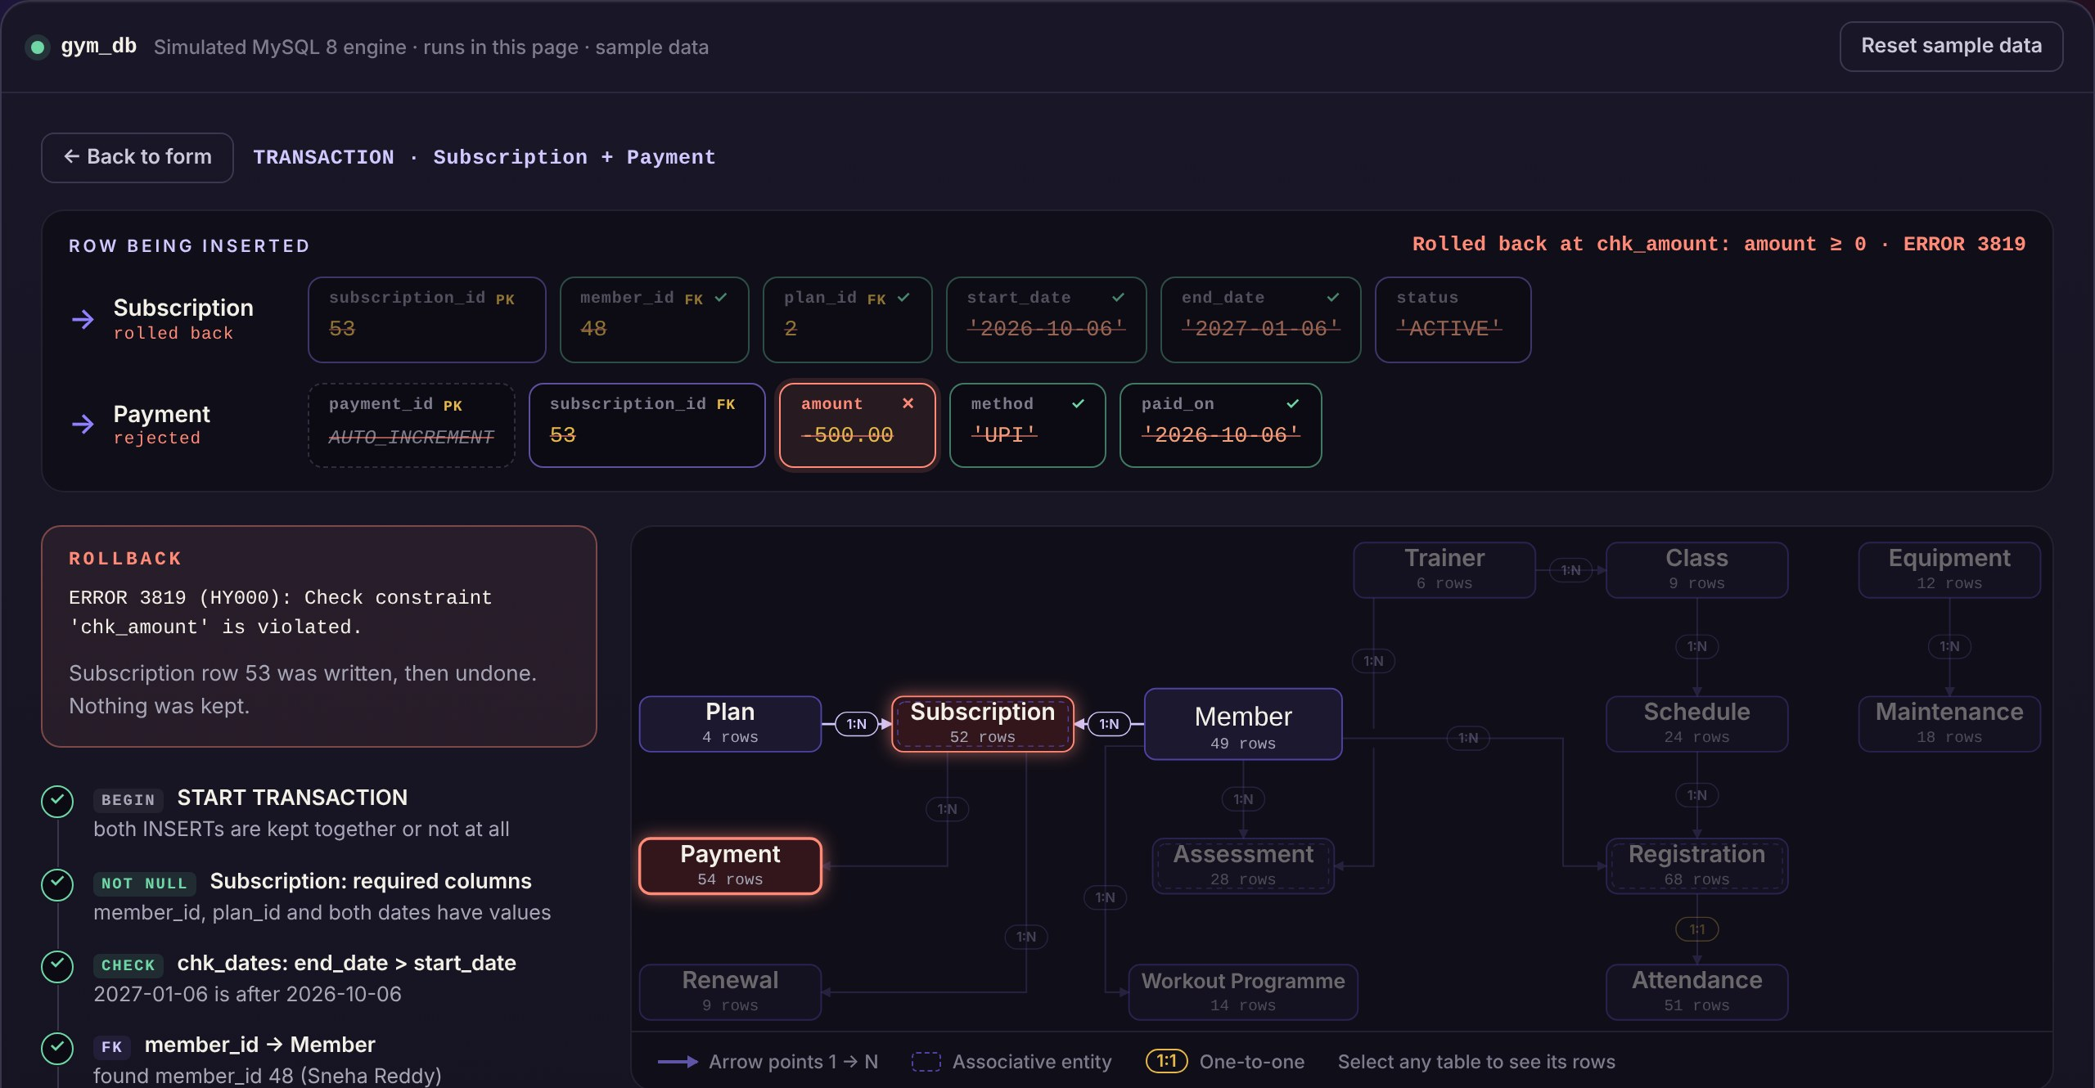
Fig. 5.2 — A negative payment violates chk_amount; the transaction rolls back the Subscription row as well.
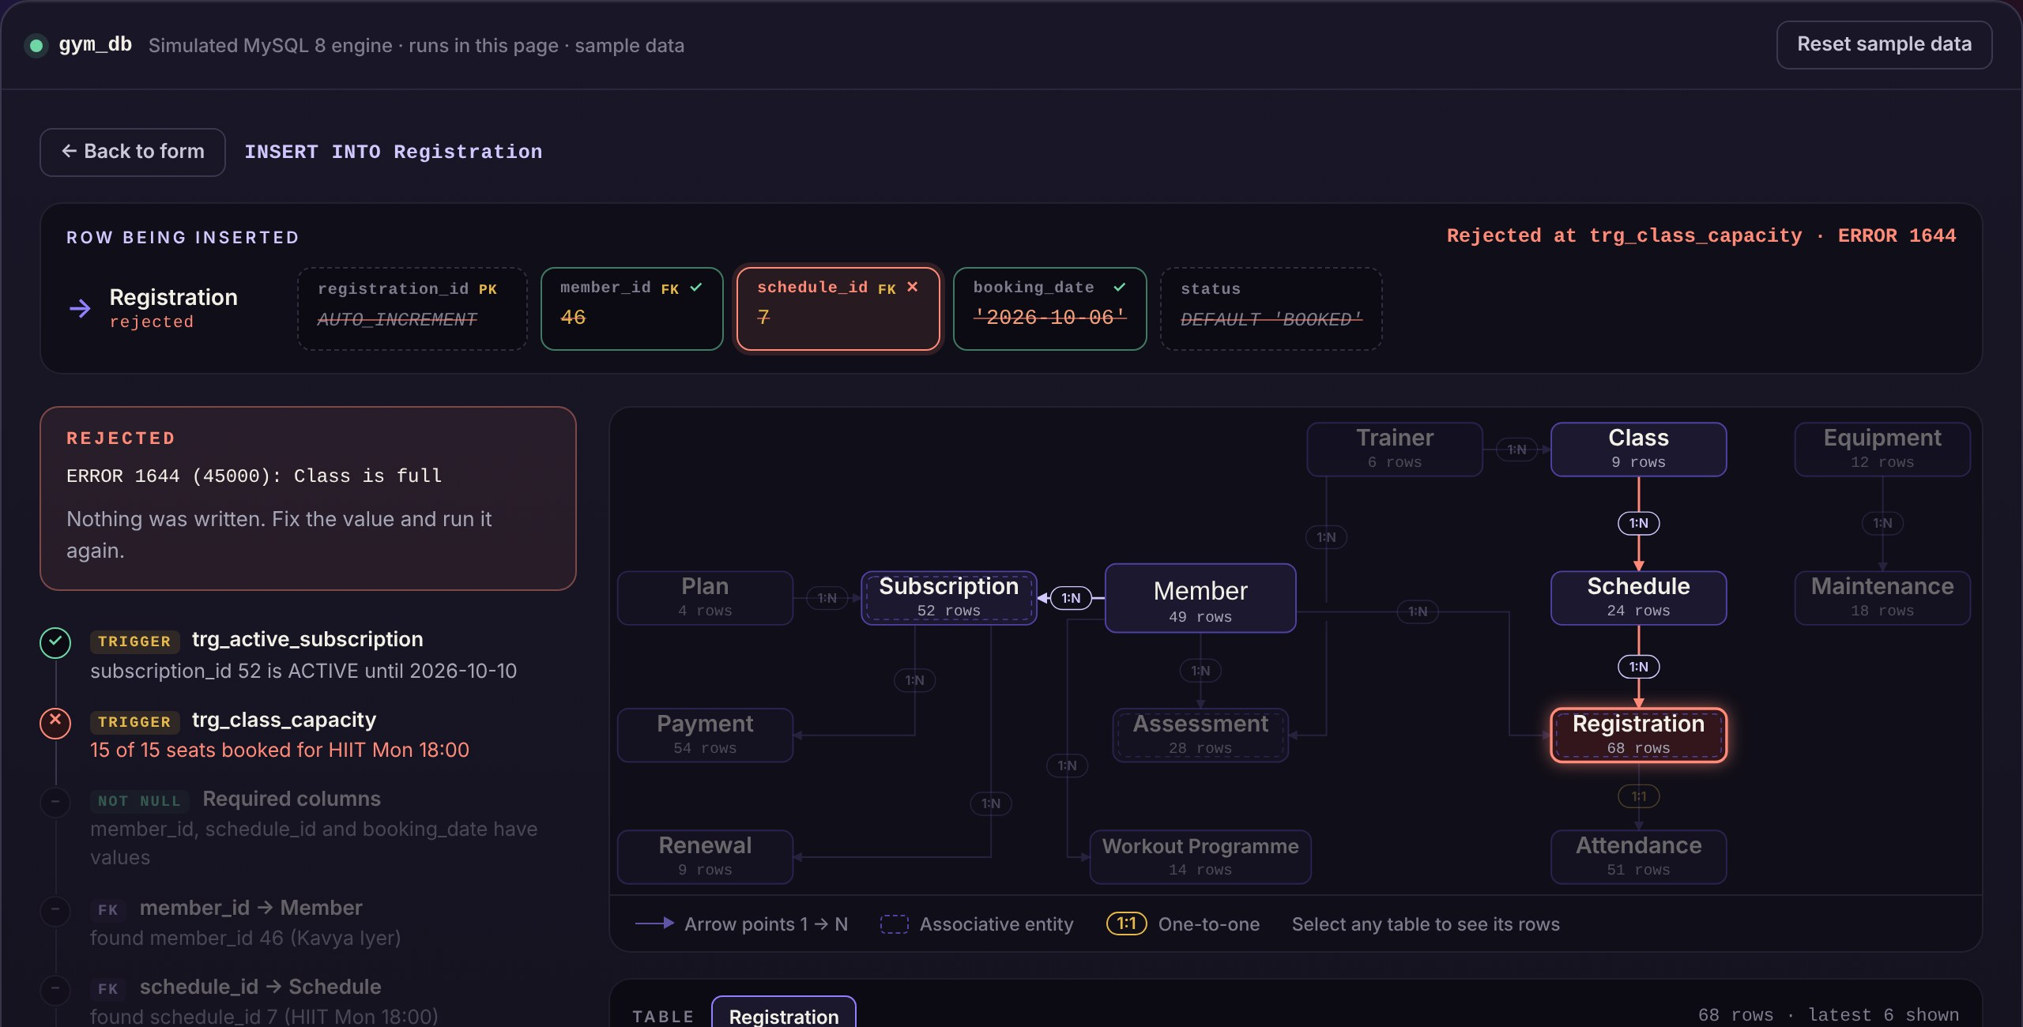
Fig. 5.3 — Booking a full class is rejected by trg_class_capacity with ERROR 1644 before any row is written.
The prototype covers membership registration, subscription with payment, class booking and attendance. The remaining application screens — trainer assignment and assessment entry, the renewals flow, maintenance logging and the full reports screen — are built on the same data-access layer and are in progress for the final submission.

CHAPTER 6 — RESULTS AND DISCUSSION

6.1 Functional Test Cases
Each constraint and trigger was tested by attempting to break it. Every case was run against the prototype with the sample data freshly loaded; Table 6.1 records the expected and the observed outcome, including the MySQL error code returned.
# | Test case | Expected outcome | Observed outcome | Status
T1 | Register a valid member | Row committed | Committed, member_id 49 | Pass
T2 | Register with an email already in use | Rejected by UNIQUE | ERROR 1062, nothing written | Pass
T3 | Register with the name left blank | Rejected by NOT NULL | ERROR 1048 | Pass
T4 | Register with an 11-digit phone | Rejected, value too long | ERROR 1406 | Pass
T5 | Subscribe and pay with valid data | Both rows committed | Subscription 53, Payment 55 | Pass
T6 | Subscription end date before start | Rejected by chk_dates | ERROR 3819, rolled back | Pass
T7 | Payment with a negative amount | Whole transaction undone | ERROR 3819, subscription removed | Pass
T8 | Subscription for non-existent member | Rejected by foreign key | ERROR 1452 | Pass
T9 | Book a class with a free seat | Row committed | Committed, registration 69 | Pass
T10 | Book a full class (15 of 15) | Rejected by capacity trigger | ERROR 1644 “Class is full” | Pass
T11 | Book with an expired subscription | Rejected by subscription trigger | ERROR 1644 | Pass
T12 | Book the same session twice | Rejected by composite UNIQUE | ERROR 1062 | Pass
T13 | Check in the same booking twice | Rejected, one visit per booking | ERROR 1062 | Pass
T14 | Check-out earlier than check-in | Rejected by chk_checkout | ERROR 3819 | Pass
T15 | Schedule an overlapping trainer slot | Rejected by overlap trigger | To be run on the MySQL server | Pending
Table 6.1 — Functional test cases and outcomes.

6.2 Objective-by-Objective Assessment
- O1 (conceptual model) is met — all fourteen entities, their relationships and four user roles are captured in the ER model of Figure 4.2.
- O2 (normalised schema) is met — every relation has a single-column key and no transitive dependency, as shown in Table 4.2.
- O3 (integrity constraints) is met — T2 to T4, T6, T8 and T12 to T14 each exercise a different constraint type.
- O4 (business rules) is met for four of five rules in testing (T6, T7, T10, T11, T14); the trainer-overlap trigger is defined and awaits its test, T15.
- O5 (transactions) is met — T7 shows the subscription row written and then removed when its payment fails.
- O6 (queries and reports) is met — the query set covers joins, aggregates, subqueries and views for all six required reports.
- O7 (indexing) is met — three secondary indexes and four UNIQUE indexes cover the frequent search paths.
- O8 (application and testing) is partially met — the prototype covers the four core flows with clear error handling; the remaining screens are in progress.

6.3 Observations and Discussion
Placing each rule is the central design decision. The most useful outcome of the project was the explicit split in Table 4.4. Rules that need only the current row are cheap and reliable as CHECK constraints; rules that need other rows cannot be CHECKs in MySQL and must be triggers. Writing that reasoning down made the design easier to defend and the triggers easier to test.
Atomicity is visible only when something fails. In the successful case a transaction looks identical to two separate inserts. Test T7, where the second statement fails after the first has succeeded, is what demonstrates that the transaction actually protects the data.
Sample data must be designed, not generated. Several queries returned empty results with the first seed data because no member had lapsed and no class was full. Choosing rows deliberately to cover each query and each rule turned the data set into a test fixture as well as a demonstration.

CHAPTER 7 — CONCLUSION AND FUTURE SCOPE

7.1 Conclusion
The project has taken a gym’s record-keeping problem from requirements to a working relational database. Fourteen entities were modelled, converted into a schema and normalised to Third Normal Form; the schema was implemented in MySQL 8 with the full range of integrity constraints; the three multi-row business rules were enforced by triggers and the two single-row rules by CHECK constraints; subscriptions and payments were made atomic with a transaction; and a query set with views and indexes produces every report the brief requires. The prototype console and fifteen test cases show the rules accepting valid data and rejecting invalid data with precise error codes.

7.2 Learning Outcomes
- Deriving a relational schema from an ER model, including associative entities for many-to-many relationships.
- Stating functional dependencies and using them to prove, rather than assume, that a schema is in 3NF.
- Distinguishing what a CHECK constraint can enforce from what requires a trigger, and writing BEFORE INSERT triggers with SIGNAL.
- Using transactions to keep related rows consistent, and testing atomicity through a failure case.
- Designing sample data and indexes around the queries the system must answer.

7.3 Future Scope
The immediate work before final submission is to complete the remaining application screens — trainer assignment and assessment entry, the renewals flow with printable receipts, maintenance logging and a consolidated reports screen — and to run test T15 on the MySQL server. Beyond the course, the following enhancements would strengthen the system:
- Role-based access control. Separate MySQL accounts and GRANT privileges for each user role, so that a trainer cannot alter payments.
- Automatic renewal reminders. A scheduled MySQL event that marks expired subscriptions and lists members due for renewal each morning.
- Online payments. Integration with a payment gateway so that renewals can be paid without visiting the desk.
- Member mobile application. A member-facing app for booking and progress tracking, reading from the same views.

REFERENCES
- Silberschatz, A., Korth, H. F. and Sudarshan, S. Database System Concepts, 7th ed., McGraw-Hill, 2020.
- Elmasri, R. and Navathe, S. B. Fundamentals of Database Systems, 7th ed., Pearson, 2016.
- Chen, P. P. “The Entity-Relationship Model — Toward a Unified View of Data,” ACM Transactions on Database Systems, vol. 1, no. 1, pp. 9–36, 1976.
- Codd, E. F. “A Relational Model of Data for Large Shared Data Banks,” Communications of the ACM, vol. 13, no. 6, pp. 377–387, 1970.
- Ramakrishnan, R. and Gehrke, J. Database Management Systems, 3rd ed., McGraw-Hill, 2003.
- Gray, J. and Reuter, A. Transaction Processing: Concepts and Techniques, Morgan Kaufmann, 1993.
- Kent, W. “A Simple Guide to Five Normal Forms in Relational Database Theory,” Communications of the ACM, vol. 26, no. 2, pp. 120–125, 1983.
- Oracle Corporation. MySQL 8.0 Reference Manual — CHECK Constraints, CREATE TRIGGER, SIGNAL, InnoDB Indexes and Transactions, dev.mysql.com, accessed 2026.
- Date, C. J. An Introduction to Database Systems, 8th ed., Pearson, 2003.
- MDN Web Docs. “JavaScript Guide,” Mozilla Foundation, developer.mozilla.org, accessed 2026.

