Anime Search Results Analysis

Search Query: 'pokemon'

Generated on: 2025-05-19 14:28:18

# Analysis Summary

Analysis based on 6 anime results.  
Average score: 7.50 (range: 6.91-7.75)  
Most common type: TV (4 titles)  
Most frequent genre: Action (appears in 6 titles)

# Detailed Statistics

## Numeric Features

|  |  |  |  |
| --- | --- | --- | --- |
| Metric | Episodes | Score | Popularity |
| count | 5.00 | 6.00 | 6.00 |
| mean | 41.80 | 7.50 | 2346.00 |
| std | 61.09 | 0.32 | 1574.80 |
| min | 1.00 | 6.91 | 917.00 |
| 25% | 4.00 | 7.45 | 1179.75 |
| 50% | 11.00 | 7.61 | 1738.50 |
| 75% | 47.00 | 7.71 | 3549.75 |
| max | 146.00 | 7.75 | 4535.00 |

## Categorical Features

### Type Distribution

|  |  |
| --- | --- |
| Type | Count |
| TV | 4 |
| TV Special | 1 |
| Movie | 1 |

### Genres Distribution

|  |  |
| --- | --- |
| Genres | Count |
| Action | 6 |
| Fantasy | 6 |
| Adventure | 5 |
| Comedy | 5 |
| AwardWinning | 1 |

### Themes Distribution

|  |  |
| --- | --- |
| Themes | Count |
| Unknown-Themes | 5 |
| School | 1 |
| StrategyGame | 1 |

### Demographics Distribution

|  |  |
| --- | --- |
| Demographics | Count |
| ['Kids'] | 6 |

# Visualizations

## Score Distribution

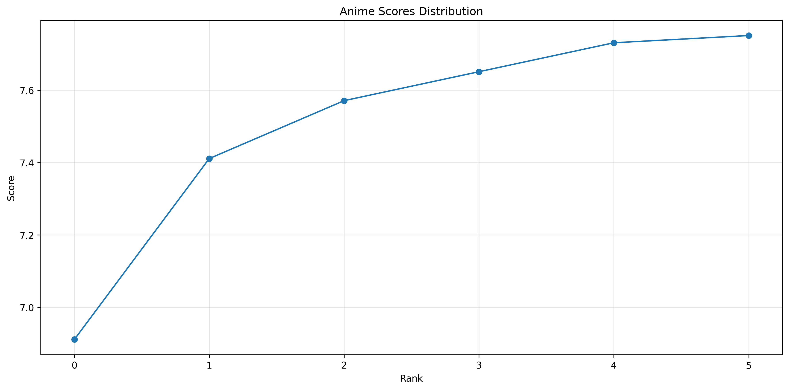

## Distribution by Type

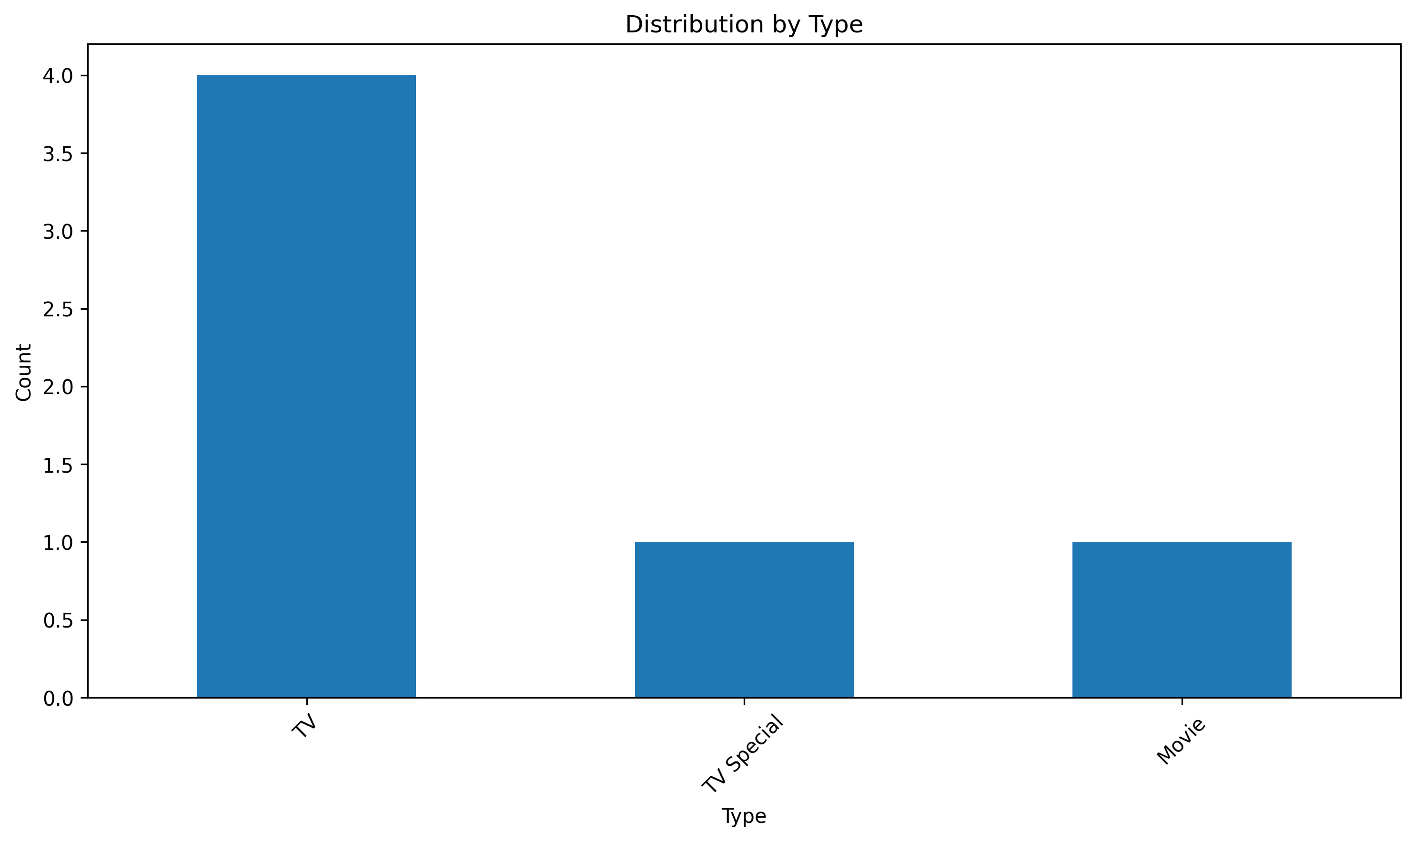

## Genre Distribution

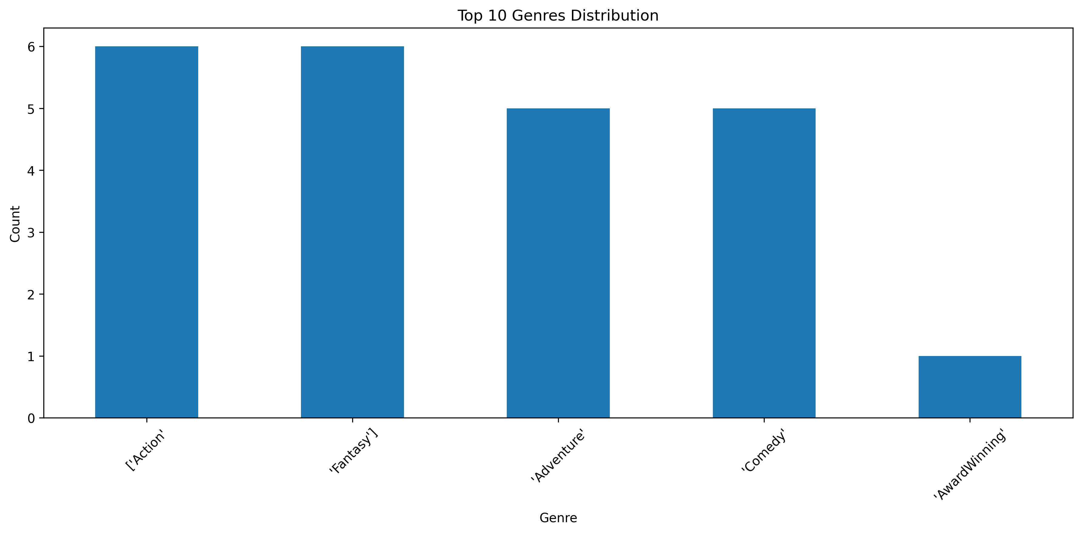

## Theme Distribution

