Homework IV Reinforcement Learning for Pathfinding

Assigned 3/2/17

Due: 3/9/17

Total points: 5

You can work in a group of two persons.

**Homework Description**: in this homework, you are going to use QLearning for pathfinding.

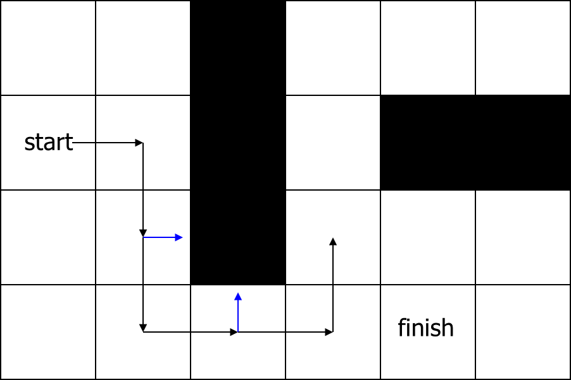

You are going to create a 10*10 grid, either with or without a graphic GUI. In case you don’t have a GUI interface, you should have a function that print out the map and the path found by your algorithm for verification purpose.

Create an algorithm that can randomly generate the start and finish locations, and create 3 different maps with 10 blocked cells in each map. Try to make these 3 maps as different as possible.

Implement Q learning in this environment, and compare its performance in these 3 different maps. When doing this comparison, you need to try at least

**Additional point options:**

1. You may get 1-3 additional points for varying α, γ, and ε (you should use ε-greedy for exploration).
2. Is there anything you can do to encourage shorter path?
3. In your current world, the actual probability of action transition is 1. You can get two additional points if you define the transition functions for the actions, i.e. (P(s, a, s’).

**Turn in:**

1) The entire project with a readme file for how to run your code

2) Report and discussions from your explorations. For each map, turn in

* A picture of your map
* A line-graph comparison of the performances of Q learning over iterations (similar to the example of the cliff problem). You can either create a plot of average Q-Value over all actions and steps versus epoch number or a plot of average reward per episode versus epoch number