JOBIFY CVUT
AI-Powered Career Opportunity Distribution System

System Architecture Documentation
Developer Guide - Architecture Section

Development Team:

Francisco Antonio Molina Alava - Team Leader
Yunus Emre Yuce, Yusuf Emre Erdem, Emir Orhan, Abdul Rahman Asaad Mourad

Czech Technical University in Prague
Faculty of Information Technology (FIT)
Course: BIE-SP2.21 - Team Software Project 2
2025 - 2026

Table of Contents
Table of Contents 2
1. System Architecture Overview 3
1.1 Architecture Summary 3
2. High-Level Architecture Diagram 3
2.1 User Layer 3
2.2 Presentation Layer 3
2.3 Application Layer 3
2.4 Data and External Services 4
3. Use Case Diagram 5
3.1 Use Case Categories 5
4. Activity Diagrams (User Flows) 6
4.1 Student User Flow 6
4.1.1 Student Flow Steps 6
4.2 HR Representative User Flow 8
4.2.1 HR Flow Steps 8
5. Backend Component Architecture 9
6. Technology Stack 10

1. System Architecture Overview
This document describes the system architecture of Jobify CVUT, an AI-powered career opportunity distribution system designed for students at FIT ČVUT. The system follows a layered architecture pattern with clear separation of concerns.

1.1 Architecture Summary
Layer | Components
User Layer | Student User, HR Representative User
Presentation Layer | Web Frontend (HTML/CSS/JS), Discord Bot (JDA)
Application Layer | Spring Boot Backend: Controllers (REST API), Services (Logic), Repositories (JPA), Security (JWT)
Data Layer | PostgreSQL Database, OpenAI API (GPT-4), EXPERTS.AI API

2. High-Level Architecture Diagram
The following diagram illustrates the high-level system architecture showing the layered structure and communication between components.
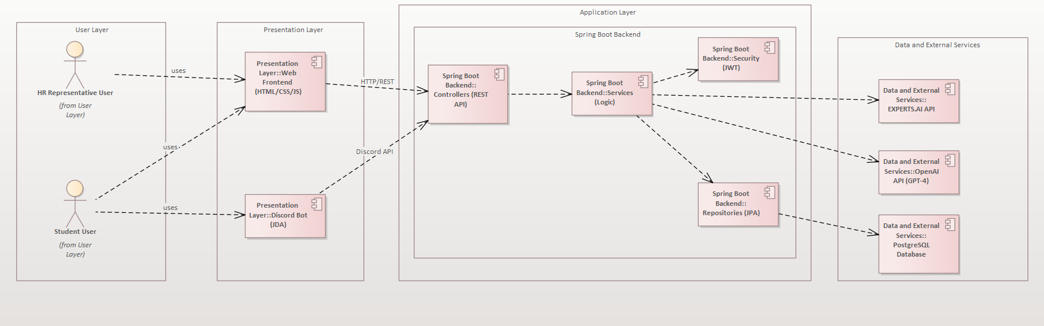
Figure 2.1: High-Level System Architecture

2.1 User Layer
The User Layer represents the two primary actor types that interact with the system:
- Student User: FIT ČVUT students seeking internships and job opportunities
- HR Representative User: Company recruiters posting job opportunities and reviewing candidates

2.2 Presentation Layer
The Presentation Layer provides two distinct interfaces for user interaction:
- Web Frontend (HTML/CSS/JS): Modern responsive web application with dark/light themes, separate dashboards for students and HR
- Discord Bot (JDA 5.0): Interactive bot for Discord-based engagement, CV processing, and AI career advice
Communication protocols: HTTP/REST for web frontend, Discord API for bot interactions.

2.3 Application Layer
The Application Layer contains the Spring Boot backend with the following components:
- Controllers (REST API): 60+ endpoints handling HTTP requests, routing, and response formatting
- Services (Logic): Business logic implementation including job matching, AI integration, and application processing
- Repositories (JPA): Data access layer using Spring Data JPA for database operations
- Security (JWT): Authentication and authorization using JSON Web Tokens with role-based access control

2.4 Data and External Services
The system integrates with the following data sources and external services:
- PostgreSQL Database: NeonDB cloud-hosted relational database with 9 normalized tables
- OpenAI API (GPT-4): AI integration for CV review, career advice, and job matching recommendations
- EXPERTS.AI API: External job opportunity sourcing from FIT/EDUMATCH feed

3. Use Case Diagram
The Use Case Diagram shows all system functionalities organized by user type and subsystem. It illustrates the interactions between actors (Student, HR Representative) and the system's main features.
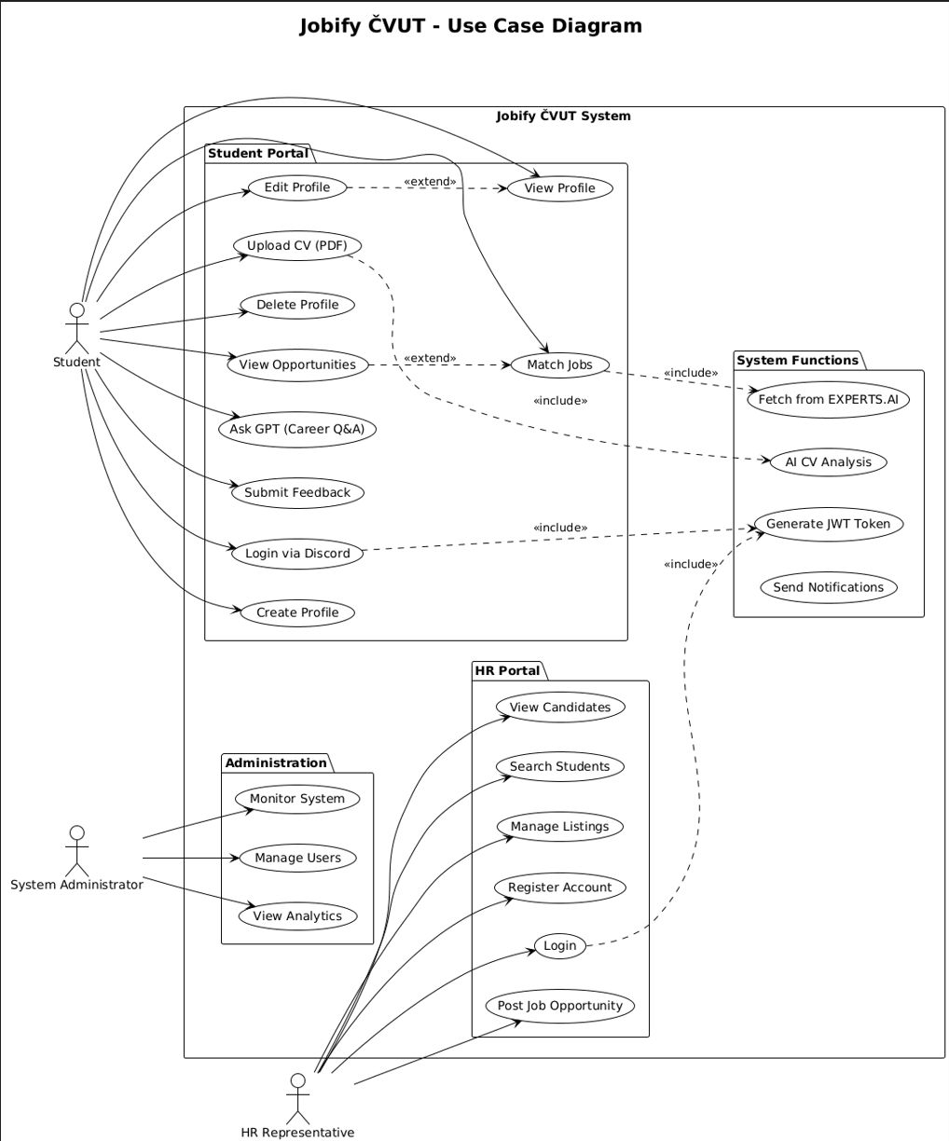
Figure 3.1: System Use Case Diagram

3.1 Use Case Categories
Category | Student Use Cases | HR Use Cases
Authentication | Register, Login, Reset Password, Logout | Register, Login, Reset Password, Logout
Profile | Create/Edit Profile, Upload CV, View Profile | View Student Profiles, Download CVs
Jobs | Browse Matches, Search, Apply, Save, Track | Post Job, Manage Jobs, View Applications
AI Features | Chat with Career Advisor, Get CV Review | Search Talent Pool, View Analytics

4. Activity Diagrams (User Flows)
Activity diagrams illustrate the workflow and user journey through the system for both Student and HR Representative users.

4.1 Student User Flow
The Student User Flow diagram shows the complete journey of a student from registration to job application and career advice.
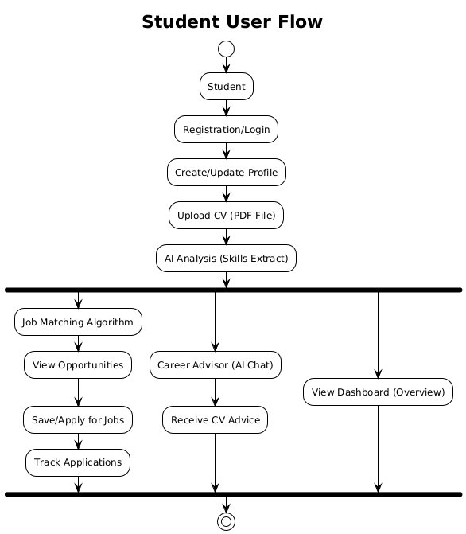
Figure 4.1: Student User Flow Activity Diagram

4.1.1 Student Flow Steps
- Registration/Login: Student creates account or logs in with existing credentials
- Create/Update Profile: Student fills in personal information, skills, education, and career interests
- Upload CV (PDF): Student uploads CV document which triggers AI analysis
- AI Analysis: System extracts skills, education, and experience using PDFBox and GPT-4
- Parallel Activities: After analysis, student can: browse job matches, use career advisor, or view dashboard
- Job Matching: AI algorithm matches student profile with available opportunities
- Apply/Save Jobs: Student can save interesting jobs or submit applications
- Track Applications: Monitor application status (Pending, Interview, Accepted, Rejected)

4.2 HR Representative User Flow
The HR User Flow diagram shows the workflow for HR representatives managing job postings and reviewing candidates.
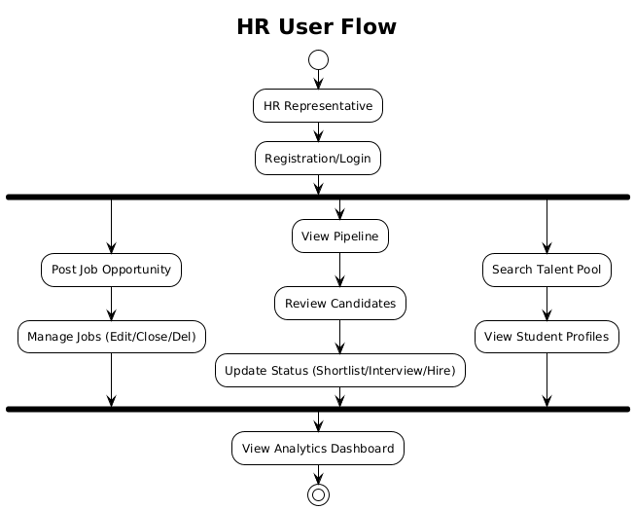
Figure 4.2: HR Representative User Flow Activity Diagram

4.2.1 HR Flow Steps
- Registration/Login: HR creates company account or logs in
- Post Job Opportunity: Create new job posting with title, description, requirements, and deadline
- Manage Jobs: Edit, close, or delete existing job postings
- View Pipeline: Review candidate applications in pipeline view
- Review Candidates: View student profiles, download CVs, assess qualifications
- Update Status: Change application status (Shortlist, Interview, Hire, Reject)
- Search Talent Pool: Proactively search for candidates by skills and qualifications
- View Analytics: Access HR dashboard with recruitment metrics and statistics

5. Backend Component Architecture
The backend follows a layered architecture with clear separation between controllers, services, and repositories.
Layer | Component | Responsibility
Controllers | AuthController | Student registration, login, token refresh
 | HrAuthController | HR registration, login, company management
 | OpportunityController | Job listing, search, filtering, details
 | AiController | GPT chat, CV review, career advice
Services | MatchService | AI-powered job matching algorithm
 | ApplicationService | Job application processing and tracking
Repositories | StudentRepository | Student entity CRUD operations
Security | JwtAuthFilter | JWT token validation and authentication
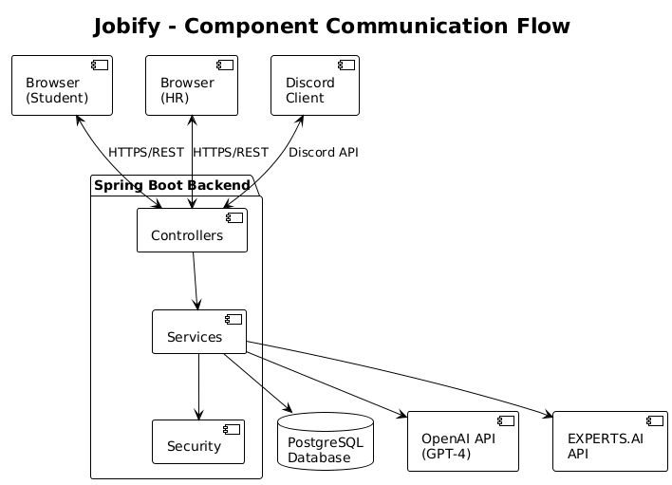
Figure 5.1: Component Communication Flow

6. Technology Stack
Category | Technology | Purpose
Backend Framework | Spring Boot 3.2.0 | RESTful API and business logic
Language | Java 17 LTS | Primary programming language
Security | Spring Security + JWT | Authentication and authorization
Database | NeonDB PostgreSQL | Cloud-hosted relational database
Discord API | JDA 5.0.0-beta.23 | Discord bot framework
AI Integration | OpenAI GPT-4 | CV review, career advice, matching
Frontend | HTML5/CSS3/JS ES6+ | Web interface with responsive design
Build Tool | Gradle 8.10 | Dependency and build management
CI/CD | GitHub Actions | Continuous integration pipeline

