**CLASS DIAGRAM:**

**PROJECT : THE HUMAN SECURITY**

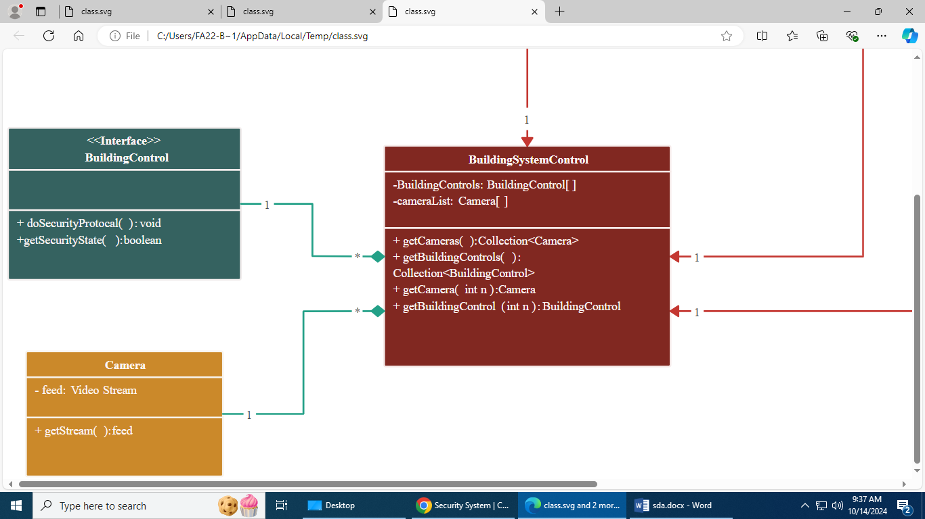

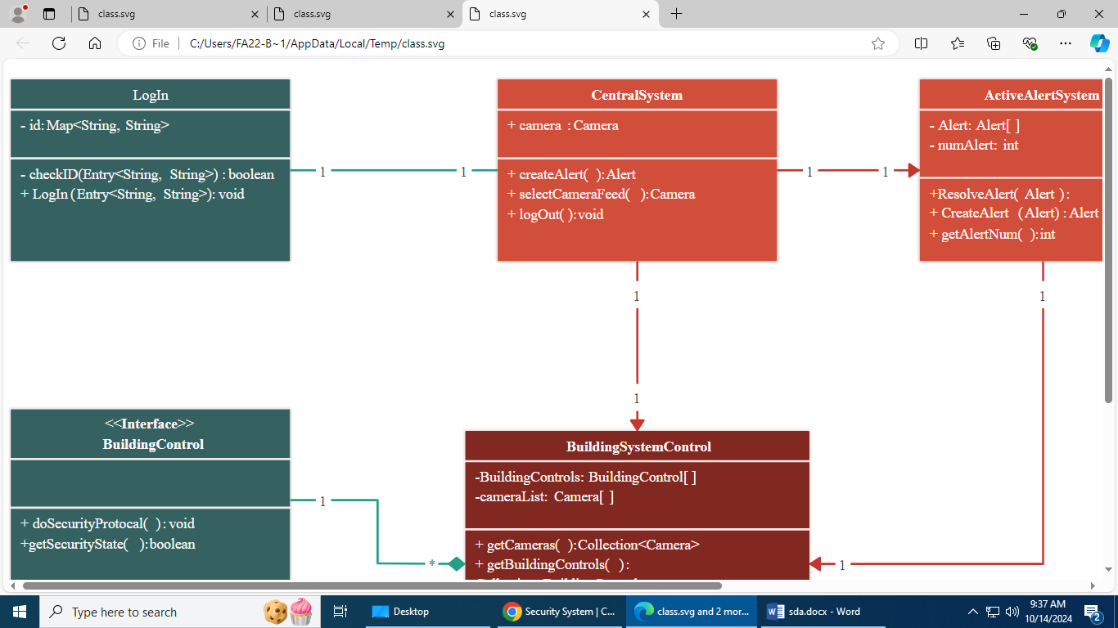

**COMMUNICATION DIAGRA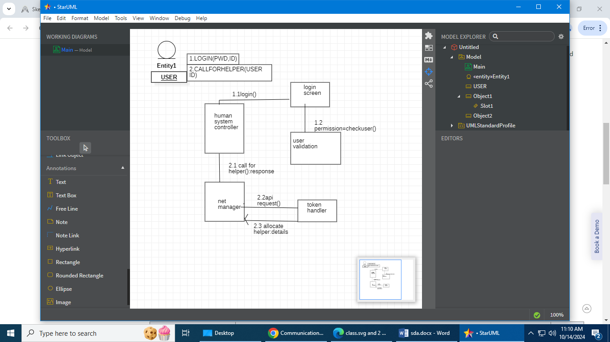M:**

**FULLY DRESSED USECASE:**

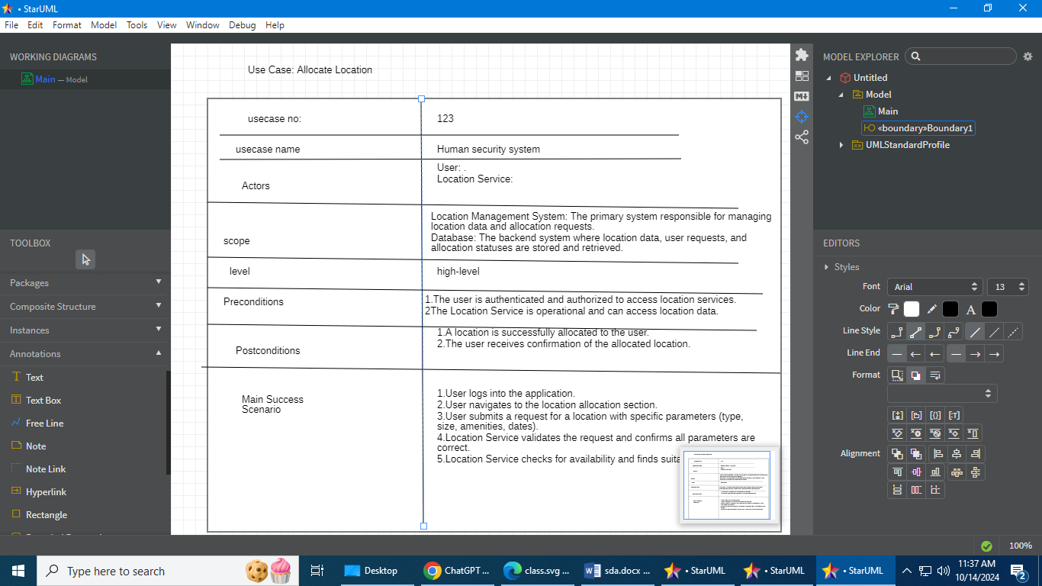

Sequence diagram:

