Week 9

MOTION IN UI/UX

Misconceptions of Motion Design
Motion design is a crucial element in making user's interactions with the brand's digital products more streamlined and intuitive. I love this quote over here.
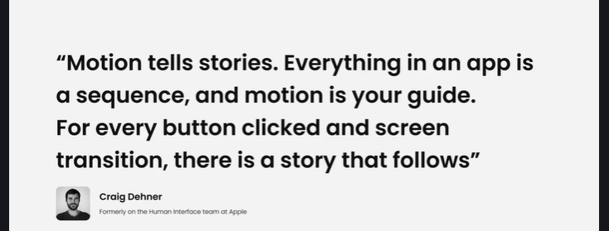

Motion tells stories.
Everything in an app is a sequence, and motion is your guide. For every button clicked and screen transition, there is a story that follows. This was said by Craig Denner, who formerly was at the Human Interface team at Apple, and this quote holds true.
The problem is, motion is often an afterthought. I hear these things all the time, like focus on the other things.
Motion is not a core part of the UX. People generally believe that the core of a product is all the other facets like design, research or UX and the UI. But this ultimately means that the motion is separate from the design process and doesn't play a large role in the usability of products, which is wrong. This belief neglects examples like, say, the Pinterest app, where motion is used to simply and effectively transition users from a list view, maybe to a detail view with minimal impact during major context switching, and you can see it on the side here in this example, whether it is, you know, clicking on a form and moving to the next screen and transitioning, tracking your progress and your completion, that is impossible without motion.

This one's a doozy. We can add motion later.
You can't. Well, you can't do that effectively.
At least motion is generally not considered in the bulk of work it takes to create a digital product.And there's this idea here where people think that once everything else has been completed, then they can just tack on motion later without giving it much thought.
That's not really going to be effective. When people think like this, they neglect to think about all the ways motion has affected interaction concepts that couldn't exist otherwise. If we take a look on the left here, if the user is going to say scroll up and leave a review, that keyboard, the iOS keyboard that's popping up nicely from the bottom, you know, that is an entirely motion dependent interaction there.
Or the iOS app switcher.
It's super important. Let's think about this one over here.
Motion is just animation.
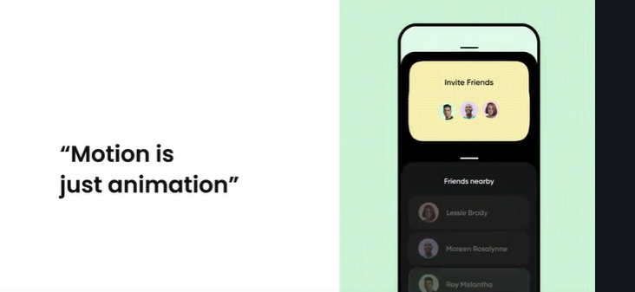

And you know, I know many people are guilty of saying stuff like this, but it isn't entirely true. Animation includes things that move and draws from our understanding of classic animation. You know, think like Disney animation.
Generally, when people think like this, they just think of motion as a way to add personality to a design and product. And you know, that is true because motion can do that. But motion is so much more. People tend to forget is that although helpful, the animation principles that are set out by Disney aren't as relevant as the motion design principles for digital products, because they're solving two entirely different problems.
You know, on the right here, we do have a lot more animation, which, you know, is pretty rare, but it is solving that problem of showing, you know, those friends being invited and being part of that group there.
But those are the common misconceptions I always hear about motion design.

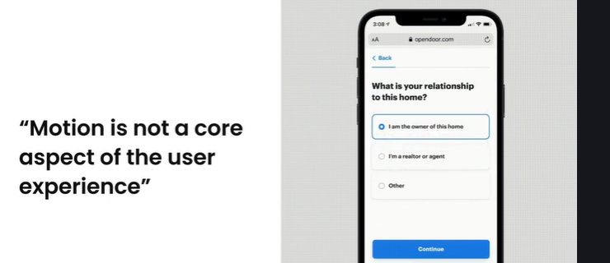

Motion Supports Usability
It's unfortunate that many places treat motion as an afterthought because of these untrue beliefs that we talked about. More specifically, treating motion as an equal to UI animation or UI animation is almost always used in a way to provide delight to users, or a cosmetic change that has no bearing on how successful the
UX is.
Contrary motion is not.
This motion is.
Behavior and behaviors can only help or hinder the user experience.

Motion design must support usability in several ways.
So let's go through what those ways are.
When users interact with the UI elements, what motion behaviors do they expect to see?
- Does motion meet the expectation or cause confusion?
When I ask myself this question, I am thinking about how users perceive what an object is and how it's going to behave. We want to minimize the gap between what the user expects and what they experience.
Our interactions consistent across the user experience.
Here I'm thinking about a couple of things.
- User flow and the general consistency of the UX.
- Ensure continuity, which is the continuity within a scene, and inter continuity the continuity within a series of scenes that make up the total user experience.
So is it what's happening within this one little animation over here, or this one little interaction?
Or is it moving from screen to screen?
We need to make sure those interactions are very consistent, whether it's the speed of the animations or just how gentle they can be.
Do the interactions and motion behaviors create a logical progression of events or interactions in the motion behaviors they trigger tied to a logical progression of events that satisfies the user's intent.
When we design experiences, we need to make sure that the moments and events that we prototype and design connect together in a logical way throughout the entire user experience.
That means if I'm going into a scene like this, is it a card that expands into that scene?
It's logical that it would. And lastly, how do the spatial, aesthetic and hierarchical attributes of UI elements relate to each other and influence user decision making?
So how does motion impact the various element relationships that exist?
Things like the different elements on the screen?

- What happens when it shifts from page to page or section to section?
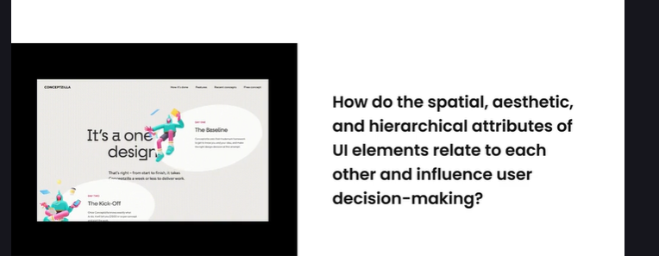
- What does that impact essentially mean for each element in the user experience?
We have to be very thoughtful. And if we do these things properly not only will our designs and user experiences just be generally better, but they will be so much more usable thanks to motion.

Narrative and Mental Models
Simply put, motion serves as an explanation to the user of how one gets to and from various places in the user interface. This explanation can be thought of in terms of coherence, the degree to which the explanation aligns with the UX, content, and mental models.
This narrative over here on the left. It would not have been possible without motion to imagine this without motion. You know you got play the interaction with a simple cut.
No nice transitions from one screen or one interaction to the next. What you are left with is that the beginning and end states of the interaction are conceptually distant.
Motion connects these two conceptually distant ideas and offers a coherent explanation.
Think about this one as well.
In this view, motion is a fundamental part of the user experience, both from a design methodology and from what the user experiences actually. So clicking on a plus or a negative button is bringing those cards in with the controllers just showing you the number of players.
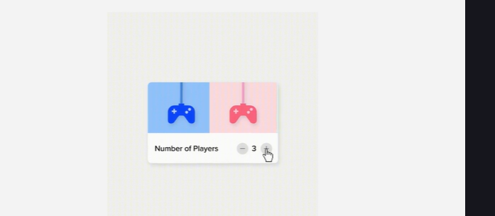

It's a nice clean way to introduce a new concept.
But motion is fundamental.
Motion is not just an add on, but something that requires deep consideration during the design of any two screens or even a simple, simple interaction.
Think of ways to actively use it throughout your design process. Mental models exist in the minds of users and designers alike. When we create products for others to consume, we need to keep in mind that when the user interacts with that product and trying to make sense of it, they have their own mental models.
The design of the system itself and the mental models of the designer. Like you, me, Anyone. This is essentially how we make sense of the products we use, with a shared understanding of how things should work.
Motion plays a very large role in how users perceive what objects are in the interface and what they are and what they do. So with that being said, motion plays a large role in mental models and specifically in how users perceive what objects in the interface are and what they do.
Motion does this by using our existing mental models or by creating new ones. And motion can do this by using a combination of three different methods.

- Skeuomorphic behavior.
We have existing mental models for interacting and navigating our physical environment. If we can understand these mental models, we will be successful at interfacing with a user's perception and reasoning.
In this example, you can see that even just pulling up gives you that bouncy feeling.
What you would expect like from a ball. It's kind of like mimicking real life.
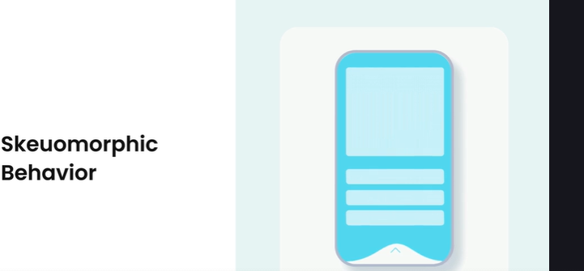

And when we have different interactions that use these types of skeuomorphic behaviors, it's almost like we're making or connecting that thought in our brain with what we're expecting something to do when we slide it up or down too much.
Rules.
As humans, we are wired to learn rules.
Generally, as a designer, we are taught never to make the user think about the design they are using.
Or to put that more simply, we don't want to have our user learn new systems or rules, right?
Like, you want to have an easy design, but there is opportunity for all user experiences, have and will continue to have state changes.

This is essentially the change from one thing to the next, an interaction or a screen change.
Simply put, there is always going to be a gap between those two things.
This gap forces the users to learn, and we are more than capable at learning interaction patterns because of this.
Motion plays a significant role in defining and reinforcing new rules.
- Interactional and visual cues.
Visual cues and static designs imply that there is some sort of cause and effect in the interface.
- The motion behavior.
- The effect is what comes after the initial cue.
- That motion either aligns or conflicts with these cues, and this is a big opportunity for designers to get right.
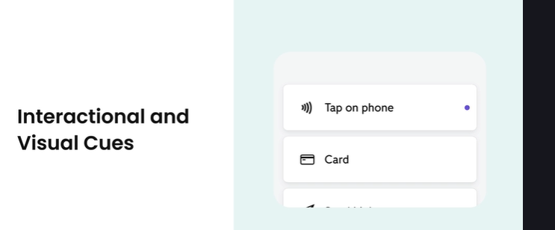
Motion really does have the potential to connect with user mental models and drive product results, so using motion in digital products is a very powerful tool. This is true for designers who look to make a great product that connects with users. It can be very challenging to deliver on because of its natural complexity, but when it's done well, it has the potential to really connect with the users mental models and create a successful product.

What is a Microinteraction?
Despite being small, micro interactions have the power to make the experience of your product more effective and human.
So let's take a look at the definition of a micro interaction.

Microinteractions are contained product moments that are meant for a single use case, and those little moments are a large part of our daily interactions with products.
So think every time you're setting your alarm could just be like the little notches over here. You know, setting those or checking your notifications, having something pop up or something like that, or adding something to your online cart.
You are engaging with Microinteractions when you're doing all these different types of things. A well-designed micro interaction will make the user experience smooth and easy.
Micro interactions can be a great tool for communicating the tone of your brand as well.
Think of Facebook reactions.
These can go on to be a part of your brand's signature moments that increase adoption and customer loyalty. It's really hard to thnk of a brand like Facebook without these anymore, and even the thumbs up is synonymous with Facebook at this point.

The Structure of a Microinteraction
There is a structure that makes Microinteractions effective, and it was created by Dan Stafford in his book Microinteractions Designing with details.
And there are four essential parts to a microinteraction like we're looking at right now.
There's the trigger rules, feedback, and modes and loops.
So let's get into what those are.
So number one is the trigger.
This is what starts the Microinteraction. It could be a user initiated trigger, like a user clicks a button or one of the icons that you see over here. Or it can be initiated by the actual product itself.
Think of a notification that a user is getting.
Number two, we got rules.
These determine how microinteractions respond to a trigger while also defining what happens during that interaction.
So what happens when you tap on an icon.
Does it jingle?

Does it fill?
Does that little ball indicate that it's active?
Number three we get feedback.
This tells the user what is actually happening during a microinteraction, inputting a wrong password and receiving an error, or inputting the proper email and actually getting through to the next form input.
This is a great way to alert users that they have done something wrong, and it will guide them to proceed properly.
And the last one is Loops and modes. These are the meta rules of a microinteraction and how it changes when used.
Understanding the structure of a microinteraction allows you to design ones that make a difference. So with loops and modes, these rules could be like whenever you click something, does it change every time you click it?
Or does it just repeat?

Smart Animate
We are going to get into smart animate now. Figma has some really cool prototyping tools here and we all know if smart anime is by now just a little bit, at least now what it does is it looks for matching layers, it recognizes those differences and then animates the layers between the frames.
So what does that mean?
Let's jump up here.
So if we look at this frame, the scale frame and this scale frame, you know, we have two frames.
And within those frames we have these elements.
Now you'll notice that these elements are named exactly the same.
They're scale and scale.
The only difference is this one is a bit larger.

Now, Figma will automatically pick that up and animate it to grow instead of just having an instant, you know, animation from here to here, smart animate allows you to quickly create advanced animations so you can use some more animate to replicate things like loading sequences, parallax scrolling, touch gestures like dragging, swiping, long pressing.
You know, we can use sliders, toggles and switches. We can expand content like showing more and less.
We can pull to refresh all those different things we can replicate with smart animate. Now what it does is, like I mentioned, it looks for those matching layers.
And that also means that your layers, if you have more than one in a frame and we'll get into that later.
But if you have more than one, you are going to need to ensure that from one frame to the next, those layers are set up the exact same way if you want them to animate nicely.
So Figma does take into account both the layers name and where it sits within the hierarchy. For layers that match between frames, Figma will recognize what's changed and apply that transition to animate between them.
So let's get into the different properties.

Figma Check In — Smart Animate Properties
Practice file here >> https://www.figma.com/file/aoHkAyWRJnpkR6FQqJgdId/13.-Motion-and-Microinteractions?type=design&t=j2lcMgAPjl0SeKq0-6
How to duplicate
https://help.figma.com/hc/en-us/articles/360038511533-Duplicate-or-copy-files
Let's jump right in because I have these connected. So I'm gonna press the presentation button. And we're going to see our scale flow over here.
So what does it mean if an object changes in size between frames?
Figma will animate it shrinking or growing like that.
Pretty sweet, right?
If we go back to our design, we will see the on click interaction. I just have it set to smart anime ese. Oh, and 500.
But we can also change that to things like bouncy and we can see what that looks like. So if you want to do something like that, you can definitely do something like that.
I'm just going to leave it on, ease out for now. And you know, I think that's fine.
Let's talk about position.

Figma will recognize if an object's location that means its x and y coordinates have changed, it will then animate that object, moving from its current position to its position in the destination frame.
So in this destination frame, it's obviously turned on. Now another thing I'm going to just sneak in here is that you can put these properties together.
So I have position and I have fill.
So I am changing the color as well.
Let's see what that looks like.
So I'm going to go to my position flow.
And you can see that I have that sliding.
If we go into here, we can see that the fill is the background and we have the toggle on top.
And this one over here we can see the fill and toggle are the exact same name as in this frame and their structure is exactly the same.
So that's really important.
Let's talk about opacity next.
So opacity smart animate can also recognize a layer or object's opacity. You can adjust opacity to make an object to appear or disappear between frames. So let's see what that means.
Whoa.
So you saw that we have reduced the opacity of the top half of this gradient, and now it's bleeding through the backgrounds.
Bleeding through.
Let's take a quick look at that.
So if we look at our design, we can see that in this frame we have that full linear gradient.
But in this frame, I have removed the opacity from the top portion.
So that's super cool.
Let's jump into the next one rotation.

Okay.
So smart animate also takes the layers, rotation and orientation into account.
So if I click this, we can spin.
Pretty simple.
I just spend.
I just rotated this whole frame over here called rotation.
It's actually a group, but I just quickly rotate it and you can see over here it's a zero.
And at this point it's 180 degrees.
And then the last one is fill.
So Figma will also animate any changes to an object's fill.
That means this allows you to animate changes between colors, gradients and even images.
So we've changed the fill of the background and the circle just based off of this click. And that is your intro to smart anime and all the properties that you can actually animate.

